# Run procedure – Azure Function DB API

### Step-1: Azure function DB API

Go to the below link to access Azure Function DB API (instance) hosted in Azure web app service. This is an Open API directly accessible from the browser

<https://azdbapi.azurewebsites.net>

### Step-2: All other Azure Functions

All available functions will look like

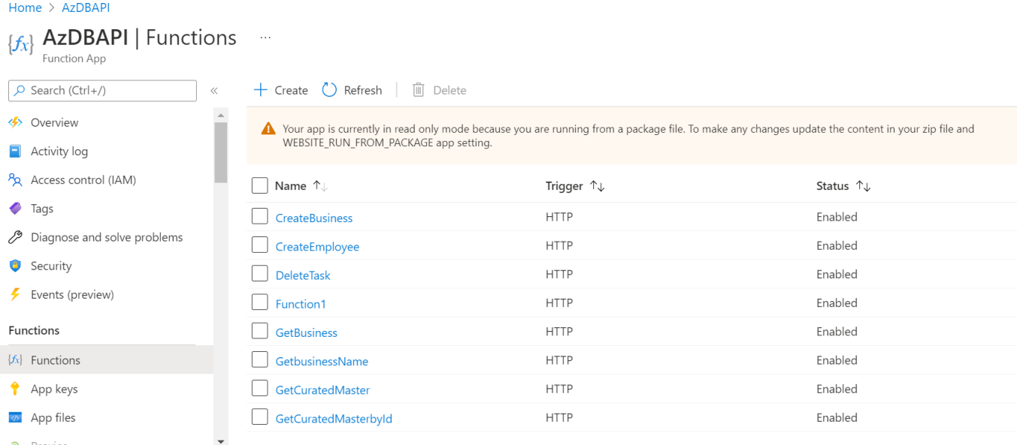

### 

### Step-3: Just for an example GetCuratedMaster link would be

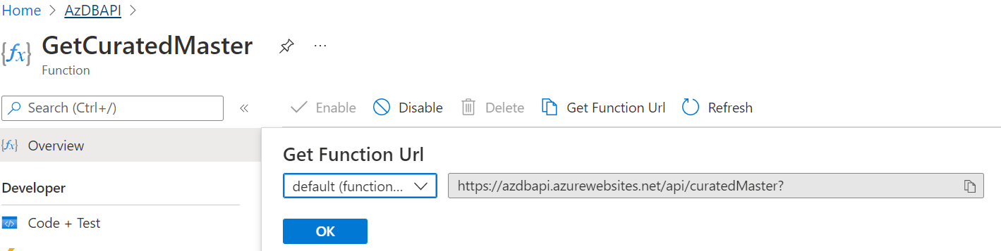

<https://azdbapi.azurewebsites.net/api/curatedMaster>

### Step-4: Service Response

Response received in json format with all available diversity dimensions

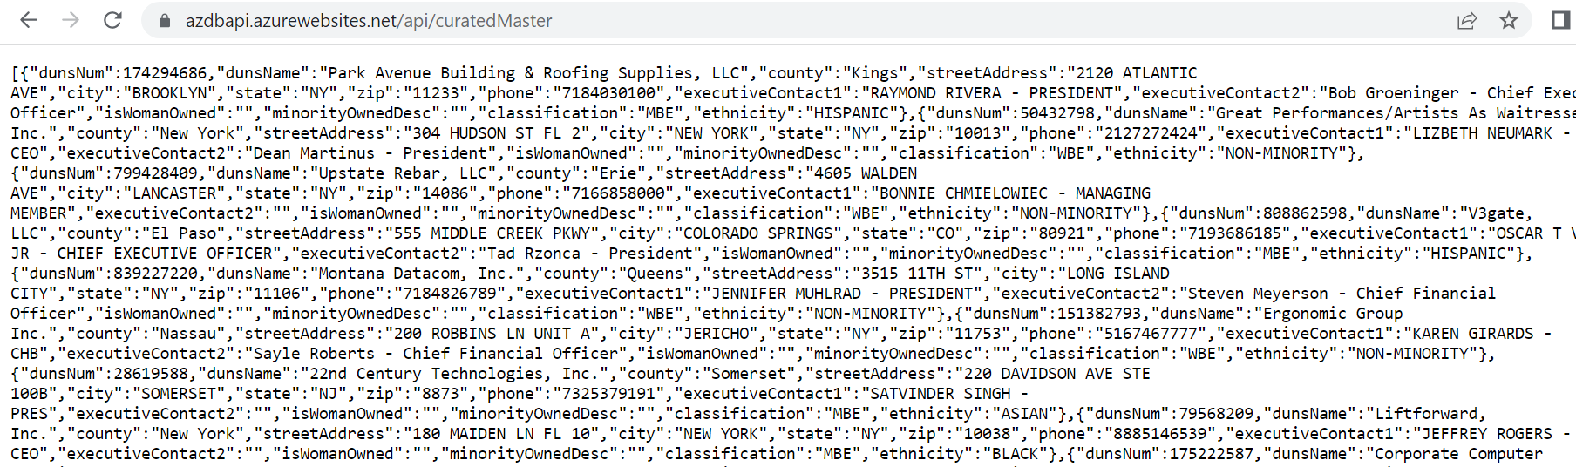

Similar way we can go ahead with different azure functions to create/update/select data.

# Run procedure – Daun & Bradstreet API

### Please run the below endpoint using curl or postman

Type: GET

Azure API endpoint:

[https://seagulls-dnb-wrapper.azurewebsites.net/api/companyprofile/{dunsnumbers}](https://seagulls-dnb-wrapper.azurewebsites.net/api/companyprofile/%7bdunsnumbers%7d)

Headers: Not required

Body: Not required

Example duns: 804735132

**Exected output:**

{

"companyName": "Gorman Manufacturing Company, Inc.",

"minorityOwnedIndicator": true,

"femaleOwnedIndicator": false,

"owners": [

{

"designation": "Secretary",

"gender": "male",

"ownershipPercentage": null,

"minority": null,

"veteran": false,

"ownerName": "Kevin J Hunt"

},

{

"designation": "President",

"gender": "male",

"ownershipPercentage": null,

"minority": null,

"veteran": false,

"ownerName": "Leslie Smith"

}

],

"ownershipEthnicity": "Hispanic"

}

Seagulls Scan API

Prerequisites:

* Access to Azure
* Postman tool is installed in machine

Steps:

# Run procedure – Scan API Azure cognitive service

Test execution of business – Bullard Company

Open Postman

1. Execute a GET request on serpapi

https://serpapi.com/search.json?q=Bullard Company MBE WBE&location=United States&hl=en&gl=us&google_domain=google.com&api_key={placeholder for key}&tbm=isch

This generates a successful response with all details about Bullard Company

From the result, in the Original link, you will find value <https://www.bullardeng.com/upload/images/blog/nmsdc_certificate_-_blog.jpg>

Open this link in a new browser window and show the certificate.

Note: api_key need to be generated and supplied

1. Run computer vision module

Login to Azure portal (portal.azure.com)

Enter “Computer Vision” in the search bar and choose Computer Vision service

List of deployed computer vision services are displayed. Click “seagulls” to view details

In the details page, scroll down to section 2.

OCR text extraction is a 2 step process – you submit the image to Azure to process. Azure sends you a reference operation id. Use this as input to a execute read analyze request to get the OCR text.

Click API Console link

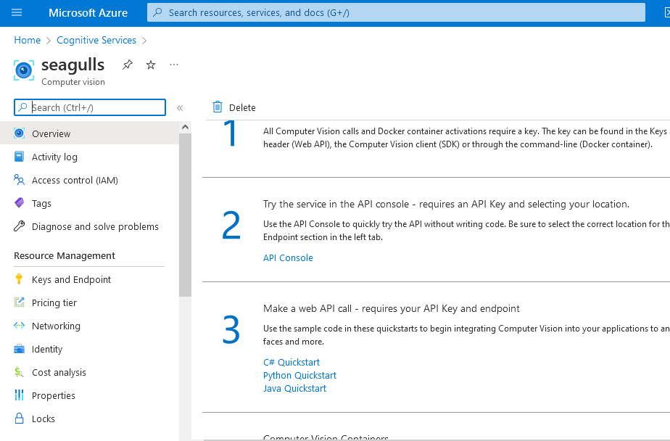

The Computer Vision API test page is opened

Click Read option on the left navigation

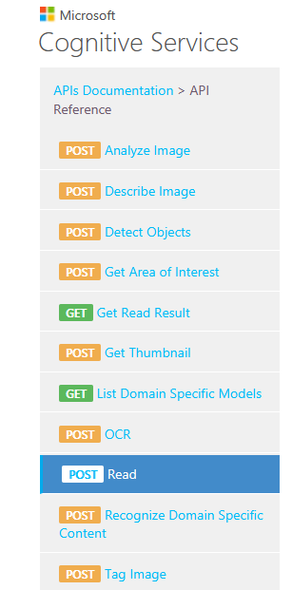

Scroll down and click East US

Enter Resource name as **seagulls**

Enter ocim subscription key as **{placeholder for key}**

For Request Body, enter **{“url”:”**<https://www.bullardeng.com/upload/images/blog/nmsdc_certificate_-_blog.jpg>**”}**

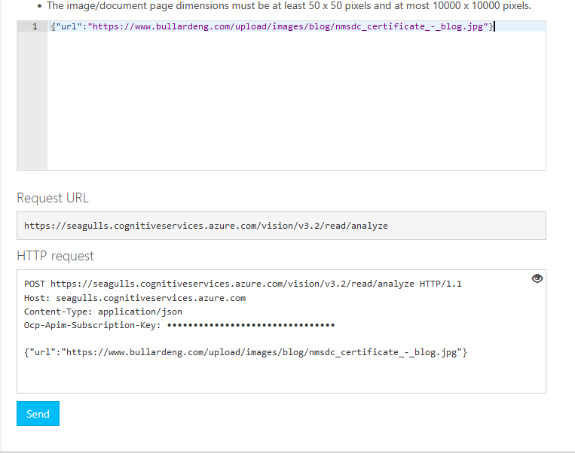

Click Send in the Computer Vision API test page. This completes the read request and Azure runs this request asynchronously.

In the response, you will get a value for Operation-Location. Copy that value in a notepad. This will be needed to get the OCR text.

Now click “Get Read Result” link on the left menu

Scroll and click “Open API Testing console” button

Enter wildcard segment value **seagulls**

Enter operationId value – this you would have got from the response of previous read – Operation-Location value

Enter Ocp-API subscription key **{placeholder for key}**

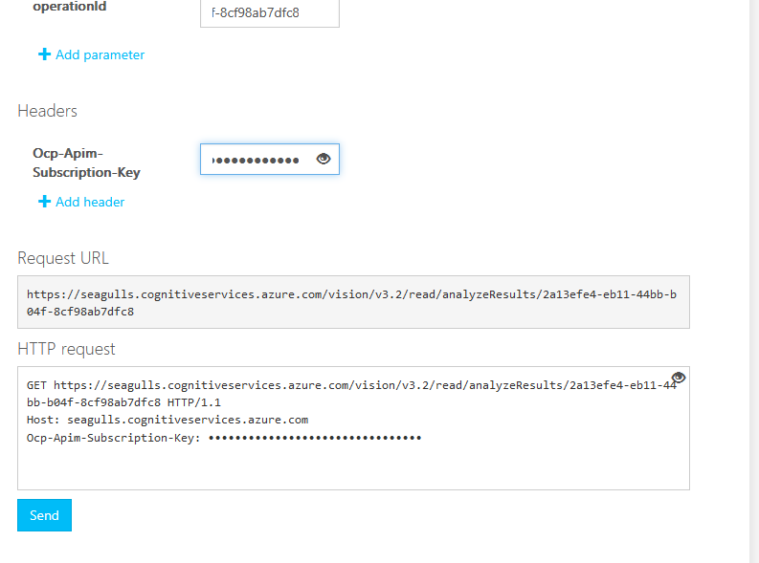

Click Send.

In the json response, scroll and show the values for field “text”. The values correspond to the text extracted from the certificate. We can see the company name – Bullard Company, NMSDC, and also the certification text.

This completes the API and we can demonstrate that using the certificate, we can identify that a business is Minority and Women owned business.

Input data 2: Company Agile Fabrics

Open Postman

1. Execute a GET request on serpapi

https://serpapi.com/search.json?q=LGBTBE Certified Agile Fabrics&location=United States&hl=en&gl=us&google_domain=google.com&api_key={place holder for key}&tbm=isch

In the response, show Original field URL value <https://agilefabrics.com//wp-content/uploads/2020/07/NGLCC%C2%AE-LGBTBE%C2%AE-Certificate-Agile-Fabrics-LLC.png>

Open this link to show the certificate.

Open Azure portal; navigate to Computer Vision. Do the same process as before using this url. The subscription key and wildcard remains same.

For every read request, you get a different operation-id value. Note it and use it as input in “Get Read Result” operation.

# Run procedure – NLP API

### Step-1: Fast API through Azure web app service

Go to the below link to access NLP Fast API application (instance) hosted in Azure web app service. This is an Open API directly accessible from the browser

<https://seagullsapi.azurewebsites.net/>



Getting above message ensures API is up and running.

### Step-2: Swagger UI

Navigate to docs page to access Swagger UI for interactive exploration

<https://seagullsapi.azurewebsites.net/docs>

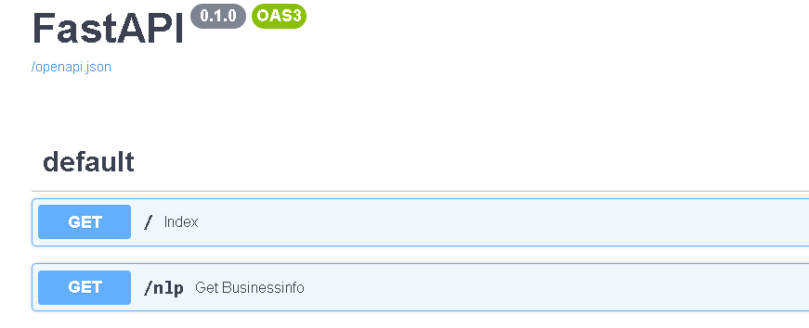

### Step-3: NLP method

Pass the company name parameter to get nlp method by clicking “Try it out” button and execute the request

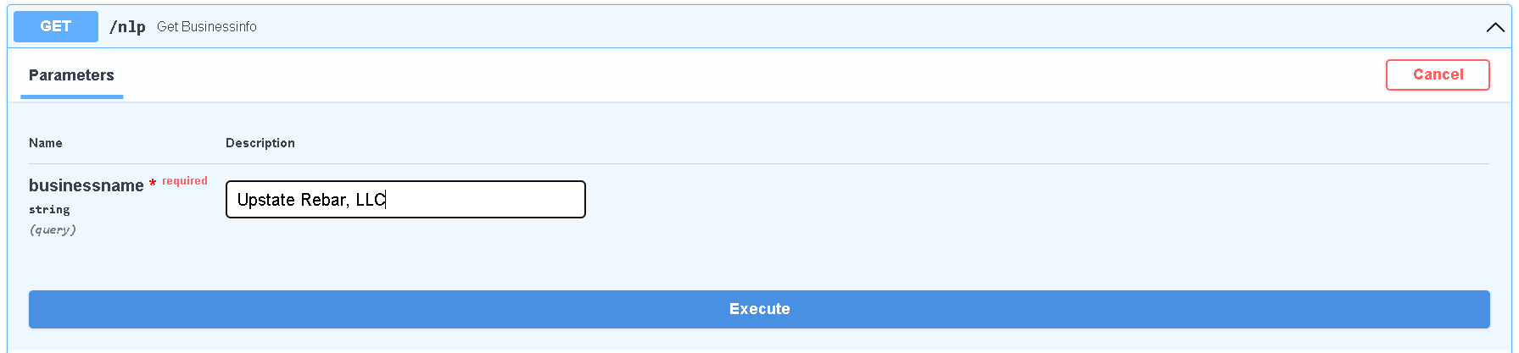

### Step-4: Service Response

Response received in json format with all available diversity dimensions

