**Steps to run the Application**

**1) Run as Spring boot Application**

**Right click on DiversityApplication.java -> Run as -> Java Application**

**2) Open the Post man and enter the below details**

**Method : Get**

**Url : http://localhost:8080/selenium?name=<UserName>&company=<Company>**

**Please enter the username and company in short form to search and hit send**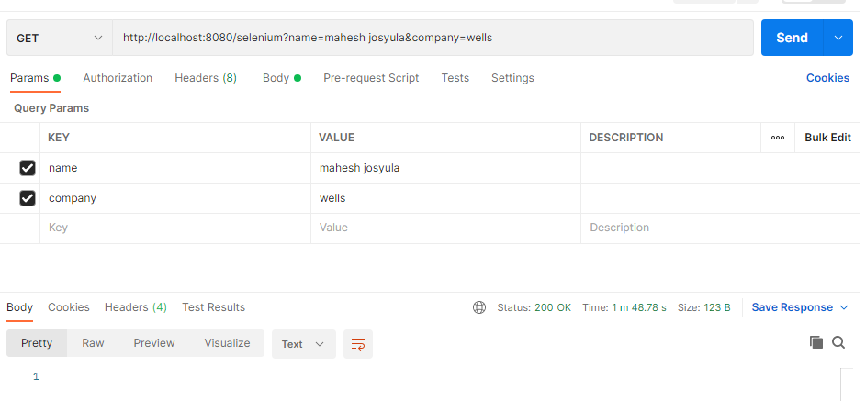

**3) login to the azure portal and navigate to blob storage as below to view the data**

**Seagullsstorage->Containers->linkedin->content.json**

