**INTRODUCTION**

1. **INTRODUCTION**

**1.1 Financial Portfolio Management System**

It’s the process of managing the various types of investments and keeping in mind the risk and profit associated with each of the investments. It also helps in making decisions about investments mix and policies, matching the investments to objectives, asset allocation for individuals and institutions and balancing risk against performance.

Portfolio can be of categorized into two forms:

**Active Portfolio Management:**

While trading on a regular basis technical, fundamental and other analytical procedures assist in making right decisions about the investments .For example, Company may buy stocks or bonds on a particular day and then later on sell it to buy another stock or bond.

**Passive Portfolio management:**

It is a financial strategy in which the decisions about the investments are made independent of market timing or stock picking. For example, a company or individual may buy mutual funds, which holds a mixture of shares and also is independent of the market.

**1.2 NEED FOR FINANCIAL MANAGEMENT SYSTEM**

For each organization or an individual having more than one liability, there is a need for an investment portfolio to manage their liabilities. The liabilities can include different stocks, bonds, mutual funds and other types of investments. The motto of creating a portfolio management system is to help an investor enhance their investment's total value by helping them make right decisions about their investments.

It keeps the investors updated on a regular basis regarding their investments. Information’s about the risk and sometime the guidance on overcoming the risk helps the investors in making the correct investments. Apart from the investor’s opinion, portfolio management system helps in providing some expert view regarding the investment.

**DRAWBACKS OF EXISITNG SYSTEMS**

1. **DRAWBACKS OF EXISTING SYSTEMS**

There are a number of free financial management systems available in the market. Each one of them aims to ease the process of trading for the investors. But many of them lack certain features. Few of the drawbacks are

1. **Real time Market Updates** – Many of the free software lack real time updates. Real time market updates help the investor obtain information about the market at one place instead of the user referring multiple sites/applications. Thus it reduces the tasks performed by the user.

ii)**Usability –** An intuitive user interface plays an important role in a financial management system. The financial management systems available in market overwhelm the user by presenting abundant data to them. They also require the user to do multiple redundant steps before a certain task can be completed.

iii)**Online Support –** Investing in shares involves a lot of risk. So the user should be able to obtain guidance at all times. So it is important to make this feature available to the user

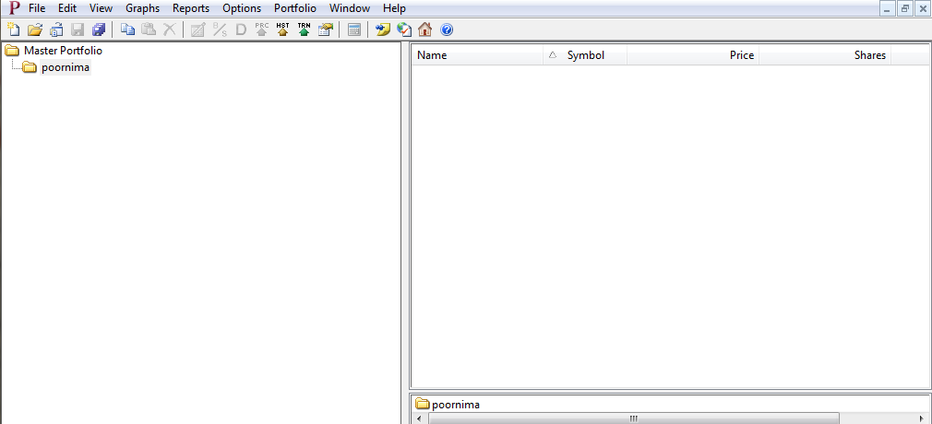

**Figure 1**

Figure1 shows a screenshot of one of software available in the market. Although the software has the major functionalities required for a financial portfolio management system, the user has to perform plenty of steps to access the functionality. This software also lacks real time market updates and online support.

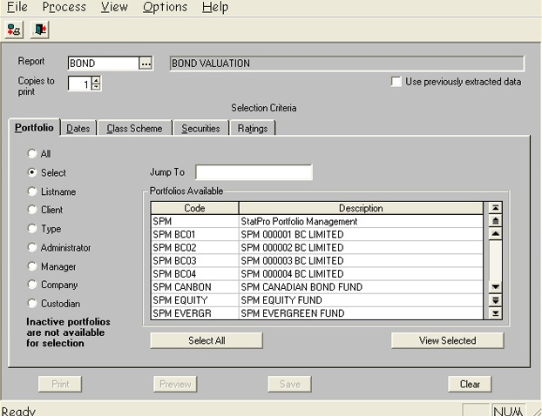

**Figure 2**

Figure 2 shows the screenshot of financial management system available in the market. Although this software has good functionality, the user interface is not intuitive. Everytime the user has to change to a different functionality, he has to click on the File menu and select an option. This requires the user performing more actions and also the user has to remember all the actions he has performed.

**TARGET USERS**

1. **TARGET USERS**

Organizations and individuals who have multiple securities can use this system. Here securities can be considered as stocks, bonds, mutual funds and other type of investments. This system helps them in managing the various securities efficiently and minimizes loses due to incorrect decisions.

**GOALS OF THE SYSTEM**

1. **GOALS OF THE SYSTEM**

**Stable Return:**

Once an investment is secured, the portfolio should yield a steady income. An income can be measured by the interest of dividends

**Marketability:**

In order to get a good return on an investment you should have a portfolio that can be easily marketed. If the number of inactive shares in your portfolio is more, it decreases the chance of encasing it for a good amount and it also affects the ability to switch investments.

**Liquidity:**

There is a constant need to ensure that enough funds are available at a given time to manage investor’s liquidity requirement. To achieve investor’s liquidity requirements an appropriate line of credit has to be maintained.

**Balance:**

To achieve a desired balance of investment in terms of number of investment parameters like long-term investments versus short-term investments; High risk vs. low risk investments; various market conditions; and diversified list of investments.

**Value Maximization:**

Maximize the value of the portfolio in terms of return on investments by providing guidance on the minimum acceptable value.

**Strategic Directions:**

It helps the investors in choosing the right investment and maximizes the return on investment and minimizes the losses which might occur due to bad decisions

**SCOPE OF THE PROJECT**

1. **SCOPE OF THE PROJECT**

* Observe the performance of portfolio by integrating latest market trends.
* Investor’s limitation, objective and priorities can be identified and put into effect
* By comparing the set target and achievements made, the portfolio income can be evaluated.
* Make amendments in the portfolio
* Strategies are implemented in sync with the investment objectives
* Improved usability of the software.
* 24/7 online customer support
* Real Time Market Updates
* Ability to manage investments in multiple countries
* Email and text notifications
* Data presentation in the form of graph & charts

**BUSINESS NEEDS**

1. **BUSINESS NEEDS**
2. **Improved customer support**: When the customer faces some issues with the software they should be able to receive support as early as possible. The software should have in-built capability to report bugs.
3. **Extended platform compatibility**: The software must be designed and developed in such a way that it should run on multiple platforms such as MacOS, Windows and tablets such as Ipad
4. **Ease of Use**: The investor should be able to use all the features of the product without much guidance or training.
5. **Real-time updates**: Software should be able to handle real time updates at a much faster pace than the currently existing software since financial data handles critical numbers
6. **Increase the sales of the product**: By following good marketing strategies such as providing good quality product at lower cost, improve the popularity of the product among the investors thereby increasing the sales.

**REQUIREMENTS ANALYSIS**

1. **REQUIREMENTS ANALYSIS**

**Functional Requirements:**

**Functions:**

**User Account Management:**

The user account management function is responsible for registering the user with the system. The user will get a unique username with which he can securely login into the system. The user will be prompted to enter a password which should abide predefined guidelines. All the user accounts will be managed by the system administrator.

Functional Requirements:

|  |  |
| --- | --- |
| **FUNCTION** | **DESCRIPTION** |
| i) Registration | The user should be able to register with the system by filling a form containing their personal and background details. |
| ii) Username | The system should be able to provide a unique username for each registered user. |
| iii) Password | The system should ensure that the user enters a strong password following the defined guidelines. The system should prompt the user to change the password every 15 days. |
| iv) Editing personal Detail | System should have an option to allow the user to update their personal details as frequent as they intend to do so. |

**Fund Management:**

The fund management function is responsible for managing the various types of investments. It helps in managing the cash flow keeping in mind the current market scenario. It also helps in fund transfer and invoice generation.

Functional Requirement:

|  |  |
| --- | --- |
| **FUNCTION** | **DESCRIPTION** |
| i) Funds Transfer | The system should allow an investor to transfer funds to a client. There should also be an option that allows institutions and brokers to transfer funds to an investor. |
| ii) Fund Status | The system should be able to provide the latest status for any requested deposits, withdrawals or transfers. |
| iii) Invoicing | The system should be able to generate monthly invoice for client accounts. |
| iv) Account Management | The system should enable an investor to transfer cash and/or gives rights to have an access of a financial advisor helping them in managing their account. |

**Report Management**

This function enables generation of statements. The investors will be able to view and print various types of forms such as tax forms. They can also view trade executions in real time. This function also enables the investors to email their statements if there is a necessity. It also helps in the conversion of statements based on the currency.

Functional Requirement:

|  |  |
| --- | --- |
| **FUNCTION** | **DESCRIPTION** |
| i) Statements | The system should enable the user to view, print and download daily, monthly and yearly statements. |
| ii) Trade Execution | The system should allow the user to view daily trade executions in real-time. |
| iii) Forms | The system should provide the user an option of viewing or printing various forms such as tax forms |
| iv) Email | The system should enable the users to email their statements. |
| v) Currency Translations | The system should be able to covert the statements based on the base currency. |
| vi) Market Data Subscription | The system should provide the user the ability to subscribe or unsubscribe to market data. |
| vii) Alert Notification | The system should be able to inform the user about alert such as risk to an investment through email or sms. |

**Graphical Representation**

The graphical representation function will allow the user to view the latest market trends in form of different type of chart eg. Pie chart, bar chart, line graph. The function implementation will allow the user of system to understand the market ups and downs in a convenient manner rather than user using numeric representations.

Functional Requirements:

* The system should be able to interpret the numerical data and represent them in graphical format.
* The system should be able to produce different types of charts. Eg. Bar graph, pie chart, line chart.
* The system should be able to present the data in a classified format by providing different colors for different data.
* The system should display detailed information on the click of a segment on the graph.

**PROPOSED SOLUTION**

**8. PROPOSED SOLUTION**

Portfolio Management is the process of determining optimal solutions for assets such as stock, bond, shares, cash that will suite a particular investment time frame and risk associated with it.

PMS is designed to address the needs of investors:

1. Helps managing different times of investments. Movable and immovable
2. It advices them about the risk associated with investments
3. It helps them maintain their spending within an estimated budget
4. It helps the investor’s in taking decisions for making investments based on the current market scenario
5. It also gives finance advices for future planning
6. Real time data regarding current market stats are provided
7. Have facility of providing reminders through emails or messages regarding bill payments in order to avoid late payment or non-payment of bills

vii) Allow investors to buy and sell mutual funds, shares, bonds or any kind of assets based on the day-to-day market trends by setting low and high range

PERSONAS

**9. PERSONAS**

1) Amy is a 56 years old who retired two years ago after her 30 years of tenure with the USOC (United States Olympic committee) . She has saved up some money from the previous employment and she also has few other investments. She wants to channelize all her money as investments and also wants to keep track of her finance and her investments. Since she is not acquainted with computer and has basic knowledge of market. She is looking for software or an application which can help her in finding the best share to buy and sell.

Her needs are:

          -Easy to use software rather than a software with a complicated user interface

          -She needs to specify the upper and lower limit of the buying and selling of shares and she also wants to be notified if any of the share or stock reaches that specified limit. This will enable her to take care of her day to day work and involve in the market only when she is notified.

2) TS Parameshwaran is based in Dubai and has few dollar based investments. He also invests in India and Dubai market.  He tracks various investments in Indian Rupees, UAE Dirhams and US Dollars. He is looking for software that can help him track his credit card, debit card and loans too. As he is looking for all these various functionality, he requires software system that has ability to provide fast support at any given time and also can help in resolving any financial detail related requests. He also needs a ticker in the software that provides **real-time** value of all shares pertaining to the market.

USE CASES

**10 .USE CASES**

**FUND MANAGEMENT MODULE**

**Use Case Id: 1**

**Use Case Name: Check fund status**

**Primary Actor:** **System User**

**Goal:**

Check the status of all the funds in the user account.

**Preconditions/Trigger:**

* List of items that must be fulfilled or true before the use case is initiated
* Secure login should happen.
* All the user transactions are updated correctly

**Basic Flow:**

The user selects the fund status tab.

A graph displaying the current and purchased values of the funds is displayed.

A table containing the details of all the funds that the user owns along with present and purchased value is displayed.

A table containing the details of the debt the user owes to different individuals/organization is displayed.

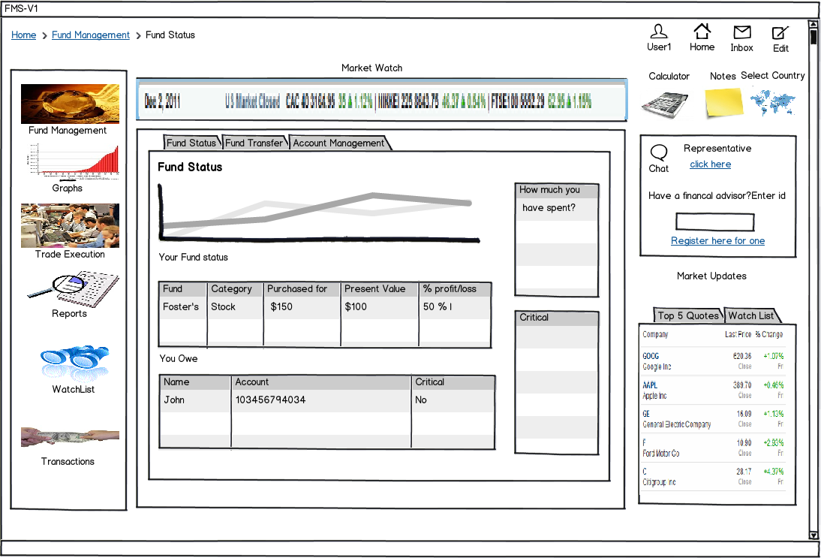

**Use Case Id: 2**

**Use Case Name: Transfer fund**

**Primary Actor: System User**

**Goal:**

Transfer funds to individuals/organizations.

**Preconditions/Trigger:**

* List of items that must be fulfilled or true before the use case is initiated
* Secure login should happen.
* The funds in the accounts are up-to-date
* The transactions are updated correctly.

**Basic Flow:**

The user selects the fund transfer tab.

A table containing details of all the recipients the user owes is displayed.

The user selects one entry for which he/she wishes to do the transfer.

The user selects the bank account from which he wishes to make the transaction.

The user confirms the transfer

**Alternate Flow:**

The user can go back and select a different transaction at any point of time.

The user can choose to view the details related to the creation of new bank accounts.

**Acceptance Criteria**

1. Select recipient to transfer

a. Required

2. On ‘submit’

Share is sold and transaction summary is generated

3. On ‘proceed’

Confirmation page is generated.

4. On ‘Go back’

The user can go back and select a different transaction.

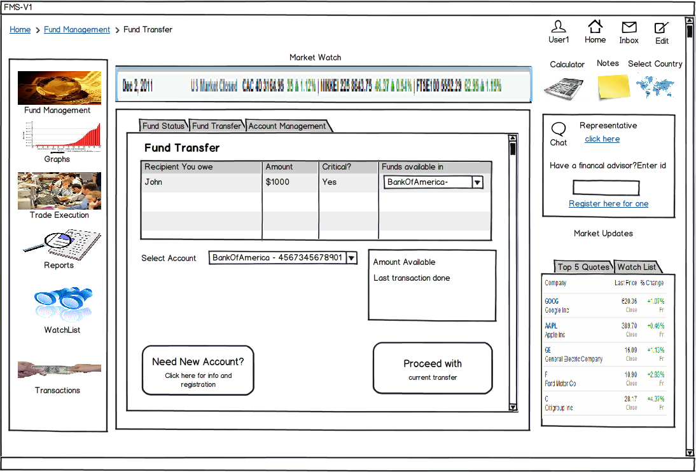

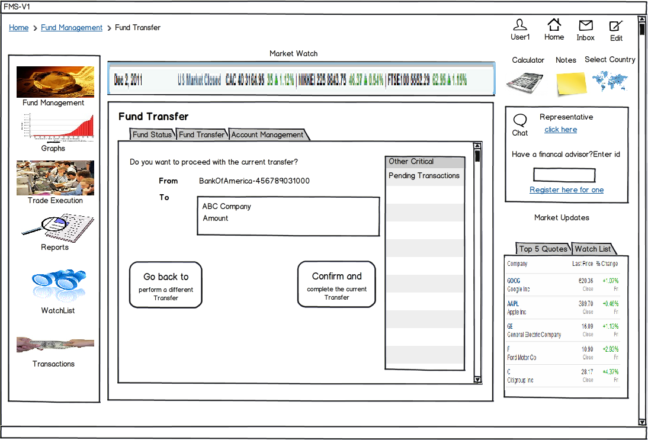

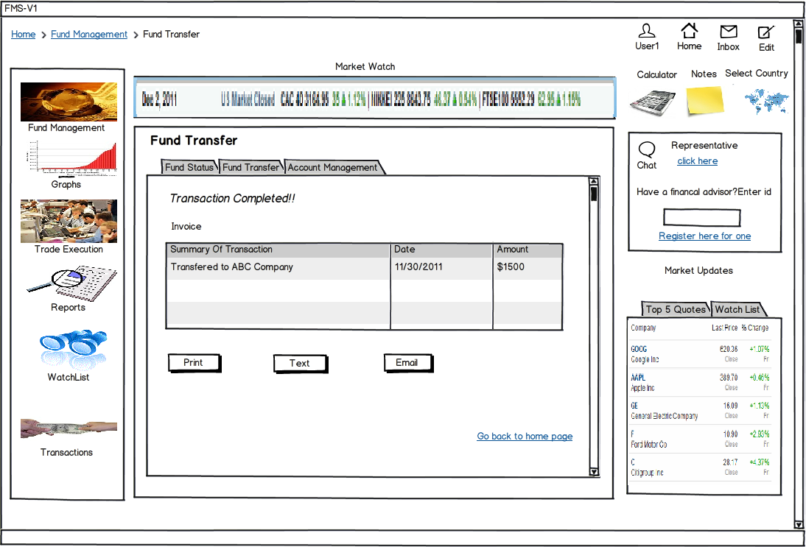

**Use Case Id: 3**

**Use Case Name: Manage bank accounts**

**Primary Actor: System User**

**Goal:**

View all the bank accounts & Transfer funds from one bank account to another

**Preconditions/Trigger:**

* List of items that must be fulfilled or true before the use case is initiated
* Secure login should happen.
* The funds in the accounts are up-to-date
* The transactions are updated correctly.

**Basic Flow:**

The user selects on the account management tab.

A table containing all the account balances is displayed.

The user selects the account from which he wishes to transfer fund

The user selects the account to which he wishes to transfer fund

The user enters the amount for the transfer.

Confirms the transaction

**Alternate Flow:**

At any point of time the user can go back and choose to make a different transfer.

The user can choose to view the details related to the creation of new bank accounts.

**Acceptance Criteria**

1. Select from field

a. Required

2 . Select to field

a. Required

3. Enter amount

a. Required

2. On ‘submit’

Transfer is completed and transaction summary is generated

3. On ‘proceed’

Confirmation page is generated.

4. On ‘Go back’

The user can go back and select a different transfer.

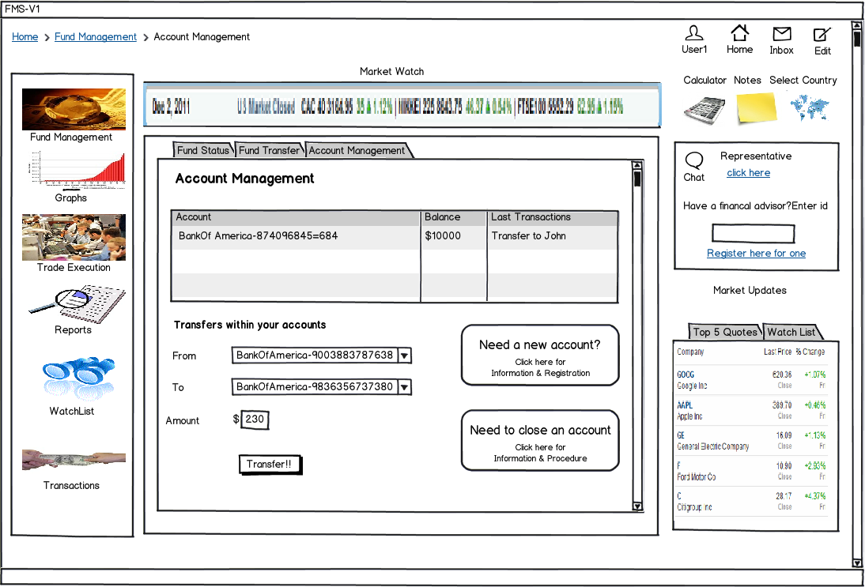

**TRADING MODULE**

**Use Case Id: 1**

**Use Case Name: Buying**

**Primary Actor: System User**

**Goal:**

Buying of shares, stocks and mutual funds. Also should be able to lookup different trading markets.

**Preconditions/Trigger:**

* List of items that must be fulfilled or true before the use case is initiated
* Secure login should happen.
* Software should display updated market data periodically

**Basic Flow:**

1)The user can select the shares, stocks and bonds to purchase from the drop-down list or the user can also select the category based on which the shares, stocks and bonds will be displayed.

2) After the user selects what he wants to purchase the fund’s name, its market availability and price is displayed

3) The user clicks on the commodity and presses Proceed button if he decides to buy it.

4) The user is provided a detailed description of the commodity and has an option to select the bank account from which he wants to make the transaction and confirms the purchase

5) The invoice is displayed and the user is given an option of printing, texting or emailing it

**Alternate Flow:**

1) Before payment the user is given an option to go back and make another selection

2) At any point the user can go back to home and start with a new purchase

**Acceptance Criteria**

1. Select Type

a. Required

2. On ‘Confirm the Purchase’

Purchase the share and invoice is generated

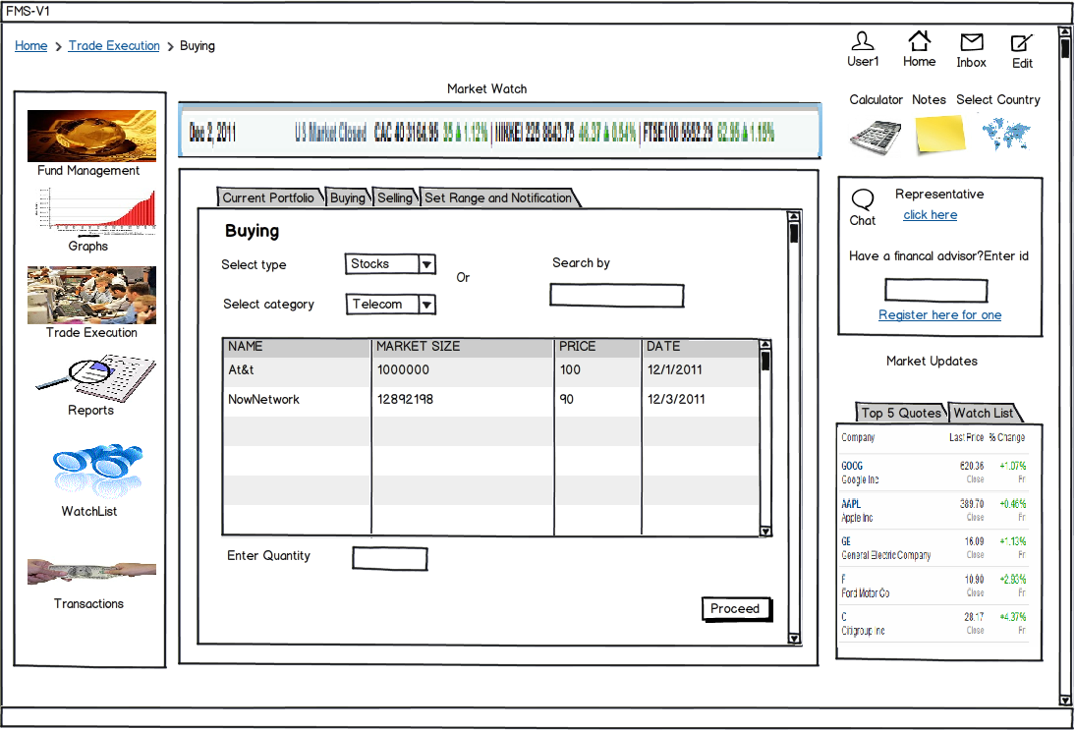

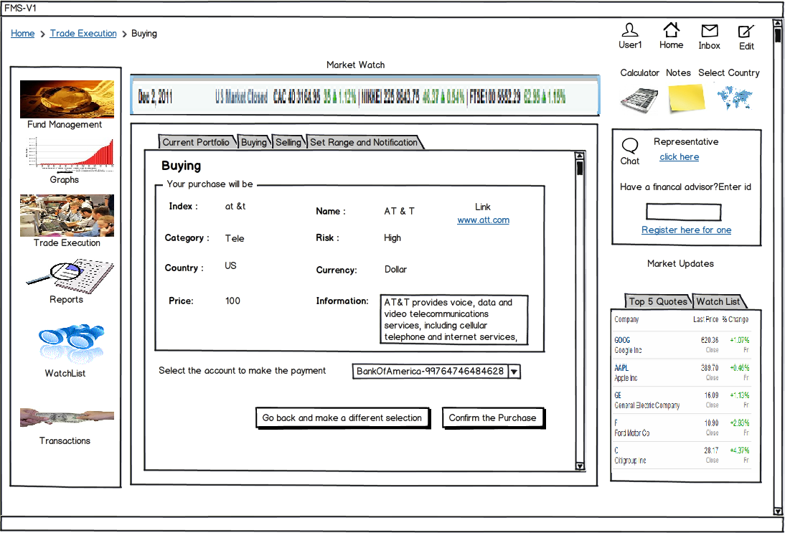

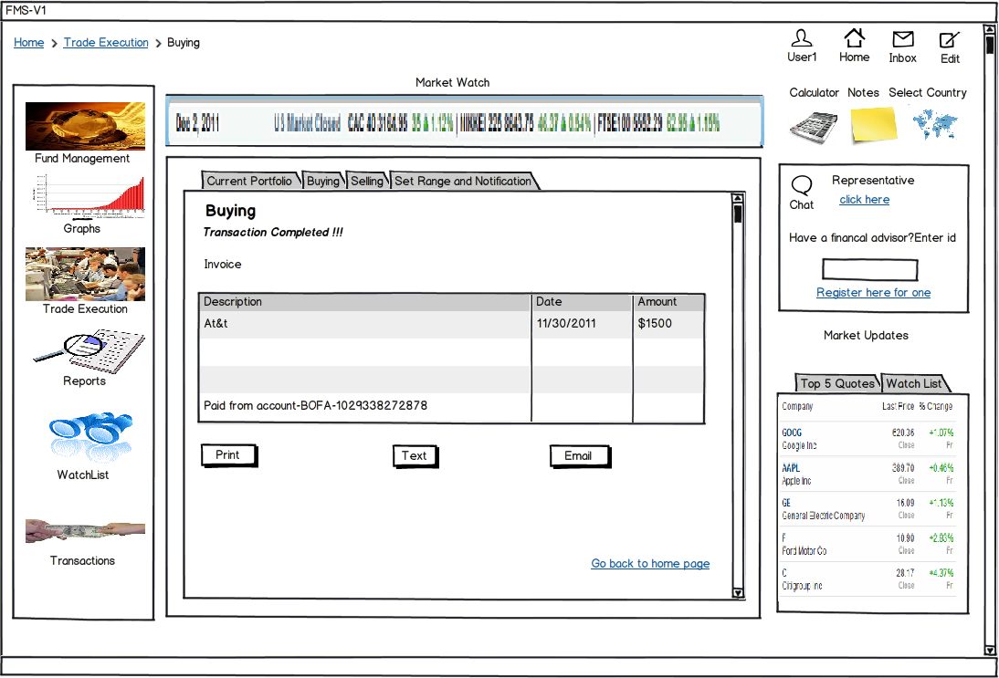

**Use Case Id: 2**

**Use Case Name: Selling**

**Primary Actor: System User**

**Goal:**

Selling of shares, stocks and mutual funds. Also should be able to lookup different trading markets.

**Preconditions/Trigger:**

* List of items that must be fulfilled or true before the use case is initiated
* Secure login should happen.
* Software should display updated market data periodically

**Basic Flow:**

1) An interactive table containing all the funds purchased by the user along with the current market value is displayed

2) The user selects the fund that he wishes to sell and proceeds

3) A panel with the selected fund, its current value and a user input text box is displayed where he enters the quantity based on which the purchase and selling cost is calculated.

4) The user selects the account were he wants the amount to be credited.

5) After Proceeding a transaction summary is generated which the user can print, text or email

**Alternate Flow:**

1) Before proceeding to selling the fund, user is given an option to go back and make another selection

2) At any point the user can go back to home and start with a new sell transaction

**Acceptance Criteria**

1. Select share

a. Required

2. On ‘Confirm and Proceed’

Share is sold and transaction summary is generated

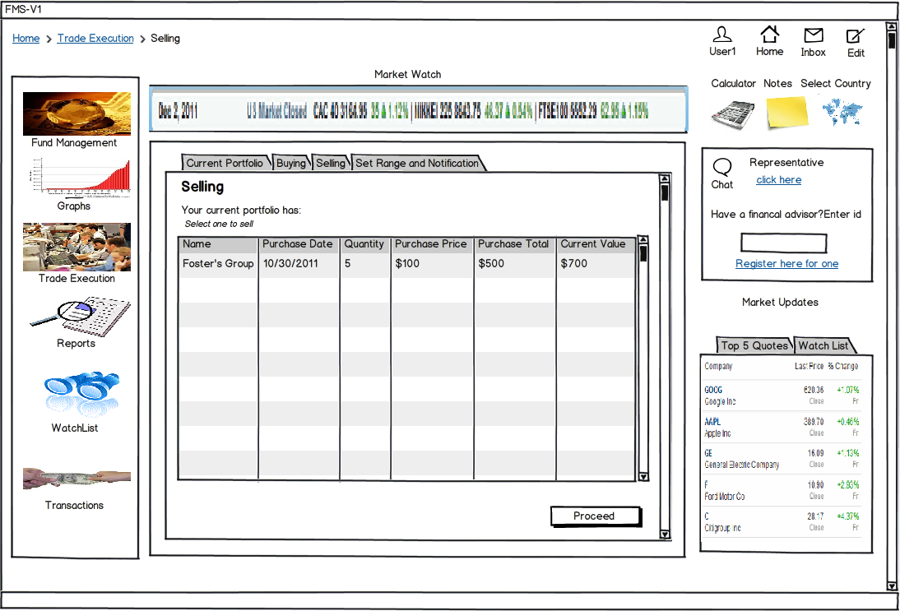

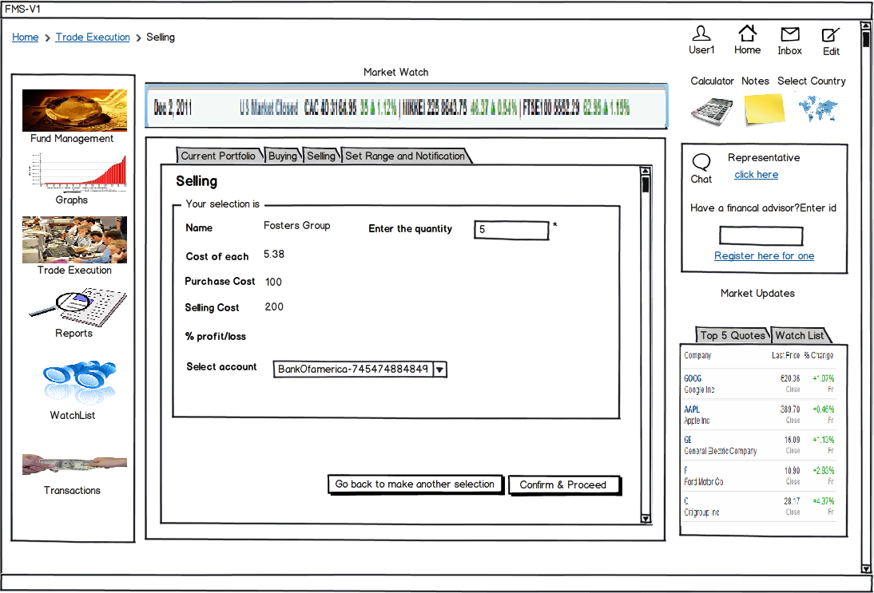

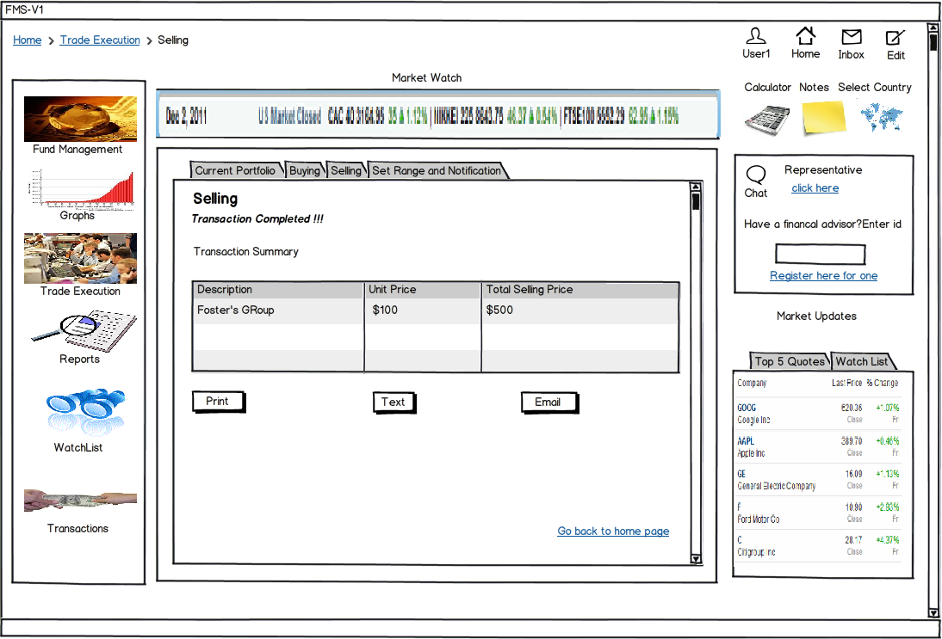

**Use Case Id: 3**

**Use Case Name: Setting of limits**

**Primary Actor: System user**

**Goal:**

The user can set upper and lower limit for the shares he has purchased and/or for the shares on the user’s wish list.

**Preconditions/Trigger:**

* List of items that must be fulfilled or true before the use case is initiated
* Secure login should happen.
* Software should display updated market data periodically
* The user should have added some shares to his wish list or he should have purchased some shares.

**Basic Flow:**

1. A table containing the funds user has purchased is shown displaying the name and its total current value.

2. The user of the FMS system has an option of setting upper as well as lower limit of the fund based on which he would receive an alert.

3. Even if the alert is set by the user, he has an option to remove it whenever he wishes to do so.

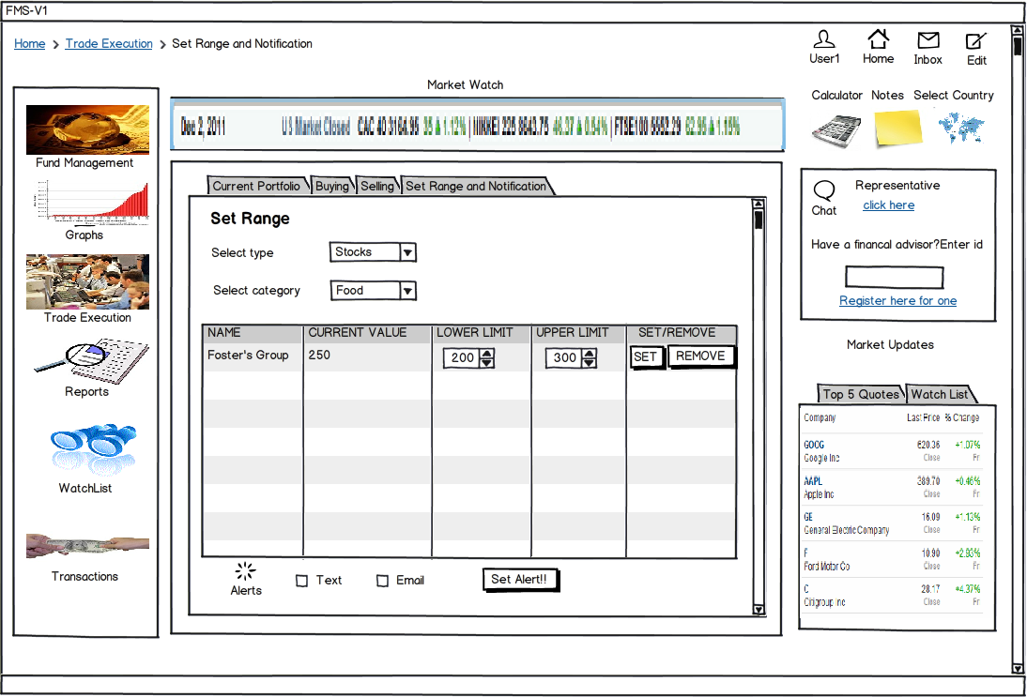

**Acceptance Criteria**

1. Select type

a. Required

2. On ‘Set Alert’

Range is set

3. On ‘save alert’

Alerts will be set to be received either by email or text message.

**REPORT MANAGEMENT MODULE**

**Use Case Id: 1**

**Use Case Name: Generate Statements**

**Primary Actor: System User**

**Goal:**

Generating monthly statement for viewing, printing or forwarding as email/text

**Preconditions/Trigger:**

* List of items that must be fulfilled or true before the use case is initiated
* Secure login should happen.
* All the user transactions must be recorded correctly

**Basic Flow:**

1. The user selects the month for which he wishes to view, print or forward the statement.
2. For printing the statement, the user clicks on the print option
3. For forwarding the statement as email, the user clicks on the email option
4. For forwarding the statement as a text, the user clicks on the text option

**Acceptance Criteria**

1. Select tmonth

a. Required

2. On ‘print’

The statement will be printed

3. On ‘email’

The statement will be mailed to the user’s email ID

4. On ‘text’

The statement will be texted to the user’s number

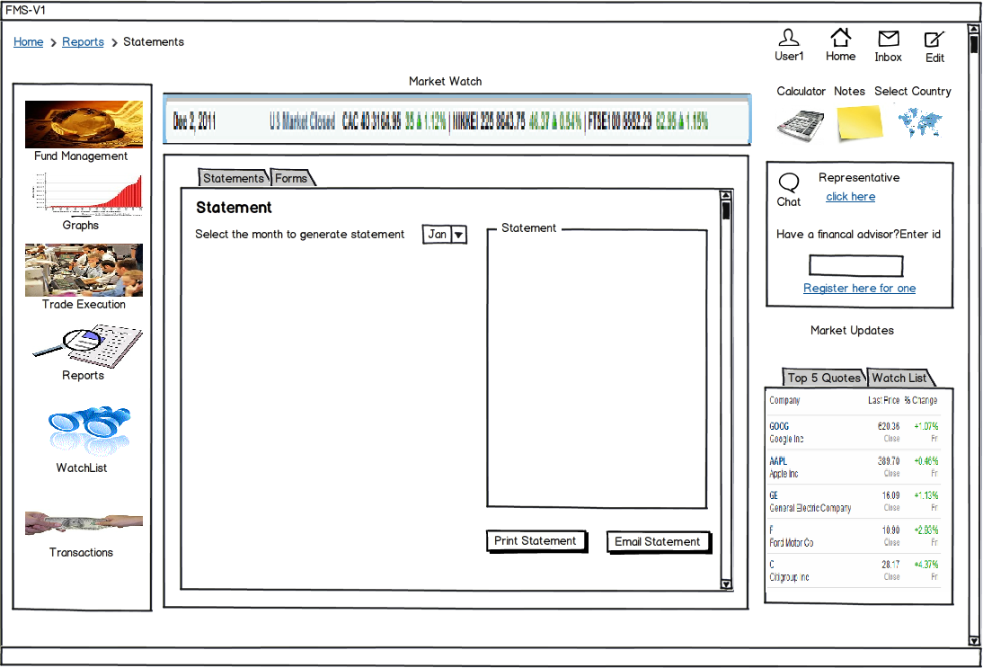

**Use Case Id: 2**

**Use Case Name: Display forms**

**Primary Actor: System User**

**Goal:**

Displaying forms such as tax forms and printing them

**Preconditions/Trigger:**

* List of items that must be fulfilled or true before the use case is initiated
* Secure login should happen.

**Basic Flow:**

1) The user selects form which he/she wishes to view

2) For printing the form, the user clicks on the print option

3) For viewing form information and filling the form, the user clicks on the link provided

**Acceptance Criteria**

1. Select form

a. Required

2. On ‘print’

The form will be printed

3. On clicking link

Takes you to the website containing the form

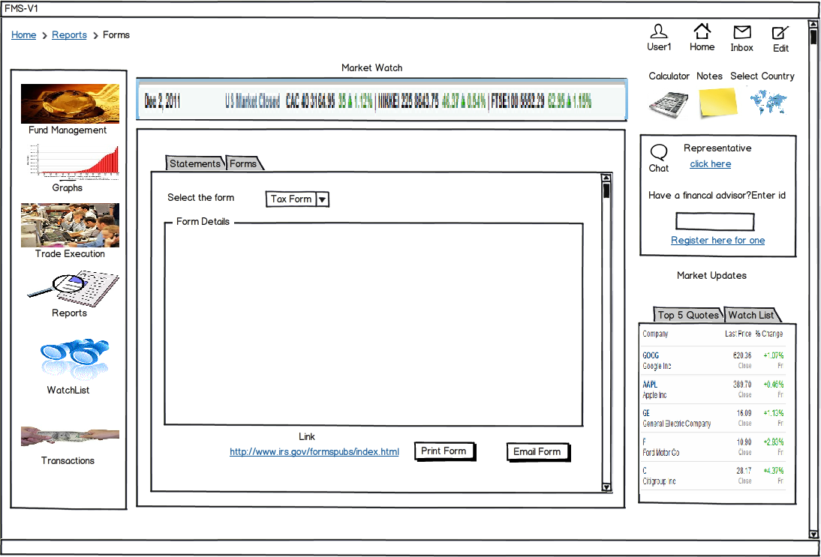

**CLASS DIAGRAM**

**11. CLASS DIAGRAM**

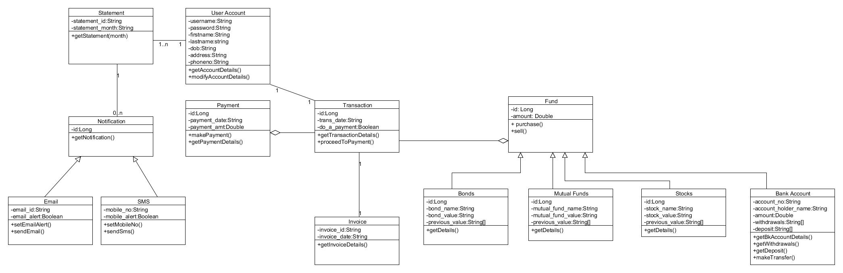

**ACTIVITY DIAGRAM**

**13. ACTIVITY DIAGRAM**

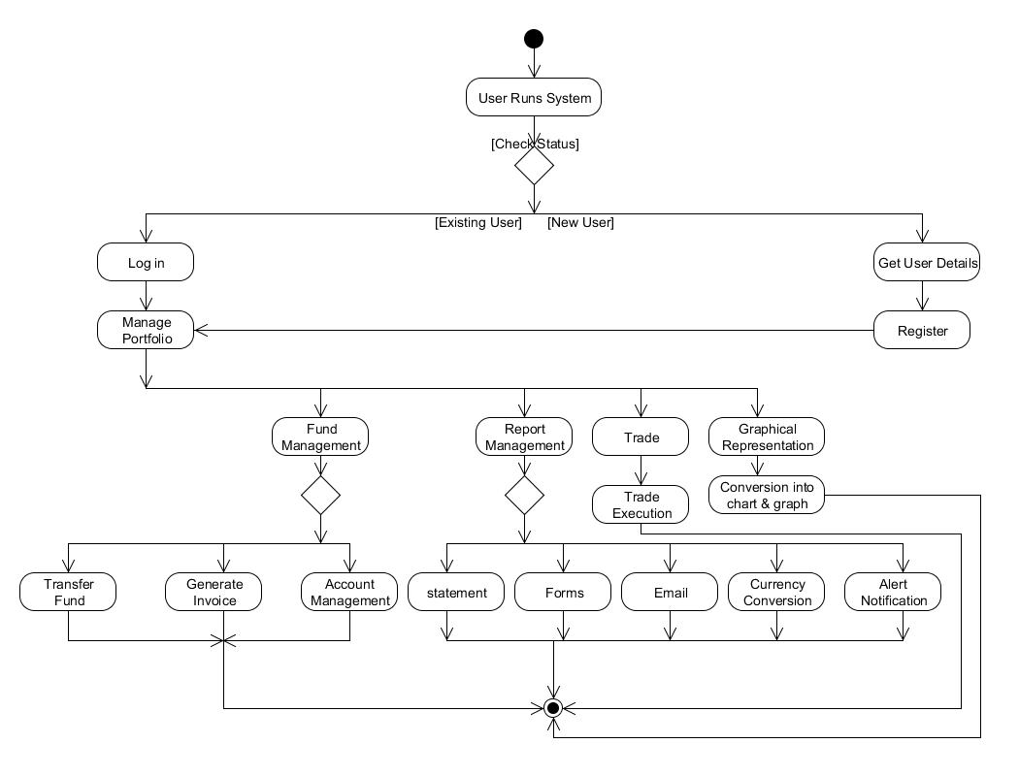

**ADDITIONAL FEATURES**

**13. ADDITIONAL FEATURES**

**Graphical Presentation**

When an investor wishes to buy/sell a certain share, he would want to look at the price variation of that particular stock over some time period. This data can be presented to the user in a tabular form having numerical values. But the disadvantage of presenting in this form is the user is not able to get a clear picture of the trend.

If a graph representing the price variations is presented, the user can quickly get an overview of the trend and this will help him in making the right decisions.

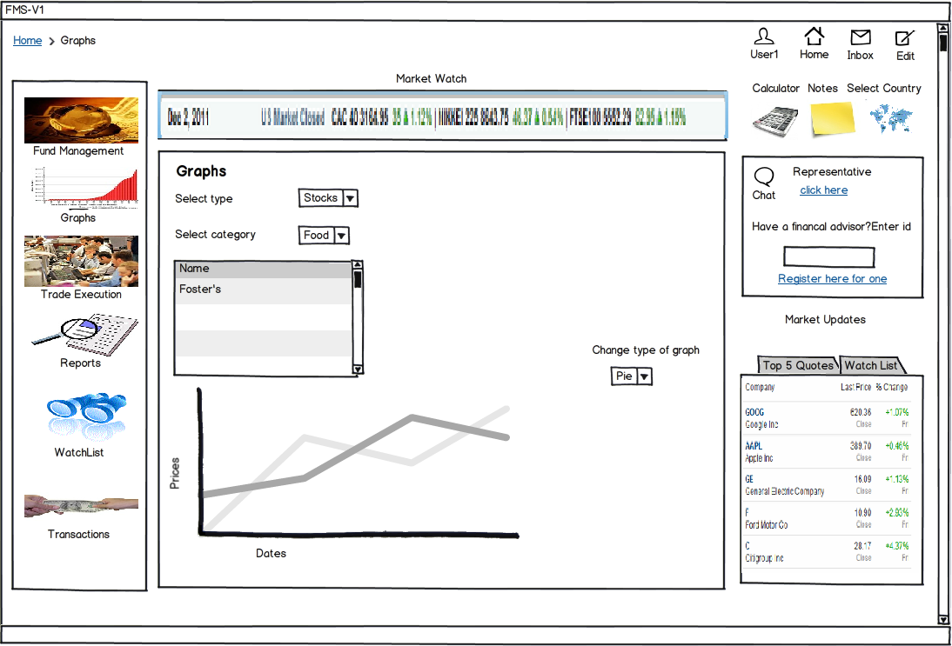

**Watch list**

Investor should get continuous updates about the shares he/she is most interested in. The watch list feature should allow the user to do this. The user should be able to add the share he/she is interested in the watch list. Once the share is added, the user should get continuous updates about the shares he/she is interested in



**THANK YOU**