# Expanded Use Cases

|  |  |
| --- | --- |
| **UC 1: Signup** |  |
| **Precondition: The user does not have a registered account in the UTA Shared Ride System.** | | |
| **Actor: Commuter/Rider** | **System: UTA Shared Ride** | |
|  | 0. System displays the Login page. | |
| 1. **TUCBW** the Commuter/rider will be able to click on the *Create a new account* link on Login Page. | 2. System display Signup form in Signup page. (Refer Figure 1) | |
| 3. Commuter/Rider fills the form and clicks on *Sign Me Up* button. | 4. System displays Signup Successful message and Commuter/Rider is redirected back to Login Page.(Refer Figure 2) | |
| **5. TUCEW** the Commuter/Rider gets the access and can view the “Login” page. |  | |
| **Post condition: A new account for Commuter/Rider is created in the system.** | | |

|  |  |  |
| --- | --- | --- |
| **UC 2: Login** |  | |
| **Precondition: The User should have a registered account in the UTA Shared Ride System** | |
| **Actor: User** | **System: UTA Shared Ride** |
|  | 0. System displays the Login page (Refer Figure 3). |
| 1. **TUCBW** the user enters the UTA email id, password and clicks on the “Login” button in the Login Page. | 2. The system displays different pages in different scenarios. (I) Admin will be shown Admin home page. (Refer Figure 4) (ii) First time Commuter/Rider will be shown Create Profile page. (Refer Figure 5) (iii) Regular Commuter/Rider will be shown Homepage. (Refer Figure 6) |
| 3**. TUCEW** the user gains access into the system. New Commuter/Rider can view the “Profile” page; existing Commuter/Rider can view “Ride Management” page and the “Admin” will be able to see “Admin Home” page. |  |
| **Post condition: The user is in the system, eligible to access the functionalities.** | |
| **UC 2.1: Reset Password** |  |
| **Precondition: The User should have a registered account in the UTA Shared Ride System** | |
| **Actor: Commuter/Rider** | **System: UTA Shared Ride** |
|  | 0. System displays the Login page. |
| 1. **TUCBW** the Commuter/Rider clicks on “Forgot Password?” link on the “Login” page. | 2. System displays Reset Password page. (Refer Figure 7) |
| 3. Commuter/Rider enters his/her registered UTA Email ID and clicks on Reset Password button. | 4. System generates a random password; email it to the registered UTA email ID. System also displays the message mentioning that new password has been emailed.(Refer Figure 8) |
| 5**. TUCEW** the Commuter/Rider sees the new password has been emailed message. |  |
| **Post condition: System updates the password of Commuter/Rider with the random password which is mailed to the Commuter/Rider.** | |

|  |  |
| --- | --- |
| **UC 3.1: Create User Profile** |  |
| **Precondition: The Commuter/Rider has registered account in the system but has not created a profile yet. The Commuter/Rider has logged into the system.** | |
| **Actor: Commuter/Rider** | **System: UTA Shared Ride** |
|  | 0. System displays the Create Profile page. (Refer Figure 5) |
| 1. **TUCBW** the new Commuter/Rider fills in ‘create profile’ form and clicks on Submit button. | 2. System creates a new profile for the Commuter/Rider with the given values. System also displays the message saying profile creation is successful. (Refer Figure 9) |
| 3**. TUCEW** the Commuter/Rider sees the successfully created profile message. |  |
| **Post condition: A new profile is created for Commuter/Rider. Commuter/Rider can now access full functionalities of the system.** | |

|  |  |
| --- | --- |
| **UC 3.2: Update User Profile** |  |
| **Precondition: the Commuter/Rider is logged into the UTA Shared Ride system** | |
| **Actor: Commuter/Rider** | **System: UTA Shared Ride** |
|  | 0. System displays the Home page. |
| 1. **TUCBW** the Commuter/Rider clicks on the Profile Management Menu on the Home Page. | 2. System shows the Update Profile submenu. (Refer Figure 10) |
| 3. Commuter/Rider clicks on Update Profile Submenu. | 4. System displays the update profile form. (Refer Figure 11) |
| 5. The Commuter/Rider can update one or more fields and clicks on Update button. | 6. System updated the user profile with new values; a message will be displayed to the Commuter/Rider saying update is successful.(Refer Figure 12) |
| 7**. TUCEW** the Commuter/Rider sees the successfully updated profile message. |  |
| **Post condition: The profile of Commuter/Rider will have updated values.** | |

|  |  |
| --- | --- |
| **UC 4.1: View User Details** |  |
| **Precondition: Admin must be logged in to the system and registered non admin users are available in the system.** | |
| **Actor: Admin** | **System: UTA Shared Ride** |
|  | 0. System displays admin homepage. |
| 1.**TUCBW** the admin will be able to click on the view user details menu. | 2.System shows the commuter details and rider details submenus. |
| 3.Admin clicks on rider details or commuter details submenu. | 4.System displays details based on the click  a) Commuter details (Refer Figure)  b) Rider details (Refer Figure) |
| 5.Admin selects single record for commuter or rider. | 6.System displays details of selected record. |
| 7.**TUCEW** the admin sees the details of commuter or rider. |  |
| **Post condition: Admin is able to see all the details of commuter and rider.** | |

|  |  |
| --- | --- |
| **UC 4.2: View Ride Details** |  |
| **Precondition: Admin must be logged in to the system and ride details are available in the system.** | |
| **Actor: Admin** | **System: UTA Shared Ride** |
|  | 0.System displays admin homepage. |
| 1.**TUCBW** the admin will be able to click on the view ride details menu. | 2.System shows the ride details. |
| 3.Admin selects single record for ride details. | 4.System displays details of selected ride. (Refer Figure 36) |
| 5.**TUCEW** the admin sees the ride details. |  |
| **Post condition: Admin is able to see all the details of ride.** | |

|  |  |
| --- | --- |
| **UC 4.3: View Feedback and Rating** |  |
| **Precondition: Admin must be logged in to the system and feedback and ratings are available in the system.** | |
| **Actor: Admin** | **System: UTA Shared Ride** |
|  | 0.System displays admin homepage. |
| 1. **TUCBW** the admin will be able to click on the view feedback and ratings menu. | 2. System shows the feedback and rating for the rides. |
| 3. Admin selects single record for the feedback and rating. | 4.System displays all the details of ride including feedback and rating. |
| 5.**TUCEW** the admin sees the feedback and ratings details. |  |
| **Post condition: Admin is able to see the feedback and ratings of rides.** | |

|  |  |
| --- | --- |
| **UC 5.1: Block User** |  |
| **Precondition: Admin must be logged in to the system and registered non admin users are available in the system.** | |
| **Actor: Admin** | **System: UTA Shared Ride** |
|  | 0.System displays admin homepage. |
| **1.TUCBW** the admin will be able to click on the block user menu. | 2.System displays block user form (Refer figure) |
| 3.Admin selects records and clicks block button. | 4.System displays successfully blocked message. |
| 5. **TUCEW** the admin sees the successfully blocked message. |  |
| **Post condition: The user will be blocked from system.** | |

|  |  |
| --- | --- |
| **UC 5.2: Unblock User** |  |
| **Precondition: Admin must be logged in to the system and blocked users are available in the system.** | |
| **Actor: Admin** | **System: UTA Shared Ride** |
|  | 0.System displays admin homepage. |
| **1.TUCBW** the admin will be able to click on the unblock menu. | 2. System displays block user form (Refer figure) |
| 3.Admin selects records and clicks unblock button. | 4.System displays successfully unblocked message. |
| 5. **TUCEW** the admin sees the successfully unblocked message. |  |
| **Post condition: The blocked user will be unblocked from system.** | |

|  |  |
| --- | --- |
| **UC 6: Book Ride** | |
| **Precondition: The commuter must have a valid profile in the system and he must be logged into the system.** | |
| **Actor: Commuter** | **System: UTA Shared Ride** |
|  | 0. System displays the Home page. |
| 1. **TUCBW** the Commuter will be able to click on the Manage Ride Menu Home Page. | 2. System shows the Book Ride submenu. |
| 3. Commuter clicks on Book Ride submenu. | 4. System shows the Book Ride Form. (Refer Figure 14) |
| 5. Commuter fills the form and clicks on the Submit button. | 6. System displays a ride is successfully booked and notification sent to Rider message. (Refer Figure 15) |
| **7. TUCEW** the Commuter sees the ride is successfully booked and notification sent to Rider message. |  |
| **Post condition: System must sent the notification about new ride to Rider and successfully create a ride** | |

|  |  |
| --- | --- |
| **UC 7: Update Ride** | |
| **Precondition: The commuter must have a booked ride which is not accepted by Rider and he must be logged into the system** | |
| **Actor: Commuter** | **System: UTA Shared Ride** |
|  | 0. System displays the Home page. |
| 1. **TUCBW** the Commuter will be able to click on the Manage Ride Menu on Home Page. | 2. System shows the Update Ride submenu. |
| 3. Commuter clicks on Update Ride submenu. | 4. System shows all the rides which are in requested status of the commuter.(Refer Figure 16) |
| 5. Commuter selects a single ride and clicks on the Update button. | 6. System displays the details of the selected ride. Refer Figure 17) |
| 7. Commuter updates the updatable fields and clicks on Submit button. | 8. System displays a ride is successfully updated message. Refer Figure 18) |
| **9. TUCEW** the Commuter sees ride is successfully updated message |  |
| **Post condition: The updated data is immediately available for view.** | |

|  |  |
| --- | --- |
| **UC 8: Join Ride** | |
| **Precondition: The commuter must be logged into the system and system must contain future rides which are not full.** | |
| **Actor: Commuter** | **System: UTA Shared Ride** |
|  | 0. System displays the Home page. |
| 1. **TUCBW** the Commuter will be able to click on the Manage Ride Menu on Home Page. | 2. System shows the Join Ride submenu. |
| 3. Commuter clicks on Join Ride submenu. | 4. System shows the Join Ride Form with Rider Name Rider Id and Ride Date. (Refer Figure 19) |
| 5. Commuter fills the form and clicks on the Search button | 6. System displays the records based on: a) if commuter passes Rider Name and Ride Date as null then all the rides which are in open status. b) If commuter passes only Rider Name then all the open rides against that rider. c) If commuter passes only Ride Date then all the open rides on that date. d) If commuter passes both Rider Name and Ride Date then all the open rides of that rider on that date. |
| 7. Commuter selects a single ride and clicks on the Join button. | 8. System displays the details of the selected ride. (Refer Figure 20) |
| 9. Commuter views the details and clicks on Submit button. | 10. System displays a successfully joined to a ride message. (Refer Figure 21) |
| **11. TUCEW** the Commuter sees successfully joined to a ride message |  |
| **Post condition: The Passenger count of the joined ride must be increased by one and Total Charge must be recomputed** | |

|  |  |
| --- | --- |
| **UC 9: Exit Ride** | |
| **Precondition: The commuter must be logged into the system and system must contain future rides which commuter already joined.** | |
| **Actor: Commuter** | **System: UTA Shared Ride** |
|  | 0. System displays the Home page. |
| 1. **TUCBW** the Commuter will be able to click on the Manage Ride Menu on Home Page. | 2. System shows the Exit Ride submenu. |
| 3. Commuter clicks on Exit Ride submenu. | 4. System shows all the future rides which commuter already joined. (Refer Figure 22) |
| 5. Commuter selects a single ride and clicks on the Exit button. | 6. System displays the details of the selected ride. (Refer Figure 23) |
| 7. Commuter views the details and clicks on Submit button. | 8. System displays a successfully exited from a ride message. (Refer Figure 24) |
| **9. TUCEW** the Commuter sees successfully exited from a ride message. |  |
| **Post condition: The Passenger count of the exited ride must be decreased by one and Total Charge must be recomputed** | |

**UC 10: Submit Ratings**

|  |  |
| --- | --- |
| **Precondition: The Commuter has logged into the system and the Commuter has completed the ride.** | |
| **Actor: Commuter** | **System: UTA Shared Ride** |
|  | 0. System displays the Home screen |
| 1. **TUCBW** the Commuter clicks on the Feedback and Rating menu on the Home screen | 2. System displays the ‘Submit Feedback and Rating submenu’. |
| 3. The Commuter clicks on the ‘Submit Feedback and Rating’ submenu option | 4. System displays the ‘Feedback and Rating’ form. (Refer Figure 30) |
| 5. The Commuter fills the Feedback and Rating’ form and clicks on the submit button. | 6. The system displays message, ‘The rating and feedback submitted successfully’.(Refer Figure 31) |
| 7. **TUCEW** the Commuter sees ‘The rating and feedback submitted successfully’ message |  |
| **Post condition: The submitted feedback and rating is immediately available for view.** | |

|  |  |
| --- | --- |
| **UC 11: Cancel Ride** | |
| **Precondition: The rider must be logged into the system and system must contain future rides which are against the rider.** | |
| **Actor: Commuter** | **System: UTA Shared Ride** |
|  | 0. System displays the Home page. |
| 1. **TUCBW** the Rider will be able to click on the Manage Ride Menu on Home Page. | 2. System shows the Cancel Ride submenu. |
| 3. Rider clicks on Cancel Ride Menu. | 4. System shows all the future rides which are against the rider. (Refer Figure 25) |
| 5. Rider selects a single ride and clicks on the Cancel button. | 6. System displays the details of the selected ride. (Refer Figure 26) |
| 7. Rider views the details and clicks on Submit button. | 8. System displays a successfully cancelled from a ride message. (Refer Figure 27) |
| **9. TUCEW** the Rider sees successfully cancelled from a ride message. |  |
| **Post condition: The cancelled ride must be immediately available for view.** | |

|  |  |
| --- | --- |
| **UC 12: Provide Ride** | |
| **Precondition: The rider must be logged into the system and system must contain future rides which are against the rider.** | |
| **Actor: Commuter** | **System: UTA Shared Ride** |
|  | 0. System displays the Home page. |
| 1. **TUCBW** the Rider will be able to click on the Manage Ride Menu on Home Page. | 2. System shows the Provide Ride submenu. |
| 3. Rider clicks on Provide Ride submenu. | 4. System shows the Provide Ride Form. (Refer Figure 28) |
| 5. Rider fills the form and clicks on the Submit button. | 6. System displays a ride is successfully created. (Refer Figure 29) |
| **7. TUCEW** the Rider sees ride successfully created message. |  |
| **Post condition: The created ride must be immediately available for view. The Passenger count of the created ride must be increased by one and Total Charge must be computed** | |

**UC 13: View Booking Request**

|  |  |
| --- | --- |
| **Precondition: The Rider has logged into the system and rider has got a booking request.** | |
| **Actor: Rider** | **System: UTA Shared Ride** |
|  | 0. System displays the Home screen |
| 1. **TUCBW** the Commuter clicks on the ‘View Booking Request’ menu on the Home screen | 2. System shows ‘Booking Request’ details.(Refer Figure 32 ) |
| 3. **TUCEW** the Rider viewing the ‘Booking Request’ screen containing all the ride details. |  |
| **Post condition: The System will provide Rider the details of the requested ride by the Commuter and the option for the Rider to Accept or Cancel the request.** | |

**UC 13.1: Accept Booking Request**

|  |  |
| --- | --- |
| **Precondition: The Rider has logged into the system and the Rider has received a Booking Request.** | |
| **Actor: Rider** | **System: UTA Shared Ride** |
|  | 0. System displays the home screen |
| 1. **TUCBW** the Commuter clicks on the ‘View Booking Request’ menu on the Rider Home screen | 2. System shows ‘Booking Request’ details.(Refer Figure 32) |
| 3. The Rider clicks on ‘Accept’ button on ‘View Booking Request’ screen. | 4. System shows a message ‘Ride successfully accepted’.(Refer Figure 33) |
| 5. **TUCEW** the Rider viewing the ‘Ride successfully accepted’ message |  |
| **Post condition: The System will show the newly accepted ride in the ‘Future Rides’ screen of the Rider, which the rider can view.** | |

**UC 13.2: Reject Booking Request**

|  |  |
| --- | --- |
| **Precondition: The Rider has logged into the system and the Rider has received a Booking Request.** | |
| **Actor: Rider** | **System: Shared Ride** |
|  | 0. System displays the home screen |
| 1. **TUCBW** the Commuter clicks on the ‘View Booking Request’ menu on the Rider Home screen | 2. System shows ‘Booking Request’ details (Refer Figure 32) |
| 3. The Rider clicks ‘Cancel’ button on ‘Booking Request’ screen | 4. System shows a message ‘Ride successfully cancelled’ (Refer Figure 34) |
| 5. **TUCEW** the Rider seeing the ‘Ride successfully cancelled’ message. |  |
| Post condition: The System will reject the booking request and rejected requests will be available under ‘Past Rides’ screen. | |

|  |  |
| --- | --- |
| **UC 17: Logout** |  |
| **Precondition: the User is logged into the UTA Shared Ride system** | |
| **Actor: User** | **System: UTA Shared Ride** |
|  | 0. System displays the Admin Home page for Admin and Homepage for Commuter/Rider. (Refer Figure 4 and Figure 6) |
| 1. **TUCBW** the user will be able to click on “Logout” button from Homepage. | 2. System displays message showing Logout Successful. (Refer Figure 13) |
| **3. TUCEW** user sees the logout successful message. |  |
| **Post condition: The user will not be able to access any functionality of the system.** | |

# UI Prototypes

**Figure 1:**

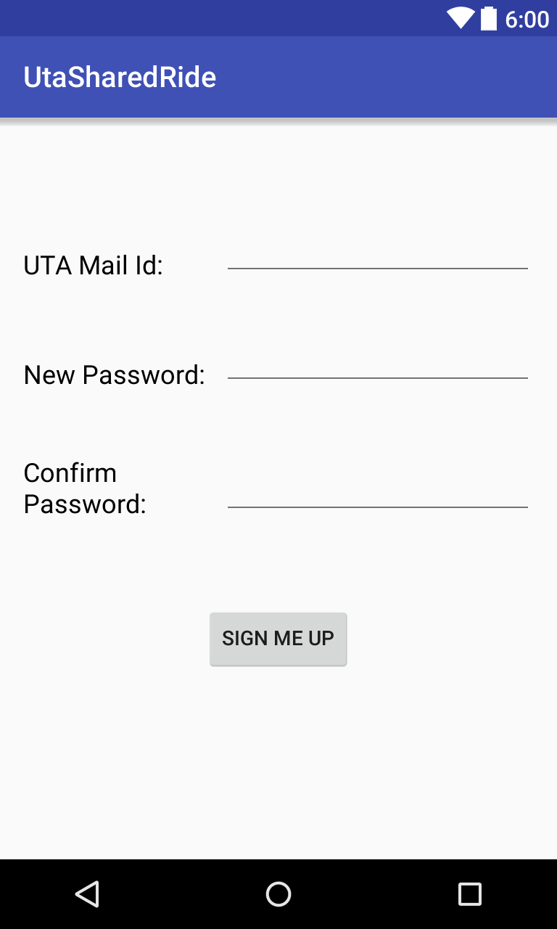

**Figure 2:**

**Figure 3:**

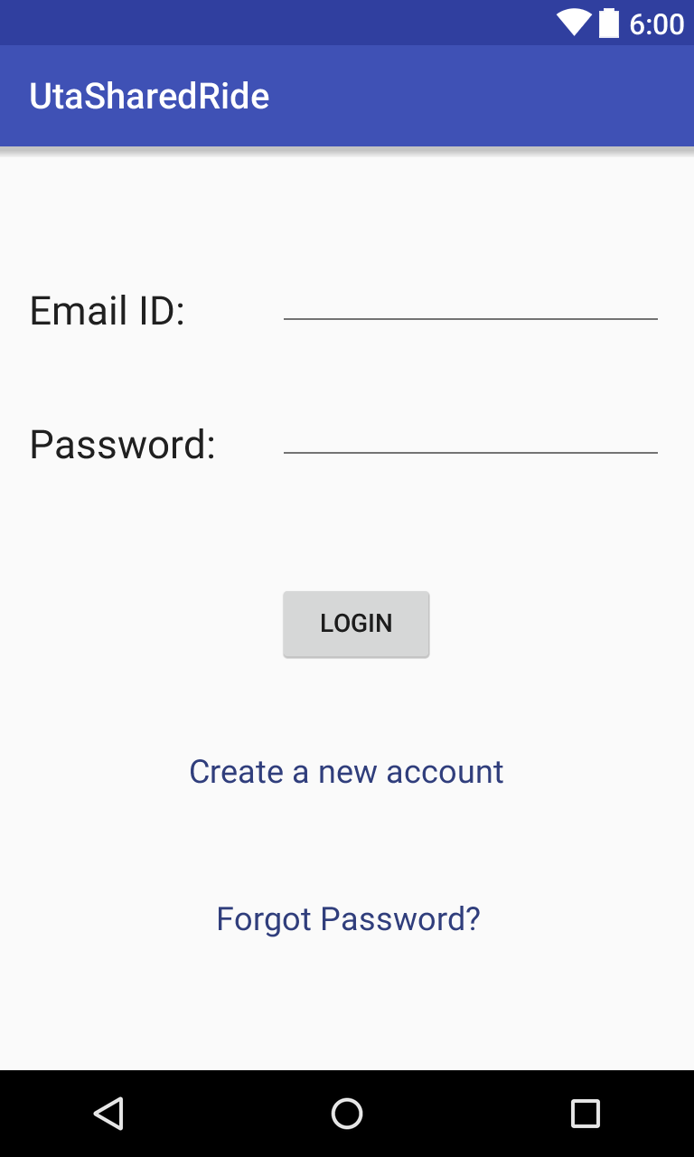

**Figure 4:**

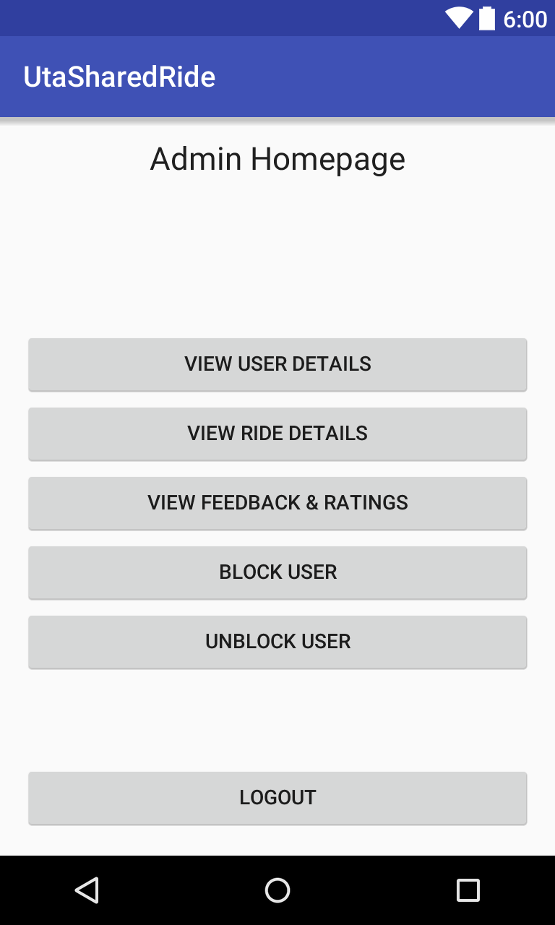

**Figure 5:**

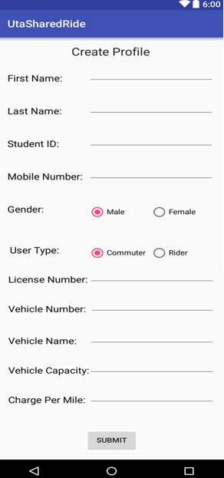

**Figure 6:**

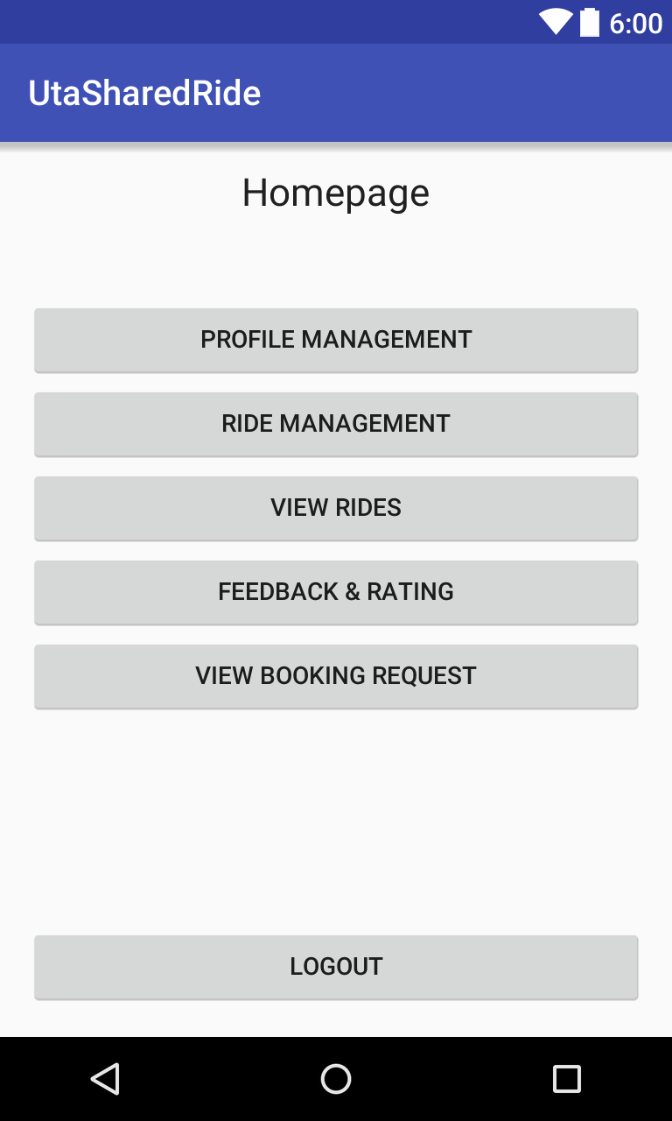

**Figure 7:**

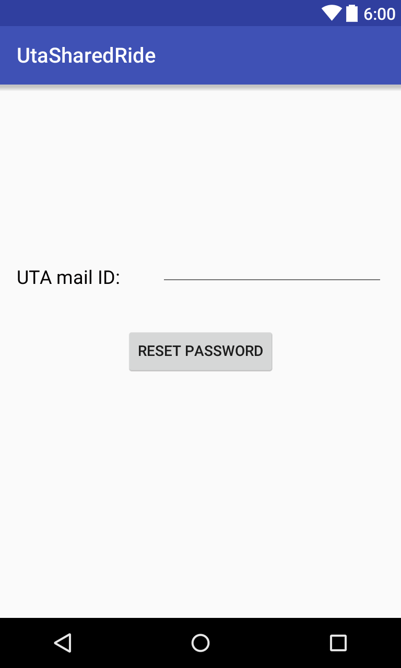

**Figure 8:**

**Figure 9:**

**Figure 10:**

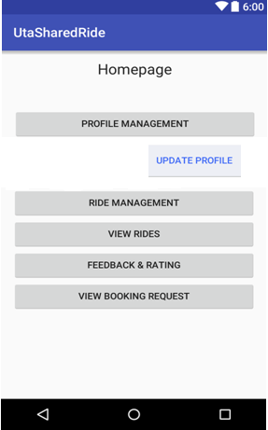

**Figure 11:**

**Figure 12:**

**Figure 13:**

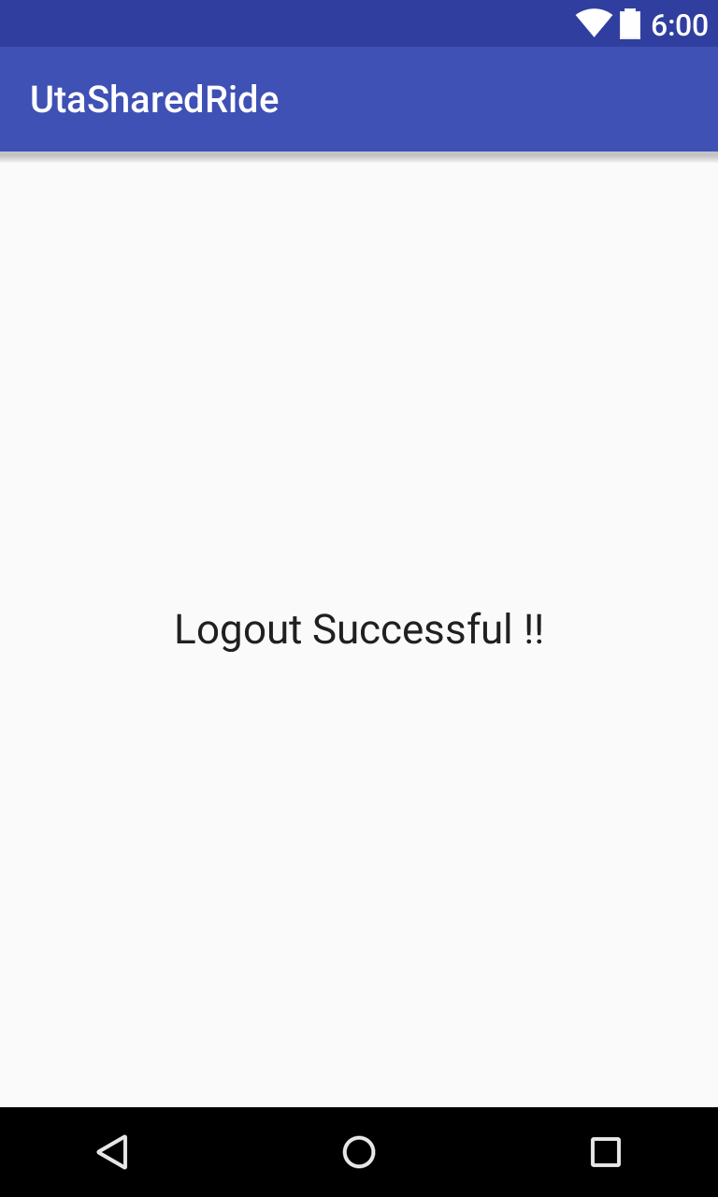

**Figure 14:**

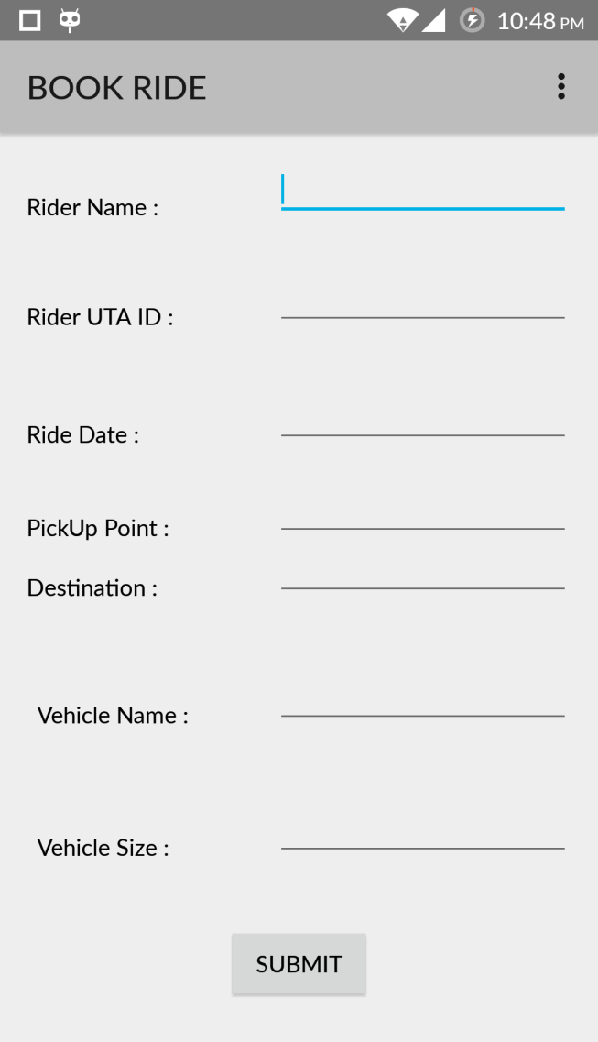

**Figure 15:**

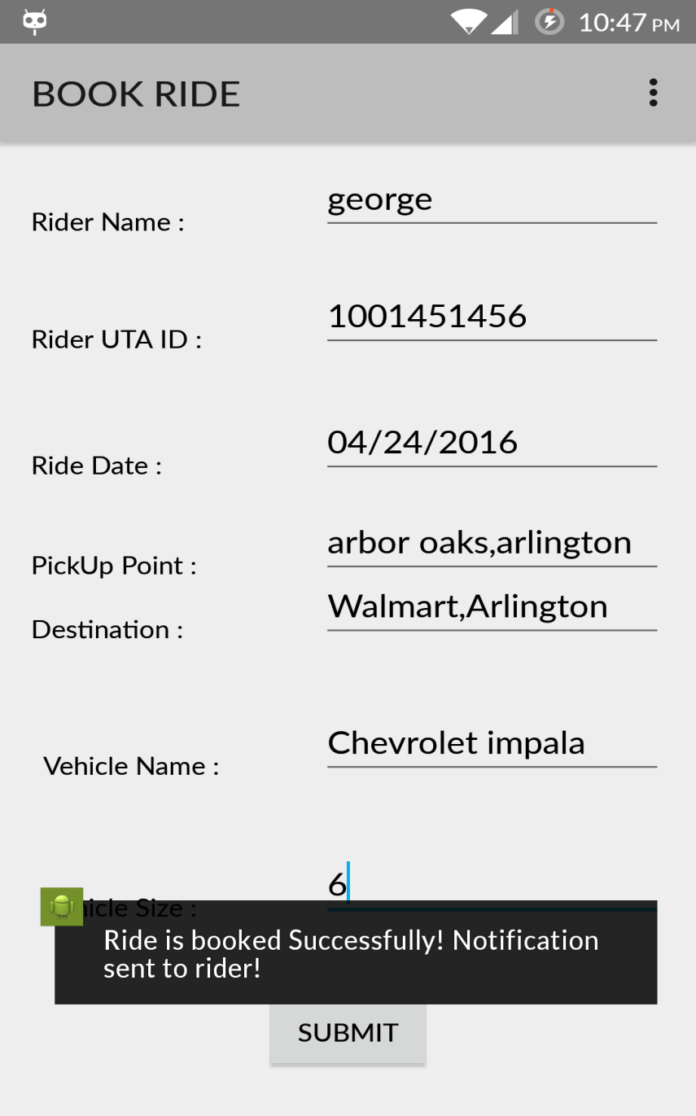

**Figure 16:**

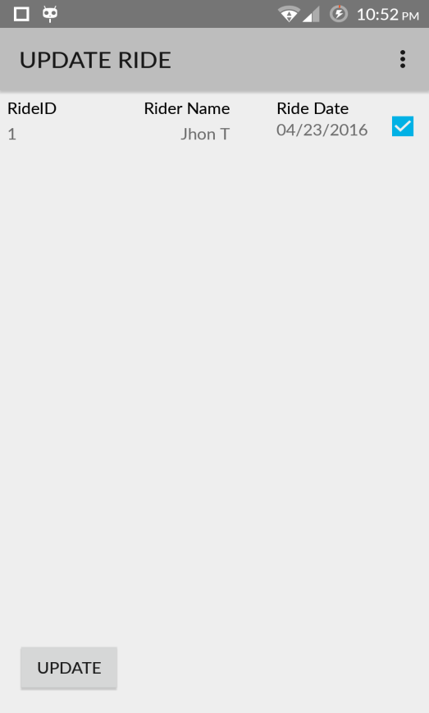

**Figure 17:**

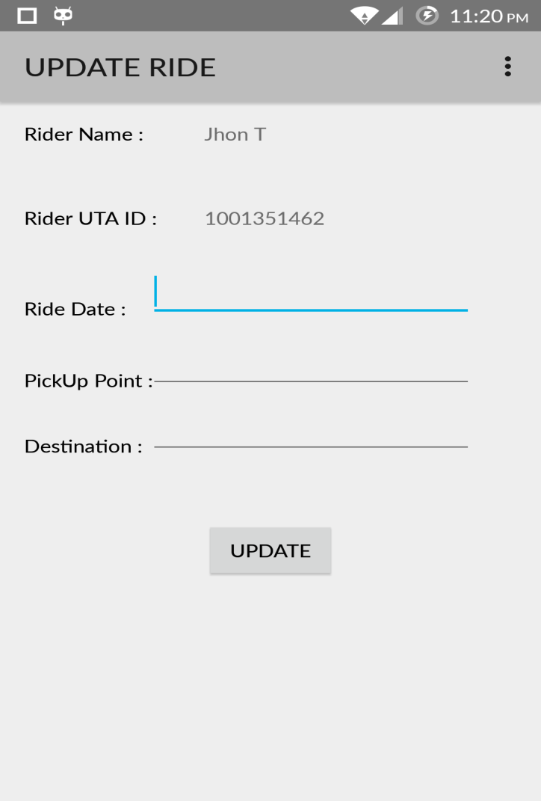

**Figure 18:**

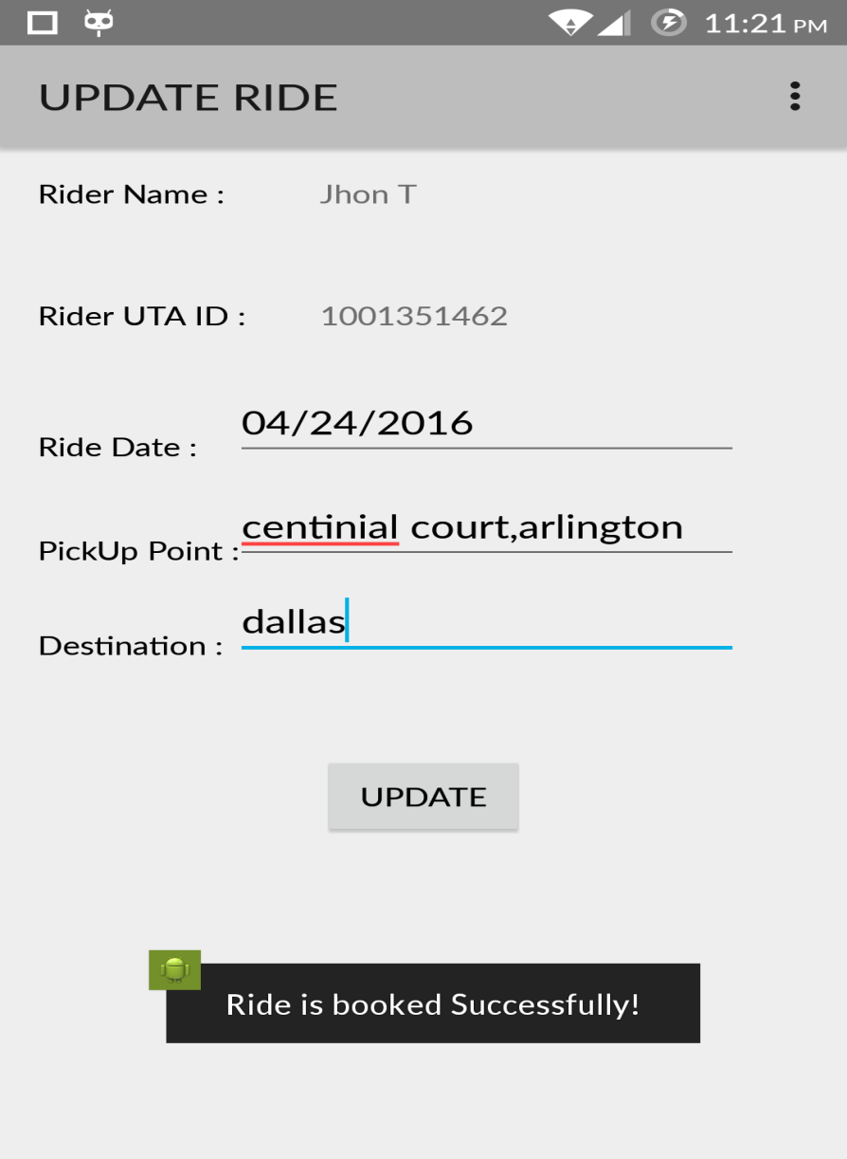

**Figure 19:**

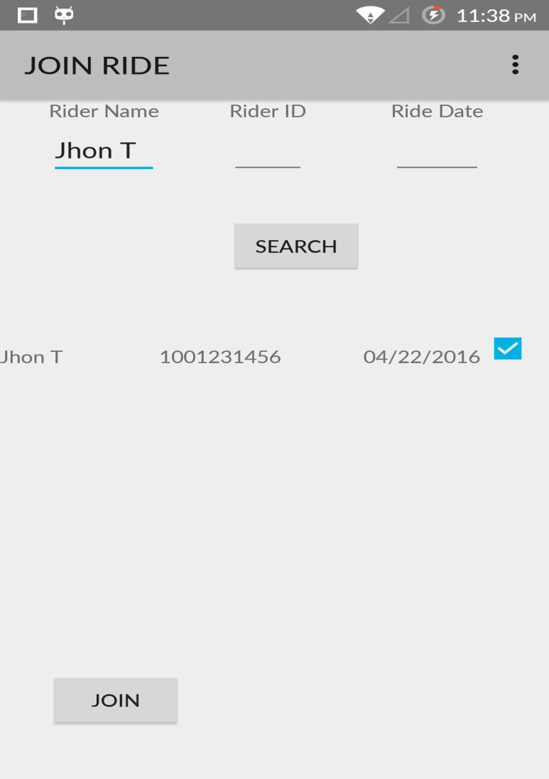

**Figure 20:**

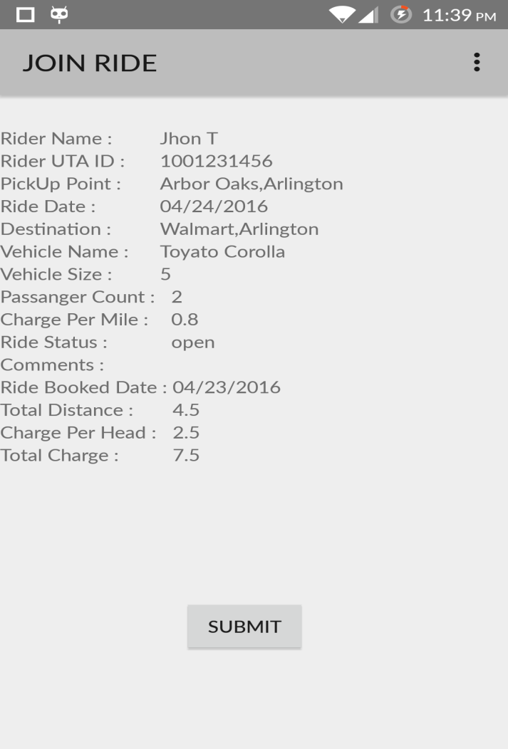

**Figure 21:**

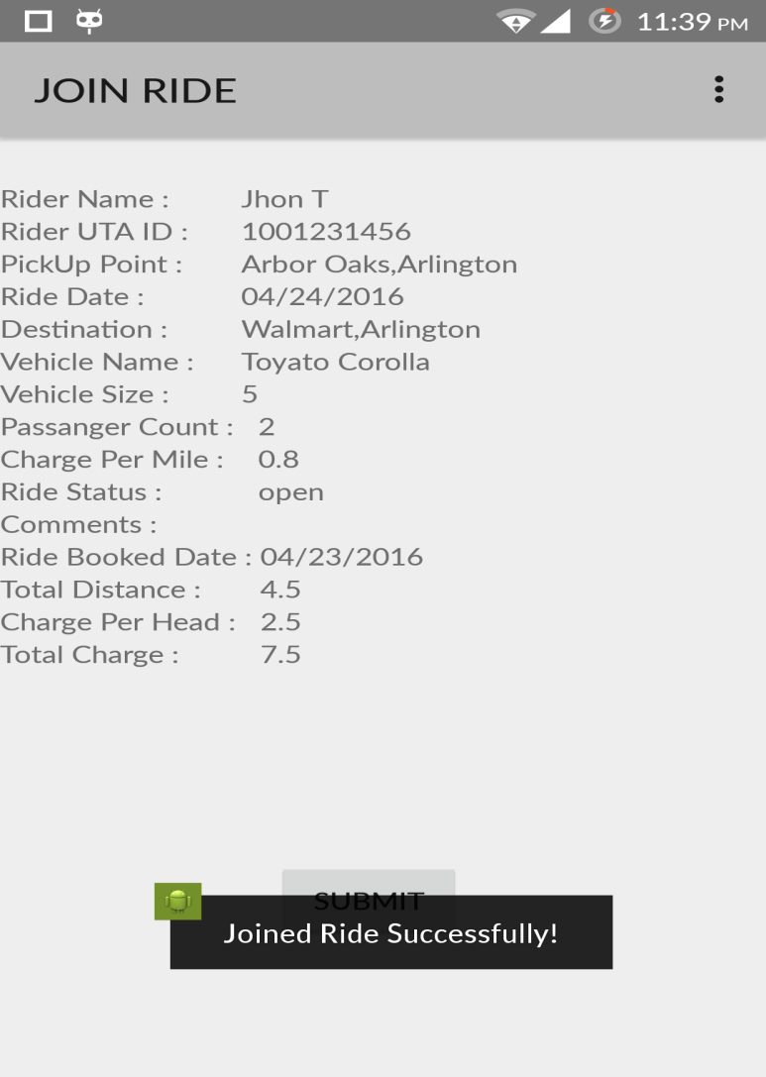

**Figure 22:**

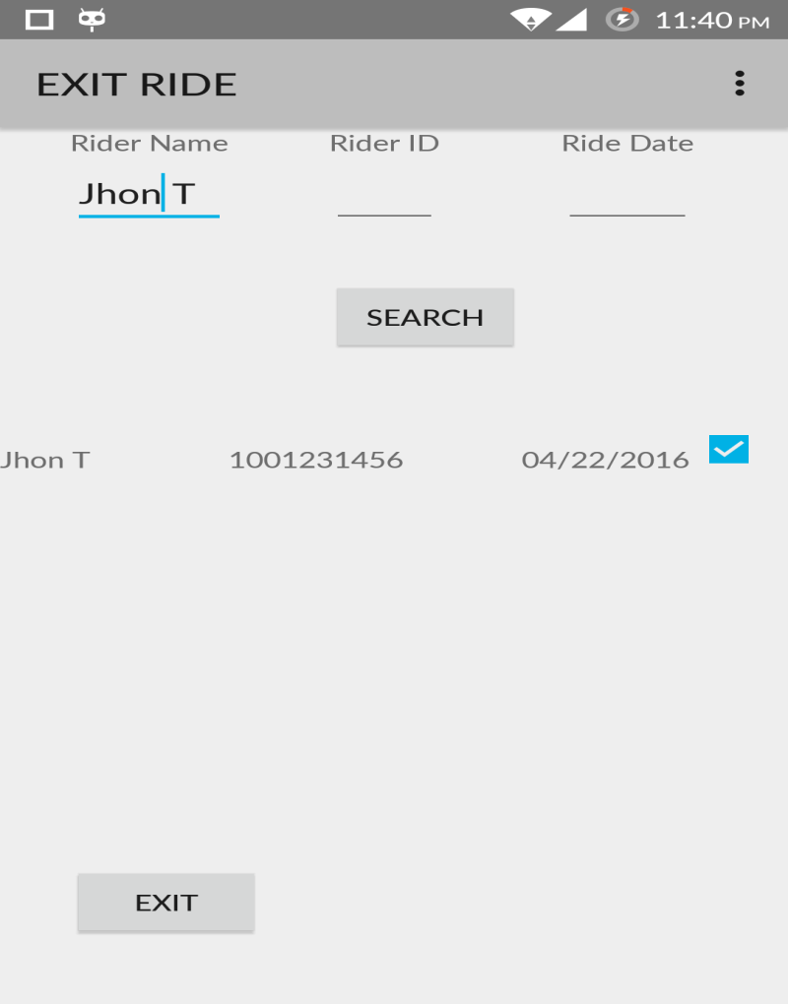

**Figure 23:**

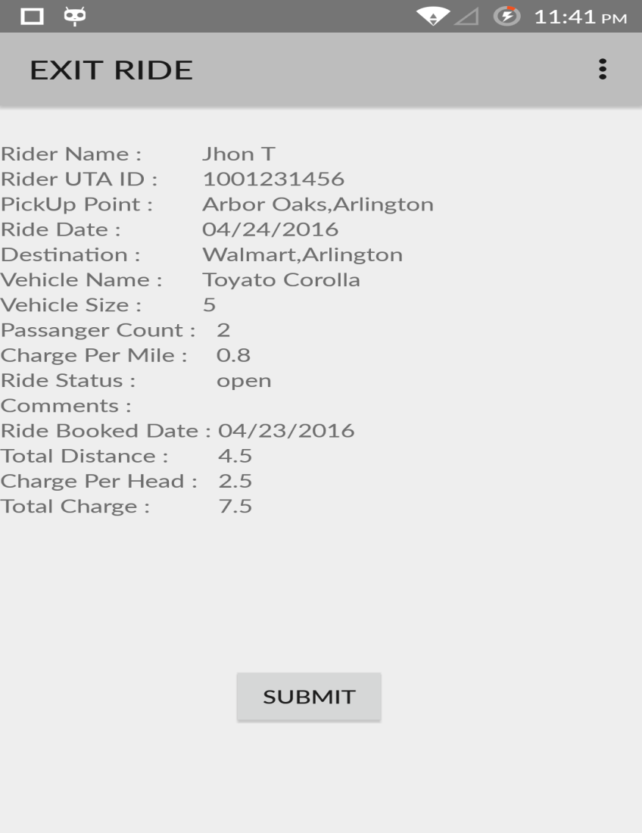

**Figure 24:**

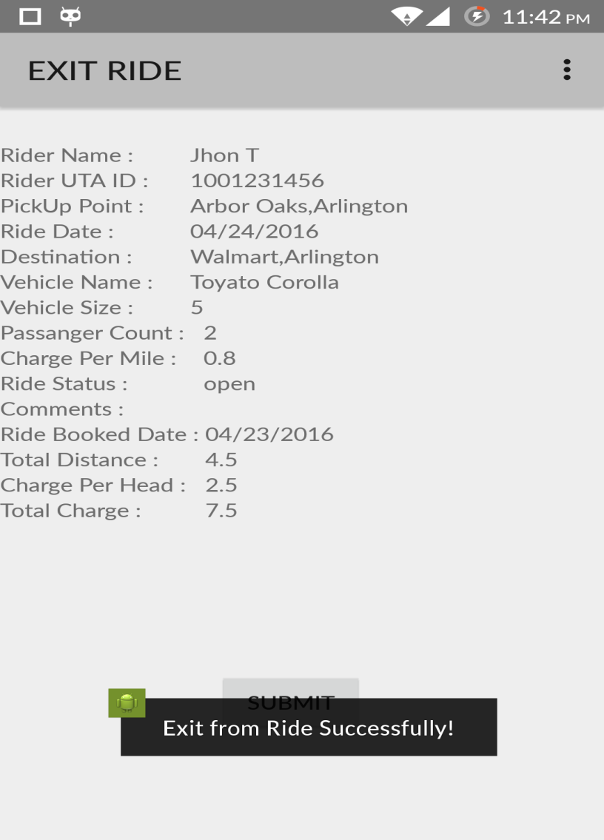

**Figure 25:**

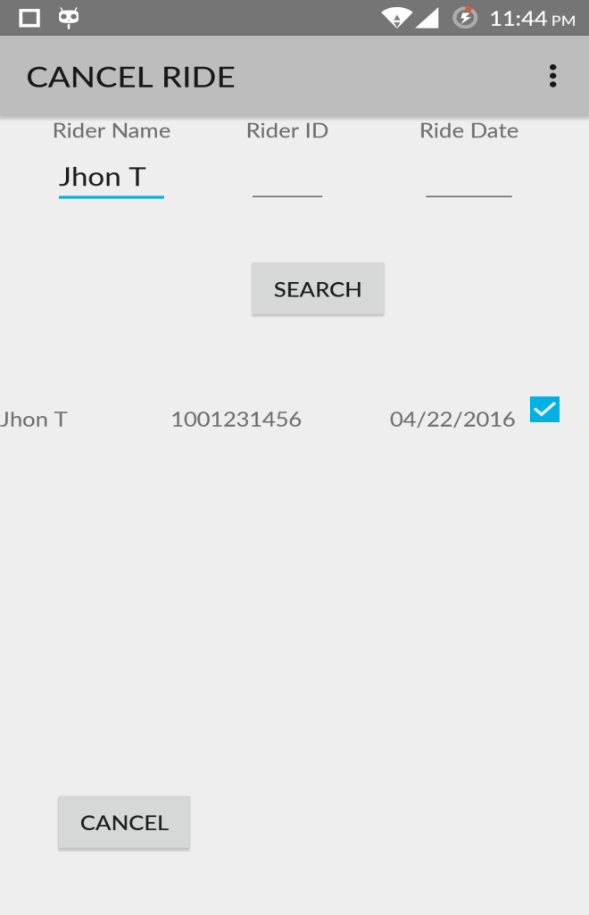

**Figure 26:**

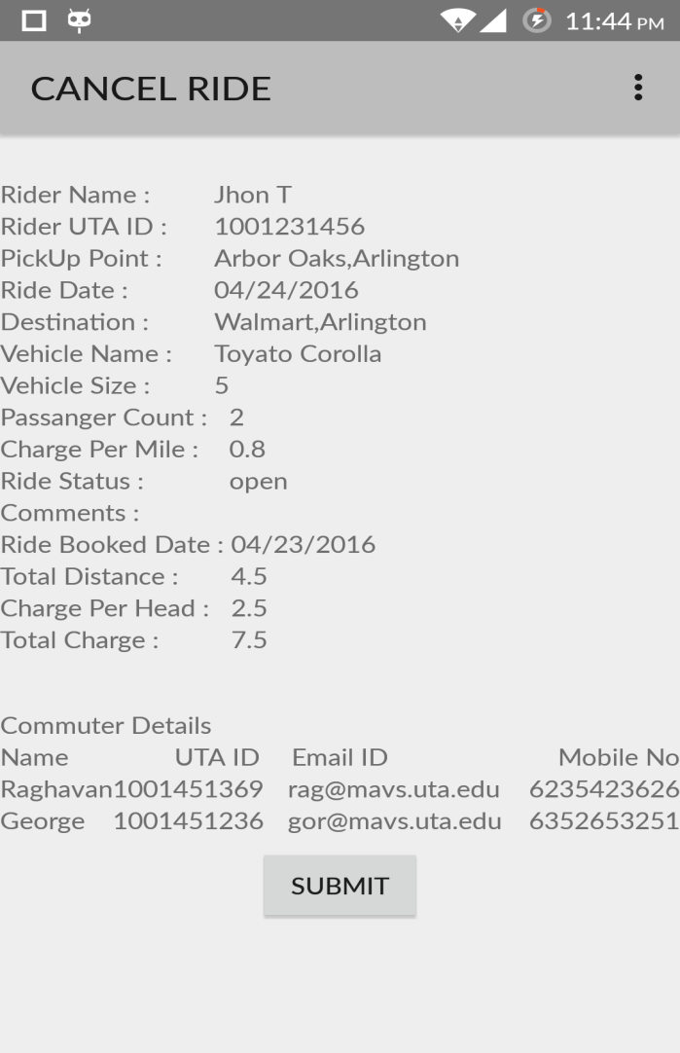

**Figure 27:**

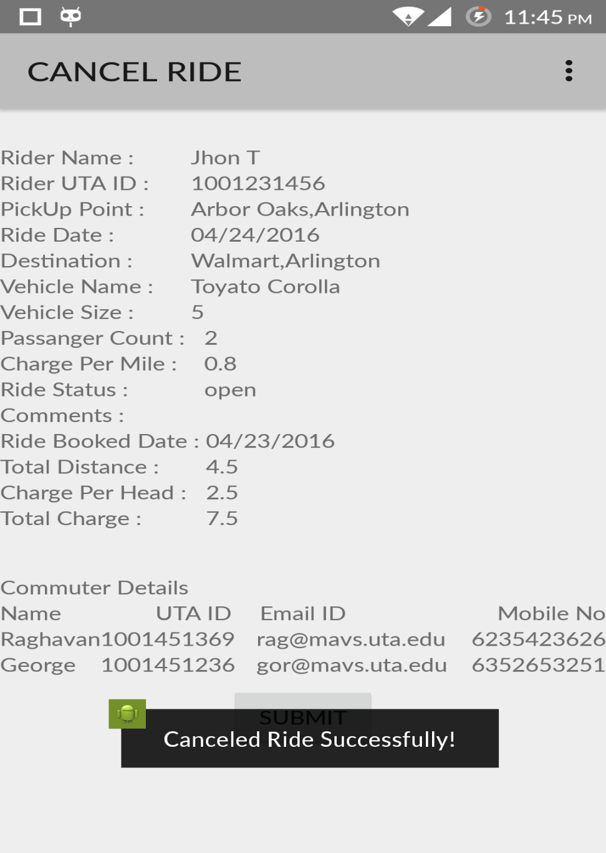

**Figure 28:**

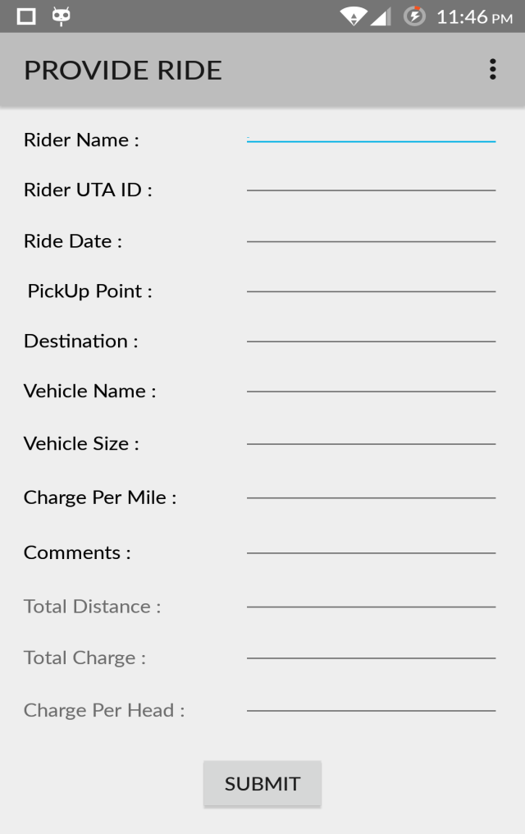

**Figure 29:**

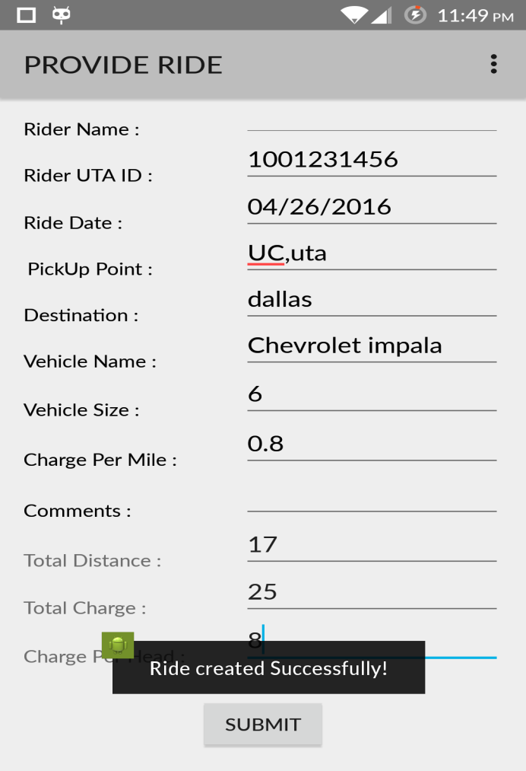

**Figure 30:**

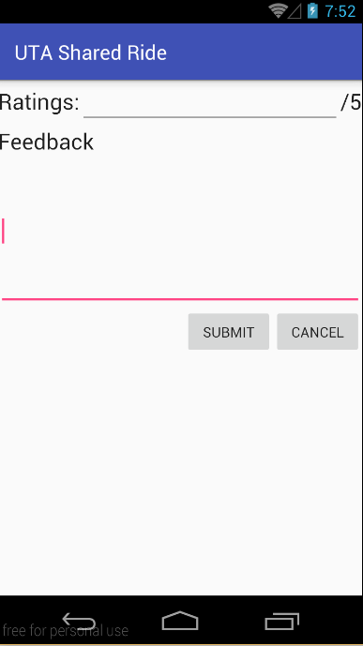

**Figure 31:**

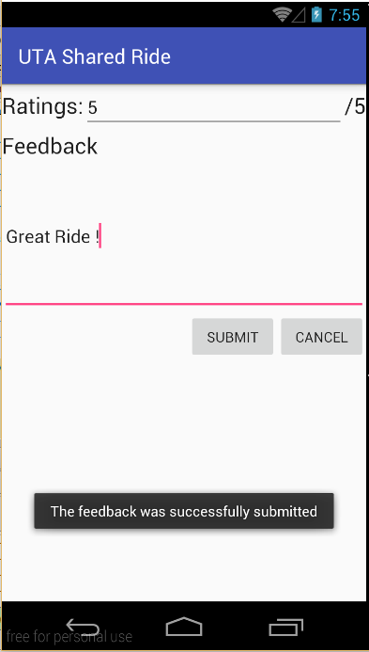

**Figure 32:**

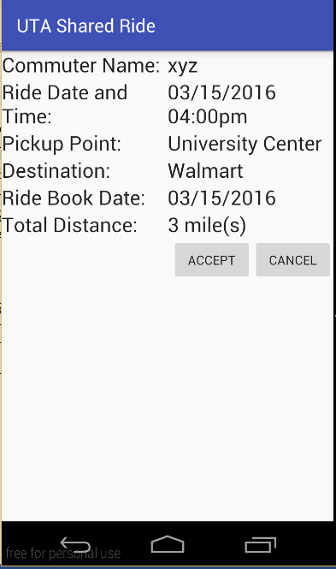

**Figure 33:**

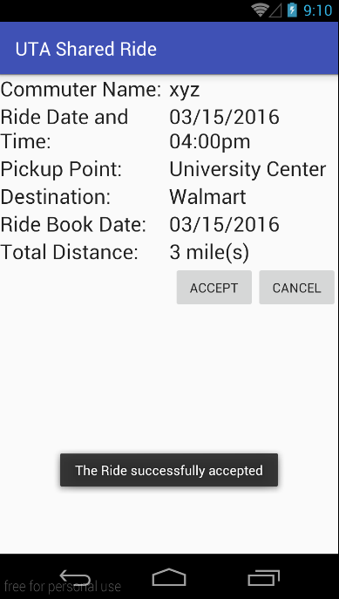

**Figure 34:**

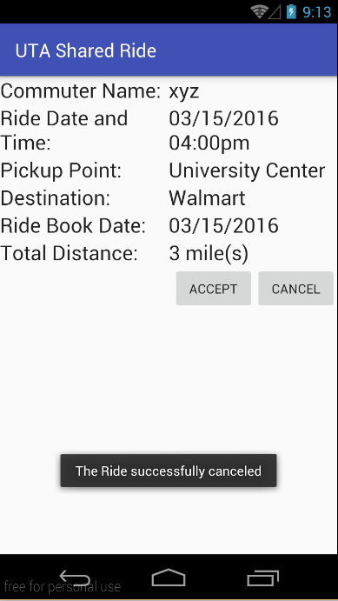

**Figure 35:**

**Figure 36:**

**Figure 37:**