SQL Server Performance Tuning
Cleaned • Topic-wise • Duplicate points removed • Interview-focused

Remember: Use this as your revision sheet. The goal is to remember the troubleshooting flow, not every counter or command.

How to use these notes
- Start with the symptom: CPU, memory, I/O, blocking/deadlock, or slow query.
- Confirm the bottleneck with waits + DMVs + PerfMon/Task Manager.
- Then inspect the execution plan and query/index/statistics.
- Do not treat one counter or one wait type as proof by itself.
- Fix the root cause and then verify that the symptom improves.

1. CPU Performance Troubleshooting

CPU investigation flow
- 1) Check overall CPU: Processor\% Processor Time\_Total.
- 2) Check SQL Server process: Process\% Processor Time\sqlservr.exe.
- 3) Check SQL workload: Batch Requests/sec, SQL Compilations/sec, SQL Re-Compilations/sec.
- 4) Check SQL schedulers: runnable_tasks_count.
- 5) Correlate with SOS_SCHEDULER_YIELD and query CPU consumption.
- 6) Find the expensive query and inspect its actual execution plan.
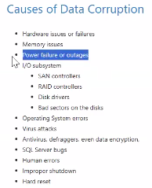

Most important CPU counters
- Process\% Processor Time → how much CPU the SQL Server process is consuming.
- Processor\% Processor Time\_Total → how busy the whole server CPU is.
- SQLServer:SQL Statistics\Batch Requests/sec → workload rate; high value alone does not prove CPU pressure.
- SQL Compilations/sec → plan compilation activity; consistently high values can contribute to CPU.
- SQL Re-Compilations/sec → recompilation activity; recompiles consume CPU.
- System\Processor Queue Length → threads waiting for CPU; interpret with CPU count and other evidence.
- System\Context Switches/sec → CPU scheduling activity; high value alone does not prove CPU pressure.

User Time vs Privileged Time
- % User Time → CPU spent in user-mode processing.
- % Privileged Time → CPU spent in Windows/kernel/driver-related processing.
- High User Time with high CPU → investigate CPU-intensive SQL workload.
- High Privileged Time → investigate OS, drivers, antivirus, I/O and other kernel-level activity.
Remember: CPU pressure is best supported by consistently high runnable_tasks_count + high CPU utilization + CPU-related waits/query CPU.

SQL Server worker states
- Running → worker is currently executing.
- Runnable → worker is ready but waiting for CPU. This is the key CPU-pressure indicator.
- Suspended → worker is waiting for another resource such as I/O, locks or memory.
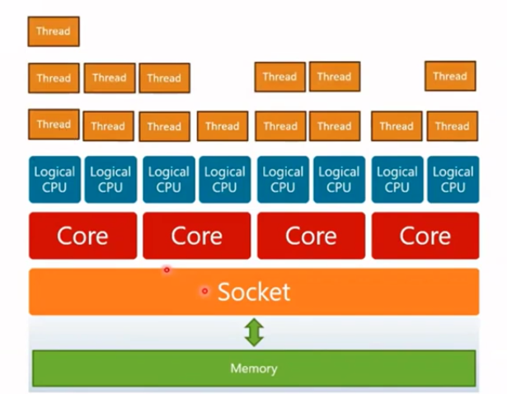

Worker pressure vs CPU pressure
- High worker count does not automatically mean CPU pressure.
- Many suspended workers → CPU may be fine; they may be waiting on I/O/locks.
- Many runnable workers → workers are waiting for CPU.
- THREADPOOL → worker threads are exhausted; this is different from CPU pressure.

Important CPU waits
- SOS_SCHEDULER_YIELD → worker yields the scheduler after its CPU quantum and goes back to the runnable queue.
- CXPACKET → coordination/waiting between parallel workers; it is not automatically a problem.
- RESOURCE_SEMAPHORE → query is waiting for a memory grant, commonly for sort/hash operations.
- ASYNC_NETWORK_IO → SQL Server is waiting for the client/application to consume returned rows.

2. Memory Performance Troubleshooting

First principle
- High SQL Server memory usage is not automatically a problem. SQL Server uses memory for caching.
- Look for memory pressure, not simply high memory consumption.

Important counters
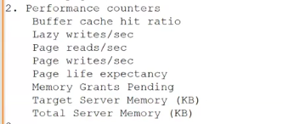
- Buffer Cache Hit Ratio → percentage of requested pages found in memory rather than read from disk.
- Page Life Expectancy (PLE) → how long pages remain in the buffer pool. Trend/drop is more useful than one fixed number.
- Lazy Writes/sec → lazy writer activity; sustained high activity can indicate memory pressure.
- Page Reads/sec → physical reads; consistently high values may indicate cache churn or insufficient memory.
- Page Writes/sec → pages written from memory to disk.
- Memory Grants Pending → queries waiting for workspace memory; investigate when sustained/non-zero.
- Target Server Memory → memory SQL Server wants/targets.
- Total Server Memory → memory SQL Server is currently using.

Memory troubleshooting flow
- Memory high → confirm SQL Server is actually the consumer.
- Check PLE and cache behavior.
- If pressure exists, separate external pressure from internal SQL Server pressure.
- External: other applications/instances or incorrect max server memory.
- Internal: plan cache bloat, memory grants, buffer pool usage, or large queries.
- RESOURCE_SEMAPHORE → investigate queries waiting for memory grants.

Useful DMVs
SELECT * FROM sys.dm_os_memory_clerks;
SELECT * FROM sys.dm_os_buffer_descriptors;
SELECT * FROM sys.dm_exec_query_memory_grants;
SELECT * FROM sys.dm_os_waiting_tasks WHERE wait_type = 'RESOURCE_SEMAPHORE';
Remember: Memory clerk = an 'accountant' showing which SQL Server subsystem is consuming memory.

Common internal causes
- Plan cache bloat → many single-use/ad-hoc plans. Consider parameterization and Optimize for Ad hoc Workloads.
- Workspace memory → large sorts/hashes/joins can request large grants or spill to TempDB.
- Large scans → can bring many pages into the buffer pool. Check indexing and execution plans.

3. I/O Performance Troubleshooting

I/O pressure means
- SQL Server is waiting because data/log I/O is not completing fast enough.

Main I/O waits
- PAGEIOLATCH_SH → waiting to read a data page from storage into memory.
- PAGEIOLATCH_EX → waiting for an I/O operation involving an exclusive page latch, commonly seen with data-page writes.
- WRITELOG → waiting for transaction-log records to be hardened before commit can complete.
- IO_COMPLETION → waiting for a general I/O operation.
- ASYNC_IO_COMPLETION → waiting for asynchronous I/O, often during large/bulk operations.
- BACKUPIO → waiting for backup-device I/O.

PerfMon + DMV checks
- PerfMon: Avg. Disk sec/Read, Avg. Disk sec/Write, Avg. Disk sec/Transfer.
- Check both physical/logical disk performance when troubleshooting storage.
SELECT * FROM sys.dm_io_virtual_file_stats(NULL, NULL);

I/O latency — remember the idea
- Use average latency per operation rather than total stall time alone.
- io_stall_read_ms ÷ num_of_reads = average read latency.
- io_stall_write_ms ÷ num_of_writes = average write latency.
- Compare data-file and log-file latency separately.
Remember: Do not diagnose storage from a single spike. Look for sustained latency and correlate it with waits and workload.

I/O troubleshooting flow
- High I/O waits → check file-level latency.
- High data-file latency → investigate storage, queueing, workload and cache/indexing.
- High WRITELOG → focus on transaction-log storage and transaction/log workload.
- High disk queue → investigate storage throughput/contention and other workloads using the disk.
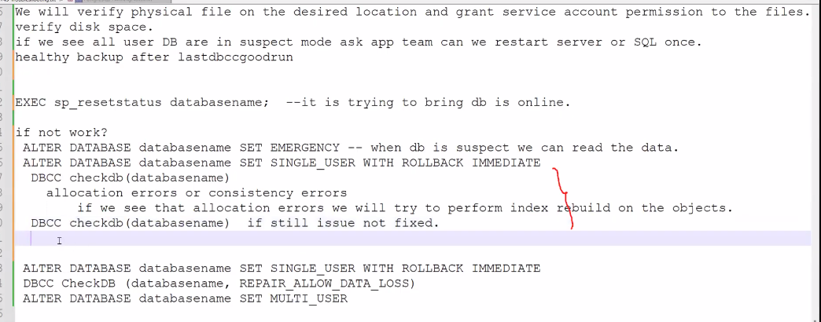

4. Wait Statistics — Fast Interview Map
- sys.dm_os_wait_stats → cumulative instance-level wait statistics.
- sys.dm_os_waiting_tasks → current/session-level waiting tasks.
SELECT * FROM sys.dm_os_wait_stats;
SELECT * FROM sys.dm_os_waiting_tasks;

Remember by category
- CPU → SOS_SCHEDULER_YIELD
- Data I/O → PAGEIOLATCH_SH / PAGEIOLATCH_EX
- Log I/O → WRITELOG
- Memory grants → RESOURCE_SEMAPHORE
- Client/application consumption → ASYNC_NETWORK_IO
- Parallelism coordination → CXPACKET
- General async I/O → ASYNC_IO_COMPLETION
Remember: A wait tells you what SQL Server is waiting for; it does not automatically tell you the root cause.

Locks vs Latches
- Locks protect data/concurrency between transactions.
- Latches protect internal in-memory structures/pages.
- PAGEIOLATCH refers to I/O-related page waits; PAGELATCH refers to in-memory page latch contention.

5. Execution Plans — How to Read Them

Reading order
- Read the plan from right to left; data generally flows from the leaf operators toward the SELECT/root.
- Read branches from top to bottom as you follow data flow.
- Use the actual execution plan when troubleshooting runtime behavior.
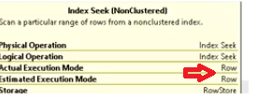
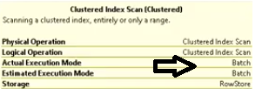

What to check first
- Estimated rows vs Actual rows.
- Scans vs Seeks.
- Expensive/large operators.
- Sort, Hash Match and Spool operations.
- Spills to TempDB.
- Warnings such as implicit conversions or missing-index suggestions.
- Parallelism operators.
- Thick data-flow lines generally indicate more rows flowing between operators.
- Operator cost percentages are estimated optimizer costs, not actual runtime percentages.

Common operators
- Nested Loops → commonly suitable when one input is small and the inner side can be efficiently sought.
- Hash Match → commonly suitable for larger/unsorted inputs.
- Merge Join → works well when both inputs are appropriately sorted.
- Compute Scalar → calculates expressions/derived values; not automatically a performance problem.
- Index Spool → builds a temporary internal index in TempDB during execution; investigate if it is expensive or repeatedly generated.

Adaptive Join
- Allows the engine to defer the choice between Nested Loops and Hash Match until runtime based on rows flowing through the operator.
- Your notes: introduced for columnstore scenarios in SQL Server 2017 and expanded to rowstore scenarios in SQL Server 2019.

6. Statistics & Cardinality Estimation

Why statistics matter
- The optimizer uses statistics to estimate row counts/selectivity and choose an execution plan.
- Stale or inaccurate statistics can produce poor row estimates and poor plan choices.

Useful commands/DMV
EXEC sp_helpindex 'TableName';
EXEC sp_helpstats 'TableName', 'ALL';
SELECT * FROM sys.dm_db_stats_properties(object_id, stats_id);
- sys.dm_db_stats_properties can show rows, sampled rows and modification information for statistics.

Selectivity
- High selectivity → predicate returns a small portion of the table.
- Low selectivity → predicate returns a large portion of the table.
- Selectivity and cardinality estimates influence Seek/Scan and join choices.

Cardinality Estimator
- SQL Server 2014 introduced the newer cardinality estimator.
- Legacy CE is associated with the older estimator (version 70).
- Compatibility level and the Legacy Cardinality Estimation setting are related but separate concepts.
Remember: Interview phrase: 'I compare estimated and actual rows. If they differ significantly, I investigate statistics, data distribution, predicates and cardinality estimation.'

7. Indexes & Fragmentation

Clustered vs Nonclustered
- A clustered index determines the logical order of the table's data pages; the leaf level contains the table data.
- A nonclustered index is a separate B-tree structure whose leaf level contains index keys plus row locators/included columns.
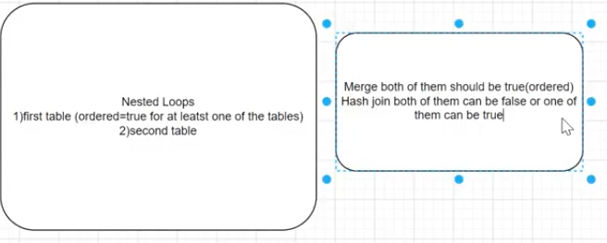

Covering index
- A covering index contains all columns needed by a query, allowing SQL Server to avoid a Key Lookup/Bookmark Lookup.
- Key columns participate in the index key and tree ordering.
- INCLUDE columns are stored at the leaf level and do not participate in the key ordering.

Index maintenance
- REORGANIZE is generally a lighter, online operation and uses less log than REBUILD.
- REBUILD recreates the index and generally uses more resources/log space.
- Online rebuild allows access during most of the operation but can require a short Schema Modification lock during the final phase.
- Offline rebuild blocks access to the affected table for the operation.
- A disabled index must be rebuilt to become usable again.
Remember: Do not memorize '30% = rebuild' as an absolute rule. Use fragmentation together with workload, page density, index size and query benefit.

Index cost trade-off
- Indexes can reduce reads and improve SELECT performance.
- Too many indexes increase storage and can add overhead to INSERT/UPDATE/DELETE operations.

8. SARGability

Definition
- A predicate is SARGable when SQL Server can use the search condition efficiently with an index.
- Avoid applying functions or calculations directly to the indexed column when possible.

Example
-- Non-SARGable
SELECT *
FROM Orders
WHERE YEAR(OrderDate) = 2025;
-- SARGable
SELECT *
FROM Orders
WHERE OrderDate >= '20250101'
AND OrderDate < '20260101';
Remember: Remember: keep the indexed column 'naked' on the predicate side whenever possible.

9. Parameter Sniffing

Simple definition
- SQL Server can compile a parameterized statement using the parameter values seen at compilation and then reuse the cached plan for later executions.
- If data is highly skewed, one plan may be good for one value and poor for another.

How to identify
- Query is fast for some parameter values and slow for others.
- Compare compiled parameter values with runtime values in the execution plan/XML plan.
- Use Query Store or DMVs to compare plans and runtime behavior.

Common mitigations
- OPTION (RECOMPILE) → create a fresh plan for that execution.
- OPTIMIZE FOR → optimize for a chosen value.
- OPTIMIZE FOR UNKNOWN → use a less value-specific estimate.
- Plan guides/query hints → advanced options when query text cannot easily be changed.
Remember: RECOMPILE can increase CPU because SQL Server must compile the statement again.

10. Blocking, Locks, Deadlocks & Isolation

Lock basics
- Exclusive (X) locks are incompatible with other lock modes that conflict with X.
- Typical lock hierarchy in the notes: database → table → page → row/key.

Blocking vs Deadlock
- Blocking → one session waits for another session's lock.
- Deadlock → two or more sessions wait on each other in a cycle; SQL Server chooses a victim.

Deadlock investigation
- Use the deadlock XML to inspect the victim, processes/queries and resources.
- Common patterns in your notes: read-write, writer-writer, key lookup, parallelism, serializable/range and partition-escalation deadlocks.
- Deadlock priority influences victim selection.

Isolation levels
- READ UNCOMMITTED → can allow dirty reads.
- READ COMMITTED → prevents dirty reads; non-repeatable reads can occur.
- REPEATABLE READ → prevents non-repeatable reads; phantoms can still occur.
- SERIALIZABLE → strongest traditional lock-based isolation; prevents phantoms.
- Snapshot-based isolation uses row versions rather than holding shared locks for reads.
Remember: Do not describe Snapshot Isolation simply as 'the highest isolation level.' SERIALIZABLE is the strictest standard lock-based isolation level; Snapshot is a different row-versioning approach.

11. Transactions

Three transaction modes
- Auto-commit → each statement is committed automatically.
- Explicit → BEGIN TRAN ... COMMIT/ROLLBACK.
- Implicit → SQL Server automatically starts a transaction for qualifying statements; the application must still COMMIT/ROLLBACK.

Performance reminder
- Keep transactions as short as practical.
- Long transactions can hold locks, increase blocking and delay log reuse.
- Do not use an explicit transaction merely because it is assumed to improve stored-procedure performance; use it when the business operation requires transactional boundaries.

12. TempDB Performance
- TempDB is used for temporary objects, worktables, row-versioning and operations such as sorts/hashes that spill.
- Sort/Hash/Spool spills are visible in execution-plan warnings.
- Investigate TempDB data-file configuration, storage performance, contention and workload.
- Your notes contain an Azure SQL Managed Instance point about TempDB file configuration; treat MI-specific limits as environment/version dependent and verify before using them in an interview.
Remember: For performance tuning, remember: 'Spill → TempDB → insufficient memory grant, bad estimates, or an operation that needs more workspace.'

13. Query Store, Plan Cache & Modern Query Processing

Query Store
- Query Store keeps query, plan and runtime history in the database and survives SQL Server restarts.
- Use it to find queries with high duration, CPU, reads, executions and plan changes.
- It can help identify problematic statements inside stored procedures.

Optimize for Ad Hoc Workloads
- Stores a small plan stub for a first-time ad-hoc query instead of immediately caching the full plan.
- If the query is executed again, SQL Server can cache the full plan.
- Useful when many single-use ad-hoc queries cause plan-cache bloat.

Forced parameterization
- Allows eligible literal-based queries to be parameterized automatically so similar queries can reuse plans.

Compatibility level & IQP
- Compatibility level controls a broad set of database-engine/query-processing behaviors.
- Intelligent Query Processing (IQP) introduced/expanded several performance features across SQL Server versions.
- Batch mode processes rows in batches rather than one row at a time; SQL Server 2019 expanded batch-mode support to rowstore scenarios.

14. Checkpoints, Transaction Log & VLF

Checkpoint
- Writes dirty data pages from the buffer cache to data files.
- Writes a checkpoint record in the transaction log and updates recovery information.
- Checkpoint behavior affects crash-recovery work.

Lazy Writer vs Checkpoint
- Checkpoint flushes dirty pages as part of checkpoint processing.
- Lazy Writer helps free buffer-pool space by removing/handling older pages when memory pressure requires it.

VLF
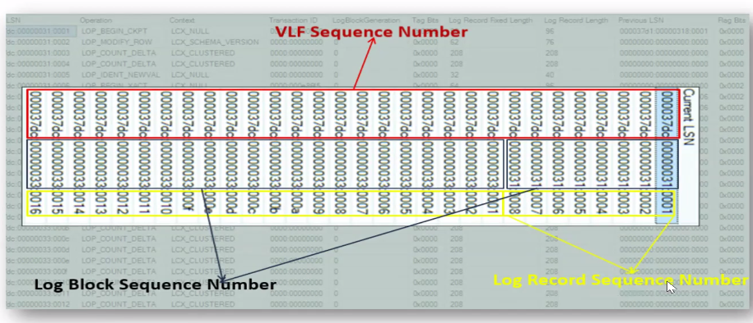
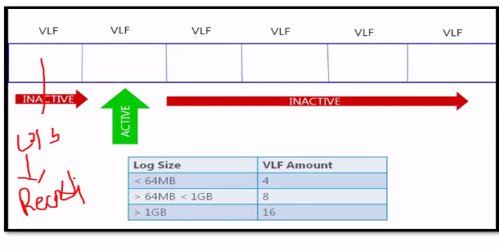
- Transaction log files are divided into Virtual Log Files (VLFs).
- DBCC LOGINFO can show VLF information; your notes use Status 0 = inactive and Status 2 = active.

Log file full
SELECT name, log_reuse_wait_desc FROM sys.databases;
DBCC SQLPERF(LOGSPACE);
DBCC OPENTRAN();
- Error 9002 indicates a transaction log full condition.
- Use log_reuse_wait_desc to identify why log space cannot be reused.
- Check for long-running/open transactions, backups/restores, replication/AG-related causes and other reuse waits as applicable.

15. Data File / Log File Troubleshooting

Data file full
- Find the growth cause and trend.
- Consider data archiving/purging, adding appropriately sized files/filegroup capacity, and fixing the workload.
- Avoid shrinking as a routine maintenance solution; shrink only when there is a specific reason to permanently reduce the file size.

Log file full
- First determine the log reuse wait reason.
- Check log space usage and open transactions.
- Do not repeatedly shrink the log as a normal fix; size the log appropriately and address the reason for poor reuse.

16. DBCC CHECKDB — Performance & Integrity
- DBCC CHECKDB checks logical and physical consistency of the database.
- NO_INFOMSGS → suppresses informational messages.
- PHYSICAL_ONLY → focuses on physical structure/page and allocation checks; it is lighter than a full CHECKDB.
- NOINDEX → skips intensive checks of nonclustered indexes for user tables, reducing execution time.
- TABLOCK → avoids the internal snapshot but can reduce concurrency/block users.
- CHECKDB normally uses an internal database snapshot; snapshot files are sparse files.
Remember: CHECKDB performance depends heavily on database size, storage speed and workload. Choose options based on what you need to verify.

17. Always On Availability Group — Performance / Latency

Key concepts
- RPO → amount of data loss the business can tolerate.
- RTO → target time to restore service after a failure.
- Log Send Queue → log records waiting to be sent from primary toward a secondary.
- Redo/Recovery Queue → log records waiting to be redone on the secondary.
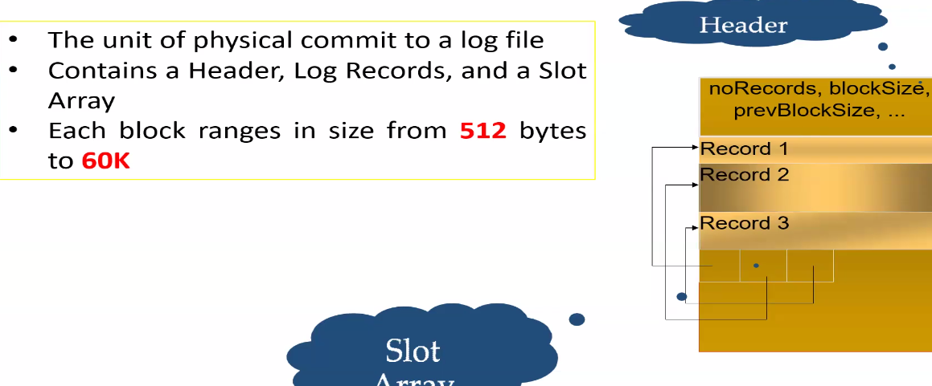
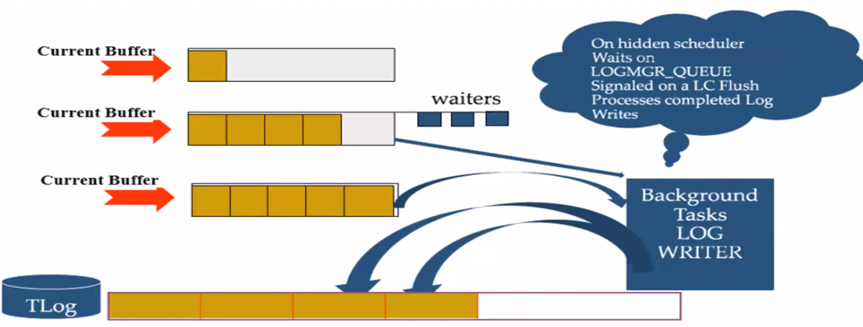

Latency investigation
- Check primary log generation rate.
- Check bytes sent to the replica.
- Check secondary receive/apply/redo rates.
- Investigate network throughput/latency, primary/secondary storage and secondary CPU workload.
- A growing log-send queue means the secondary path is not keeping up with log generation/sending.

Useful DMVs/counters
sys.dm_hadr_database_replica_states
SQLServer:Databases → Log Bytes Flushed/sec
SQLServer:Availability Replica → Bytes Sent to Transport/sec
SQLServer:Availability Replica → Bytes Sent to Replica/sec
SQLServer:Database Replica → Log Send Queue
SQLServer:Database Replica → Recovery Queue

18. SQL Server Index / I/O Quick Commands

Execution and workload
SET STATISTICS IO ON;
SET STATISTICS TIME ON;
SELECT * FROM sys.dm_exec_query_stats;
SELECT * FROM sys.dm_exec_requests;

Schedulers / CPU
SELECT * FROM sys.dm_os_schedulers WHERE status = 'VISIBLE ONLINE';
SELECT * FROM sys.dm_os_waiting_tasks;

I/O
SELECT * FROM sys.dm_io_virtual_file_stats(NULL, NULL);

Memory
SELECT * FROM sys.dm_os_memory_clerks;
SELECT * FROM sys.dm_os_buffer_descriptors;

Statistics
SELECT * FROM sys.dm_db_stats_properties(object_id, stats_id);

19. One Master Troubleshooting Flow
Slow query / performance issue
- 1. Confirm the symptom and time window.
- 2. Check CPU, memory and I/O at the same time.
- 3. Check waits: what is SQL Server waiting for?
- 4. If CPU → runnable_tasks_count + CPU-heavy queries + execution plan.
- 5. If memory → PLE + memory grants + memory clerks + plan cache.
- 6. If I/O → PAGEIOLATCH/WRITELOG + file latency + disk queue.
- 7. If blocking → identify blocker and blocked sessions; inspect transaction duration.
- 8. If deadlock → capture/read deadlock XML and identify the cycle.
- 9. If query-level → actual execution plan: estimates vs actuals, scans/seeks, joins, spills, warnings.
- 10. Check statistics, indexes, SARGability and parameter sniffing.
- 11. Apply the smallest appropriate fix.
- 12. Re-test and compare before/after metrics.

20. Final Interview Memory Sheet

CPU
- CPU pressure = high CPU + consistently high runnable tasks + supporting evidence.
- SOS_SCHEDULER_YIELD = CPU scheduling/yield wait.
- THREADPOOL = worker-thread exhaustion, not simply CPU pressure.

Memory
- High memory usage ≠ automatically a problem.
- PLE trend + memory grants + clerks tell the story.
- RESOURCE_SEMAPHORE = waiting for memory grant.

I/O
- PAGEIOLATCH = data-page I/O wait.
- WRITELOG = transaction-log flush wait.
- Measure file latency; correlate with workload and waits.

Execution plan
- Right → left; compare estimated vs actual rows.
- Look for scans, expensive joins, spools, spills and warnings.
- Actual plan is especially useful for runtime troubleshooting.

Indexes / stats
- Good statistics → better cardinality estimates → better plan choices.
- SARGable predicates help indexes be used efficiently.
- Covering index can avoid lookups.
- Index maintenance has a write/storage cost.

Parameter sniffing
- Compile-time parameter values can influence a cached plan.
- Skewed data can make one cached plan unsuitable for another value.

Blocking / deadlocks
- Blocking = waiting.
- Deadlock = circular waiting; SQL Server chooses a victim.

TempDB
- Spills → TempDB.
- Investigate memory grants, estimates, operators and TempDB configuration.

The sentence to memorize
Remember: “I first identify whether the bottleneck is CPU, memory, I/O, blocking or the query itself. Then I correlate waits, DMVs and PerfMon with the actual execution plan, check estimates/statistics/indexes, fix the root cause, and validate the improvement.”

Appendix — Pictures kept from your original notes
- Only diagrams/screenshots that directly help remember CPU architecture, performance counters, execution-plan operators, transactions, VLFs, Always On flow, or CPU troubleshooting were retained.
- Repeated screenshots, decorative images, and screenshots that duplicated nearby text were left out.
