**OUTPUT SCREEN SHOTS WITH DESCRIPTION.**

**Home Page:**

Here user view the home page of phishing website prediction web application.

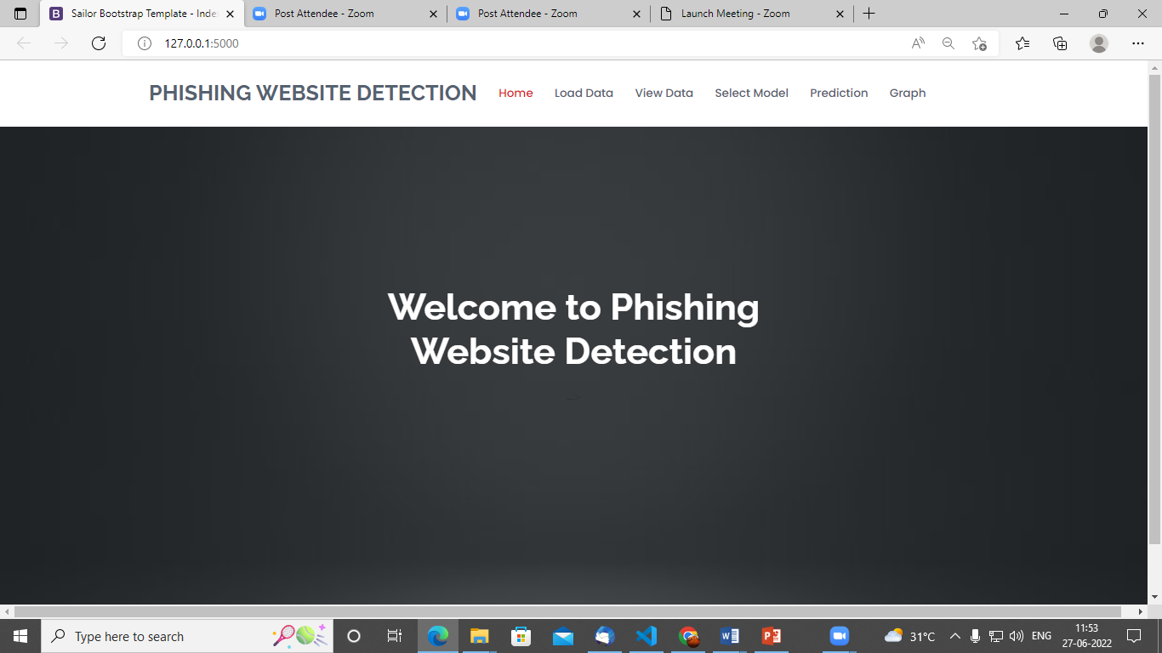

**Fig1**: Home Page

**Load:**

In the load page, users can load the website dataset.

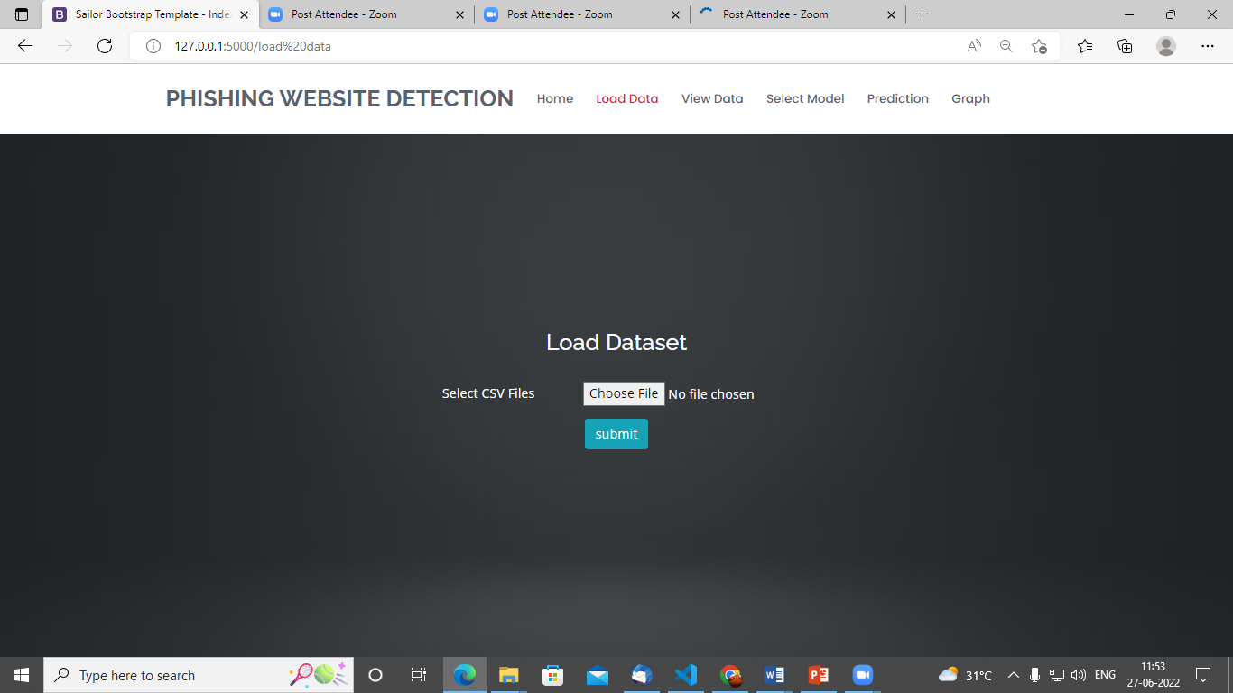

**View:**

Here we can see the uploaded data set.

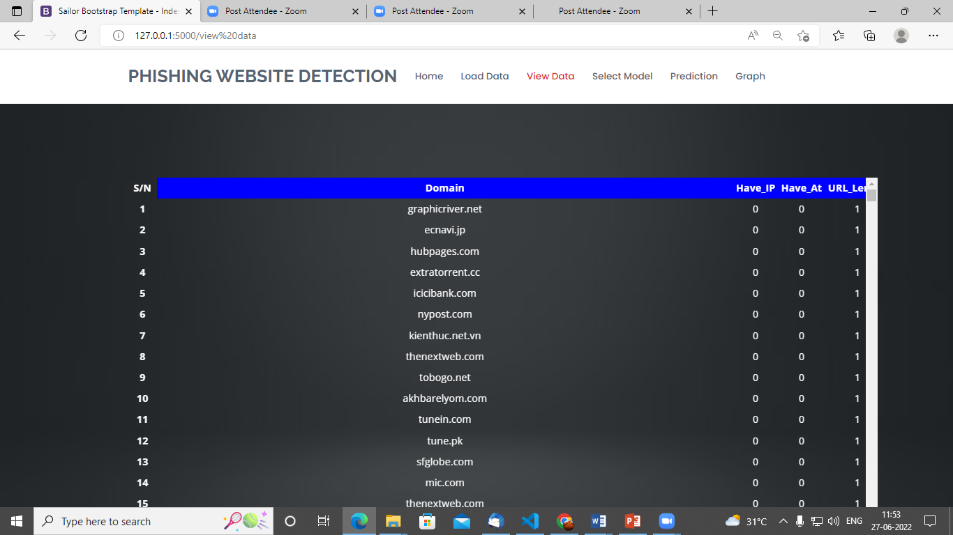

**Model:**

Here we can train our data using different algorithm.

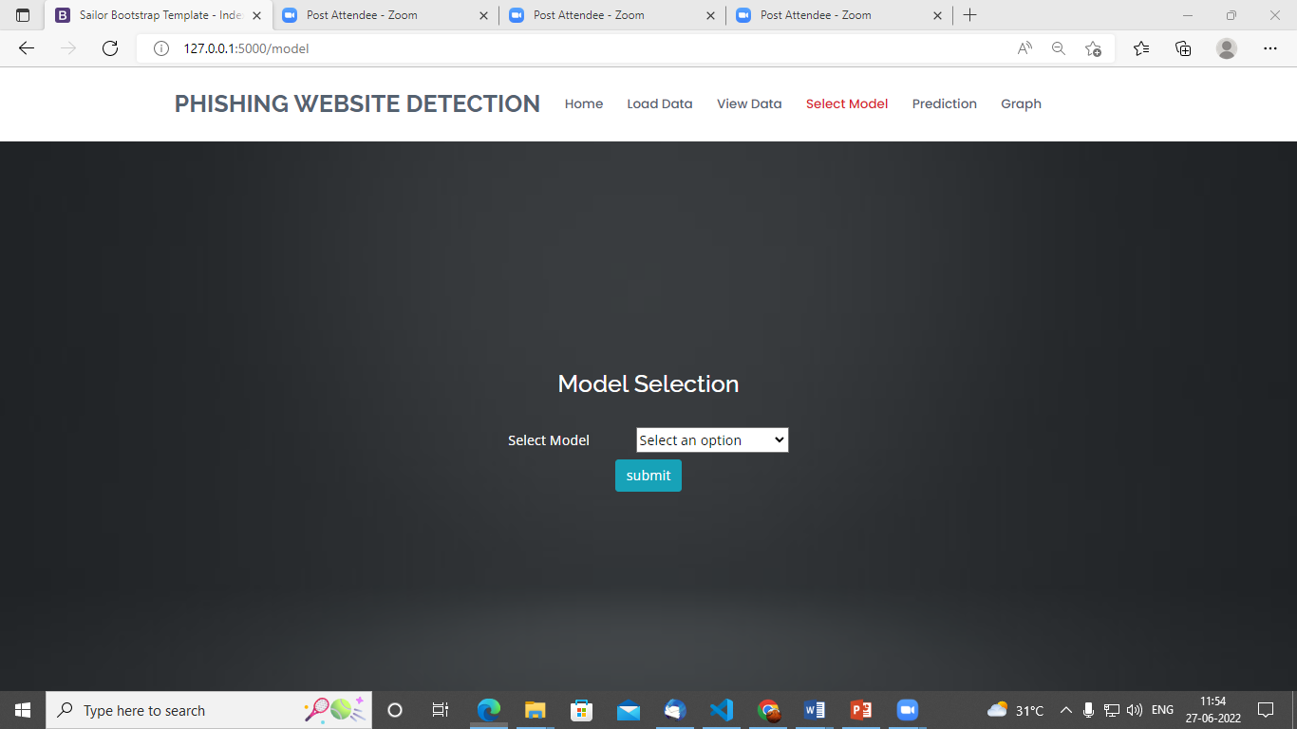

**Prediction:**

This page show the detection result that whether the website is a phishing website or legitimate.

