Power BI Assignment 2 DAX and Data Visualization
E-Commerce Sales Analysis | Submitted by Mahesh Sundaran
This submission presents the calculated columns, measures and report visuals requested in the assignment. Each item includes the task, a brief implementation note and a screenshot from the completed Power BI report.

01 Category Type calculated column
Create a Calculated Column for 'Category Type': Add a calculated column in the Order Details table that combines the 'Category' and 'Sub-Category' columns into a single 'Category Type' column.
Implementation The Order Details table combines Category and Sub-Category into Category Type.
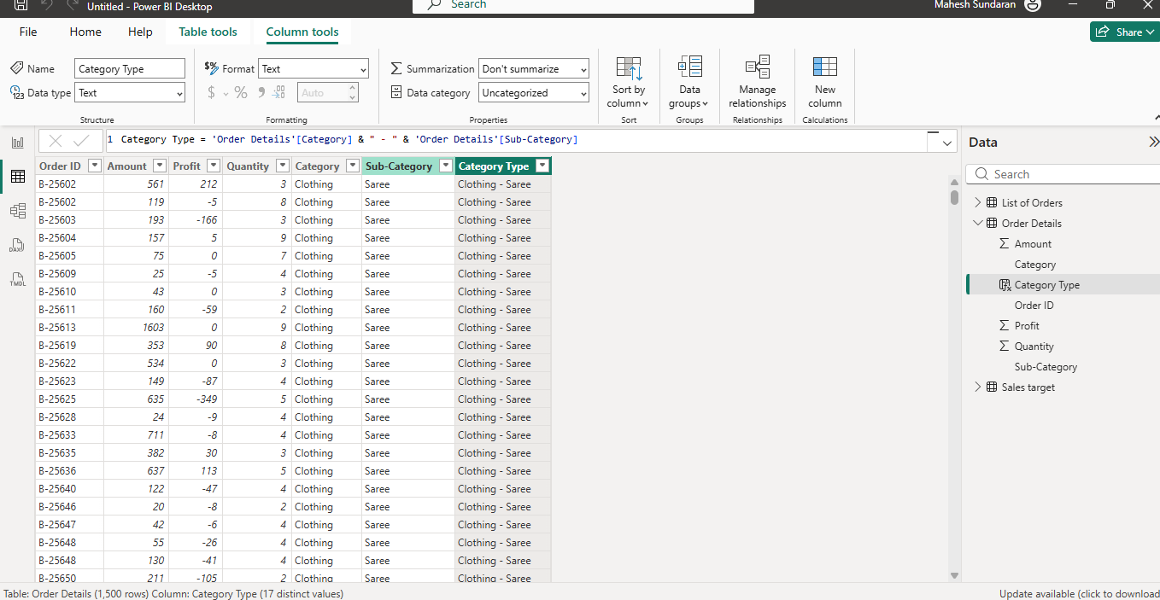

02 Revenue per Order calculated column
Calculate Revenue per Order in Order Details Table: Create a calculated column in the Order Details table to compute the revenue (Amount * Quantity) per order.
Implementation Revenue per Order is calculated from Amount and Quantity in Order Details.
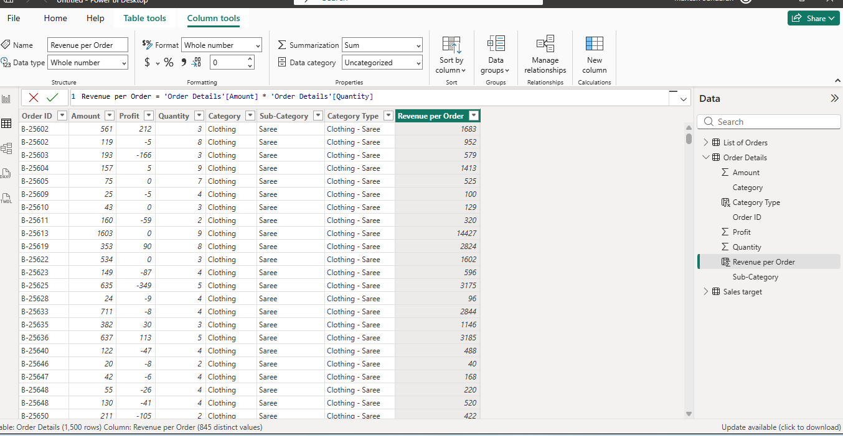

03 Sales Category calculated column
Create a Calculated Column to Categorize Sales: Add a calculated column named 'Sales Category' in the Order Details table that categorizes each order as 'Above Average' or 'Below Average' based on the Amount value.
Implementation Each Order Details row is classified as Above Average or Below Average using its Amount.
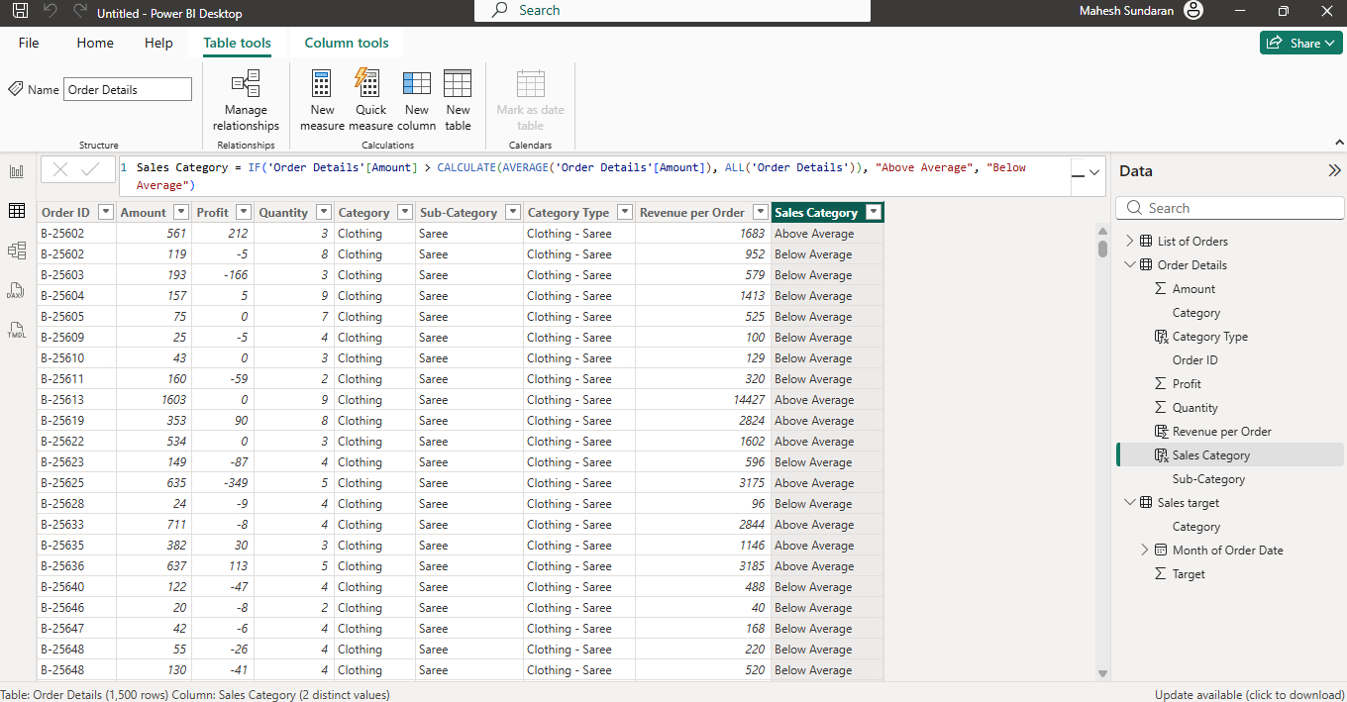

04 Order Count measure
Calculate Order Count: Define a measure to count the total number of orders in the Order Details table.
Implementation The Order Count measure is displayed in a card and used again in the state funnel.
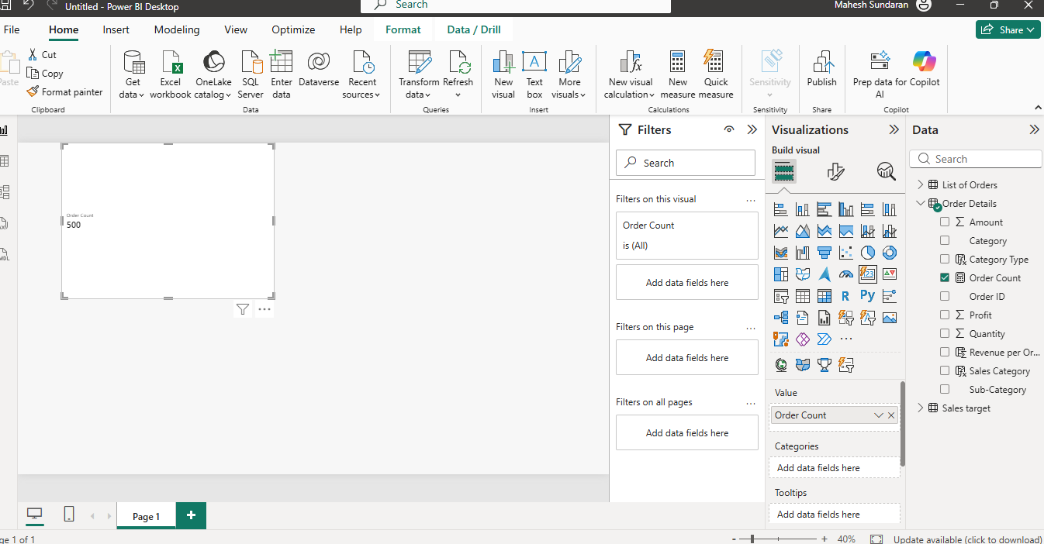

05 Average Profit in Delhi measure
Calculate Average Profit in Delhi: Create a measure to calculate the average profit for orders placed in Delhi.
Implementation The measure filters orders to Delhi and calculates their average profit.
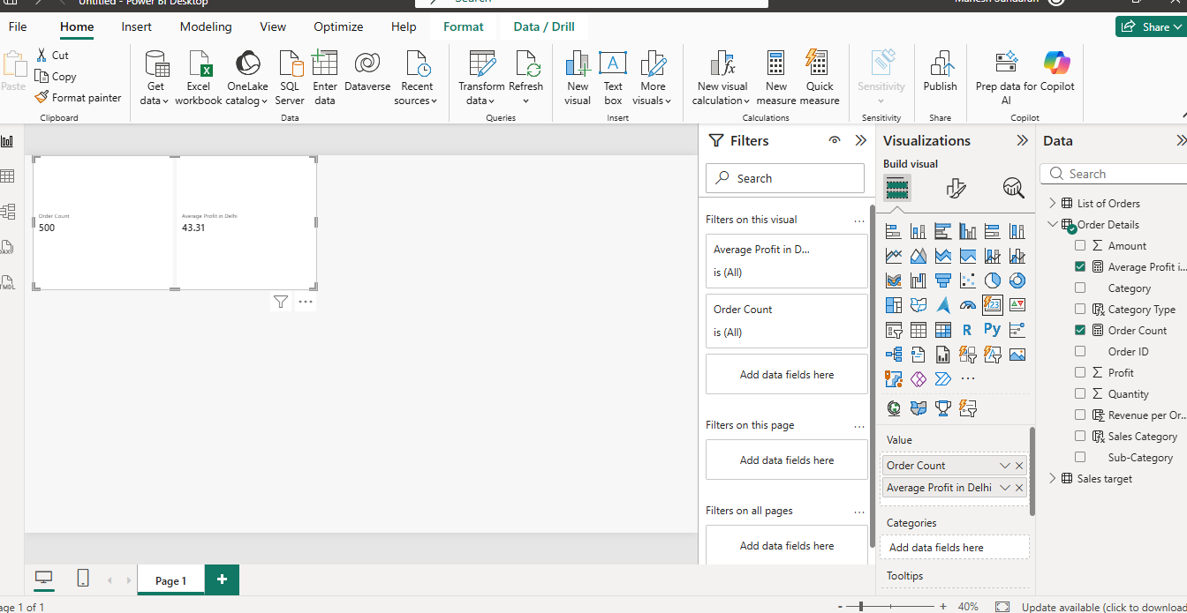

06 Year to Date Sales measure
Calculate Year-to-Date (YTD) Sales: Define a measure to calculate the total sales amount accumulated from the earliest order date up to each order date.
Implementation The line chart shows accumulated sales through each order date.
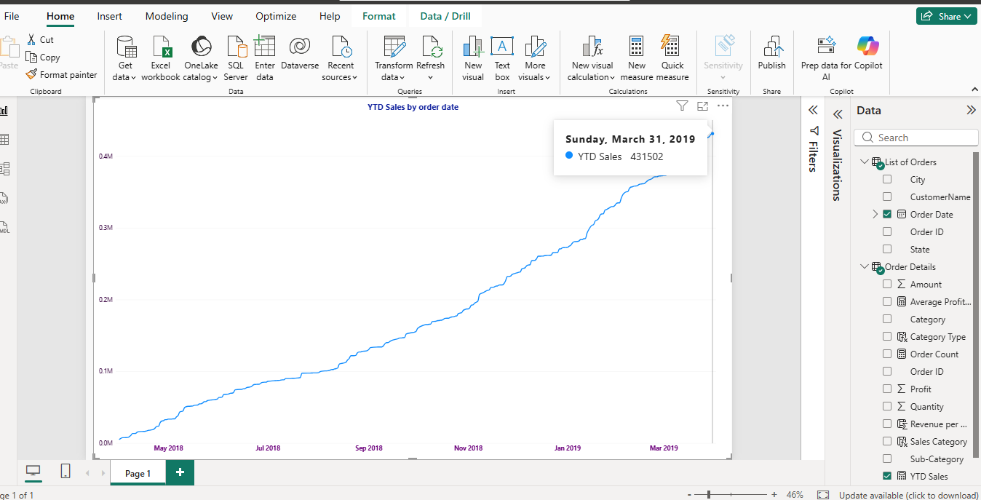

07 Sales and target by category
Sales Target Achievement by Category: Compare actual sales with sales targets by category using a clustered column chart.
Implementation The clustered columns compare actual sales and targets across Clothing, Electronics and Furniture.
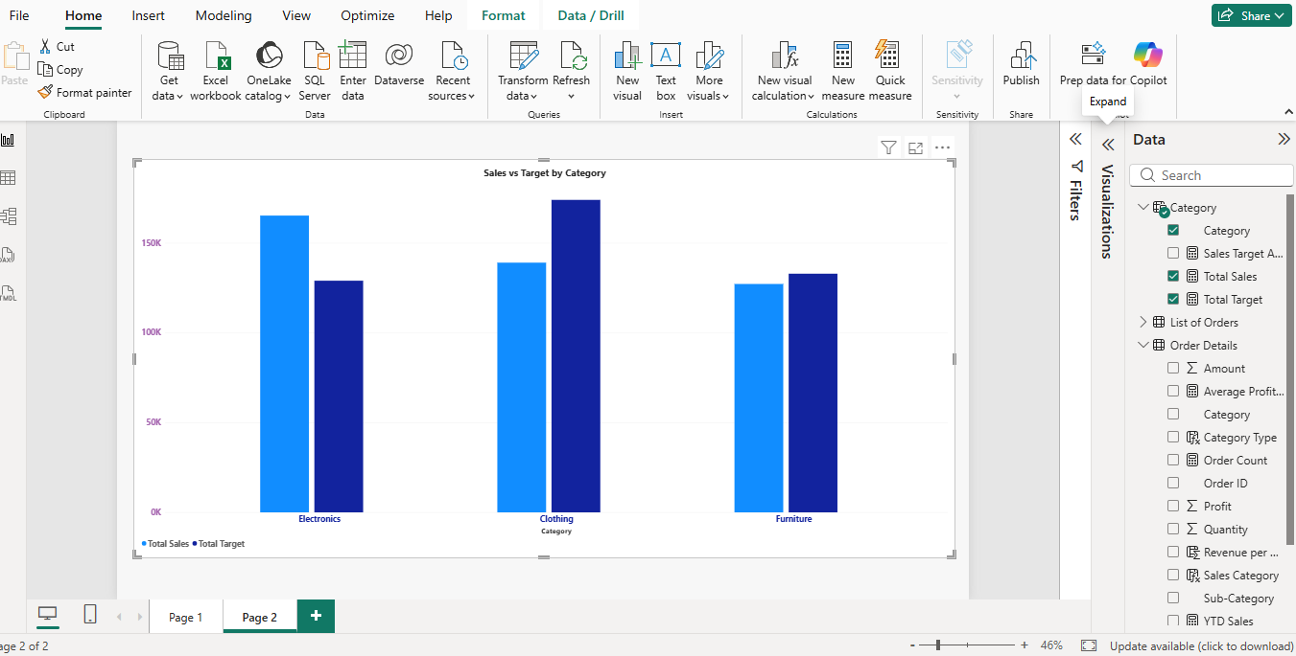

08 Profit margin by sub category
Max Profit Margin by Sub-Category: Analyze the maximum profit margin for each sub-category of products using a donut chart.
Implementation The donut chart displays the sub-category profit margin comparison.
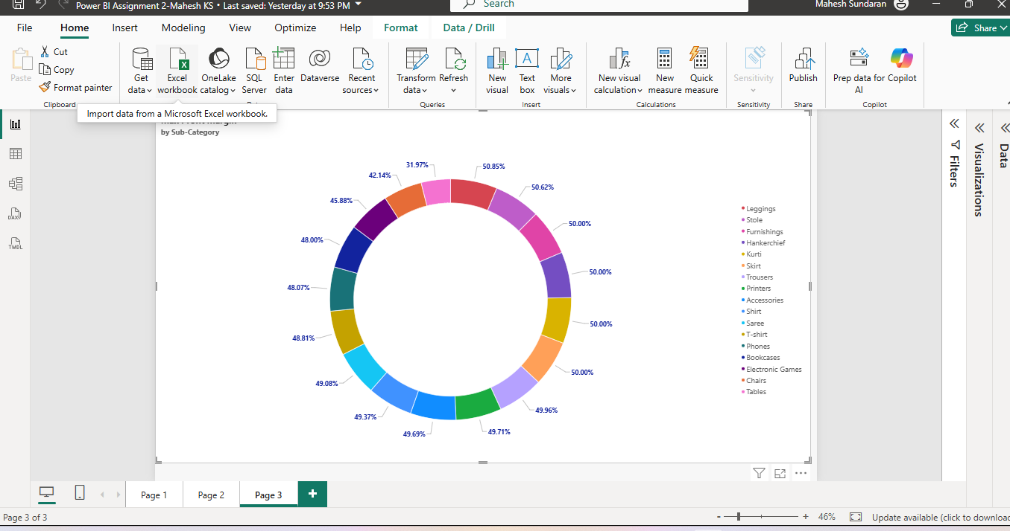

09 Monthly sales trend
Monthly Sales Trend: Show the trend of monthly sales over time using a line chart.
Implementation The line chart displays how monthly sales change over time.
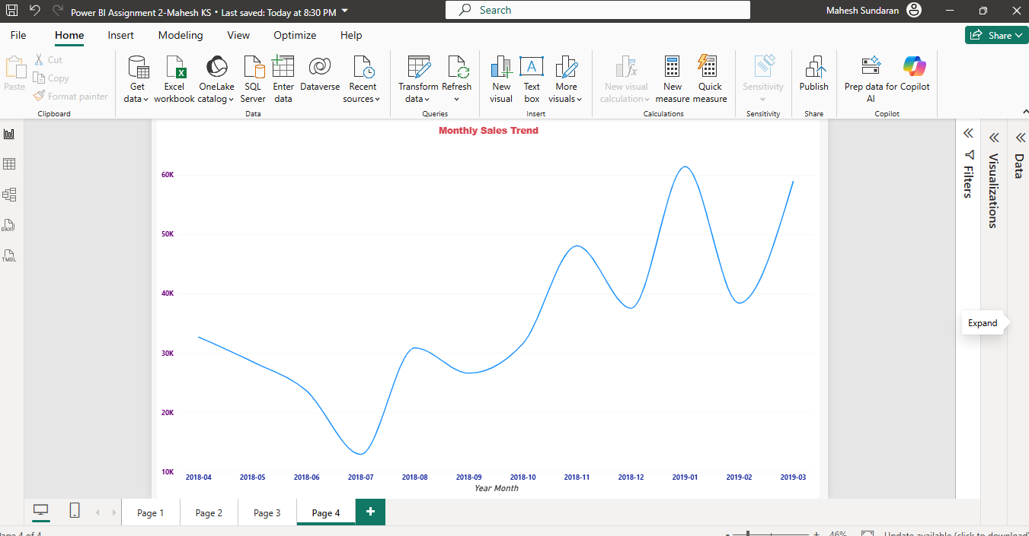

10 Profit and quantity scatter chart
Comparison of Profit and Quantity by Sub-Category: Compare the relationship between profit and quantity sold for different sub-categories using a scatter chart.
Implementation The scatter chart plots profit against quantity for sub-categories.
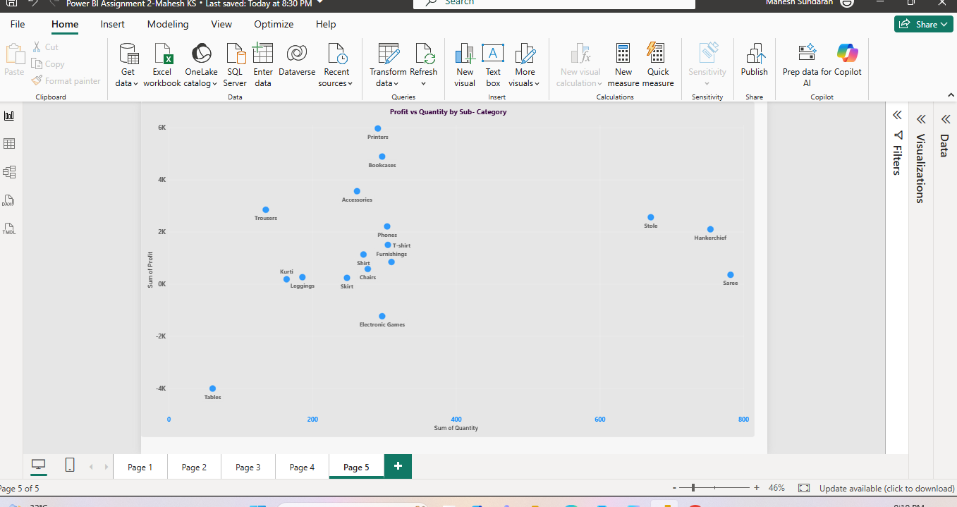

11 Sales and target cards
Comparison of Total Sales Amount and Target: Create cards to succinctly display the total sales amount alongside the sales target for quick comparison and analysis. Also, create a multi-row card to display the minimum target for each segment.
Implementation Two cards show total sales and target; the multi-row card shows minimum targets by category.
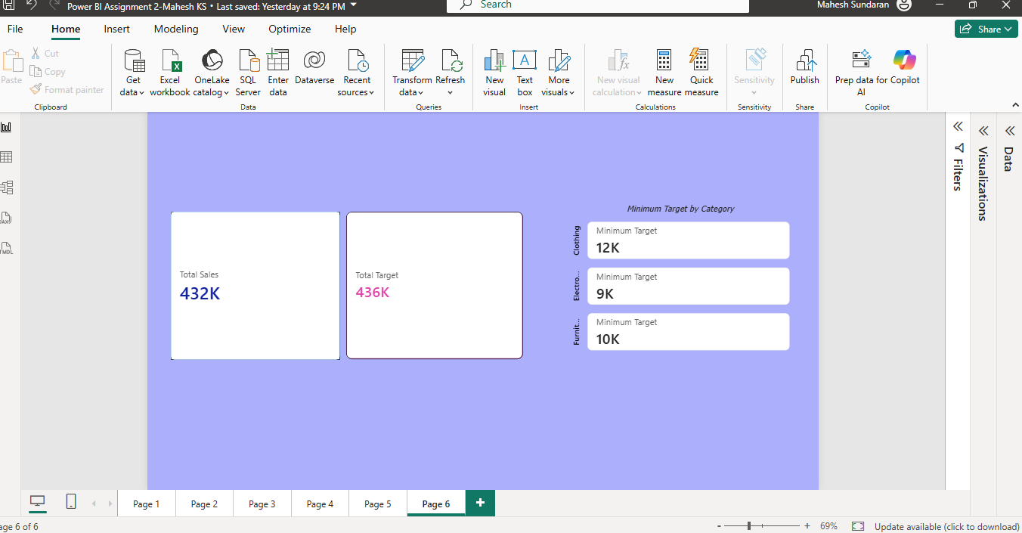

12 Sales performance matrix
Sales Performance Matrix: Build a matrix view to analyze how actual sales compare to sales targets across different categories and months.
Implementation The matrix shows actual sales against target by category and by year and month.
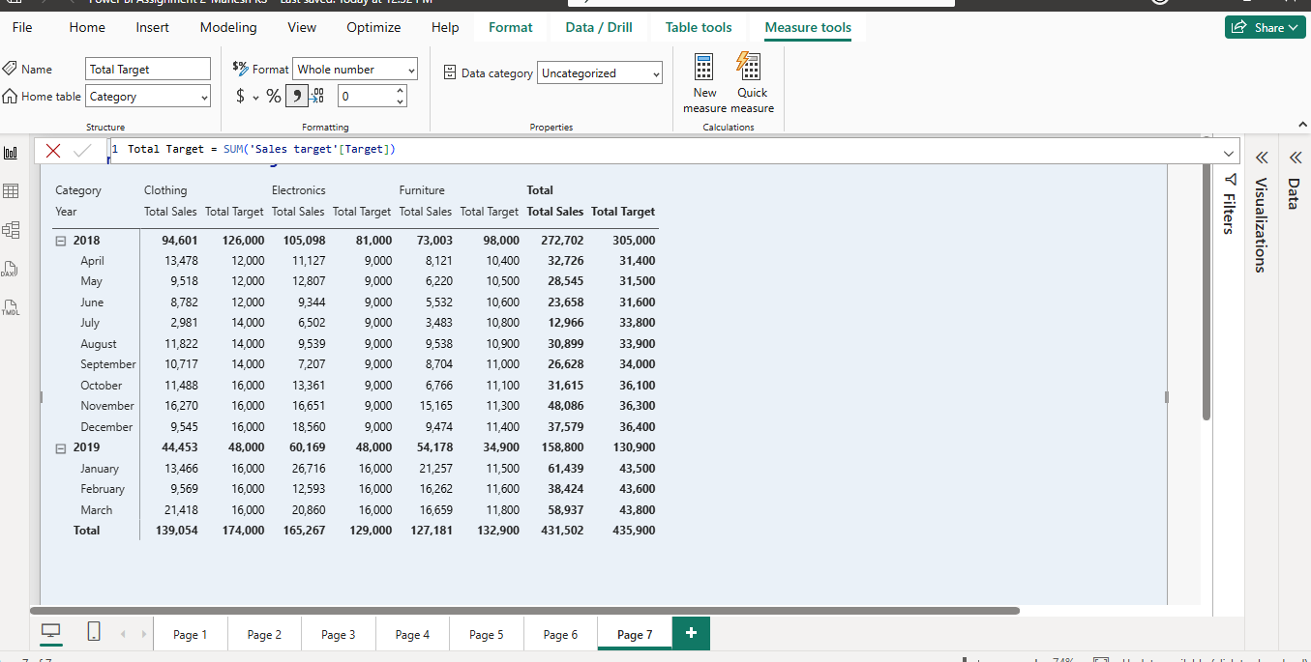

13 Geographic sales map
Geographic Sales Analysis: Visualize total sales on a map by city to identify regional sales patterns.
Implementation City and state are combined into a location field; bubble size represents total sales.
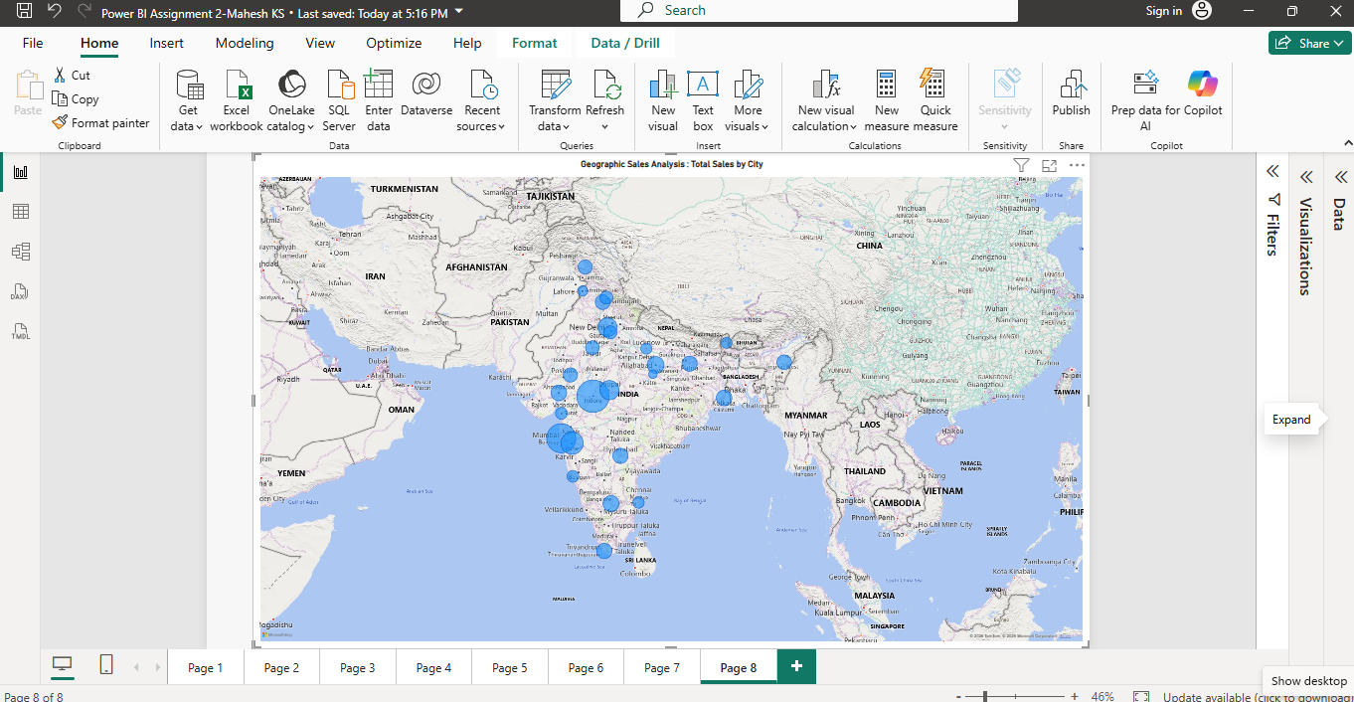

14 Sub category sales treemap
Sales Distribution by Sub-Category: Represent the sales distribution across different sub-categories using a treemap.
Implementation The treemap groups sales by Category Type, with rectangle area representing total sales.
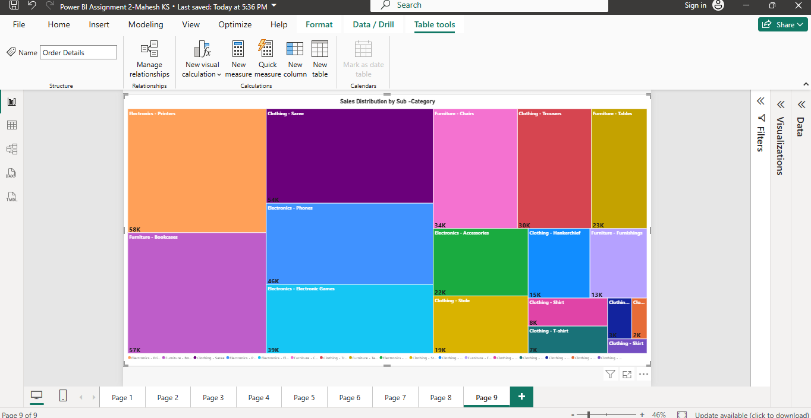

15 Orders by state funnel
Order Count Analysis by State: Create a funnel chart to visualize the distribution of order counts across different states.
Implementation The funnel ranks states by Order Count. State is the category and Order Count is the value.
