**Collecting Information About Computers.**

Cmdlets from CimCmdlets module are the most important cmdlets for general system management tasks. All critical subsystem settings are exposed through WMI. Furthermore, WMI treats data as objects that are in collections of one or more items. Because Windows PowerShell also works with objects and has a pipeline that allows you to treat single or multiple objects in the same way, generic WMI access allows you to perform some advanced tasks with very little work.

**Listing Desktop Settings**

We'll begin with a command that collects information about the desktops on the local computer.

PowerShellCopy

Get-CimInstance -ClassName Win32_Desktop

Because most of these metadata properties have names that begin with Cim, you can filter the properties using Select-Object. Specify the -ExcludeProperty parameter with "Cim*" as the value. For example:

PowerShellCopy

Get-CimInstance -ClassName Win32_Desktop | Select-Object -ExcludeProperty "CIM*"

To filter out the metadata, use a pipeline operator (|) to send the results of the Get-CimInstance command to Select-Object -ExcludeProperty "CIM*"

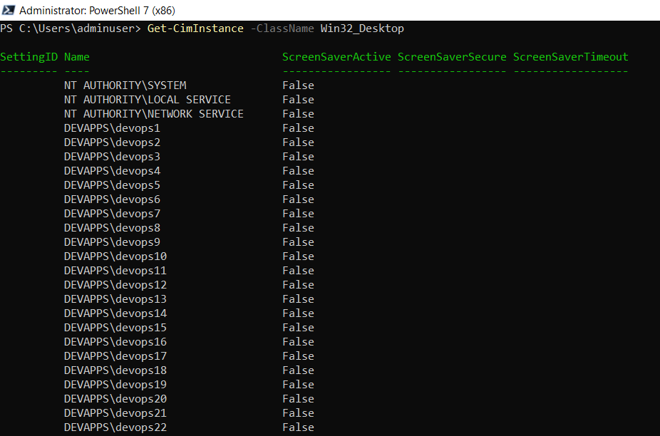

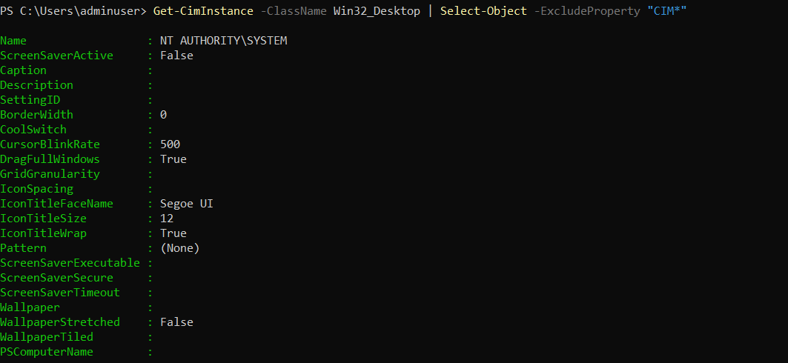

**Listing BIOS Information**

The WMI Win32_BIOS class returns fairly compact and complete information about the system BIOS on the local computer:

PowerShellCopy

Get-CimInstance -ClassName Win32_BIOS

**Listing Processor Information**

You can retrieve general processor information by using WMI's Win32_Processor class, although you will likely want to filter the information:

PowerShellCopy

Get-CimInstance -ClassName Win32_Processor | Select-Object -ExcludeProperty "CIM*"

For a generic description string of the processor family, you can just return the SystemType property:

PowerShellCopy

Get-CimInstance -ClassName Win32_ComputerSystem | Select-Object -Property SystemType

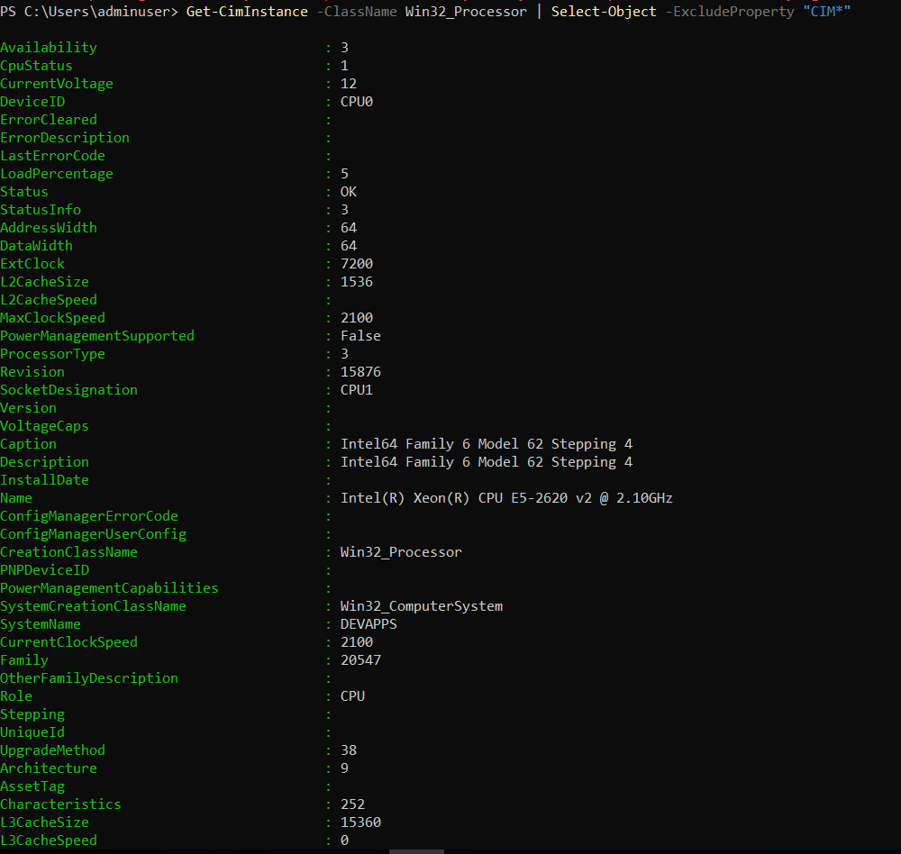

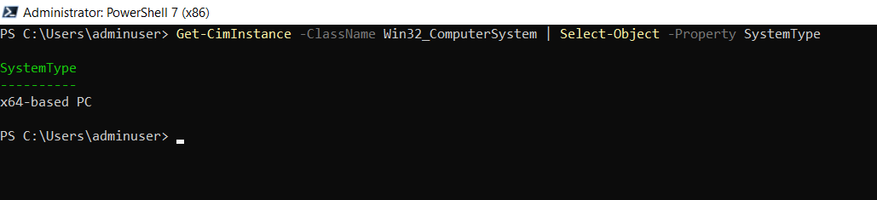

**Listing Computer Manufacturer and Model**

Computer model information is also available from Win32_ComputerSystem. The standard displayed output will not need any filtering to provide OEM data:

PowerShellCopy

Get-CimInstance -ClassName Win32_ComputerSystem

Your output from commands such as this, which return information directly from some hardware, is only as good as the data you have. Some information is not correctly configured by hardware manufacturers and may therefore be unavailable.

**Listing Installed Hotfixes**

You can list all installed hotfixes by using Win32_QuickFixEngineering:

PowerShellCopy

Get-CimInstance -ClassName Win32_QuickFixEngineering

For more succinct output, you may want to exclude some properties. Although you can use the GetCimInstance's Property parameter to choose only the HotFixID, doing so will actually return more information, because all the metadata is displayed by default:

PowerShellCopy

Get-CimInstance -ClassName Win32_QuickFixEngineering -Property HotFixID

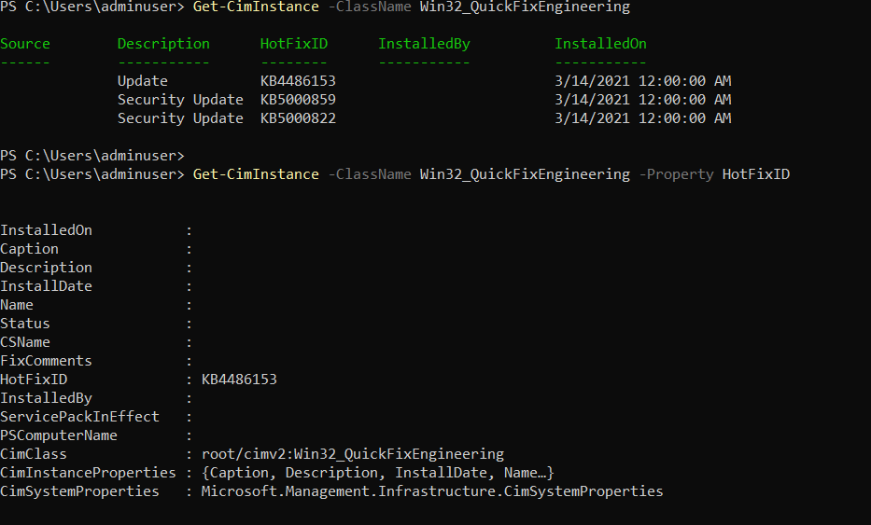

The additional data is returned, because the Property parameter in Get-CimInstance restricts the properties returned from WMI class instances, not the object returned to PowerShell. To reduce the output, use Select-Object:

**Listing Operating System Version Information**

The Win32_OperatingSystem class properties include version and service pack information. You can explicitly select only these properties to get a version information summary from Win32_OperatingSystem:

PowerShellCopy

Get-CimInstance -ClassName Win32_OperatingSystem |

Select-Object -Property BuildNumber,BuildType,OSType,ServicePackMajorVersion,ServicePackMinorVersion

You can also use wildcards with the Select-Object's Property parameter. Because all the properties beginning with either Build or ServicePack are important to use here, we can shorten this to the following form:

PowerShellCopy

Get-CimInstance -ClassName Win32_OperatingSystem | Select-Object -Property Build*,OSType,ServicePack*

OutputCopy

BuildNumber : 18362

BuildType : Multiprocessor Free

OSType : 18

ServicePackMajorVersion : 0

ServicePackMinorVersion : 0

**Listing Local Users and Owner**

Local general user information — number of licensed users, current number of users, and owner name — can be found with a selection of Win32_OperatingSystem class properties. You can explicitly select the properties to display like this:

PowerShellCopy

Get-CimInstance -ClassName Win32_OperatingSystem |

Select-Object -Property NumberOfLicensedUsers,NumberOfUsers,RegisteredUser

A more succinct version using wildcards is:

PowerShellCopy

Get-CimInstance -ClassName Win32_OperatingSystem | Select-Object -Property *user*

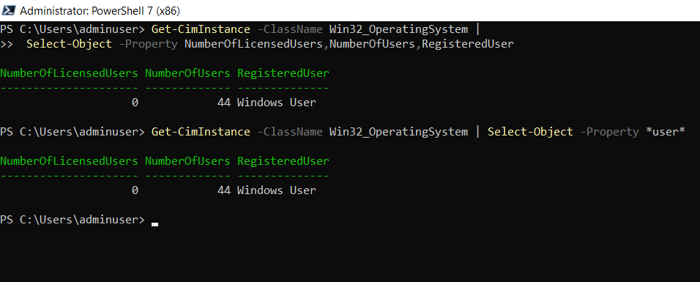

**Getting Available Disk Space**

To see the disk space and free space for local drives, you can use the Win32_LogicalDisk WMI class. You need to see only instances with a DriveType of 3 — the value WMI uses for fixed hard disks.

PowerShellCopy

Get-CimInstance -ClassName Win32_LogicalDisk -Filter "DriveType=3"

PowerShellCopy

Get-CimInstance -ClassName Win32_LogicalDisk -Filter "DriveType=3" |

Measure-Object -Property FreeSpace,Size -Sum |

Select-Object -Property Property,Sum

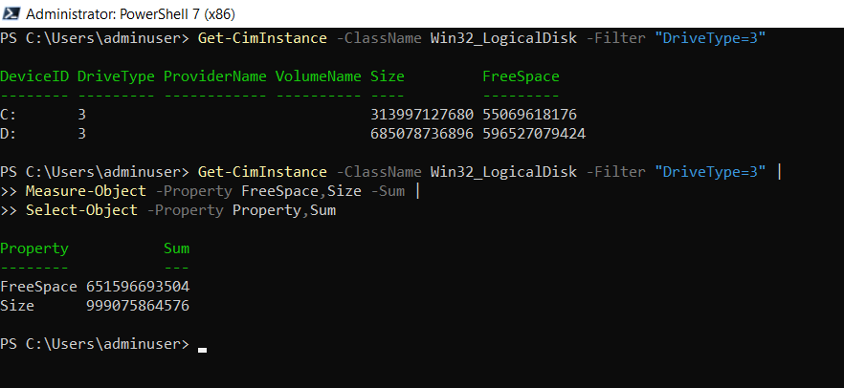

**Getting Logon Session Information**

You can get general information about logon sessions associated with users through the Win32_LogonSession WMI class:

PowerShellCopy

Get-CimInstance -ClassName Win32_LogonSession

**Getting the User Logged on to a Computer**

You can display the user logged on to a particular computer system using Win32_ComputerSystem. This command returns only the user logged on to the system desktop:

PowerShellCopy

Get-CimInstance -ClassName Win32_ComputerSystem -Property UserName

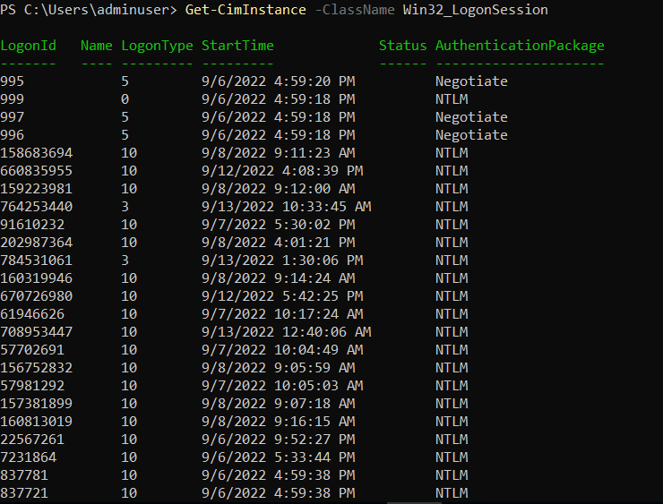

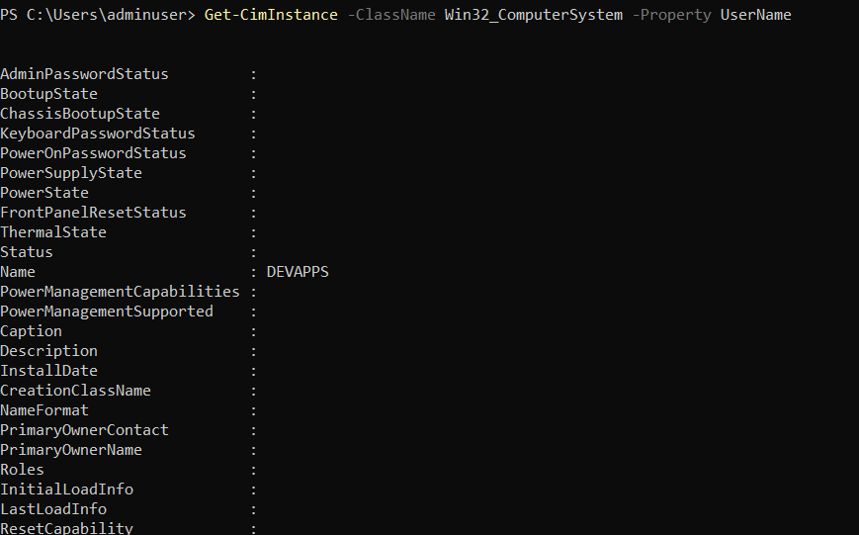

**Getting Local Time from a Computer**

You can retrieve the current local time on a specific computer by using the Win32_LocalTime WMI class. PowerShellCopy

Get-CimInstance -ClassName Win32_LocalTime

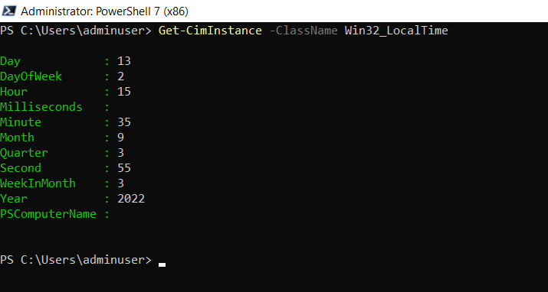

**Getting Local Time from a Computer**

You can retrieve the current local time on a specific computer by using the Win32_LocalTime WMI class

PowerShellCopy

Get-CimInstance -ClassName Win32_LocalTime

OutputCopy

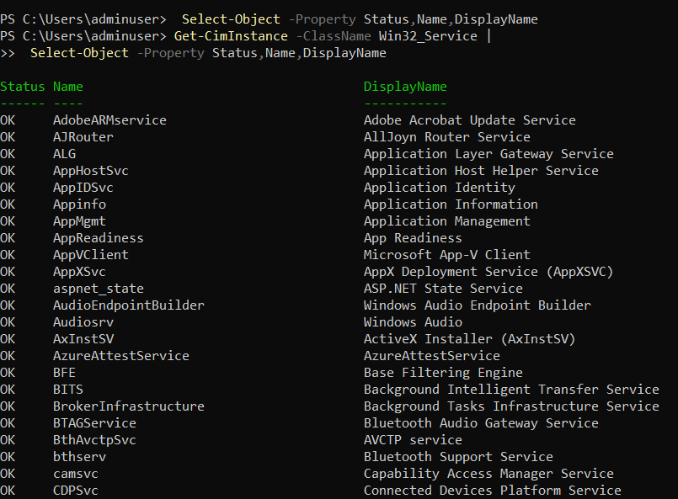

**Displaying Service Status**

To view the status of all services on a specific computer, you can locally use the Get-Service cmdlet. For

remote systems, you can use the Win32_Service WMI class. If you also use Select-Object to filter the

results to Status, Name, and DisplayName, the output format will be almost identical to that from GetService:

PowerShellCopy

Get-CimInstance -ClassName Win32_Service |

Select-Object -Property Status,Name,DisplayName

To allow the complete display of names for the occasional services with extremely long names, you may

want to use Format-Table with the AutoSize and Wrap parameters, to optimize column width and allow

long names to wrap instead of being truncated:

PowerShellCopy

Get-CimInstance -ClassName Win32_Service |

Format-Table -Property Status,Name,DisplayName -AutoSize –Wrap

