**Using Static Classes and Methods**

Not all .NET Framework classes can be created by using New-Object. For example, if you try to create a System.Environment or a System.Math object with New-Object, you will get the following error messages:

PowerShellCopy

New-Object System.Environment

PowerShellCopy

New-Object System.Math

OutputCopy

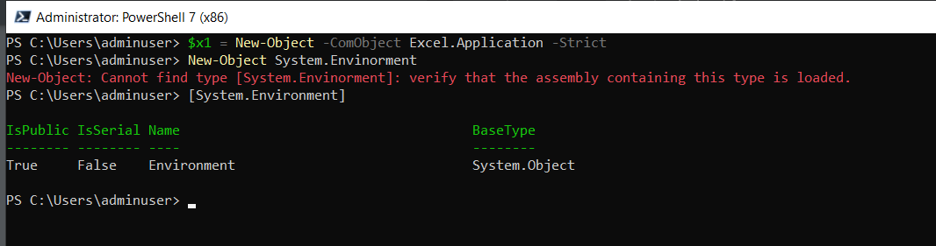

These errors occur because there is no way to create a new object from these classes. These classes are reference libraries of methods and properties that do not change state. You don't need to create them, you simply use them. Classes and methods such as these are called static classes because they are not created, destroyed, or changed. To make this clear we will provide examples that use static classes.

**Getting Environment Data with System.Environment**

Usually, the first step in working with an object in Windows PowerShell is to use Get-Member to find out what members it contains. With static classes, the process is a little different because the actual class is not an object.

**Referring to the Static System.Environment Class**

You can refer to a static class by surrounding the class name with square brackets. For example, you can refer to System.Environment by typing the name within brackets. Doing so displays some generic type information:

PowerShellCopy

[System.Environment]

As we mentioned previously, Windows PowerShell automatically prepends 'System.' to type names when you use New-Object. The same thing happens when using a bracketed type name, so you can specify [System.Environment] as [Environment].

The System.Environment class contains general information about the working environment for the current process, which is powershell.exe when working within Windows PowerShell.

If you try to view details of this class by typing [System.Environment] | Get-Member, the object type is reported as being System.RuntimeType , not System.Environment:

PowerShellCopy

[System.Environment] | Get-Member

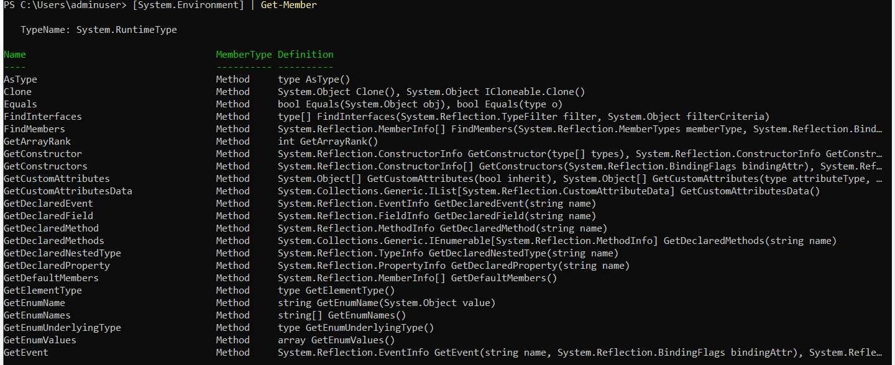

PowerShellCopy

[System.Environment] | Get-Member

To view static members with Get-Member, specify the Static parameter:

PowerShellCopy

[System.Environment] | Get-Member -Static OutputCopy

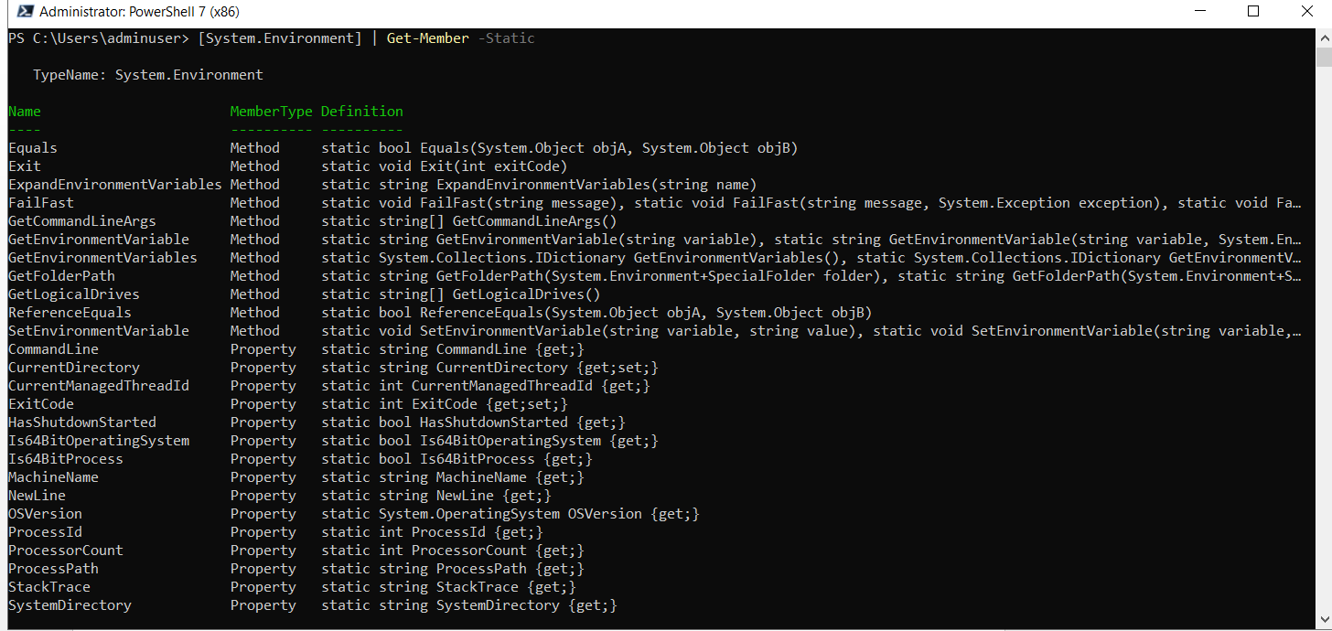

**Displaying Static Properties of System.Environment**

The properties of System.Environment are also static, and must be specified in a different way than normal properties. We use :: to indicate to Windows PowerShell that we want to work with a static method or property. To see the command that was used to launch Windows PowerShell, we check the CommandLine property by typing:

PowerShellCopy

[System.Environment]::Commandline

To check the operating system version, display the OSVersion property by typing:

PowerShellCopy

[System.Environment]::OSVersion

We can check whether the computer is in the process of shutting down by displaying the HasShutdownStarted property:

PowerShellCopy

[System.Environment]::HasShutdownStarted

OutputCopy

