Hotel Reservation System (HRS)

Final Project Report

CS5200: Database Project Design Report of HRS

April 2017

Authors: Dharshini - govindarajan.d@husky.neu.edu
Dipanjan - haldar.d@husky.neu.edu
Mahesh - bhaskaran.m@husky.neu.edu
Sanhita - bangaloresreeniva.s@husky.neu.edu
Contents
Abstract 2
Introduction 2
Requirements 3
Design 4
Implementation 4
Discussion (Some sample implementation of HRS functionality) 5
1.Booking a Room 5
2.Cancelling a Booking 6
3.Deletion of a Room 6
4.Adding a Room 7
5. Addition of a Customer 8
6.Addition of dishes into the Menu 8
Conclusion 8
References 9
Appendix A: Java classes 10
Appendix B: SQL tables 10
Appendix C: MYSQL Database table description 11

Abstract
The report provides a brief overview of the various aspects of HotelReservationSystem(HRS). It gives the information about the software’s used, different actors of the HRS and the key functionalities implemented. References to other project artifacts like the Use cases, UML diagrams, DB tables and Java classes used in the implementation of the project have been referenced/described in the report. In brief, this report acts as a concise document to cover the overall working functionality of the HRS

Introduction
The purpose of the project is to automate the cumbersome process of making a hotel reservation as well as the process of updating the hotel database with the available rooms and facilities. The project automates the following:

Operations performed by the System Administrator:
- Adding a room to the existing list of available rooms
- Deleting a room from the existing list of rooms
- Adding a customer
- Adding a food-item to the menu
Operations performed by a customer:
- Reserving a new room from the list of available rooms
- Cancelling an already booked room
- Querying information on an existing reservation
- Search Menu
- Food Ordering

Requirements
The requirements for the project are described in detail in the Use case description document.
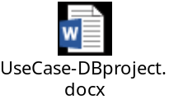

Software: MYSQL and Java 8

Design
Our basic approach for the project was to build a Hotel Reservation system which would make life easier for customer and Hotel administrator and get rid of the manual work. Our goal was to develop it with MySQL database and Java 8. We began the project by planning, design, and review of the requirements and use-cases, followed by the implementation of the requirements defined in the use-cases.

We developed seven new tables and designed the java code to interact with the database and perform the different operations as defined in the use-case description.

The following UML diagram represents the design:



Implementation
Programming language: Java 8
IDE: Eclipse Neon
Database: MySQL 5.7.1

A brief description of the JAVA artifacts is available in Appendix A
A brief description of the SQL tables is available in Appendix B
A brief description of the SQL table description is available in Appendix C

The detailed implementation artifacts are submitted as part of Project implementation.

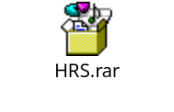

Discussion (Some sample implementation of HRS functionality)
The Project aims at the different aspects involved in a Hotel Reservation System. Some of them are:
- Booking a Room
- Cancelling a Booking
- Deletion of a Room
- Adding a Room
- Addition of a Customer
- Addition of dishes into the Menu
- Check-in
- Check-out
- Search Menu
- Viewing booking details.

A sample representation of few functionalities is given below:

1.Booking a Room

- Description: This allows the Customer to book a room specifying the check-in and check-out date.
- Required fields: Connection connection, int custid, Date startDate,
    - Date endDate, String roomType, float payment
- Command: hrs.bookRoom(connection, 1, Date.valueOf("2017-05-13"),Date.valueOf("2017-05-21"), "deluxe", 10);

- Result:

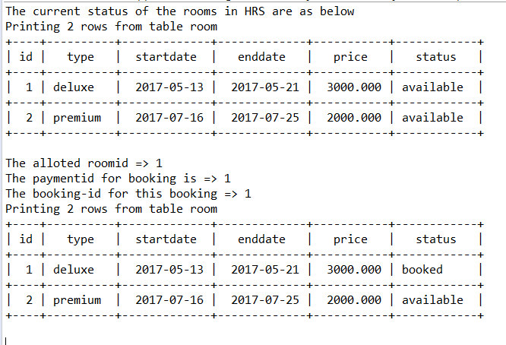

2.Cancelling a Booking
- Description: This allows the Customer cancel the room that he/she had booked earlier.
- Required fields: Connection connection, int custid, int bookingid
- Command: hrs.cancelBooking(connection, 1, 1);
- Result:
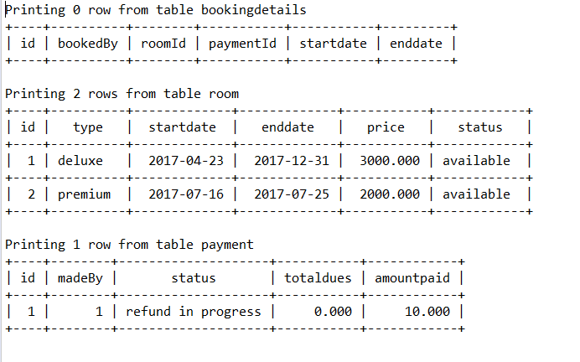

3.Deletion of a Room

- Description: This allows the Admin to delete the room from the database
- Required fields: Connection connection, int roomid
- Command: hrs.deleteRoom(connection,1);
- Result:

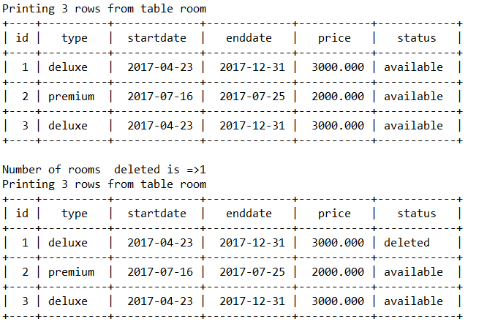

4.Adding a Room
Description: This allows the Admin to add a room to the database
Required fields: Connection connection, String roomType,
float roomprice
Command: hrs.addRoom(connection, "deluxe", 3000);
Result:

5. Addition of a Customer
- Description: This allows the Admin to add a new customer to the database
- Required fields: Connection connection, String name, String email,int age
- Command: hrs.addCustomer(connection, "Mary", "Mary@yahoo.com", 25);
- Result:

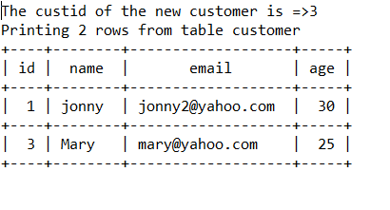

6.Addition of dishes into the Menu
- Description: This allows the Admin to add a new customer to the database
- Required fields: Connection connection, String description
- Command: rs.createMenu(connection,"hotdog");
- Result:

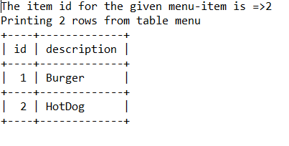

Conclusion
The current implementation achieved the goal of building a hotel reservation system which caters to the need of the customer and Hotel administrator in performing their tasks without much manual intervention. We are planning to extend the capabilities of the project by building a front-end portal which would make the implementation automated end to end.

References

Appendix A: Java classes

The Java Classes used in the HRS project are as given below:

- BookingDetails.java - This class provides the various fields to retrieve booking made by a customer.
- Customer.java - This class provides access to fields such as id, name, email and age of the customer.
- Foodorder.java - This class provides access to the fields such as order id and the customer id who ordered the dish.
- FoodOrderDetails.java - This class provides access to fields such as id, description of the food that has been ordered, quantity of food ordered by the Customer.
- HRS.java - This class consists of the main method and all the other methods which help in the functioning of the HRS.
- Menu.java- This class provides access to the id and description of the food items on the menu.
- Payment.java- This class provides access to the fields which gives the status of the payment, total due and amount paid by the customer.
- Room.java- This class provides access to the fields related to a room such as the start-date and end-date of the booking of a room. It also gives access to the price of the room, status of booking of the room and price of the room.

Appendix B: SQL tables

The database consists of seven tables. Appendix B shows the complete entity-relationship diagram

DATABASE TABLE | DESCRIPTION
Customer | Contains information about the customer’s information.
Room | Contains information about the different rooms in the hotel
Payment | Contains information about the payment made by customer problem
BookingInformation | Contain information about the customer booking record
Menu | Contain information about the food items available in the hotel
FoodOrder | Contains information about the food ordered by a customer
FoodOrderDeails | Contains information about the information of the food ordered by a customer

Appendix C: MYSQL Database table description

BookingDetails:
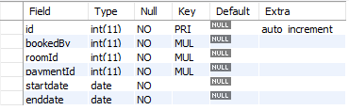
Customer:
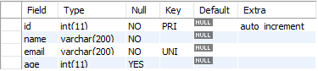
FoodOrder:
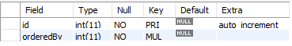
FoodOrderDetails:
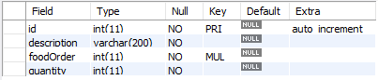
Room:
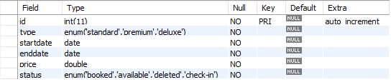
Payment:
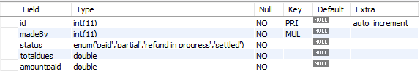
Menu:
