**  [](http://rdmservice.ru/news/)**

**PO BOX 1010, LIVERPOOL**

**L70 1NL, UNITED KINGDOM**

**EMAIL ID: samsunggalaxyaward@qq.com**

**CONTACT NUMBER: +448719747281,**

**WEB SITE//: www.samsung.com/music/en_Uk/125year/postlive.html?lang=en!**

**http://www.your3dsource.com/images/congratulationblueglow.gif**

**We are pleased to inform you that your email address has been awarded the sum of (500,000.00,GBP) Five Hundred Thousand Great Britain Pounds by Samsung Award Lottery United Kingdom. We have randomly selected 5 email addresses through a computer ballot system to receive an award of Five Thousand Great Britain Pounds (500,000.00GBP) each as a part of our 2016 email philanthropically winning promotion.**

**The 2016 Online Award was conducted from an exclusive list of over 305,000,000 e-mail addresses of individuals and cooperate bodies picked by an advanced automated random computer search machine. After the automated computer ballot system, your e-mail address emerged as one of the five lucky winners in the category ‘A’ with the following: Batch Number: Ccuk004412012 and Winning Number: Ccuk04567 which we would want you to re-confirm below as you reverse this email with the below claims information.**

**VERIFICATION AND FUNDS RELEASE FORM**

**KINDLY SEND YOUR DETAILS TO THIS EMAIL ID: (samsunginfoukawrad@qq.com ) FOR THE RELEASE OF YOUR FUND IN TIME**

**1. Full Name:**

**2. Full Address:**

**3. Occupation:**

**4. Age:**

**5. Sex:**

**6. Mobile Number:**

**7. State:**

**8. Country:**

**9 Winning Email:**

**10. Spoken Language:**

**PLEASE RE-COMFIRM YOUR WINNING DETAILS BELOW:**

**10. Batch No:**

**11. Winning No:**

**Above all, we urge you to send all the necessary details via:** **samsunginfoukawrad@qq.com to enable us expedites action towards the delivery/transfer of your entitled fund.**

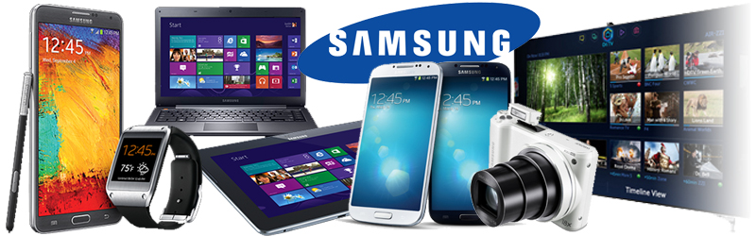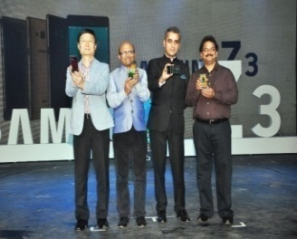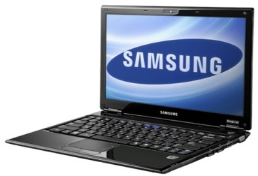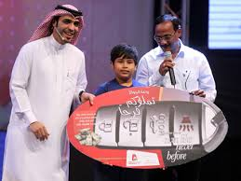

**DR HENRY KEN**

**EVENT – MANAGER**

**SAMSUNG MOBILE COMPANY**

**TEL: +448719747281**

**EMAIL: samsunginfoukawrad@qq.com [](http://www.androidbeat.com/2013/10/samsung-publishes-q3-results/)**