**ABSTRACT**

In any of the organization or enterprise, it is quite obvious to have certain management activities involved apart from its core work management. For example: Gardening, Vehicle Parking system, Employee Health management, Welfare Management, Cultural Events Management etc. One of the main area which is very much essential for any employee in organization is sports or extra-curricular activities. Any organization could be considered as incomplete without having sports activities or sports events being conducted. In order to manage or cope up things of all such sports related activity in organized way, we need to have well specialized tool. Without having any tool, management would become cumbersome and headache to control manually by any staff. Sports complex is one of the solution which solves this problem and helps any Sports admin staff or employees to manage their daily basis sports activities in organization. It includes intelligence to deduct any cost due for any activity to be tracked in payroll process also. We demonstrate how to apply the proposed tool to securely and efficiently manage all activities in single centralized tool for any organization.

**CONTENTS**

**CHAPTER: 1**

**INTRODUCTION**

* 1. **About Project**

Let us imagine a scenario where an Organization A has many sports activities like Gymnasium, Badminton Court, Billiard Court, Tournaments being conducted on occasionally, Indoor game activities etc. Let us say, to manage all these activities for employees there would be some Sports Admin staff. And also, let us assume, there would be some cost needs to be deducted from any employee using any of these activities. So staff admin has to manage ledger or paper records who has involved in which activity and he has to make an entry in ledger for all corresponding participation. Indeed for each module, he might needs to maintain separate list of entries or record. The same records has to be intervened and processed by Payroll team on every month to deduct respective resource usages by any employee. Though it can be done in small or minor organization which contains very few employees, imagine a very big organization containing thousands of employees and maintaining record on every resource and same being processed by payroll team is not at all a feasible task.

Secondly, if employer size is big, it is very difficult to maintain the rush of employees on any resource usage. For example: In organization A, let us say badminton court is bookable only between specified timings in a day. In order to book that resource, there could be huge queue or rush by any employee. And also any employee E will not get to know that if any resource is being already booked by any other employee unless that employee E contacts Site Admin. And all these activities will be bottleneck to manage for any sports admin staff all the time.

With manual management process, it is also difficult to take a report on monthly or dates range basis in order to track total income or maintenance cost. It involves manual calculation of cost and intervention.

So the described problem can be solved by having centralized internet/intranet application which manages all activities in simple and organized manner. The main advantage of having such online tool is, it reduces manual intervention and ease by performing all automatic calculation and report generation. It also gives live feedback to users on which resource has been booked by which user. So that it may also reduce any employee contacting staff admin for booking.

We have named this online tool as **Sports Complex**, since it manages all activities being controlled or managed in any sports complex of any organization. The main idea for having this tool is to make all sports activity management to be available online and to make easy management of the same which reduces manual requirement.

The main feature it contains are: Resource Management (Badminton and Billiard), Gymnasium, and Tournament Management. Apart from these, it also report generation mechanism on monthly basis, it gives feedback immediately to payroll team via mail to deduct on any employee resource usage. It contains provision to view any NEWS or gallery photos being uploaded by Sports Admin.

Perhaps, with this tool end to end management of sports activities becomes systematic and ease to any organization. It makes management online, easily accessible to any employee and can be accessed from anywhere. Since it contains centralized database for all sports activities, any changes in system or information in database by admin will be rendered to all employees immediately via SPORTS COMPLEX tool.

* 1. **Company details**

C:\Mahesh\Others\Projects\SportsComplexProject\Git\sportscomplex\SportsComplex.Application\Images\logo_larsen_toubro.jpg

Larsen & Toubro Limited is an Indian largest engineering and construction company offering its hands in IT services, few hardware products and in many critical sectors like construction. Its headquarters is in Mumbai, Maharashtra, India. It was founded by Danish Engineers named Henning Holck Larsen and Soren Kristian Toubro. L&T has many major subsidiaries and joint ventures. Few are mentioned below.

* L& T Construction Equipment Limited
* L& T Technology Services (TS)
* L&T Finance
* L& T Metering & Protection System (MPS)
* L&T InfoTech etc.

L&T has its one of its campus in Mysore covering around 40 acres of industrial land. It has five modules which will work for different business units. The campus is ecofriendly and inherits many conservation principals like rain water harvesting, vermicomposting etc.

L&T Mysore houses L&T Technology Services (TS), Metering & Protection System (MPS) and L&T InfoTech. It also has very good and well maintained sports complex which contains Hi-Fi Gymnasiums, Football ground, Volleyball court, basketball court, badminton court, and many indoor game resources.

Hence, it is very much needed and appropriate to have our proposed system of online SPORTS COMPLEX tool to be leveraged in L&T Mysore campus.

**CHAPTER: 2**

**LITERATURE SURVEY**

1. **Existing System and Proposed System:**
2. **Existing System:**

Manual process of management and intervention is one of the mechanism where sports admin staff all activities and records in bundle of paper records. Any employee who needs participation on any sports activity needs to contact Sports admin staff and register every time.

L&T has its intranet website which contains management activities in one site. Employee who wants to participate in any of the activity has to login to that intranet site and navigates to respective module and register.

1. **Disadvantages of existing system:**

There are many disadvantages in existing system. Few points are mentioned below,

* In manual management process, people or resource management would become overhead for sports admin.
* Manual calculations are more prone to error.
* Paper record maintenance is not an efficient management.
* Time consuming process and could cause queue on limited resource booking activities.
* Payroll team has to go through all paper records every month to deduct amount for employee resource usage.
* Existing Intranet site may give unwanted information to end user which he doesn’t want to know or navigate through.
* Intranet Site is integrated with too many management modules and there is no isolated tool for sports activities management which can be managed by sports admin.
* No centralized database for sports management alone and maintenance depends on intranet site.
* Live feedback is not available by end user to administrators and payroll team.
* Report generation could be an issue in manual process of management.

1. **Proposed System:**

SportsComplex being an online intranet tool which manages all activities being controlled or managed in any sports complex of any organization. It provides efficient online solution to the end user who wants to utilize sports resource in any organization. It makes administrators and payroll staff jobs easier and precise reducing error introductions. In this tool, we can have isolated centralized database which can be maintained separately by sports administrator alone. End user need not have to visit any other info or navigate away. Website maintenance can be done by administrator regardless of other portal maintenance. It makes end user to book resources and report generation easily available at his hand tips. Moreover, we can have more user friendly website which will give an end user a very good user experience which will in turn induces him to utilize the resource more often.

The main feature it contains are: Resource Management (Badminton and Billiard), Gymnasium, and Tournament Management. Apart from these, it also report generation mechanism on monthly basis, it gives feedback immediately to payroll team via mail to deduct on any employee resource usage. It contains provision to view any NEWS or gallery photos being uploaded by Sports Admin.

1. **Advantages of proposed system:**

Leveraging proposed system will have many advantages over traditional management system. Few points are mentioned below.

* Since all resource management is online, there will not be any overhead for sports admin.
* Calculations will be more precise and correct since it is done by tool and with no manual calculation.
* Removal of paper usages.
* No rush for booking limited resource activities.
* Automatic feedback goes to payroll team by which there work is reduced for every month’s employee payroll update.
* It provides more precise, only necessary and specific information to end user.
* Isolated intranet website which is meant only for sports activities.
* Provides centralized database which can be maintained by Sports administrator alone.
* Live feedback is available to end user, administrators and as well as payroll team.
* Report generation is automatic and provides feasibility to generate report monthly basis or date ranges.

1. **Feasibility Study:**

On any project cycle, it is very much necessary to do feasibility study which gives more information on Risks, Cost Estimation and Time Estimation of a project. By doing so, we can actually derive at set of actions which can be taken on early stages of project implementation. This will reduce any risk or impact that can happen at later stages of the project cycle. Mainly, we will perform these studies in three perspectives. They are mentioned and briefed as below:

* ECONOMICAL FEASIBILITY
* TECHNICAL FEASIBILITY
* SOCIAL FEASIBILITY
  + 1. **Economical Feasibility:**

Here, we analyze where is the need of financial account and how efficient will it become on leveraging the product. Since it’s a website development, it doesn’t involve any hardware costs but it requires some development software’s or IDE for implementation. Once its deployment is done, it will actually improves financial level of organization in some way in small manner if not in large quantity. Because, it reduces manual efforts in managing and maintaining sports resource which in turn increase organizations savings or turn over we can say,

* + 1. **Technical Feasibility:**

Looking into technical aspects involved in the project, it makes implementation in cleaner way. Since there are wide and more technologies available to do website development, it makes more feasible to develop a website. In fact, many tools are readily available which can be made use in project cycle to ease our implementation phase of project cycle. One good example for that, is using Resharper along with Visual Studio integration which will help in code refactoring and reducing bugs.

* + 1. **Social Feasibility:**

Though it’s an intranet website, we need to have a look at social vulnerable and loop poles which can incur if we don’t secure employee or resource information to the outside world. We need to think of risky cyber-attacks or hacks that can happen via social media websites like Facebook, Twitter etc., which will lead in loss of organization data at last. We need to put proper authentication and authorization in place to avoid those kind of attacks from outside world. But having said that, we should not make things more complex for the end user as well. At the end of the day, any end user using our SPORTS COMPLEX website should feel our site as easier as any of other social media websites.

1. **Tools and Technologies used:**
   * 1. **Tool Used:**

Below are the tools used for software implementation,

* Visual Studio IDE 2013
* Resharper 10.0.1
* SQL Management Studio 2008
  + 1. **Technologies Used:**

Listed are the technologies used for website development,

* .Net Framework 4.5
* ASP.NET MVC Architecture
* C# Language
* SQL Server Query

1. **Hardware and Software Requirements:**
   * 1. **Hardware Requirements:**

System : Pentium IV 2.4 GHz or above

Hard disk : Minimum 40GB or above

RAM : 2GB or above

* + 1. **Software Requirements:**

Operating System : Windows XP or above

Coding Language : C#. Net

Coding IDE : Visual Studio 2013 (with Resharper integration)

Database Server : MS SQL Server 2008

Database Tool : MS SQL Management Studio

Browser : Google Chrome (Recommended)

**CHAPTER: 3**

**SOFTWARE REQUIREMENTS SPECIFICATION**

* 1. **Users:**

In Sports complex, users are mainly handled in two roles. Each role has different privileges and access to different modules. Those roles are,

* Employee
* Admin

Any end user who registers in SPORTS COMPLEX module is considered as Employee by default.

EMPLOYEE:

Any employee who logins to the sports complex can book resource for usage, joins for Gymnasium and enroll himself for tournament. And also he can see monthly report which gives him a summary of all his activities on that month.

ADMIN:

Admin is the one who has full control on SPORTS COMPLEX software. He can book resource or gymnasium for other employees using employees PS Number. He can also add new tournaments and set priority for the same. Admin has privilege to add and delete images to gallery. He can also manages NEWS which will be displayed to all users on home screen of application.

* 1. **Functional requirements:**

In any application, functional requirements are listed down to track all major features are being implemented on development phase. It is also helpful for testers to verify features. It gives everyone a clear view of features contained in any of the application.

In our documentation, we are going to specify every functionality contained in our proposed system with success scenario and verification criteria. So that any developer on implementing any of the feature can verify all scenarios being mentioned here for each use case. And also we are segregating requirements into 3 sets based on user roles:

* GENERAL (for everyone)
* EMPLOYEE
* ADMIN

|  |  |  |  |  |
| --- | --- | --- | --- | --- |
| **SI No** | **Name** | **Description** | **Success Scenario** | **Verification Criteria** |
| 1 | New User Registration | Any new user or employee in an organization shall be able to register in SPORTS COMPLEX website | User should be registered and should be able to login using credential | 1. If new user, user should be registered successfully. 2. If user already exists with same PS Number, it should show error on registration. 3. If some mandatory fields are missing, it should proper error message. |
| 2 | User Login | Any registered user shall be able to login to SPORTS COMPLEX application using his credentials | User should be able to login to application and access his modules | 1. If PS number and password is proper, user should be taken to home page where he can see his accessible modules 2. If PS number and password does not match, proper error message should be thrown back. 3. Any unregistered user shouldn’t be able to login |
| 3 | Search Employee | Any end user shall be able to search any registered employees in SPORTS COMPLEX application | List of users matching search criteria should be displayed | 1. If search criteria doesn’t match any user’s data, it should display empty list 2. If search criteria matching any employees data, those data should be displayed |
| 4 | Gallery | Any end user shall be able to see gallery images on home page of SPORTS COMPLEX application | Any end user should be able to see gallery images on home page of SPORTS COMPLEX application | 1. If any images, user should be able to see 2. If no images, user should see proper info |
| 5 | News | Any end user shall be able to see NEWS on home page of SPORTS COMPLEX application | Any end user should be able to see NEWS on home page of SPORTS COMPLEX application | 1. If any news, user should be able to see 2. If no news, user should see proper info |

|  |  |  |  |  |
| --- | --- | --- | --- | --- |
| **SI No** | **Name** | **Description** | **Success Scenario** | **Verification Criteria** |
| 1 | Employee Home Page | Any registered user on login, shall be able to see EMPLOYEE MODULES | Any registered user on login, should be able to see EMPLOYEE MODULES( Resource booking, Gymnasium, Tournament Booking and My Charges) | 1. On employee login, he should be able to see home page with employee module options. 2. If he is not of employee role, he should not be able to see employee modules |
| 2 | Employee Resource Booking | Any Employee booking any resource (Badminton or Billiards) shall be booked for that day and amount shall be deducted from his payroll package | Any Employee booking any resource (Badminton or Billiards) should be booked for that day and amount should be deducted from his payroll package. Mail should be sent to both employee and payroll team. | 1. If resource is already booked on any slot, it shouldn’t be able to book the same slot for any other employee 2. If slot is available, employee should be able to book. |
| 3 | Gymnasium | Any employee joining Gym data shall be shown in Gymnasium module. An option shall be provided to Leave for already Joined employee and vice versa. On any action, mail shall be sent to employee and payroll team. | Any employee joining Gym data should be shown in Gymnasium module. An option should be provided to Leave for already Joined employee and vice versa. On any action, mail should be sent to employee and payroll team. | 1. User who has already joined should see only Leave option 2. User who has not joined or left should see Join option. |
| 4 | Tournament Booking | Any employee shall be able enroll to any of the tournament once. | Any employee should be able enroll to any of the tournament once. | 1. User who has already enrolled should not be able to enroll again. 2. User who has not enrolled can enroll to any active tournaments, |
| 5 | My Charges | Any employee shall be able to generate a report of his charge deduction on monthly basis. Also he shall download the same generated report into CSV file | Any employee should be able to generate a report of his charge deduction on monthly basis. Also he should download the same generated report into CSV file | 1. User who has done some activities in SPORTS COMPLEX should be able to see list of his charges on that particular month 2. User who doesn’t have any activities, on report generation it should populate empty list. |

|  |  |  |  |  |
| --- | --- | --- | --- | --- |
| **SI No** | **Name** | **Description** | **Success Scenario** | **Verification Criteria** |
| 1 | Admin Home Page | Any admin user on login, shall be able to see ADMIN MODULES | Any admin user on login, should be able to see ADMIN MODULES( Resource booking, Gymnasium, Tournament Booking, Gallery, Manage News and Sports Report) | 1. On admin login, he should be able to see home page with admin module options. 2. If he is not of admin role, he should not be able to see admin modules |
| 2 | Admin Resource Booking | Any admin booking a resource (Badminton or Billiards) for any other employee shall be booked for that employee, for that day and amount shall be deducted from his payroll package | Any admin booking a resource (Badminton or Billiards) for any other employee should be booked for that employee, for that day and amount shall be deducted from his payroll package | 1. If resource is already booked on any slot, it shouldn’t be able to book the same slot for any other employee 2. If slot is available, admin should be able to book for other employees, |
| 3 | Gymnasium | Any admin shall make other employee to join to Gym. An option shall be provided to Leave for already Joined employee and vice versa. On any action, mail shall be sent to employee and payroll team. | Any admin should make other employee to join to Gym. An option shall be provided to Leave for already Joined employee and vice versa. On any action, mail shall be sent to employee and payroll team. | 1. User who has already joined should see only Leave option for admin Gym page 2. User who has not joined or left should see Join option for admin Gym page |
| 4 | Tournament Booking | Admin shall be able to add and delete tournament | Admin should be able to add and delete tournament | 1. Admin should be able to add new tournament 2. Admin should be able to delete existing tournament |
| 5 | Gallery | Admin shall be able to add and delete images to gallery | Admin should be able to add and delete images to gallery | 1. Admin should be able to add new images to gallery 2. Admin should be able to delete existing images in gallery |
| 6 | News | Admin shall be able to add and delete news | Admin should be able to add and delete news | 1. Admin should be able to add news 2. Admin should be able to delete news |
| 7 | Sports Report | Any admin shall be able to generate a report of all employee charge deduction on monthly basis. Also he shall download the same generated report into CSV file | Any admin should be able to generate a report of all employee charge deduction on monthly basis. Also he shall download the same generated report into CSV file | 1. All employees who has done some activities in SPORTS COMPLEX should be able to see list of All charges on that particular month by admin 2. Any employees who doesn’t have any activities, on report generation it should populate empty list. |

* 1. **Non-functional requirements:**

Nonfunctional requirements are those requirements which are not of any features, but is very much essential to make any feature complete. Accomplishing these requirements ensures that application handles all kind of usable scenarios. Below are few NFR’s captured for SPORTS COMPLEX application.

|  |  |  |
| --- | --- | --- |
| **SI No** | **Name** | **Description** |
| 1 | Number of users | Minimum of 2000 employees shall be able to use SPORTS COMPLEX application seamlessly. |
| 2 | Error handling | Any error on server should be handled by application and appropriate message shall be given to end user |
| 3 | Ease of use | Application should render proper information to the end user to use, There shall not be any complicated operations or actions. |
| 4 | Ease of use | Application should render proper information to the end user to use, There shall not be any complicated operations or actions. |
| 5 | Performance | Any action shall be happened at possible efficient time span |
| 6 | Logging | All actions shall be logged to debug at any point of time if any issues occurs |
| 7 | Data security | Since it contains very sensitive data of employees and organization, it is very much essential to have secured database |

**CHAPTER: 4**

**SYSTEM DESIGN**

* 1. **System perspective:**

For any problem statement in this world, there would be some or the other view or analysis which gives solution for that problem. To find a solution, primary thing is to visualize things as system. In this section, we will see how our proposed method can be treated as a system which gives efficient problem solving mechanism for any organization which needs sports management.

Firstly, SPORTS COMPLEX is not just an application which can be used solely via any browser and having some bandwidth in internet. It gives entire sports activities to be managed in systematic way. For example: deduction of money from payroll directly on enrolling to tournament or booking for any resource provides extension of management till finance level. So we can easily say that, our proposed system does manages all activities to its completeness and hence we can view our application as SYSTEM.

* 1. **Context diagram:**

For any application, it is very much essential to view our all parts of system in one single diagram which provides a high level relationship idea on components and entities. It can also be represented using block diagram.

Below is the context diagram for SPORTS COMPLEX which is a simple management system for sports activities in any organization.

* 1. **High level architecture:**

SPORTS COMPLEX application is a web application developed using ASP (Active Server Page) DOT NET framework 4.5. It uses MVC (Model-View-Controller) architecture which is 3 tier architecture. We have developed this application using MVC 5 with razor engine. For server coding it using C# (C Sharp) language.

MVC is 3-tier architecture. It stands for Model, View and Controller.

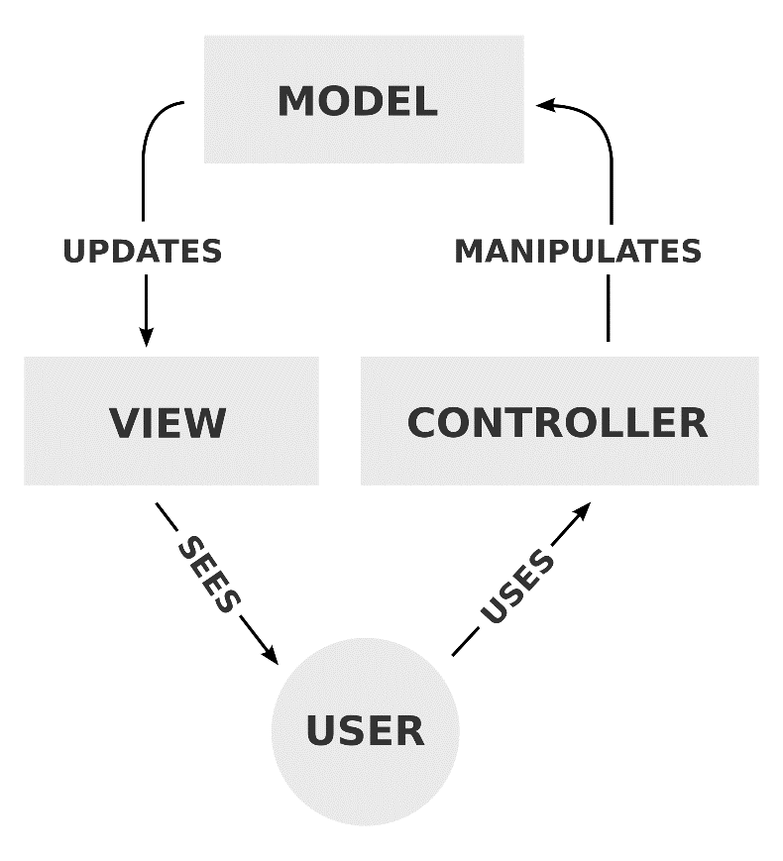

1. View: It’s a front end Graphical User Interface (GUI) which can be seen in browser when application URL is given. Those are just HTML pages which are being displayed based on server side manipulation. It contains CSS which is responsible for styling and JavaScript which is required for client side data manipulation and validation.
2. Controller: It is hitting point in MVC application since any requests by user via URL is redirected to Controller first. Controller decides which view it has to render in view and what business logic it has to manipulate. So all redirecting logic can be written in Controller.
3. Model: This layer contains DTO or model classes along with business logic where all our application server logic resides. This layer interacts with database to store and retrieve data. Ideally all business logic methods should be unit testable code.

**CHAPTER: 5**

**DETAILED DESIGN**

* 1. **Use Case Diagrams:**

Any application contains user actions in all operations. It is necessary to know user interactions with system which shows relationship between user and modules or use cases. These kind of relationship can easily be represented diagrammatically using USE CASE DIAGRAMS. Below are few use case diagrams of SPORTS COMPLEX application.

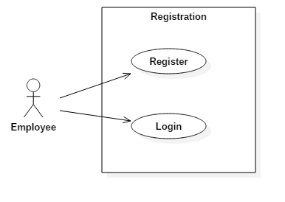

Use case diagram for Registration

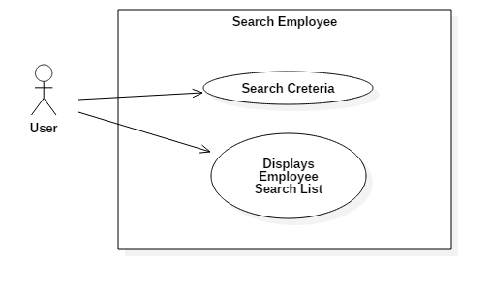

Use case diagram for Search User

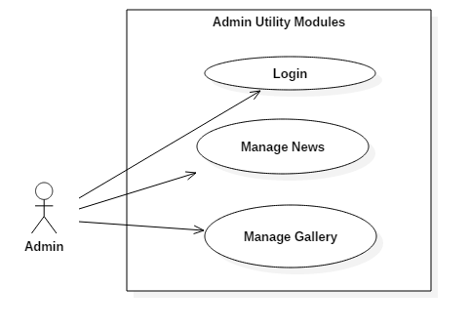

Use case diagram for Admin Utility Modules

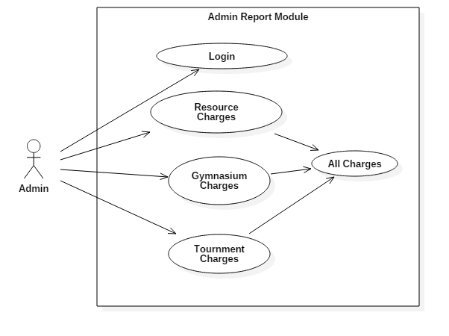

Use case diagram for ADMIN sports report module

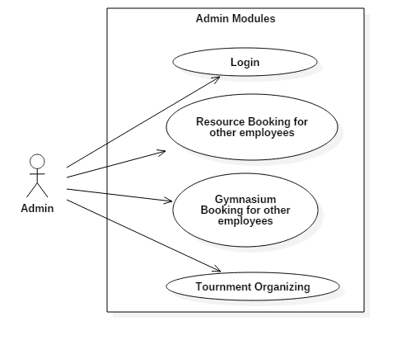

Use case diagram for ADMIN modules

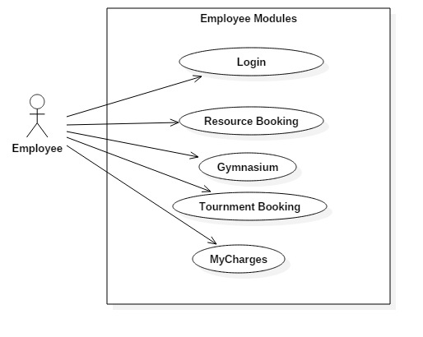

Use case diagram for EMPLOYEE modules

* 1. **Sequence Diagrams:**

Sequence diagram shows sequence or order of process in which any request is processed on any action. Below are sequence diagrams for SPORTS COMPLEX.

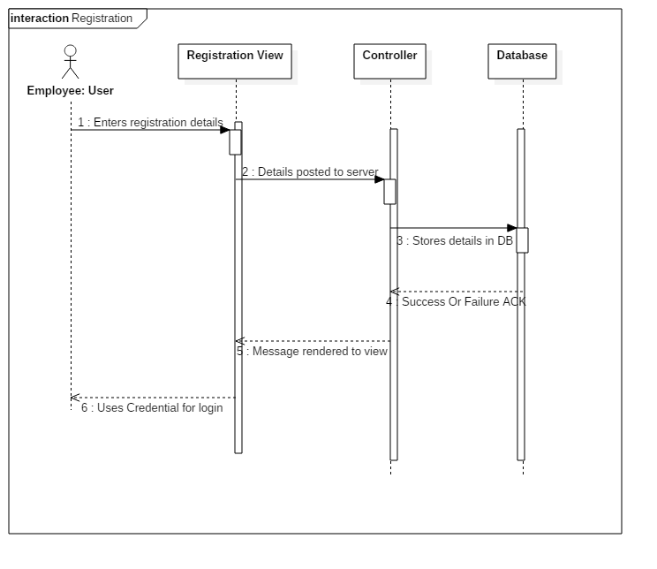

Sequence diagram of User Registration

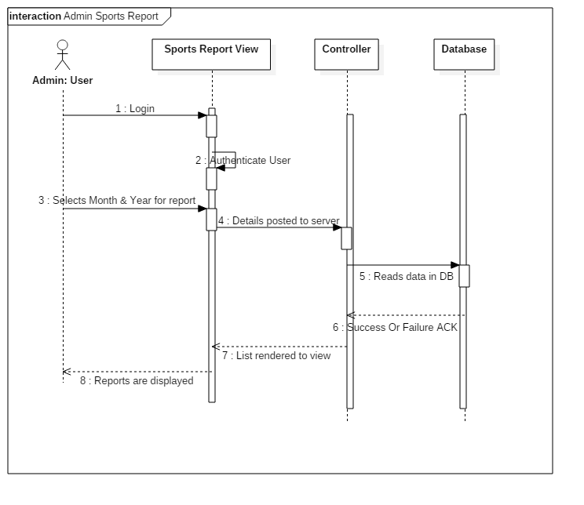

Sequence diagram of ADMIN sports report

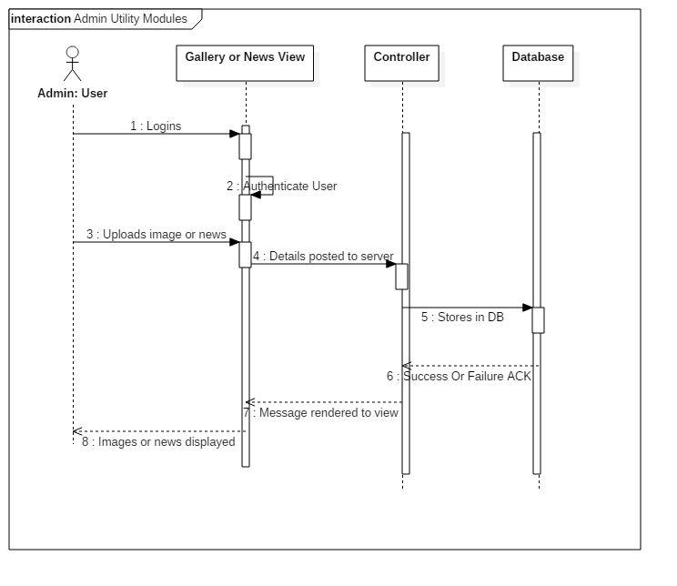

Sequence diagram of ADMIN utility modules report

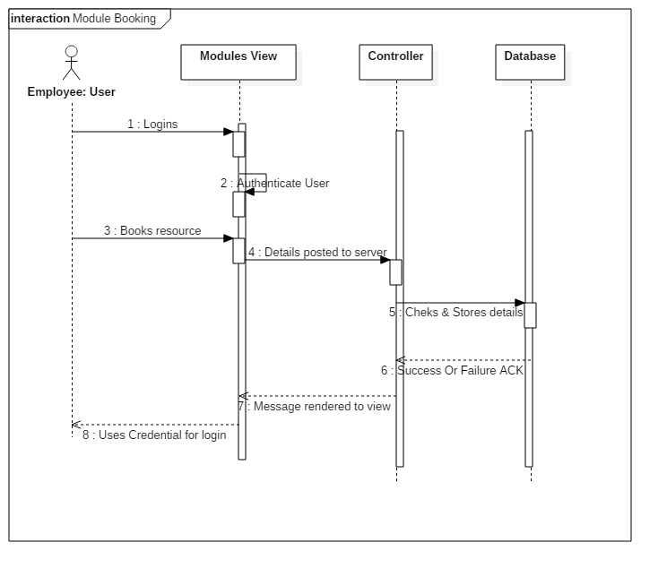

Sequence diagram of EMPLOYEE module booking

* 1. **Activity Diagrams:**

Activity diagrams represents is graphical representation of activities and its workflow on actions. In UML (Unified Modeling Language), activity diagrams shows the flow of control. It uses limited number of shapes and arrows to represent the diagram. Below are the activity diagrams for SPORTS COMPLEX.

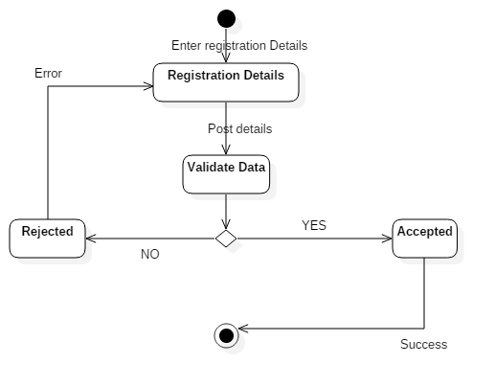

Activity diagram for User Registration

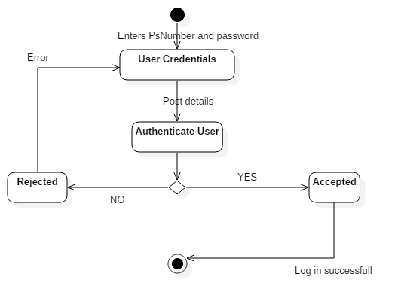

Activity diagram for User Login

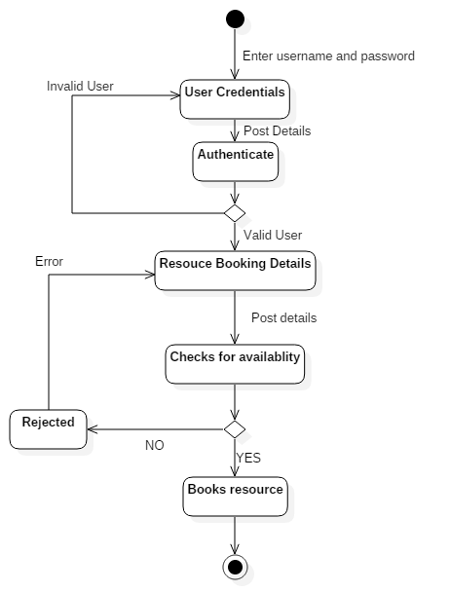

Activity diagram for Resource Booking

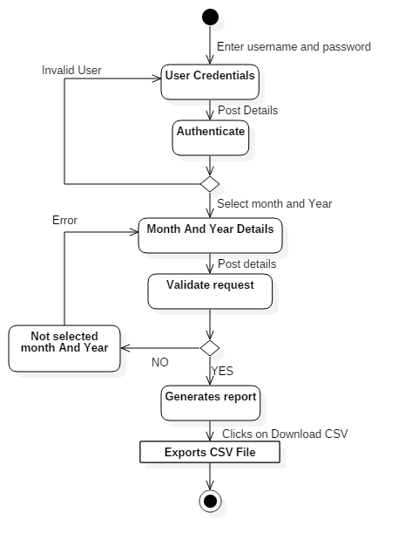

Activity diagram for Sports Report

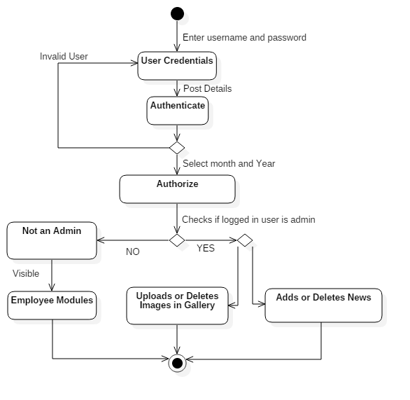

Activity diagram for ADMIN utility modules

* 1. **Database Design:**

Database design is graphical representation of database structure and tables. It also show relationship between tables and constraints if any. Below is the database diagram for SPORTS COMPLEX.

* 1. **Class Diagrams:**

In UML, class diagram represent a static structure of system by its class connections. Below is the class diagram of SPORTS COMPLEX application.

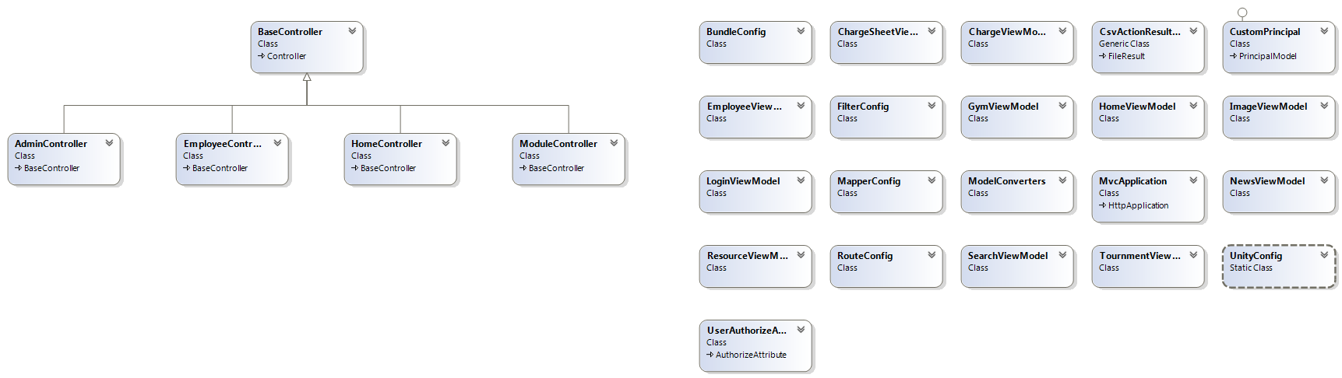

**CHAPTER: 6**

**IMPLEMENTATION**

* 1. **Modules:**

Sports Complex application modules can be classified according to the user roles. Few modules are accessible only to admin. All modules are briefed as below.

1. Resource Booking: Here employee can book resource (Badminton or Billiard) a slot for his usage for that day. It’s bookable only after 4 PM of every day. On booking any slot of resource a mail will go to employee as acknowledgement and another mail will reach to payroll team to deduct amount from employee payroll pocket. For admin, a special privilege to book a slot for any other employee is available.
2. Gymnasium: In this module, employee can join or enroll himself for GYM usage. Based on this, amount will be deducted automatically on every month for its usage. Similar to resource booking, admin has privilege to enroll any other employee to Gym.
3. Tournament: Admin can conduct and add new tournaments in application for which any employee can enroll with in time limited period. Admin can also disable or delete tournaments when he wants. On successful enrollment amount will be deducted for that employee by payroll team.
4. Sports report: All money transaction or activities can be viewed on monthly basis in sports report module. Admin can see all employee transactions which includes all resource bookings, Gymnasium transactions and Tournament charges. Whereas employee can only see his transactions of any resource or sports assets on monthly basis. They can also download the report to CSV file.
5. Gallery: Admin can add or delete images to gallery. These images can be viewed by any end user who visits SPORTS COMPLEX home page.
6. NEWS: Admin can add or delete NEWS which can be viewed by any end user who visits SPORTS COMPLEX home page. Admin can also set priority of NEWS.
   1. **Screenshots:**

**CHAPTER: 7**

**SOFTWARE TESTING**

Any application or project cycle to be completed, it has to undergo testing process. Testing is meant to find errors or defects in application. It helps to make product more precise and perfect. It plays a major role in any software product cycle which results in defect less product to the market.

Entire Software testing can be divided into 3 types:

1. Unit testing
2. Integration testing
3. System testing
   1. **Unit Testing:**

Unit testing is used to test individual part or method of code. It ensures that any method in code performs its function properly in all test case scenarios. For any good application, it is essential to write testable code always. While testing any method, external component will be mocked or stubbed and method will be tested. It is good practice to write any method to perform single responsibility. It’s smallest unit level testing.

* 1. **Integration Testing:**

After performing unit testing, each module should be tested individual to ensure that particular module is working properly. As name indicates, it’s integrating all methods and testing for module. It can done manual or by writing automation scripts. We can also do integration testing to check performance of any module. Functional testing can be part of integration test.

* 1. **System Testing:**

System testing is entire components integrated together as one single software piece which is tested end to end to satisfy desired workflows and functionality. Though system testing is conducted by any developer, it is recommended to have dedicated tester doing black box testing of system which allows him to find more defects before prerelease of any product. This helps in increasing quality of product being developed to the market.

* 1. **Test cases:**

Below we have highlighted test cases for SPORTS COMPLEX project.

|  |  |  |  |  |
| --- | --- | --- | --- | --- |
| **Test Case No** | **Description/Steps** | **Expected Result** | **Actual Result** | **Pass/Fail** |
| TC1 | Run application | Application shall run without any errors | Application ran without any errors | Pass |
| TC2 | Go To Register page | It shall navigate to register web page | It navigated to register web page | Pass |
| TC3 | Enter details | Validate fields and displays if any errors | Errors displayed on invalid data | Pass |
| TC4 | Click Register | User shall be registered on all valid data | User registered successfully | Pass |

Test case for Register Use case

|  |  |  |  |  |
| --- | --- | --- | --- | --- |
| **Test Case No** | **Description/Steps** | **Expected Result** | **Actual Result** | **Pass/Fail** |
| TC1 | Run application | Application shall run without any errors | Application ran without any errors | Pass |
| TC2 | Login with employee credential | It shall login if valid credentials | Logged in as employee | Pass |
| TC3 | Go to Resource Booking module | Resource and available slots shall be displayed to book | Resource and available slots displayed to book | Pass |
| TC4 | Book resource slot | Click book on any available slot shall block that slot of resource | Click book on any available slot blocked that slot of resource | Pass |
| TC5 | Check mail box | After booking, mail shall be received as acknowledgement | After booking, mail received as acknowledgement | Pass |

Test case for Resource Booking Use case

|  |  |  |  |  |
| --- | --- | --- | --- | --- |
| **Test Case No** | **Description/Steps** | **Expected Result** | **Actual Result** | **Pass/Fail** |
| TC1 | Run application | Application shall run without any errors | Application ran without any errors | Pass |
| TC2 | Login with employee credential | It shall login if valid credentials | Logged in as employee | Pass |
| TC3 | Go to Gym module | If employee not joined for Gym, Join option shall be shown. | Respective option showed | Pass |
| TC4 | Click Join if new user, or click Leave if already joined | Shall remove user from Gym if he chooses to Leave. Or shall enroll to Gym if he leaves | Respective action taken | Pass |
| TC5 | Check mail box | After Join or Leave action, mail shall be received as acknowledgement | mail received as acknowledgement | Pass |

Test case for Gymnasium Use case

|  |  |  |  |  |
| --- | --- | --- | --- | --- |
| **Test Case No** | **Description/Steps** | **Expected Result** | **Actual Result** | **Pass/Fail** |
| TC1 | Run application | Application shall run without any errors | Application ran without any errors | Pass |
| TC2 | Login with employee credential | It shall login if valid credentials | Logged in as employee | Pass |
| TC3 | Go to Tournament module | List of active tournaments shall be displayed | List of active tournaments displayed | Pass |
| TC4 | Enroll for tournament | After enroll, enroll button or option shall be disabled | After enroll, enroll button or option shall be disabled | Pass |
| TC5 | Check mail box | mail shall be received as acknowledgement | mail received as acknowledgement | Pass |

Test case for Tournament Use case

|  |  |  |  |  |
| --- | --- | --- | --- | --- |
| **Test Case No** | **Description/Steps** | **Expected Result** | **Actual Result** | **Pass/Fail** |
| TC1 | Run application | Application shall run without any errors | Application ran without any errors | Pass |
| TC2 | Login with employee credential | It shall login if valid credentials | Logged in as employee | Pass |
| TC3 | Go to My Charges | Report page shall be displayed | Report page displayed | Pass |
| TC4 | Select month and year, Click Generate | Charges or employee report for selected month shall be displayed | Charges or employee report for selected month displayed | Pass |
| TC5 | Click Download CSV button | Report shall be downloaded to CSV file | Report downloaded to CSV file | Pass |

Test case for Sports Report Use case

**CHAPTER: 8**

**CONCLUSION**

Sports Complex is a software piece made to ease life of any sports management or similar kind of activity management in any of the organization. It gives an end user or employee a very good user experience on utilizing the sports resource and thus by inducing its production or turn over. It adds a huge value to those organizations which contains many employees and having so many sports resources and tournaments being conducted. Nor only to the employee, it also helps payroll staff by providing then a required data for their payroll process. They can easily extract any months report and process it.

Main key advantage of having such system or software is, it reduces almost all manual intervention where ever needed in managing sports activities. It also keeps database centralized which can be maintained by administrator at any point of time. It gives isolation from other management tools or intranet websites.

To summarize in one statement, SPORTS COMPLEX is an intelligent online solution which replaces an overhead manual job with systematic management of sports resource or utilities in any of the organization.

**CHAPTER: 9**

**FUTURE ENHANCEMENTS**

Though our implemented SPORTS COMPLEX feature is well enough to manage any sports management activity, it is always good to have future enhancements set in place to improvise its scope and usage. Few of them are listed below.

* Admin Rights Module can be added for Admin users where he can give admin rights easily to other employees whom he wants.
* Admin approval for employee registration: We can provide admin module where he can see all new registration for SPORTS COMPLEX and approves it. Employee should be able to login once admin approves its registration request. By doing this, it becomes more secure.
* Improve application security level by encrypting data over a network.
* We can get rid of employee registration process if we integrate our database to existing employee database of company.
* Connect to payroll database: Instead of sending live feedback to payroll team via mail, we can connect to payroll database which will directly deducts amount from employee payroll package on resource usage.
* Module for admin to choose resource settings. We can provide more option to admin to control resource settings like number of badminton courts, slots etc.
* We can also transit to cloud storage instead of maintaining local SQL database. This will help in less maintenance from administrator on database.

**Appendix A**

**BIBLIOGRAPHY**

* <http://www.codeproject.com/>
* [www.wikipedia.com](http://www.wikipedia.com)
* Into to ASP.NET MVC with Visual Studio, Rick Anderson and Scott Hanselman
* Programming ASP.NET MVC 4, Jess Chadwick, Todd Snyder, and Hrusikesh Panda

**Appendix B**

**USER MANUAL**