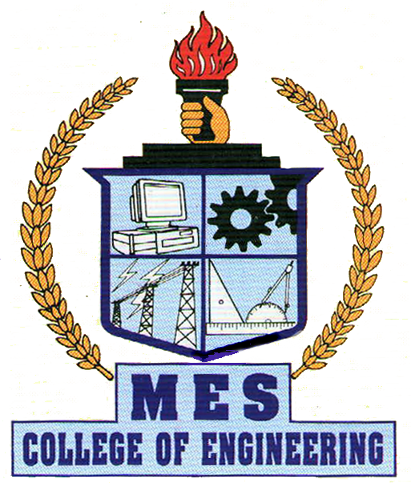

DEPARTMENT OF COMPUTER SCIENCE & ENGG.
MES COLLEGE OF ENGINEERING
KUTTIPPURAM – 679 573, KERALA

IMPLEMENTATION OF VIRTUAL FILESYSTEM ON REACTOS

Main Project Report

Submitted in the partial fulfillment of the requirements in Degree of Bachelor of Technology in Computer Science and Engineering of the University of Calicut during the year 2008-2009

MAHESH M.
DEPARTMENT OF COMPUTER SCIENCE & ENGG.
MES COLLEGE OF ENGINEERING
KUTTIPPURAM – 679 573, KERALA

CERTIFICATE

Certified that this is a bonafide record of the main project entitled
“Implementation of Virtual Filesystem on ReactOS” was done by

CS05103049 MAHESH M.

of the eighth semester Computer Science and Engineering submitted in partial fulfillment of the Degree of Bachelor of Technology in Computer Science and Engineering of the University of Calicut during the period 2008-09.

Lecturer-in-Charge Head of the Department

Place :
Date :

