COP5615 Fall 2015

Programming Assignment 1

Team Member:

Mahesh Kumar Mahadev (1913 6115)

Shantanu Kande (1940 1519)

* A work unit of 100,000 resulted in optimal performance for our implementation which was on a 4 core machine. We discovered that this was the optimal size by measuring performance of different work unit values starting from 10,000 up-to 150,000 (with an increment of 10,000 between each subsequent value).
* A total of 2881 bitcoins were found in 300,000ms or 5 minutes upon running the program for scala project1.scala 4 i.e 4 leading zeros. The results have been submitted in a separate text-file named results2.txt (which can be found in the docs folder).
* The running time for scala project1.scala 5 is summarized by the screenshot below:

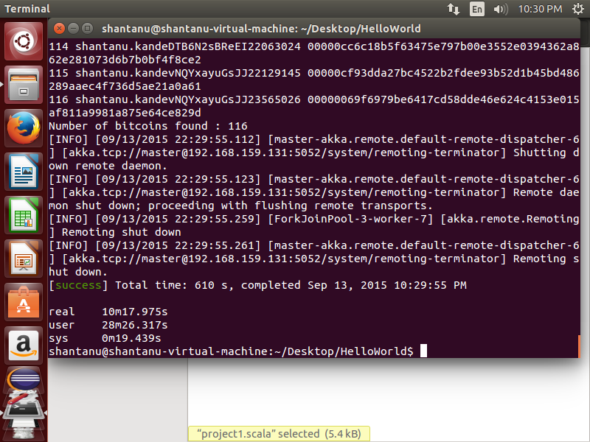

As we can observe, total CPU time (i.e user + sys) is 1725.756 seconds and the real time is 617.975 seconds.

Therefore, CPU time/real time = 2.792 which is close to the number of cores used i.e 4

* The coin with most leading 0’s was found when k=7 and time =300,000ms. It is given below:

[INFO] [09/11/2015 18:17:51.020] [main] [akka.remote.Remoting] Starting remoting

[INFO] [09/11/2015 18:17:51.641] [main] [akka.remote.Remoting] Remoting started; listening on addresses :[akka.tcp://master@192.168.1.7:5052]

[INFO] [09/11/2015 18:17:51.644] [main] [akka.remote.Remoting] Remoting now listens on addresses: [akka.tcp://master@192.168.1.7:5052]

invoke the master

invoke the worker

Number of workers: 14

Number of inputs processed: 84171385

**1 shantanu.kande0ZaoDkCCtRL15520544 000000091dbfac4df65798bb94e76744d4c24301604df518d48e3209de75839d**

**Number of bitcoins found: 1**

* The largest number of machines the code was simultaneously tried on was 3 machines.