Work Completion Report for Solar Power Plant
Sr.No | Component | Observation
1 | Name | {Consumer Name}
2 | Consumer number | {Consumer Number}
3 | Site/Location With Complete Address | {Address} Pin code : {Pincode}
4 | Category: Govt/Private Sector | Residential
5 | Sanction number | {Sanction No}
6 | Sanctioned Capacity of solar PV system (KW) Installed | {Sanction Load}
 | Capacity of solar PV system (KW) | {System Size} KW
7 | Specification of the Modules
 | Make of Module | Premier Energies
 | ALMM Model Number
 | Wattage per module | {Wattage} watt
 | No. of Module | {Qty Modules} nos
 | Total Capacity (KWP) | {System Size} kwp
 | Warrantee Details (Product + Performance) | 12 +30 years
8 | PCU
 | Make & Model number of Inverter | Sungrow
 | Rating | {INV Rating} kw
 | Type of charge controller/ MPPT | {MPPT} Mppt
 | Capacity of Inverter | {INV Rating} KW
 | HPD
 | Year of manufacturing | {Year Of MNF}
9 | Earthing and Protections
 | No of Separate Earthings with earth Resistance | 3 nos (0.3 Ohm,0.2 ohm,0.3 ohm)
It is certified that the Earth Resistance measure in presence of Licensed Electrical Contractor/Supervisor and found in order i.e. < 5 Ohms as per MNRE OM Dtd. 07.06.24 for CFA
Component.
 | Lightening Arrester | 1 nos

We Terra Edge Renewables LLP &… {Consumer Name} bearing Consumer Number {Consumer Number}. Ensured structural stability of installed solar power plant and obtained requisite permissions from the concerned authority. If in future, by virtue of any means due to collapsing or damage to installed solar power plant, MSEDCL will not be held responsible for any loss to property or human life, if any.
This is to Certified above Installed Solar PV System is working properly with electrical safety & Islanding switch in case of any presence of backup inverter an arrangement should be made in such way the backup inverter supply should never be synchronized with solar inverter to avoid any electrical accident due to back feeding. We will be held responsible for non-working of islanding mechanism and back feed to the de-energized grid.

Signature [Vendor] Signature [Consumer]

Guarantee Certificate Undertaking to be submitted by VENDOR
The undersigned will provide the services to the consumers for repairs/maintenance of the RTS plant free of cost for 5 years of the comprehensive Maintenance Contract (CMC) period from the date of commissioning of the plant. Non performing/under-performing system component will be replaced/repaired free of cost in the CMC period

Signature [Vendor] Stamp & Seal

Identity Details of Consumer: -
Aadhar Number: 7191 3036 0201

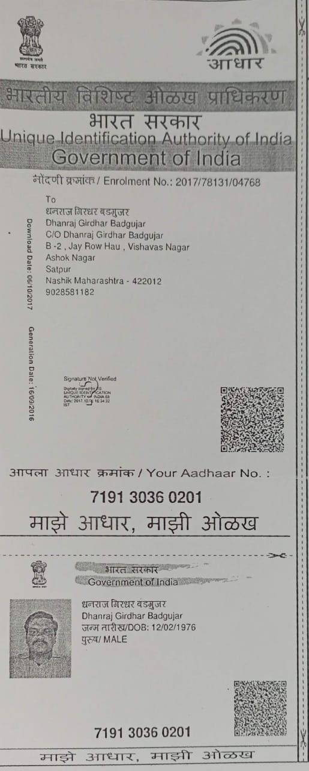

Upload Xerox of AADHAR CARD HERE SHOULD BE SELF ATTESTED BY CONSUMER

