Chapter – MUSCLE

Myocytes (Muscle fibers) - The cells of muscular tissue are I called Myocytes. The myocytes are elongated or spindle shaped they are also called muscle fibers.

Histologically, the muscles are classified into three groups

1. Skeletal muscle.

2. Cardiac muscle.

3. Smooth muscle

The differences between skeletal, cardiac & senooth muscles are

SKELETAL MUSCLE (SAQ)

Skeletal Muscles are also called striated Muscle (because or voluntary muscles.

Histology

Microscopically, skeletal muscle consists of muscle cells called

myocyte or muscle fiber

Muscle fiber is a multinucleated syncytium of varied length.

Each muscle fiber is elongated, unbranched cell

Nuclei are flat & located in the periphery of the cell just beneath the sarcolemma (plasma membrane).

On H&E staining - skeletal muscle fiber shows transverse (cross)

striations of alternate dark & light bands:

Connective tissue of skeletal muscle consists of

1. Endomysium is a layer of reticular fibers that cover an individual muscle layer.
2. Perimysium - covers a bundle of muscle fibers (fascicle)
3. Epimysium - Covers the entire skeletal muscle.

CARDIAC MUSCLE (SAQ)

Cardiac muscle fibers. aree located in the heart.

It is involuntary in action (striated involuntary muscle).

Histology

Cardiac muscle consists of long, thick, branching muscle fibers.

Each muscle fiber shows various number of cardiac myocytes that are joined with other by intercalated discs.

Intercalated discs are dark staining transverse fire sevenning across the muscle fibers.

Nucleus - is single, centrally placed, large & oval.

Cardiac myocytes show a biconical juxta nuclear region

(perinuclear halo). Most of the cell organelles are arranged Drier.

Cardiac muscle shows less number of myofibrils (thick & thin filaments than that of skeletal muscle. Hence, striations are less. prominent in cardiac musch fibers.

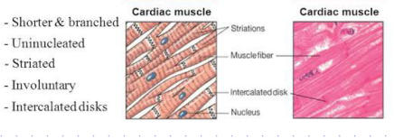

SMOOTH MUSCLE (SAQ)

Smooth muscles are non-striated, involuntary muscle

They are supplied by autonomic nerves (sympathetic & parasympathetic

Locations Wall of gastrointestinal tract, blood vessels, respiratory Deat - wrinary tract, arrector pili muscle.

Histology

Longtitudinal section

The cells are elongated spindle shaped

Cytoplasm-stairs dark eosinophilic (pink) because of myofilaments.

Nucleus elongated, lightly stained with hematoxylins.

The cells are arranged parallel to each other & placed closely.

Transverse section

The smooth muscle cells stains dark eosinophilic & centrally. placed nuclei

The smooth muscle cells are arranged in bundles - longtitudinally or concentrically arranged.

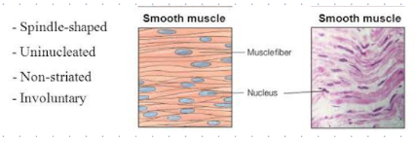

SAQ

1. striated Muscle

2. Cardiac Muscle

3. Smooth Muscle

Crossword

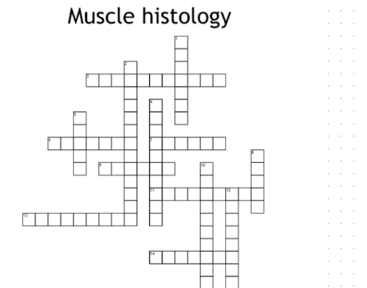

Across

cardiac and smooth muscle are _______________

found in the wall of the heart

type of muscle tissue that does not have striations

Less movable attachment where muscle originates

pulled towards the origin

Skeletal muscle contractions are

connects muscle to bone

Down

Function: Maintenance of________________

ability to shorten

recoiling after being stretched

what% of body weight is skeletal muscle

function: ______________ stabilization

lines within the muscle tissue

nerve fibers cause electrical ____________________