Chapter - FOURTH VENTRICLE

LAQ - Name the lateral boundaries and structure in the floor and roof of the fourth ventricle.

The cavity of the hindbrain is called the fourth ventricle.

Features

1. Shape -> Tent shape 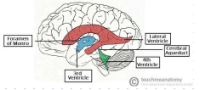

2. Situation ->

Between pens and upper part of medulla oblongata in front and cerebellum behind

It has lateral boundaries, floor, Roof, and cavity with recesses and angles.

LATERAL BOUNDARIES

On each side, the fourth ventricle is bounded.

1. Superolateral -> by superior cerebellar peduncles

2. Inferolateral -> by gracile, cuneate tubercle and inferior cerebellar peduncles

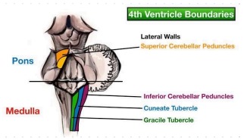

FLOOR/RHOMBOID FOSSA (SAQ)

A. shape -> Thromboid

B. Formation -> The floor is formed by:

(i) the Posterior (dorsal) surface of the lower (closed) part of the pons.

(ii) Posterior (dorsal) surface of upper(open)part of Medulla oblongata

C. Structural Layers -> The floor is lined by

(i) Ependyma

(ii) The layer of neuroglia beneath ependyma

(iii) Layer of grey matter (forming various nuclei deep to neurologic)

D. Parts -> It is divisible into:

(i) Upper Triangular part -> formed by dorsal surface of pens

(ii) Intermediate part -> at the junction of pons and medulla, marked transversely by running fibers of stria medullaris.

(iii) Lower triangular part -> formed by dorsal surface of the medulla

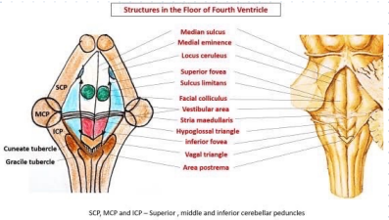

Features

1. Dorsal Median Sulcus -> divides floor into too symmetrical halves

2. sulcus limitans -> duress each half into median eminence and lateral vestibular area

* Superior Fovea - Depression at the cranial end of sulcus limitations
* Inferior Fovea - depression at caudal end of sulcus limitans
* Vestibular area - lies lateral to the inferior fovea overlying the vestibular nuclei.

3. Medial Eminence -> It is wider about and narrow below

* + - Facial colliculus -> is present opposite and medial to the superior fovea.
    - Fenie of Facial Nerve -> is formed by Facial Nerve looping around the abducent nucleus.

4. Locus coeruleus -> Blush colored is in the uppermost part (pontine part) Reticular Formation

5. Sulcus descending from inferior fovea running obliquely towards midline dreads medial eminence into two triangles

* Hypoglossal Tringale -> lies medially overlying the hypoglossal nerve.
* Vagal triangle -> lies laterally overlying the vagal nerve.

6. Area postrema -. are between the vagal triangle above and the gracile tubercle below.

* Fascicules separations-> Ependymal thickening separates the vagal triangle and gracile tubercle.

7. calamus scriptures -> lowest part of the floor (resembles painter's nib of a pen)

ROOF (Posterior wall)

1. Shape -> Tent shape

Apex extends posteriorly into the white core of the cerebellum.

2. Formed by ->

(i) upper part -> formed by convergence of two superior cerebellar peduncles and a thin sheet of white matter - superior medullary velum

(ii) Lower part - formed by thin sheet of non-nervous tissue - inferior medically velum

Foramen of Magendie -> is a large aperture in the median plane of the lower part of the inferior medullary velum.

It forms the communication of the Fourth ventricle to the subarachnoid space of the cerebellomedullary certain (cisterna magna)

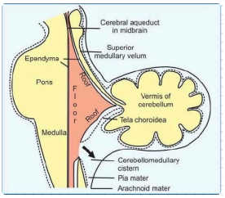

Tela Chordae of Fourth ventricle:

It is a double-layer fold of the pia mater between the inferior vermis of the cerebellum and the lower part of the roof of the fourth ventricle.

Its dorsal layer lines the inferior vermis, which on reaching the module is reflected upon itself to form its ventral layer.

The ventral layer lies over the roof of the lower part of the fourth ventricle.

Choroid pleasure of the Fourth ventricle:

It is a capillary plexus of blood vessels between two layers of Tela choro idea - forming a rich vascular fringe projecting through the lower part of the roof of the fourth ventricle.

It is derived from branches of posterior inferior cerebellar arteries.

. Shape - The entire plexus is T-shaped-

(i) Vertical Limb - is double with the foreman of Magendie intervening between two limbs

(ii) Horizontal Limb - Present on either side, extends into lateral recess and protrudes through the lateral aperture, the formula of Luschka into subarachnoid space

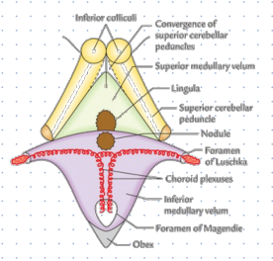

OPENINGS IN THE FOURTH VENTRICLE(SAQ)

There are five openings in the fourth ventricle through which cerebrospinal fluid (CSF) can leave the cavity of fourth-

1. central aperture in the roof (Foreman of Magendie)

2. Two lateral apertures in the rood (Foreman of Luschka)

3. Central canal of the medulla oblongata

4. Cerebral aqueduct of midbrain

Clinical Anatomy:

1. Medulloblastoma-> is the most common tumor in the region of the fourth ventricle. It arises from poorly differentiated primitive neuroectoderm cells cerebellar Vermes and occurs mostly in children.

2. Internal Hydrocephalus ->

Tumor in the region of the fourth ventricle or formation of fibrous adhesions in subarachnoid space

can block openings in the roof of the fourth ventricle.

Excessive Accumulation of CSF within the ventricular system

|

Internal Hydrocephalus

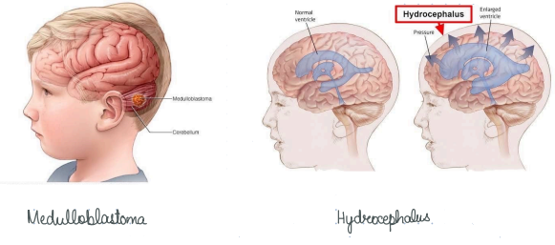

MCQ

1. Inferolateral 4th ventricle is not bounded by

a. cradle Tubercles b. Cuneate Tubercles

c. Inferior cerebellar peduncles d. Superior cerebellar peduncles

2. Which of the following Nuclei is related to the 4th ventricle?

a. Facial Nerve Nucleus b. Hypoglossal Nucleus

c. Vascular Nuclide d. All the above

3.Area postrema fictions as

a. Chemoreceptor b. Osmoreceptor

c. Nociceptor d. None of the above

4. Which structure forms the choroid plexus?

a. Tela Coreidae b. Lateral recess

c. obex d. Secretory ependymal

Answer:

MCAQs - 1-d; 2-d; 3-a; 4-a