Chapter - NERVOUS TISSUE

Nervous tissue is a specialised tissue that shows property of irritability & conductivity

Ganglion

is the aggregation of cell bodies of neurons outside the ・central nervous system.

SENSORY GANGLIA.

Sensory ganglia osce present just outside the central nervous system

Neweans of sensory ganglia carry impulses toward CNS.

Sensory ganglia have Pseudounipolar neurons - these have a peripheral process that carries information from sensory receptor & a central process that pass recaved information to CNS.

A section of sensory ganglia shows large newcoms that are. present in groups, mostly at the periphery of ganglia.

Nuclei lage, vesicular & Centrally placed

Group newens are separated by bundles of myelinated nerve fibers

Satellite cells / Capsular cells - Each neuronal body is.

surrounded by a complete capsule of satellite or capsular cells. Satellite cells are flattened cells (low cuboidal).

The ganglion is covered by fire connective tissue capsule.

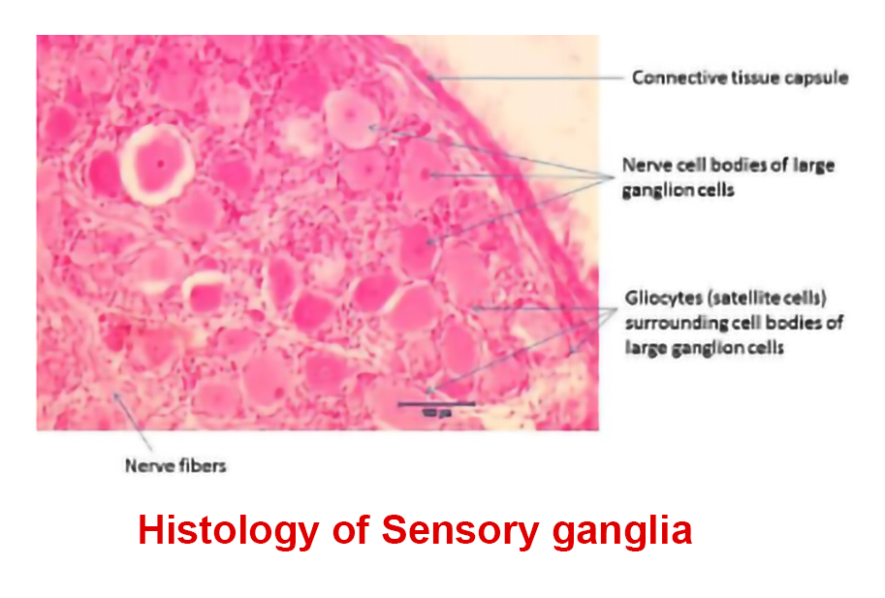

AUTONOMIC GANGLIA SYMPATHETIC GANGLIA

Autonomic Ganglia supply smooth muscles & glands.

Autonomic Nervous System shows two neurons preganglionic neuron & postganglionic neuron

eg. Sympathetic ganglia - Sympathetic trunk, Paravertebral ganglia, adrenal medulla

Parasympathetic ganglia - Ciliary ganglion, submandibular region, - otic ganglion, pterygopalatine ganglion

On H&E staining - Multipolar postganglionic neurons of autonomic ganglia are scattered throughout ganglia

The neurons are separated from each other by discrete bundles. of. nerve fibers.

Nucler- large, pale-staining with prominent nucleolus & eccentrically placed in the cytoplasm.

SAQ

1. Sensory ganglia

2. Autonomic ganglia

MCQ

1. Myelin is formed by
2. Oligodendrocyte
3. Satellite cells
4. Schwanen cells
5. Microglia
6. Autonomic ganglia contain

a escudounipolar nerve cells

b. Bipolar nerve cells

c. Stellate nerve cells

d. Pyramidal nerve cells