Chapter - LYMPHOID TISSUE

LYMPH NODE

Lymph Node is a small kidney shaped structure that filters lymph

Histology

Section of a lymph node shows capsule, subcapsular sinus, outer cortex, paracortex & medulla

Capsule

Lymph Node is covered by dense connective tissue capsule.

Trabeculae extend from capule in the substance of lymph node

Reticular Meshwork

Reticular tissue forms supporting meshwork

Consists of Reticular cells, follicular dendritic cells, macrophages, Reticular fibers.

Synthesises • Type III collagen/ reticular fibers

Parenchyma of Lymph Node.

Parenchyma of Lymph Node shows

1. Cortex (Outer Darkly stained)

It is darkly stained outer part of parenchyma

1. Superficial Nodular Cortex - shows presence of lymphatic follicler Nodular cortex contains mainly B lymphocytes.
2. Deep Cortex or Paracortex - lies between nodular cortex & medulla Paracortex contains mainly Tlymphocytes.
3. Medulla (Inner Lightly stained) It consists of
4. Medullary cords - These are anastomosing cords of lymphocytes, macrophages & plasma cells.
5. Medullary sinuses - These ovce spaces that separate adjacent medullary cords. They converge at hilum & form. efferent lymphatic vessels

Suruses of Lymph Node

There are three types of sinuses in lymph node.

1. Subcapsular Sinus / Cortical sinus It lies just beneath the capsule. It receives lymph from afferent lymphatic vessels.
2. Intermediate/Trabecular Sinuses- It is present adjacent to Drabecube Trabecular sinuses connect subcapsular strus with medullary sinuses
3. Medullary Sinuses - It les among the anastomosing medullary cords. They receive lymph from trabecular sinus & drain it into efferent lymph vessels.

THYMUS

Thymus & Bone Marrow are primary lymphoid organs

Structure - Bilobed structure

Location - Anterior part of superior mediastinum.

Histology

Thymus has capsule, cortex & medulla

Capsule & Septa

Thymus is covered by thin connective tissue capsule.

Trabeculae /septa extend into parenchyma of thymus & divide it into incomplete thymic lobules. Each lobule consists of outer darker cortex & inner lighter medulla.

Cortex

cortex is peripheral darker / basophilic zone of thymus

Contains closely packed T lymphocytes (Thymocytes)

supported by meshwork of epithelio-reticular cells.

Medulla

Medulla is an inner lighter zone of thymus.

Medulla of each thymic lobule is continuous with medulla of adjacent lobules..

Unique feature of Thymic Medulla is Hassall's Corpuscle

Hassall's Thymic Corpuscles

Structure - small rounded or avoid structure present in Thymic medulla

Consists of eosinophilic hyaline mass at the center that is surrounded by concentrically arranged Type II epithelioreticular cells

Represent - degenerating thymocytes & there number increases with age

Produces - Thymosin & Thymapaction hormones.

Functions of Thymus

1. Maturation of T-lymphocytes.

2. To provide isolated environment for T lymphocyte maturation. 3. Secretion of thymosin & thymopoetion

4. Development of immunity in early life. After puberty, thymus gets atrophied.

Blood - Thymic Barrier

Immature T lymphocytes mature in thymus in an isolated environment They are prevented from exposure to antigens by blood-thymic baskite.

Components - Blood-Thymic Barrier has following components

1. Capillary endothelium with basal lamina & few pericytes.

2. Perivascular connective tissue with few macrophages.

3. Type I epithelioreticular cells.

SPLEEN

Spleen is the largest lymphoid organ.

Histology

Spleen shows capsule, white pulp & red pulp.

Capsule & Trabeculae

•Spleen is covered by a dense connective tissue capsule

• Trabeculae - arise from capsule & enter into parenchyma of spleen.

• Reticular cells & Reticular fibers form a meshwork in spleen.

•Connective tissue of spleen also contains myofibroblasts that contract the capsule & trabeculae

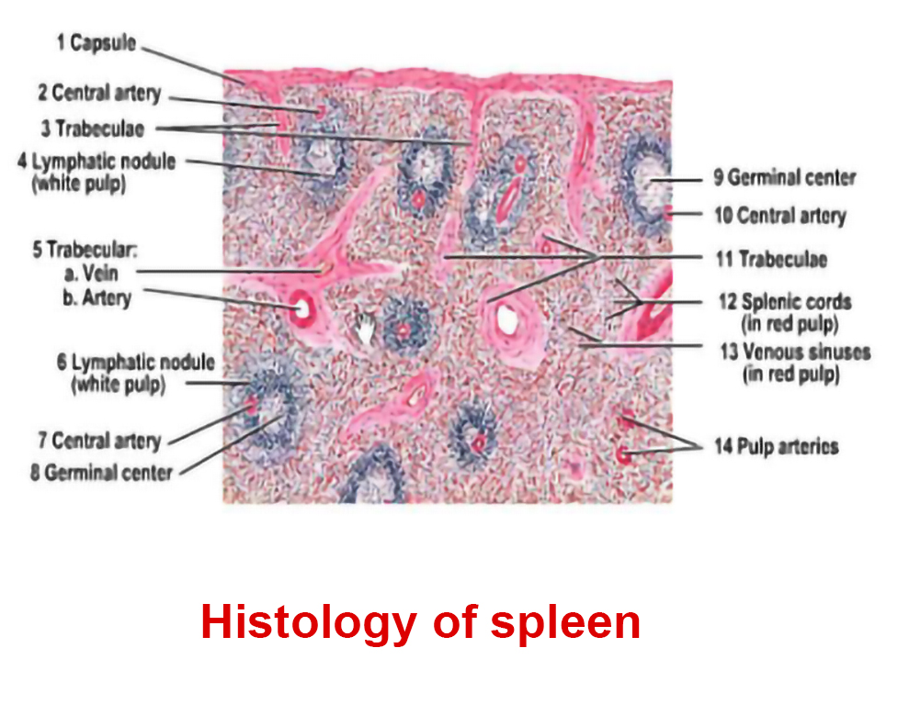

Based on colour of fresh section, parenchyma of spleen has two regions-

White Pulp - consists of lymphoid tissue.

-Trabecular branches of splenic artery give selse to central arterioles that enter into parenchyma of spleen.

-White pulp forms sheaths of lymphoid tissue surrounding

central arterioles. These are called Periarterial lymphatic Sheaths (ers)

•Splenic Nodule/Malphigian corpuscles - At some places, B cells

proliferate in PALS on exposure of antigen & develops germinal centre Such nodules are called splenic nodules or malphigian corpuscles. They have eccentric arteriole (central arteriale pushed to one side). because of formation of germinal centers.

B. Red Pulp

White Pulp is surrounded by seed pulp.

Red Pulp forms a major part of the splenic parenchyma. -Red Pulp consists of two components

1. Cords of Billrath or splenic cords -

are veregular anastomosing conds

Splenic cords are made up of reticular cells, lymphocytes, macrophages, plasma cells & large number of RBCS.

2. Splenic sinusoids -

Splenic cords are separated by splenic sinusoids.

Splenic sinusoids have widen lumen & are lined by elongated endothelial cells that lie parallel to longtitudinal axis of sinusoids.

Marginal Zone –

The zone of red pulp that lies immediately surrounding the white pulp is called marginal zone

Functions of spleen

1. Spleen activates lymphocytes by using antigen presenting cells & induces sommmune response.
2. Spleen is the site for proliferation of T & B lymphocytes
3. Spleen helps in the destruction of old & damaged RBCs & Platelets.
4. In embryonic life, spleen acts as the Dematopoetic organ

PALATINE TONSIL

Tonsils are collection of lymphoid tissue near the junction of oral & nasal cavity with pharynx.

Histology

A section of Palatine Tonsil shows-

1. Lining epithelium - Non- keratinised stratified squamous epithelium
2. Tonsillar crypts - The epithelium invaginates internal sweface of tonsil & forms tonsillex crypts.
3. Lymphatic follicles - Just beneath epithelium, palatine tonsil shows dense aggregation of lymphatic follicles. Lymphatic follicles are supported meshicork of reticular fibers.

Functions of Tonsil

1. Production of lymphocytes.

2. Antigen Presentation & development of immune response

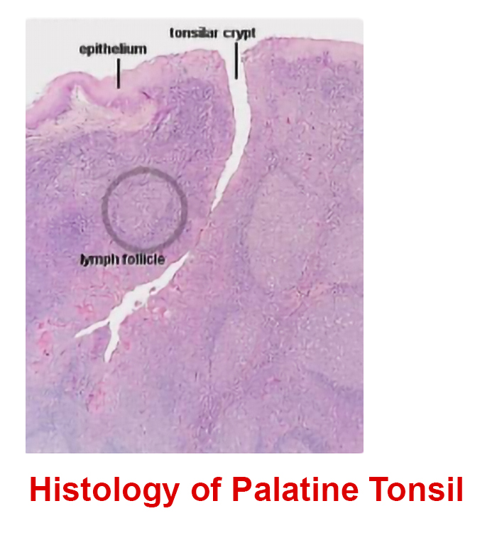

SAQ

1. Lymph Node.

2. Thymus

3. Spleen

4. Palatine Tonsil

Match the following lymphoid tissue & feature

1. Lymph Node a. Hassall's Corpuscles
2. Thymus b. Geypts
3. Spleen C. Sinus
4. Palatine tonsil d. White & Red pulp.

Answers –

1-c, 2-a, 3-d, 4-b