Lungs

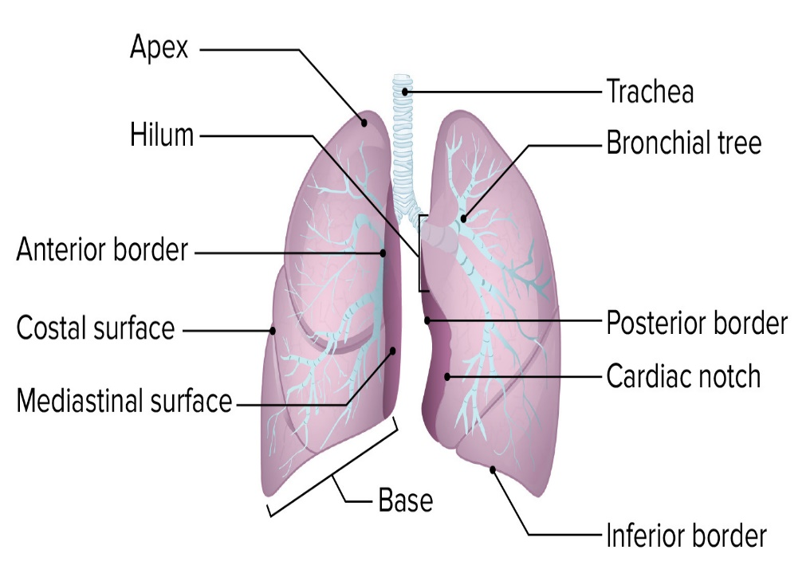

External feautres

* Apex
* Base
* Three borders ( anterior , posterior , inferior )
* Two surfaces ( costal & medial )

Relations

* Apex

|  |  |
| --- | --- |
| Anterior relation | Posterior relation |
| Subclavian artery | Neck of first rib |
| Internal thoracic artery | Ventral ramus of first thoracic nerve |
| Scalenus anterior | First posterior intercostal artery |
|  | First posterior intercostal vein |
|  | Sympathetic chain |

* Base
* Rests on the dome of diaphragm hence called diaphgramatic surface

|  |  |
| --- | --- |
| Right side | Left side |
| Lung is separated from liver by right dome of diaphragm | Lung is separated from spleen & fundus of stomach by left dome of diaphragm |

* Borders

|  |  |
| --- | --- |
| Anterior border | Cardiac notch is occupied by heart & pericardium.  Below the cardiac notch tongue shaped projection called uvula is seen |
| Posterior border | Extends from spine of C7 vertebra to spine of T10 vertebra |
| Inferior border | Seperates costal & medial surface |

* Costal surface
* Upper 6 ribs in midclavicular line
* Upper 8 ribs in midaxillary line
* Upper 10 ribs in scapular line
* Medial surface
* Divided into two parts :
* Posterior vertebral part
* Anterior mediastinal part

|  |  |
| --- | --- |
| Vertebral part relations | Vertebral column |
|  | Posterior intercostal vessel |
|  | Greater & lesser splanchnic nerves |

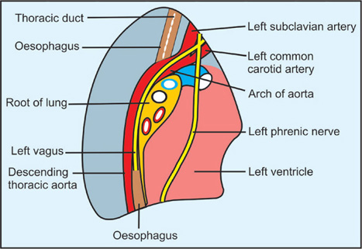 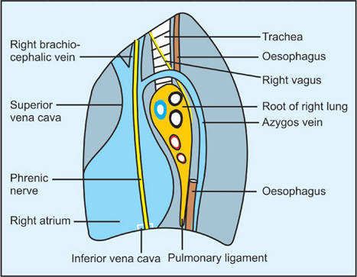

|  |  |
| --- | --- |
| Mediastinal surface of right lung | Mediastinal surface of left lung |
| Right atrium | Left ventricle |
| Superior & inferior vena cava | Ascending aorta |
| Azygous vein | Arch of aorta & descending thoracic aorta |
| Right brachiocephalic vein | Left subclavian & left common carotid arteries |
| Esophagus & trachea | Esophagus & thoracic duct |
| Neural structures   * Right phrenic nerve * Right vagus nerve * Right sympathetic chain | Neural structures   * Left phrenic nerve * Left vagus nerve * Left recurrent laryngeal nerve * Left sympathetic chain |

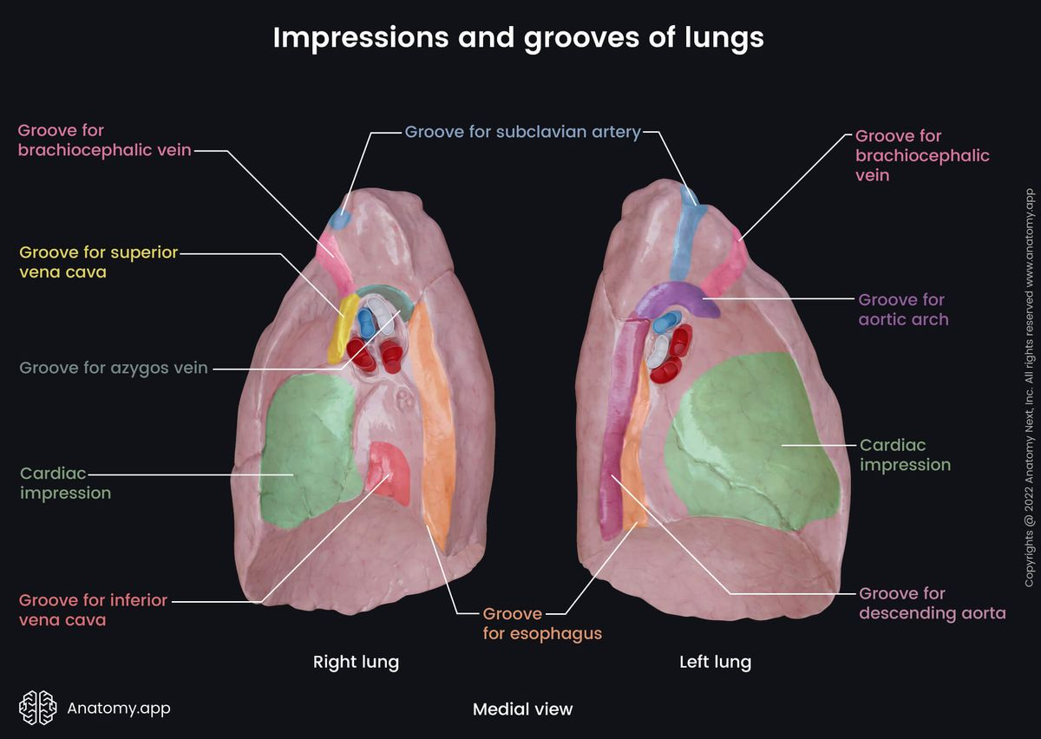\

Lobes & Fissures of lung

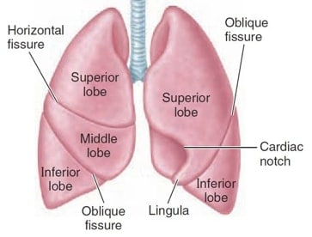

* Right lung

|  |  |
| --- | --- |
| Lobes | Fissure |
| Superior lobe | Oblique fissure |
| Middle lobe | Horizontal fissure |
| Inferior lobe |  |

* Left lung

|  |  |
| --- | --- |
| Lobes | Fissure |
| Superior | Oblique fissure |
| Inferior |  |

Root of lung

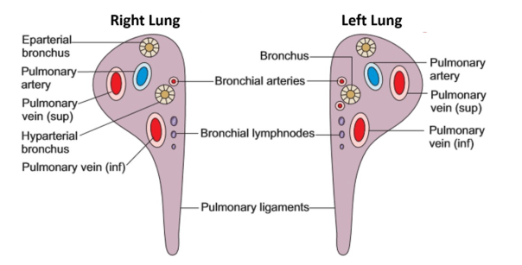

* Root of lung connects medial surface of lung with the mediastinum
* Structures enter or leave the lung through hilum
* Components of root of lung include :
* Principal bronchus in left lung
* Eparterial &Hyparterial bronchi in right lung
* Pulmonary artery
* Pulmonary vein
* Bronchial arteries ( one on right side & two on left side )
* Bronchial veins
* Lymphatic of lung
* Anterior & posterior pulmonary plexus of nerves
* Relations of the root of lung

|  |  |
| --- | --- |
| Anterior | * Phrenic nerve * Anterior pulmonary plexus * Superior vena cava |
| Posterior | * Vagus nerve * Posterior pulmonary plexus * Descending thoracic aorta |
| Superior | * Arch of azgous vein (on right side only) * Arch of aorta ( on left side only) |
| Inferior | Pulmonary ligament |

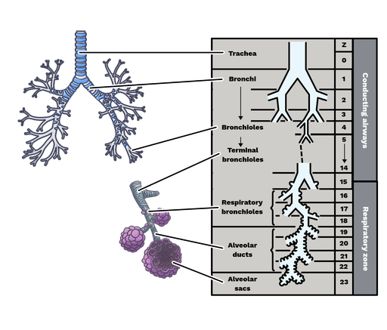

Blood supply of bronchus

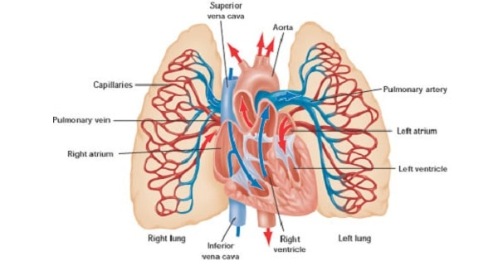

Arterial supply

* Bronchial arteries supply nutrition to the bronchial tree & pulmonary tissue
* Right lung is supplied by one bronchial artery , which arises from third posterior intercostal artery
* Left lung is supplied by two bronchial arteries which arise from descending thoracic aorta
* Pulmonary artery supply deoxygenated blood to the lungs

Venous drainage

* Bronchial vein drain the deoxygenated blood from the bronchial tree & pulmonary tissue
* Right bronchial vein drains into azygous vein
* Left bronchial vein drains into hemiazygous vein
* Pulmonary vein drains oxygenated blood from the lungs

Bronchopulmonary segment

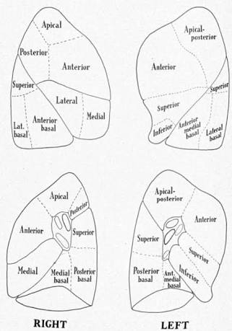

|  |  |  |
| --- | --- | --- |
|  | Lobes | Segments |
| Right lung | Superior | Apical |
|  |  | Posterior |
|  |  | Anterior |
|  | Middle | Lateral |
|  |  | Medial |
|  | Inferior | Superior (apical) |
|  |  | Medial basal |
|  |  | Anterior basal |
|  |  | Lateral basal |
|  |  | Posterior basal |
| Left lung | Superior | Apical |
|  |  | Posterior |
|  |  | Anterior |
|  |  | Superior lingular |
|  |  | Inferior lingular |
|  | Inferior | Superior (apical) |
|  |  | Medial basal |
|  |  | Anterior basal |
|  |  | Lateral basal |
|  |  | Posterior basal |

Applied Anatomy

* Segmental resection of the lung : Done in localized disease like tuberculosis , bronchiectasis , or benign neoplasm restricted to one segment
* Bronchiectasis : Bronchi & bronchioles are dilated permanently , filled with pus leading to airway obstruction
* Aspiration pneumonia : In supine position aspirated material enters superior (apical segment) of lower lobe on right side because it is the dependent segment in this position
* Emphysema : alveoli of lung are damaged by chemicals released by pollutants
* Bronchial asthma : due to bronchospasm diameter of bronchioles is reduced . Clinical feautres include difficulty in breathing , wheezing