Chapter – EPITHELIUM

Definition

The sweface of the body (inner & outer) & inner surfaces of tubular structures within the body are covered by a layer. of cells that rest on basement membrane. Such a covering is called Epithelium.

Classification of Epithelia (MCQ, Viva).

Epithelia are classified are classified according to –

1. Layers of epithelial cells
2. Shape of cells facing toward free surface of epithelivom.

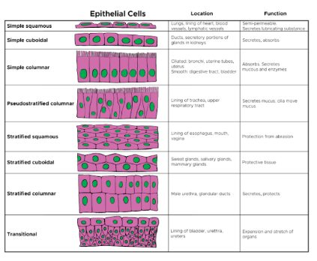

PSEUDOSTRATIFIED EPITHELIUM (SAQ)

Features

1. Pseudostratified epithelium consists of cells that rest on basal lamina & only some of these cells reach up to free surface of epithelium.
2. It is not a true stratified epithelium. It appears to be stratified
3. Height of cells is differential, their nuclei lie at different levels & form two to three rows of nuclei.
4. Epithelium has small cuboidal basal cells that divide mitotically. replace other cells of epithelium.
5. Fully matured cells are columnar & reach up to free surface. Hence, this is called pseudostratified columnar epitheliven.

Locations

1. Respiratory Tract - The tallest cells of epithelium show cilia on the free surface: hence called ciliated pseudostratified columnar epithelium
2. Male Reproductive Tract - In epididymis, pseudostratified columnar epithelium with stereocilia (long microvillus)
3. Pseudostratified columnar epithelium (non-ciliated) is present in auditory tube, dictus deference & membranous & penile weather

Functions

1. Protection of underlying structures
2. Ciliary movements remove the mucus.
3. Stereocilia help in absorption of fluid.
4. Goblet cells secrete mucus
5. Basal cells act as stem cells for remaining cells of epithelium.

TRANSITIONAL EPITHELIUM / UROTHELIUM (SAQ)

Features

1. Transitional epithelium lines the major port of weinasey passage, hence, it is also called urothelium.
2. Appearance (Cell Thickness) of Transitional Epithelium depends on stretching.

Full (distended) bladder - looks 2-3 cell layers thick; cells become thickened

Empty (relaxed bladder - looks 5-6 cell layers thick; cells become - cuboidal or polygonal

1. Cells of Layers

Basal cells - are cuboidal & seest on basal lamina

upper layer - are polygonal

Superficial layer - are dome shaped / umbrella shaped & more casinophilic due to presence of plaque.

Surface cells may show mitotic activity (two nuclei in single cell)

Location

1. Renal Pelvis & calyces of kidney.

2. Ureter

3. Urinary bladder

4. Part of weather.

Function

1. Provides ability of distension to urinary bladder
2. Acts as -Barrier because of presence of occluding functions. & intramembranous plaques.

Q. Label the following epithelium.

