Solution Architecture Document: Custom Chatbot Q&A (RAG Application)

1. Overview
The Custom Chatbot Q&A system is an AI-driven solution that allows users to upload documents (TXT, PDF, DOCX), index their content into a vector database, and ask natural language questions to retrieve precise answers. It leverages Retrieval-Augmented Generation (RAG) with a combination of LangChain, ChromaDB, and a free LLM (FLAN-T5 small) for generating contextual answers.
The system consists of two main components:
- Backend (BE) – Handles document ingestion, text chunking, vector embedding, storage in ChromaDB, and query answering via RAG.
- Frontend (FE) – Provides a user-friendly Streamlit interface for uploading documents, submitting questions, and displaying answers.

2. Key Features
- Document Ingestion: Supports TXT, PDF, DOCX files. Automatically extracts text, splits into overlapping chunks, and stores vector embeddings in ChromaDB.
- Vector Search: Uses HuggingFace sentence embeddings (all-MiniLM-L6-v2) to represent chunks for semantic search.
- RAG Answering: Retrieves top-k relevant chunks and uses FLAN-T5 small to generate a concise answer.
- Q&A History: Frontend maintains session-based history of questions and answers.
- Health Check: Provides a /health endpoint for service monitoring.

3. System Components

3.1 Backend (FastAPI)

Module | Responsibility
config.py | Defines ChromaDB persistence directory, collection name, and text chunking parameters.
utils.py | Extracts text from uploaded documents and splits into overlapping chunks. Supports TXT, PDF, DOCX.
ingest.py | Processes document uploads: extracts chunks, generates embeddings, stores them in ChromaDB.
retriever.py | Retrieves top-k relevant chunks for a query from ChromaDB and generates an answer using FLAN-T5 small.
main.py | FastAPI endpoints: /ingest (file upload), /query (RAG Q&A), /health.

Backend Flow:
- Document Upload → main.py receives file → ingest.py extracts chunks → embeddings via HuggingFaceEmbeddings → ChromaDB storage.
- Question Query → main.py receives query → retriever.py retrieves top-k chunks → FLAN-T5 generates answer → response returned to frontend.

3.2 Frontend (Streamlit)

Module | Responsibility
app.py | Provides UI for document upload, question input, answer display, and session history management.

Frontend Flow:
- Document Ingest UI: Upload multiple files → sends POST /ingest to backend → shows ingestion status.
- Q&A Interface: User types a question → sends POST /query → displays generated answer → maintains session history.
- History Management: Stores current and previous Q&A in session state → allows clearing history.

4. Technology Stack

Layer | Technology
Backend Framework | FastAPI
Frontend Framework | Streamlit
Embeddings | HuggingFace Sentence Transformers (all-MiniLM-L6-v2)
Vector Database | ChromaDB
LLM / RAG Model | Transformers FLAN-T5 small (text2text-generation)
File Parsing | PyPDF2 (PDF), python-docx (DOCX)
Deployment | Local/Cloud (supports REST API consumption by frontend)

5. Architecture Diagram
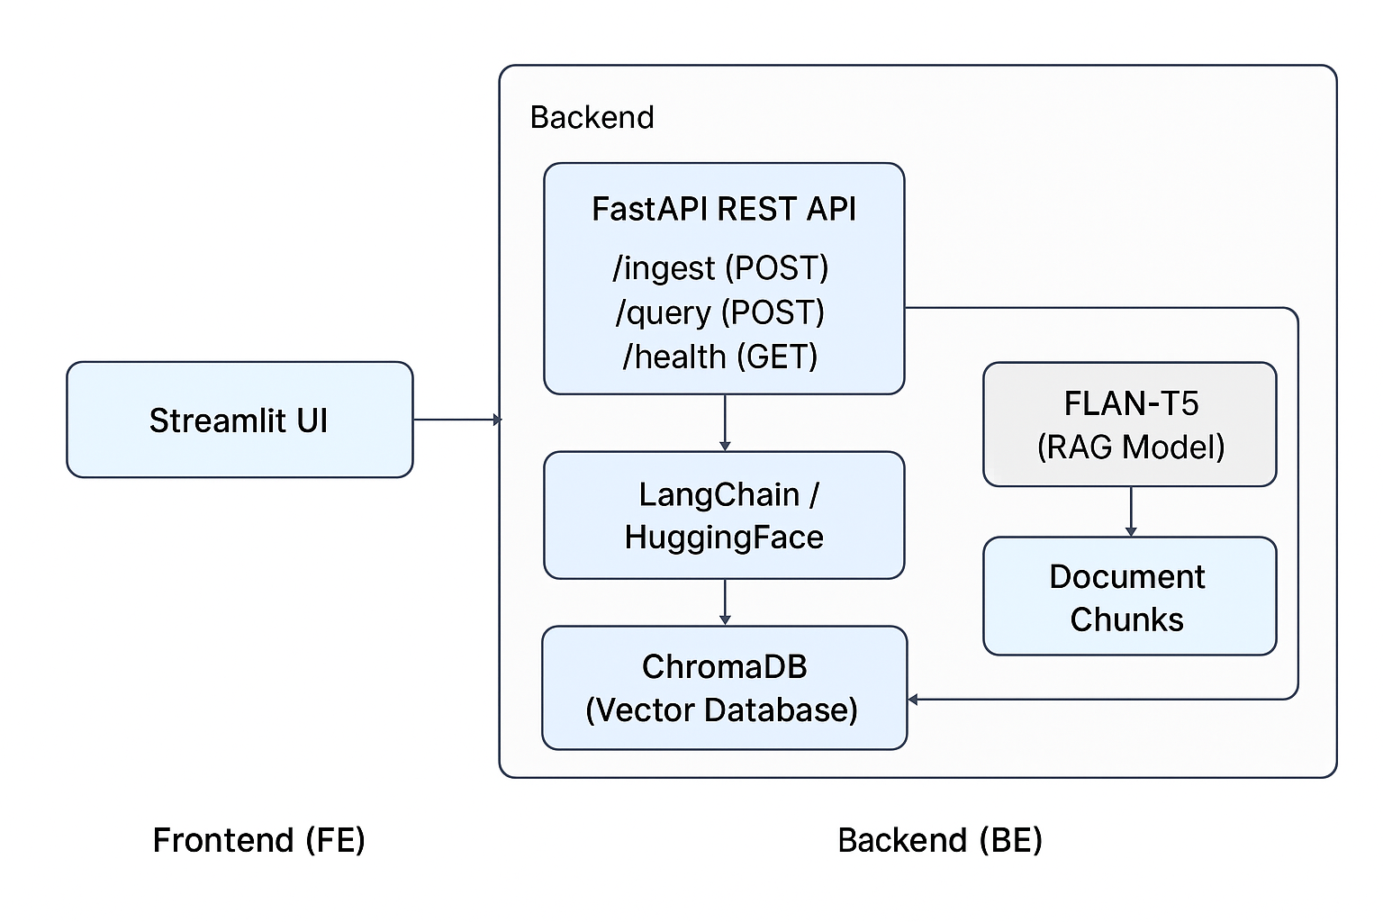

6. Data Flow
- Document Ingestion
  - User uploads file → FastAPI /ingest endpoint → utils.extract_text() → split into chunks → generate embeddings → store in ChromaDB.
- Query Handling
  - User submits query → FastAPI /query endpoint → ChromaDB retrieves top-k relevant chunks → FLAN-T5 generates answer → returned to frontend.
- Frontend Interaction
  - Streamlit displays current answer and maintains history → allows user to clear history.

7. Deployment Considerations
- Persistence: ChromaDB uses local directory chroma_db. Can be extended to remote storage.
- Scaling: Backend can be containerized; multiple workers can handle ingestion and query requests.
- Model Efficiency: FLAN-T5 small ensures lightweight, free, and fast inference.
- Security: CORS enabled for all origins (can be restricted in production).
- Extensibility: Supports adding more document types, different embeddings, or larger LLMs for improved accuracy.

8. Advantages
- Lightweight, free RAG solution.
- Supports multiple document formats.
- Session-based Q&A history for users.
- Modular architecture separating embeddings, retrieval, and generation.

