Solution Architecture Document: Meeting Notes & Action Item Extractor

1. Overview
The Meeting Notes & Action Item Extractor is an end-to-end system designed to convert meeting audio recordings into structured summaries, action items, and task lists. It leverages Whisper for speech-to-text transcription and LLM models (local or OpenAI) for extracting structured meeting artifacts.
Key features include:
- Audio transcription (MP3, WAV, M4A, OGG)
- Automated summary generation
- Extraction of decisions, action items, and follow-ups
- Web-based frontend for file upload and interactive visualization

2. System Components

2.1 Frontend
- Technology: Streamlit
- Responsibilities:
  - Upload meeting audio files
  - Display audio player for playback
  - Trigger backend transcription and analysis
  - Display structured summary, action items, and full transcript
- File: streamlit_app.py
- Interaction: Calls the /transcribe/ API on the backend via HTTP POST

2.2 Backend API
- Technology: FastAPI
- Responsibilities:
  - Accept audio file uploads via REST endpoint
  - Transcribe audio using Whisper
  - Extract action items and summary using regex-based heuristics or LLM
  - Return structured JSON containing transcription, summary, action items
- File: app.py
- Endpoint:
  - POST /transcribe/ – accepts UploadFile, returns {"transcription": ..., "structured_data": ...}
Key Features:
- CORS enabled for frontend integration
- Temporary storage for uploaded files
- Whisper model (small, CPU, int8) for transcription
- Simple regex-based action item extraction

2.3 Transcription Engine
- Technology: Faster Whisper
- Responsibilities:
  - Convert audio into text segments
  - Provide start/end timestamps per segment
- File: transcribe.py
- Details:
  - Beam search decoding for improved transcription
  - Supports multiple audio formats
  - Returns both full transcript and segment-wise data

2.4 Artifact Extraction Engine
- Technology: LLaMA-based local LLM (llama_cpp)
- Responsibilities:
  - Generate structured meeting notes:
    - Summary
    - Decisions
    - Action items (task, owner, due date, priority, context)
    - Follow-ups
  - Parses JSON output from LLM
- File: extractor.py
- Details:
  - Prompts LLM with the transcript
  - Handles malformed JSON gracefully with regex fallback
  - Supports up to 40,000 characters per prompt

2.5 Data Flow
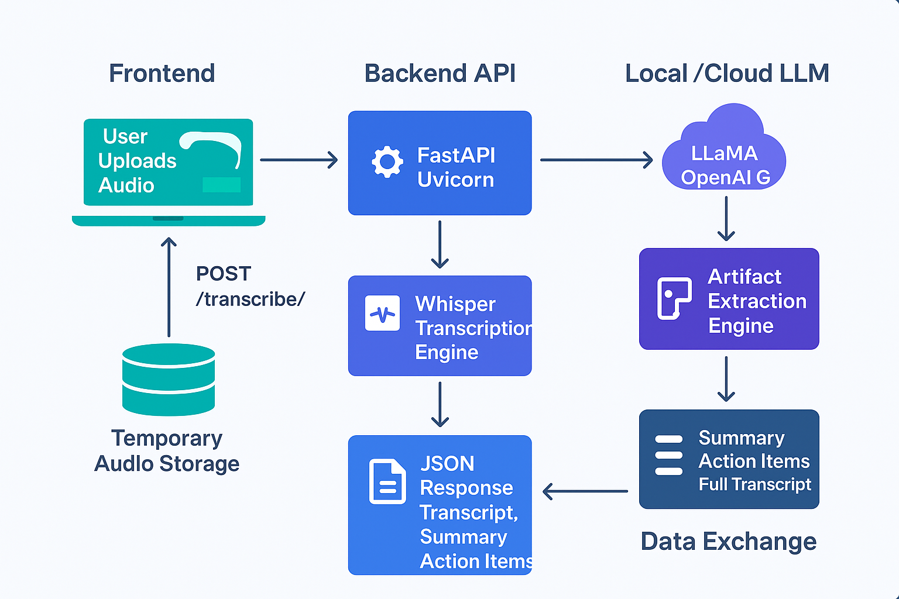
Explanation of Flow:
- User uploads audio in the frontend.
- Streamlit sends audio file via POST to FastAPI backend.
- Backend saves audio temporarily and runs Whisper transcription.
- Transcript is processed with either:
  - Regex-based action item extraction (lightweight)
  - LLaMA-based LLM extraction for structured artifacts
- Backend returns JSON with transcription and structured data.
- Frontend displays summary, action items, and full transcript.

3. Technology Stack

Layer | Technology / Library
Frontend | Streamlit
Backend API | FastAPI, Uvicorn
Speech-to-Text | Faster Whisper (WhisperModel)
Artifact Extraction | LLaMA (llama_cpp) / regex
Audio Processing | tempfile, pathlib
Deployment | Local / Docker / Cloud VM
Data Exchange | JSON over HTTP

4. Key Design Considerations
- Model Efficiency:
  - Uses small Whisper model with int8 quantization for CPU inference.
  - Allows fast processing without GPU.
- Error Handling:
  - Graceful handling of malformed JSON in LLM output
  - Temporary audio files are cleaned after processing
- Scalability:
  - Backend can be containerized and scaled with multiple FastAPI instances.
  - Frontend is decoupled; can integrate with other transcription services.
- Extensibility:
  - LLM prompt can be enhanced for richer action item extraction.
  - Regex-based extractor can serve as fallback for offline or lightweight mode.

5. Future Enhancements
- Use OpenAI GPT or other LLMs for cloud-based extraction
- Support multi-speaker diarization
- Automatic due date extraction from context
- Integration with task management tools (Trello, Asana, Jira)
- Dashboard for tracking action item completion

