Product Design
Team | 23; Manas Kabre, Naman Baheti, Maheshwara Rao, Yeshwanth Baliwada

Design Overview

Architectural design
Our system consists of the following subsystems :
1. Static match visualization:
This part of the system is for visualizing the match after it is over. It includes static visualization such as heat map, point map, pass map, etc. These are created for the sport football and badminton. These visualization form the core of this part of the system, they give enough detail about the entire game and the game can be analyzed with the help of them.
2. Dynamic match visualization:
This part of the system is for adding dynamic visualization to a match video which helps in analyzing the game. There is a interface which allows the user to modify a running video, have passes being shown in a running video, have player tracking of one or more player if player analysis is to be done.

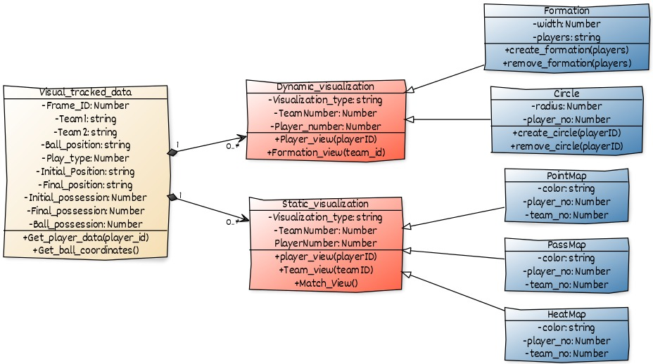

System interfaces

User Interface
User will be able to switch between different players and teams to view their statistics in their preferred forms like heatmap, pointmap, etc. User can get detailed analytics of the match like all passes, ball possessions, etc.

Model
Dynamic_visualization | Make dynamic visualization on a video for which you are given a data of all player’\s.  → Methods :  Player_view(player_id) : Used for player tracking in the video  Formation_view(team_id): Used to highlight a particular formation of a team
Static_visualization | Make static visualization on a given data of players and ball for a match.  → Methods :  Player_view(player_id): Used to have the view for a single player.  Team_view(Team_id): Used to see the entire team game visualization  Match_view(): Gives visualization of the match
Visual_tracked_data | Class that stores visual tracked data on which visualization are going to be done.  → Methods:  Get_player_data(player_id) : Used to get coordinates of player for each frame.  Get_ball_Data() : Used to get position of ball in each frame.
Heatmap | Class that creates heatmap.
Pointmap | Class that creates pointmap.
Passmap | Class that creates passmap.
Circle | Class that creates circle on selected player in a video  → Methods:  create_circle(player_id): Used to create circle on player with given playerID in whole video.  Remove_circle(player_id): Used to remove the created circle from player with given playerID.
Formation | Class that hightlights the formation of a team by creating a line between them.  → Methods:  create_formation(players): Used to highlight formation of given players.  remove_formation(players): Used to remove a formation from given players.

Sequence Diagram(s)
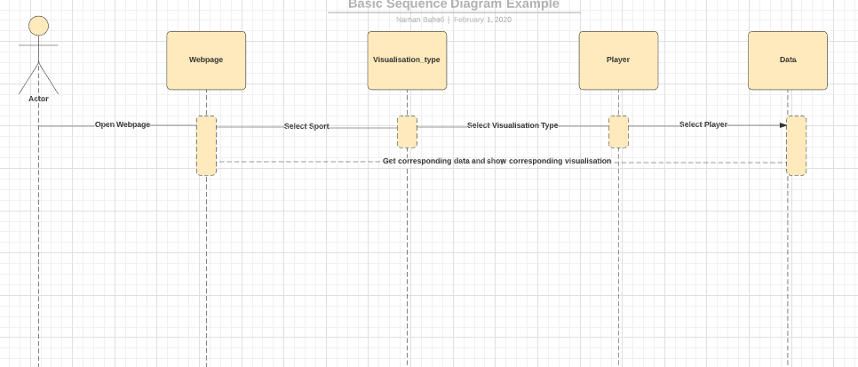

Design Rationale
1. The decision to use javascript for creating Heatmap instead of python.
→ Our initial decision was to use matplotlib,seaborn in python for making heatmap but creating a field itself took too much time in matplotlib and according to requirements of client, this process should be fast. So, we switched to javascript for creating heatmap.

