Software Requirements Specification (SRS) Document

Project number | 23
Project Title | Revolutionary sports data visualization dashboard
Document | Software Requirements Specification (SRS) Document
Creation date | 1st Feb, 2020
Created By | The entire team sat together discussed and made the document
Client | Harshavardhan kommana

Brief problem statement
The project mainly focuses on visualizing data related to football and badminton, as this helps to convert the visual tracked raw data into a more presentable form which helps coaches to analyze the data . This product will help in bridging the gap between data and the coach. At an outcome level, raw data of a match must be presented in a format that gives the user all the functionalities of a pivot table/chart in a visually interactive manner. As we proceed we need to apply similar visualization, but this time it needs to be on a video of some given match.

System requirements
IDE and Software setup: Python 3.7 with Conda and Pip , D3.js for Heatmap ,Gitlab for Version control.

Core Library Usage: Numpy and Seaborne for Heatmap.

Users profile
Our system has primarily three types of users
1. Developer: These mainly constitute the development team and and do the work for linking the point map heat map and pass maps on the web application which will work on live steaming also.
2. Analyst:These are a part of development team who will get the data from match and represent the data as heat map , pass map and point map.
3. Users: These are users who will be using web application for viewing the heat maps, pass maps for the whole match and for a singe player also on dashboard

Feature requirements (described using use cases):

1. Football :
N o. | User Case Name | Description | Release
- 11 1 | View the Dashboard | User will be able to view the Dashboard | R1
2 2 | View Match Center | User will be able to view the initial formation of the Team | R1
22 3 | View the  Heat Map. | User will be able to view heat maps based on players he selected or for the entire team | R1
4 | View Pass Map | User will be able to view the pass map based on players he selected. | R1
5 | View Point Map | User will be able to track the point map by a team | R1
6 | Goals | User will be able to view the shots converted into goals by each team | R1
7 | View Match Video | User can view a plain video of the match | R2
8 | Change Playback Speed | User can change the playback speed | R2
9 | Stop the video | User can stop or pause the video | R2
10 | Formations to see | User can select players he want to see their formations | R1
11 | Highlight Formation in the video | User will be able to view a edited video with formation of players specified by us. | R2
12 | Highlight a Player | Players will be highlighted with a circle below them in the video | R2

Use case diagram
Football:
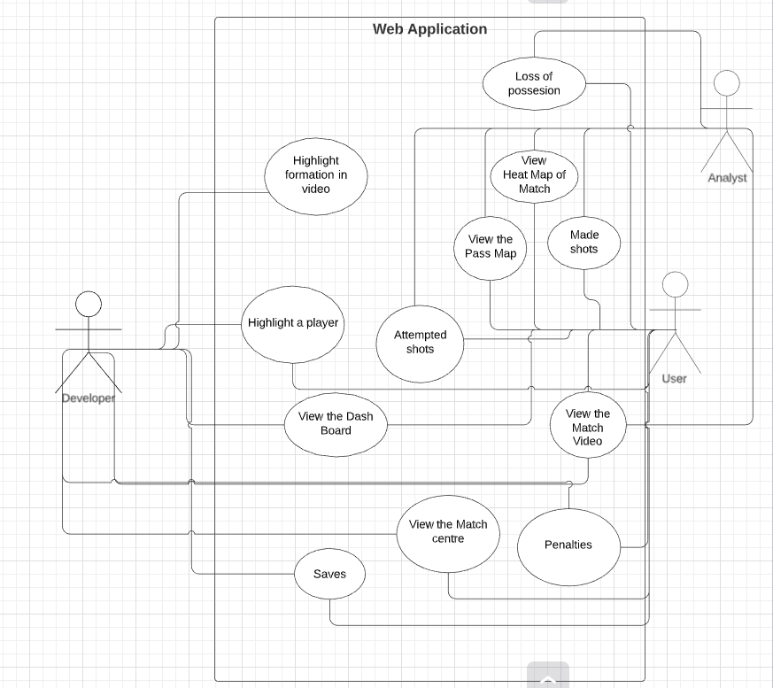

Use Case Number: | UC-1
Use Case Name: | View the Dashboard
Overview: | User will be able to view the dashboard
Actors:
Pre condition: | Enter the condition that must be true before the main flow is executed.
Flow: | Main (success) Flow: Steps should be numbered.
 | Alternate Flows: Include the post condition for each alternate flow if different from the main flow.
Post Condition: | Enter the condition that must be true when the main flow is completed.

Use case description

Use Case Number: | UC-1
Use Case Name: | View the Dashboard
Overview: | User will be able to view the dashboard
Actors: | User
Pre condition: | User should open the link.
Flow: | 1.Browser accepting the link and open the dashboard
 | Alternate Flows:Display appropriate error messages
Post Condition: | Front end of the web application can be viewed by user

Use Case Number: | UC-2
Use Case Name: | View the Match center
Overview: | User will be able to view the initial formation of team
Actors: | User
Pre condition: | User should press the button named match center on navigation bar in front end
Flow: | 1.When clicked on the button the match center image of 2 teams can be seen
 | Alternate Flows:Display appropriate error messages
Post Condition: | User will be able to view the match center image

Use Case Number: | UC-3
Use Case Name: | View the Heatmaps
Overview: | User will be able to view the heatmaps of players he selected.
Actors: | 1.User  2.Analyst
Pre condition: | User should press the button named heatmaps on navigation bar in front end
Flow: | 1.When clicked on the button heatmap a heatmap image can be seen initially with all players of both team involved.  2. User can also remove some players I.e selecting only some players and can view the heatmap
 | Alternate Flows:Display appropriate error messages
Post Condition: | User will be able to visualize the heatmap.

Use Case Number: | UC-4
Use Case Name: | View the passmaps
Overview: | User will be able to view the passmap of match.
Actors: | 1.User  2.Analyst
Pre condition: | 1.User should press the button chalkboard on navigation bar in front end  2.User should press the button passes on chalkboard page in front end
Flow: | 1.When clicked on the button passes a passmap image can be seen initially with all players of both team involved.  2. User can now select a point I.e dot of them and see between which players  pass happened.
 | Alternate Flows:Display appropriate error messages
Post Condition: | User will be able to visualize the passmap.

Use Case Number: | UC-5
Use Case Name: | Loss of possession
Overview: | User will be able to track the loss of possessions by a team
Actors: | User
Pre condition: | 1.User should press the button chalkboard on navigation bar in front end  2.User should press the button Loss of possession on chalkboard page in front end
Flow: | 1.When clicked on the button Loss of possession a passmap image can be seen initially with all players of both team who lost possession in match.  2. User can now select a point i.e. dot of them and see between which players  loss of possession happened.
 | Alternate Flows:Display appropriate error messages
Post Condition: | User will be able to know the strength and weakness of players .

Use Case Number: | UC-6
Use Case Name: | Attempted shots
Overview: | User will be get the data of shots attempted by each team
Actors: | 1.User  2.Analyst
Pre condition: | 1.User should press the button chalkboard on navigation bar in front end  2. User should press the button Attempted shots on chalkboard page in front end
Flow: | 1.When clicked on the button Attempted shots a passmap image can be seen initially with all players of both team who attempted shots in match.  2. User can now select a point i.e. dot of them and see how the shot happened .
 | Alternate Flows:Display appropriate error messages
Post Condition: | User will be able to know how the goal keeper stopped the shots.

Use Case Number: | UC-7
Use Case Name: | Made shots
Overview: | User will be able to view the shots converted into goals by each team
Actors: | 1.User  2.Developer
Pre condition: | 1.User should press the button chalkboard on navigation bar in front end  2. User should press the button Made shots on chalkboard page in front end
Flow: | 1.When clicked on the button made shots a passmap image can be seen initially with all players of both team who scored goals in match.  2. User can now select a line of them and see how the shot happened .
 | Alternate Flows:Display appropriate error messages
Post Condition: | User will be able to know how the player scored a goal.

Use Case Number: | UC-8
Use Case Name: | Saves
Overview: | User will be able to view the shots saved by each team
Actors: | 1.User  2.Developer
Pre condition: | 1.User should press the button chalkboard on navigation bar in front end  2. User should press the button saves on chalkboard page in front end
Flow: | 1.When clicked on the button saves a passmap image can be seen initially with all players of both team who saved goals in match.  2. User can now select a line of them and see how the save happened .
 | Alternate Flows:Display appropriate error messages
Post Condition: | User will be able to know how the player saved a goal.

Use Case Number: | UC-9
Use Case Name: | Penalties
Overview: | User can view the data for penalties, if any
Actors: | 1.User  2.Analyst
Pre condition: | 1.User should press the button chalkboard on navigation bar in front end  2. User should press the button penalties on chalkboard page in front end
Flow: | 1.When clicked on the button penalties a passmap image can be seen initially with all players of both team who saved goals in match.  2. User can now select a line of them and see how the penalty happened .
 | Alternate Flows:Display appropriate error messages
Post Condition: | User will be able to visualize the penalties.

Use Case Number: | UC-10
Use Case Name: | View the match video
Overview: | User can watch the match.
Actors: | 1.User  2.Analyst  3.Developer
Pre condition: | 1.User should press the button video on navigation bar in front end.
Flow: | 1.When clicked on the button video user can be able to watch the match.
 | Alternate Flows:Display appropriate error messages
Post Condition: | User will be able to watch the match.

