INTRUSION DETECTION SYSTEM USING MACHINE LEARNING
A MINI PROJECT REPORT SUBMITTED TO

Swarnandhra College of Engineering and Technology
in partial fulfillment of the requirements for the award of
the degree

MASTER OF COMPUTER APPLICATIONS

By

N.S.D.R.MAHESH

(24A21F0066)

Under the guidance of

CH.DURGA DEVI
Associate professor


DEPARTMENT OF MASTER OF COMPUTER APPLICATIONS
SWARNANDHRA COLLEGE OF ENGINEERING AND TECHNOLOGY
(AUTONOMOUS)

(Approved by AICTE & Permanently Affiliated to JNTUK)(Accredited by NAAC with “A” Grade) SEETHARAMPURAM, NARASAPUR-534280
2024-2026

DEPARTMENT OF MASTER OF COMPUTER APPLICATIONS
SWARNANDHRA COLLEGE OF ENGINEERING AND TECHNOLOGY (AUTONOMUS)
Seetharampuram, Narasapur-534 280.

CERTIFICATE

This is to certify that this project work entitled “INTRUSION DETECTION SYSTEM” is the Bonafide work of MR. N.S.D.R.MAHESH who carried out the work under my supervision, and submitted in partial fulfillment of the requirements for the award of the degree, Master of Computer Applications, during the academic year 2024-2026.

Project Coordinator Project Supervisor

Dr.B.GOHIN CH.DURGA DEVI
Associate Professor Associate Professor

Head of Department
Mr. A.N.L. KUMAR
Head Of the Department of MCA

DECLARATION

I certify that

The work contained in the project work is original and has been done by me under the guidance of my supervisor The work has not been submitted to any other University for the award of any degree or diploma. The guidelines of the University are followed in writing this report.

Date: N.S.D.R.MAHESH
(24A21F0066)

ACKNOWLEDGEMENT

I extend my heartfelt gratitude to the Almighty for giving me strength in proceeding withthis project title “INTRUSION DETECTION SYSTEM”.

I express my heartfelt gratitude to my parents for supporting me in all the ways in every walkof my life.

I express my sincere thanks to Honorable Sri. K.V. Satyanarayana, Chairman of our collegefor making necessary arrangement for doing the project.

I wish to express my gratitude to Dr. S. Suresh Kumar, principal of our college, for givingus permission to carry out this project.

I express my sincere thanks to Mr. A.N.L. Kumar, Head of the Department of M.C.A. forhis learned suggestions and encouragement which made this project a successful one.

I convey my sincere thanks to my project guide CH.DURGA DEVI, Associate Professor, Department of MCA for his learned suggestions and encouragement which made this project a success.

I express my sincere thanks of all the faculty members of our Department of MCA for their valuable support throughout this project work.

I wish to express my thanks to my friends for their enthusiasm, support and encouragement for the completion of this project.

N.S.D.R.MAHESH Regd. No.24A21F0066

INTRUSION DETECTION SYSTEM
USING MACHINE LEARNING

ABSTRACT
Intrusion detection is a crucial challenge in cybersecurity due to the growing complexity of network attacks and the increasing volume of online traffic. This project aims to develop a machine learning-based approach to detect malicious network activities in real time using Python. By employing techniques such as Random Forest, and Decision Trees, we analyze the NSL-KDD dataset containing various types of network connections labeled as either normal or intrusive.

Key features of the dataset include protocol type, service, flag, duration, and byte counts, which are processed and transformed to improve model efficiency. We apply techniques like normalization, one-hot encoding, and feature selection to handle data imbalance and enhance detection accuracy. The models are evaluated using metrics such as precision, recall, and F1-score, ensuring a balance between identifying intrusions and reducing false alarms.

Our findings indicate that the Random Forest model significantly outperforms traditional detection methods, achieving an accuracy of over 98% in identifying malicious network activities. This project highlights the importance of utilizing machine learning for proactive intrusion detection, ultimately strengthening the security and reliability of computer networks. Future work will focus on implementing real-time detection systems and exploring advanced techniques like deep learning and hybrid ensemble-based intrusion analysis.

Index

S.No | Topic | Page No
1 | Chapter 1: Introduction | 1-2
1 | 1.1 Project Overview | 2
1 | 1.2 Problem Statement | 2
1 | 1.3 Project Objectives | 2
1 | 1.4 Project Scope | 2
2 | Chapter 2: Literature Survey | 3-4
2 | 2.1 Existing System Analysis | 3
2 | 2.2 Research Papers Review | 3
2 | 2.3 Similar Systems Study | 3-4
2 | 2.4 Technology Review | 4
3 | Chapter 3: System Analysis | 5-6
3 | 3.1 Requirement Gathering | 5
3 | 3.2 Feasibility Study | 5
3 | 3.2.1 Technical Feasibility | 5
3 | 3.2.2 Economic Feasibility | 6
3 | 3.2.3 Operational Feasibility | 6
3 | 3.3 SWOT Analysis | 6
4 | Chapter 4: System Requirements Specification | 7-12
4 | 4.1 Functional Requirements | 7
4 | 4.2 Non-Functional Requirements | 7
4 | 4.3 Hardware Requirements | 8-10
4 | 4.4 Software Requirements | 11
4 | 4.5 Network Requirements | 11-12
5 | Chapter 5: System Design | 13-18
5 | 5.1 Architecture Design | 13

 | 5.2 UML Diagrams | 13-16
 | 5.2.1 Use Case Diagrams | 13
 | 5.2.2 Class Diagrams | 14
 | 5.2.3 Sequence Diagrams | 14-15
 | 5.2.4 Activity Diagrams | 15-16
 | 5.3 Database Design | 17-18
 | 5.3.1 ER Diagrams | 17
 | 5.3.2 Data Dictionary | 17-18
6 | Chapter 6: Implementation | 19-25
6 | 6.1 Algorithms | 19-20
6 | 6.2 Pseudocode | 21-22
6 | 6.3 Source Code | 22-24
6 | 6.4 Database Queries | 24-25
7 | Chapter 7: Testing | 26-30
7 | 7.1 Test Plan | 26-27
7 | 7.2 Test Cases | 27-30
7 | 7.2.1 Unit Testing | 27-28
7 | 7.2.2 Integration Testing | 28-29
7 | 7.2.3 System Testing | 29-30
7 | 7.3 Test Results | 30
8 | Chapter 8: Implementation Results | 31-34
8 | 8.1 Screenshots | 31
8 | 8.2 Output Screens | 32-34
9 | Chapter 9: Conclusion and Future Scope | 35-36
9 | 9.1 Conclusion | 35
9 | 9.2 Limitations | 35-36
9 | 9.3 Future Enhancements | 36

10 | References | 37
11 | Appendices | 38-39
11 | Appendix A: Dataset Description | 38
11 | Appendix B: Performance Metrics | 38
11 | Appendix C: Algorithms Used | 38
11 | Appendix D: Tools and Libraries | 38
11 | Appendix E: Real-Time Setup | 39
11 | Appendix F: Ethical Considerations | 39

- Introduction
Intrusion detection is a critical component of modern cybersecurity, aimed at identifying and preventing unauthorized access or malicious activities within network systems. As digital connectivity and online services have expanded, so too have the tactics used by attackers, making it essential for organizations to strengthen their defense mechanisms. These systems employ advanced technologies, such as machine learning algorithms and artificial intelligence, to analyze network traffic patterns and detect anomalies in real time.

The primary objective of intrusion detection is to minimize security breaches and data loss for organizations while maintaining seamless network operations. By continuously monitoring network traffic and user activity, these systems can quickly identify suspicious behaviors, such as unauthorized access attempts or abnormal data transfers. This proactive approach not only helps in preventing cyberattacks but also strengthens trust in the safety and reliability of digital infrastructures.

Moreover, the landscape of network intrusions is continuously evolving, necessitating constant advancements in detection methodologies. As attackers adopt more sophisticated techniques, such as zero-day exploits and advanced persistent threats, organizations must adapt by implementing innovative defense strategies and fostering collaboration across the cybersecurity community. Ultimately, effective intrusion detection balances security with performance, ensuring that legitimate network activities continue seamlessly while protecting systems from malicious attacks.

To effectively combat network intrusions, organizations implement a multi-layered security approach that combines both rule-based detection and advanced analytical techniques. Rule-based systems rely on predefined signatures or thresholds to flag suspicious network activities, such as repeated login failures or unusual data transfers. While effective for known threats, this method often generates numerous false alarms, reducing overall efficiency. To improve detection accuracy, many systems now integrate machine learning models that learn from historical network traffic, identifying subtle behavioral patterns that may indicate potential cyberattacks.

Project Overview
This project aims to develop a machine learning-based intrusion detection system using the NSL-KDD dataset. The dataset includes key features such as protocol type, service, flag, duration, and byte counts, which serve as inputs for training and testing the model. Various machine learning algorithms are evaluated for performance, and the most effective model is deployed through a Flask web application for real-time intrusion detection. The solution emphasizes scalability, accuracy, and seamless integration into modern cybersecurity infrastructures.

Problem Statement
Network intrusion poses a significant challenge to the cybersecurity domain, with evolving attack techniques that frequently bypass traditional security measures. The limitations of conventional rule-based systems in identifying complex or novel attack patterns often result in undetected breaches or excessive false alerts. This problem demands a robust, efficient, and adaptive solution that leverages data-driven intelligence to accurately detect and mitigate malicious network activities.

Project Objectives
Develop a machine learning model capable of detecting malicious network activities with high accuracy. Generate and preprocess a synthetic dataset to simulate realistic network traffic for model training and evaluation. Compare the performance of multiple machine learning algorithms using metrics such as precision, recall, and F1-score. Deploy the best-performing model through a Flask-based web application with a user-friendly interface for real-time intrusion detection now.

Project Scope
The scope of this project includes designing a comprehensive intrusion detection pipeline, from data generation to deployment. It involves synthetic traffic generation, feature engineering, model selection, and evaluation. The system is limited to supervised learning techniques applied to a structured dataset. While the project does not address advanced persistent threats or zero-day exploits, it establishes a scalable framework that can be enhanced with external threat intelligence more.

Literature Survey

Existing System Analysis
Traditional intrusion detection systems rely on predefined rules, such as known attack signatures or threshold-based network activity monitoring. These rule-based systems are effective for detecting common or well-documented attack patterns but often fail to identify sophisticated or evolving cyber threats. Additionally, they tend to produce a large number of false positives, resulting in wasted resources and alert fatigue for security analysts. The inflexibility of such systems makes them insufficient for addressing the dynamic nature of modern cyberattacks, where attackers constantly adapt to evade detection. These shortcomings have led to the adoption of machine learning-based approaches, offering improved adaptability and precision.

Research Papers Review
Research in intrusion detection has explored various machine learning approaches to enhance detection performance and adaptability. For instance, Mukkamala et al. [1] investigated the application of neural networks and support vector machines for intrusion detection, demonstrating improved accuracy compared to traditional signature-based systems. Tavallaee et al. [2] addressed the problem of dataset imbalance using the NSL-KDD dataset and introduced refined preprocessing methods to improve model generalization. Shone et al. [3] proposed a deep learning framework combining stacked autoencoders with softmax classifiers to efficiently extract hierarchical features from network data. More recent studies [4] have focused on hybrid models that integrate supervised and unsupervised techniques, enabling detection of both known and novel attacks. These studies collectively highlight the importance of combining robust algorithms, effective feature engineering, and advanced evaluation strategies to strengthen intrusion detection systems.

Similar Systems Study
Organizations and cybersecurity researchers have developed machine learning–based intrusion detection systems tailored for real-world network environments. For example, IBM’s QRadar and Cisco’s Secure Network Analytics use advanced anomaly detection algorithms to analyze vast amounts of network traffic in real time, identifying potential threats with high precision. Similarly, open-source frameworks

like Snort and Suricata incorporate machine learning modules to enhance traditional signature-based detection. In academia, publicly available datasets such as NSL-KDD and CICIDS2017 are widely used for benchmarking IDS performance. These systems underscore the importance of scalability, accuracy, and real-time detection capabilities in modern intrusion detection frameworks

Technology Review
The backbone of machine learning-based intrusion detection systems lies in scalable and efficient technological frameworks. Programming languages such as Python and R are widely utilized for developing models due to their rich ecosystems for data analysis and machine learning. Libraries like Scikit-learn, TensorFlow, and PyTorch enable the implementation of algorithms ranging from traditional classifiers to advanced deep learning architectures. Deployment technologies such as Flask and Django support the creation of interactive web applications, allowing real-time network monitoring and intrusion detection through user-friendly dashboards.

System Analysis

Requirement Gathering
The intrusion detection system requires a combination of functional and non-functional requirements. Functionally, the system needs a dataset containing network traffic details such as protocol type, service, flag, duration, byte counts, and attack labels. It must support data preprocessing tasks like encoding categorical features and normalizing numerical attributes. Additionally, the system should implement multiple machine learning models for performance comparison and provide a real-time detection interface through a web-based application. Non-functional requirements include scalability, high detection accuracy, and an intuitive user interface to ensure seamless integration with organizational cybersecurity infrastructures.

Feasibility Study
A feasibility study assesses whether the proposed intrusion detection system can be effectively developed and implemented within technical, economic, and operational constraints. It examines the availability of computational resources, the ability to process both synthetic and real-world network datasets, and the expected impact on threat prevention. The study concludes that a machine learning–based approach is feasible, providing greater adaptability, scalability, and improved detection accuracy compared to traditional rule-based intrusion detection systems.

    - Technical Feasibility
From a technical perspective, the system is feasible due to the availability of powerful tools and frameworks. Python and its libraries, such as Scikit-learn for model development and Flask for web deployment, provide all essential components for training and implementing intrusion detection models. The required computational resources are minimal, allowing execution on local systems while maintaining the option to scale using cloud-based platforms. Furthermore, modern techniques for managing imbalanced datasets and optimizing model performance ensure that the system can effectively achieve accurate and reliable intrusion detection.

    - Economic Feasibility
The economic feasibility of the project is highly favorable, as the initial develop-ment expenses are minimal due to the use of open-source tools and publicly available datasets like NSL-KDD. The cost of integration is low compared to the potential losses caused by cyberattacks, making the system a cost-effective solution for intrusion detection.

    - perational Feasibility
The system is operationally feasible because it aligns with the needs of organizations aiming to strengthen network security and prevent intrusions. It can be seamlessly integrated into existing network infrastructures without disrupting ongoing operations. The web application’s user-friendly interface ensures ease of use for security personnel, while its scalability enables efficient handling of growing network traffic and data volumes.

SWOT Analysis
- Strengths: The use of machine learning enables adaptability to evolving attack patterns, high detection accuracy, and real-time intrusion identification. The system utilizes open-source tools and frameworks, making it a cost-effective and easily maintainable cybersecurity solution.
- Weaknesses: Dependence on the quality and quantity of network traffic data; synthetic datasets may not fully replicate the complexity and variability of real-world network environments.
- Opportunities: Scalability and potential to integrate advanced methods like deep learning and real-time network traffic analysis in the future. It can be expanded to detect other types of cyber threats, such as insider attacks and advanced persistent threats.
- Threats: The continuously evolving nature of cyberattack techniques and potential adversarial attacks targeting machine learning models. Competition from well-established intrusion detection and cybersecurity solutions in the market also poses a significant challenge.

System Requirements Specification

Functional Requirements
- Network Data Input: The system should accept network traffic details such as protocol type, service, flag, duration, source bytes, and destination bytes as input data.
- Data Preprocessing: The system should preprocess network data by handling missing values, encoding categorical features such as protocol and service, and normalizing numerical attributes like duration and byte counts.
- Intrusion Detection Model: The system must implement Random Forest for intrusion detection.
- Real-Time Prediction: The system should classify network activities as intrusive or normal in real-time.
- Model Evaluation: The system should evaluate intrusion detection models based on accuracy, precision, recall, and F1-score to select the best-performing model.
- Model Training: The system should support training of machine learning models using historical network traffic data to learn intrusion patterns.
- Intrusion Alert Generation: When an intrusive activity is detected, the system should generate alerts for further investigation.
- Data Logging: The system must log network traffic data and detection results for audit and analysis purposes.
- Web Interface: The system should provide a user-friendly web interface for organizations to submit network traffic or upload logs and view detection results.
- Reporting: The system should generate reports on intrusion detection performance, including statistics on false positives and negatives.

Non-Functional Requirements
- Performance: The intrusion detection model should provide real-time predictions with minimal delay.
- Accuracy: The system should achieve high accuracy in detecting network intrusions while minimizing false positives.
- Usability: The web interface should be easy to navigate and intuitive for non-technical security personnel.
- Reliability: The system should operate with high availability, ensuring minimal downtime.

- Security: The system must ensure secure handling of sensitive network telemetry and logs using encryption and secure communication protocols.
- Maintainability: The system should be easy to update with new models and detection features.
- Compliance: The system should comply with relevant data protection and cybersecurity regulations (e.g., GDPR, NIST standards).
- Modularity: The system should be modular, allowing for easy integration of new machine learning models or intrusion detection techniques.
- Adaptability: The system should be able to adapt to new attack patterns by retraining the model with updated network data.

Hardware Requirements

- Processing Power (CPU/GPU) Central Processing Unit (CPU):
High-performance multi-core processors (e.g., Intel Xeon or AMD Ryzen) are needed to handle large datasets and perform complex computations during model training and inference.
Number of Cores: At least 8–16 cores for processing multiple tasks concurrently. For real-time fraud detection, faster processing is crucial.
  - Graphics Processing Unit (GPU) (Optional for Deep Learning):
    - NVIDIA GPUs (e.g., Tesla or RTX series) are recommended for training complex deep learning models (such as Neural Networks or Autoencoders). GPUs speed up matrix and vector calculations, which are common in machine learning algorithms.
    - GPU Memory (VRAM): At least 8 GB VRAM for deep learning model training.
- Memory (RAM)
  - Minimum RAM: 16 GB for basic intrusion detection systems.
  - Recommended RAM: 32 GB or more for systems that need to handle large datasets or real-time processing.
  - 3. Storage
  - Solid State Drive (SSD):

    - At least 512 GB SSD for storing transaction data, feature sets, and models. SSDs provide faster data access compared to traditional Hard Disk Drives (HDD).
    - For large datasets, 1 TB or more of SSD storage is preferable.
  - Backup Storage: Cloud-based storage (e.g., AWS S3, Google Cloud Storage) for long-term data archiving and scalability.
  - 4. Network
  - High-speed Network:
    - A stable and fast network connection is essential for real-time intrusion detection. This is important for transmitting and analyzing network traffic data from various sources, as well as integrating the system with existing security infrastructure or monitoring platforms.
    - Minimum 1 Gbps network speed is required for efficient data transfer, especially when processing large volumes of network traffic in real time.
  - 5. Server or Cloud Infrastructure
  - On-Premise Servers:
    - For large organizations, dedicated on-premise servers may be used to handle high volumes of network traffic and maintain control over sensitive security and infrastructure data.
    - Examples: Servers with multiple processors, large RAM, and SSD storage, such as HP ProLiant or Dell PowerEdge.
. Cloud Infrastructure:

    - Cloud computing platforms like AWS, Microsoft Azure, or Google Cloud can provide scalable resources for both training and real-time fraud detection. Services like AWS EC2 or Google Compute Engine can scale up or down based on traffic.
    - Managed Databases: Cloud platforms offer database services like Amazon RDS, Google Cloud SQL, or Azure SQL for managing network logs, intrusion records, and detection results.
  - 6. Power Supply & Cooling
  - Uninterrupted Power Supply (UPS): Ensure constant power supply to avoid system downtimes, particularly for real-time intrusion detection systems.

  - Cooling Systems: Adequate cooling is necessary for machines with high processing power (e.g., GPU-heavy servers) to prevent overheating.

Software Requirements
- programming Languages Python:
  - Widely used for machine learning and data science tasks. It supports numerous libraries for data manipulation, model building, and evaluation.
  - Popular libraries:
    - pandas: Data manipulation and analysis.
    - numpy: Numerical computations.
    - scikit-learn: Supervised and unsupervised learning algorithms.
    - TensorFlow / Keras: For deep learning and neural networks.
    - XGBoost / LightGBM: For gradient boosting models.
    - Matplotlib / Seaborn: For data visualization.
- Machine Learning Frameworks scikit-learn:
  - A robust library for implementing classic machine learning models like logistic regression, decision trees, random forests, and support vector machines (SVM).
  - It also provides utilities for model evaluation (e.g., accuracy, precision, recall).
TensorFlow / Keras:
  - For developing deep learning models such as neural networks and autoencoders, especially for anomaly detection.
  - TensorFlow is more flexible and scalable, while Keras simplifies model- building.
- Data Storage and Databases Relational Databases:
  - MySQL, PostgreSQL, or SQL Server can be used for storing network traffic data and intrusion detection results with structured queries.

  - Ensure that the database is optimized for fast read/write operations, especially for real-time systems.
NoSQL Databases:
  - MongoDB or Cassandra may be used for storing unstructured data, such as logs or complex user behaviors, in a scalable manner.

- Data Preprocessing and Feature Engineering Tools Apache Spark:
  - For handling big data in parallel, especially useful when working with large datasets or real-time transaction data. Spark can scale across clusters of machines, making it efficient for distributed data processing.
  - Integrates with PySpark for Python-based data processing.

Network Requirements

- Internet Bandwidth Minimum Bandwidth:
  - 10 Mbps (suitable for small-scale intrusion detection systems with low network traffic volume or for development and testing environments).
Recommended Bandwidth:
  - 1 Gbps or higher for medium to large-scale intrusion detection systems, especially when analyzing high volumes of network traffic or performing real-time intrusion detection.
- Low Latency
Real-Time Detection:
  - A system that detects intrusions in real time (as network traffic is analyzed) requires low-latency communication between various components, including data capture modules, machine learning models, and intrusion detection APIs.
  - Latency should typically be below 100 milliseconds for optimal real-time detection.

- Data Transfer & Throughput Data Throughput:

  - Intrusion detection systems need to handle large volumes of network traffic, especially in high-bandwidth environments like enterprise networks or data centers. Ensuring that the system can process hundreds or thousands of network packets or connections per second is essential.
- Secure Communication Encrypted Data Transmission:
  - Sensitive information, such as network traffic logs and user activity data, must be transmitted securely.
  - VPNs (Virtual Private Networks) or dedicated private networks may be used for internal communications within organizations or data centers to ensure data privacy and secure transmission of network information.
- Cloud Connectivity
Cloud-based Processing:
  - If the intrusion detection system relies on cloud resources (e.g., AWS, Google Cloud, Azure), high-speed internet connectivity to the cloud is essential to ensure smooth communication between on-premises network monitoring systems and cloud-based models or databases.
  - Using cloud services like AWS Direct Connect or Google Cloud Interconnect can help establish a dedicated connection for enhanced performance, lower latency, and improved security in cloud-based intrusion detection operations.
- API Integration & Webhooks
API Calls: The intrusion detection system must support API integrations for communication with external services, such as network monitoring tools, security information and event management (SIEM) systems, or third-party threat intelligence platforms.
  - APIs should be RESTful or gRPC-based, providing asynchronous processing for scalable and efficient network traffic monitoring.
- Redundancy & Failover High Availability:
  - Intrusion detection systems require redundant network paths to ensure uptime and reliability, particularly in mission-critical environments such as enterprise networks or government data centers.

System Design

Architecture Design
The architecture design for the intrusion detection system Figure[1] consists of several key components: data collection, preprocessing, machine learning model, and deployment layers. The system receives network traffic data through a secure web interface (via HTTPS) and preprocesses it by handling missing values, encoding categorical features such as protocol and service types, and normalizing numerical attributes like duration and byte counts.
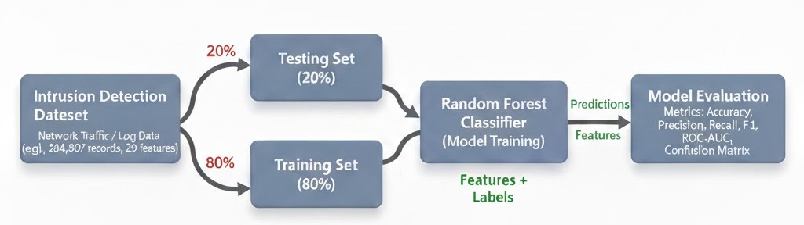

Fig 1: Architecture of intrusion detection system

UML Diagrams
    - Use Case Diagrams
The Use Case Diagram for the intrusion detection system Figure[2] illustrates the interactions between various actors (users) and the system’s functionalities. Key actors include the Network Administrator, Security Analyst, and System Administrator. The Network Administrator can submit network traffic or log data to the system and receive intrusion detection results in real time.
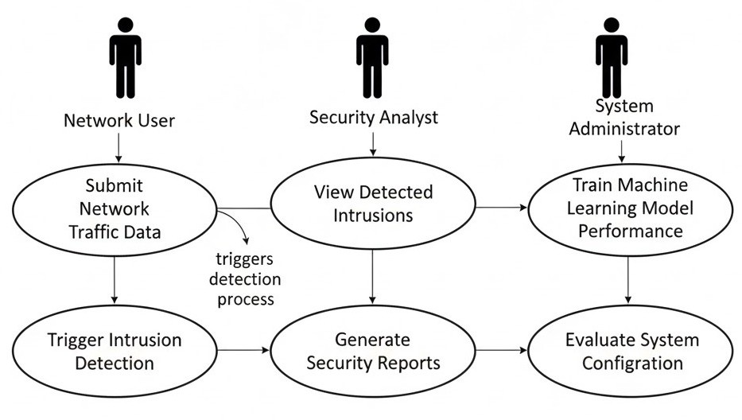

Fig 2: Use case of intrusion detection system

    - Class Diagram
The Class Diagram for the intrusion detection system Figure[3] consists of several key classes that interact with each other to facilitate the detection process. The NetworkPacket class holds packet-related details such as source IP, destination IP, protocol, payload size, and timestamp, and provides methods to parse, normalize, and extract packet fields. The Intrusion Detection Model class encapsulates the machine learning model used for intrusion detection, including attributes like model type, feature list, and accuracy, and methods for training, evaluating, and predicting intrusions.
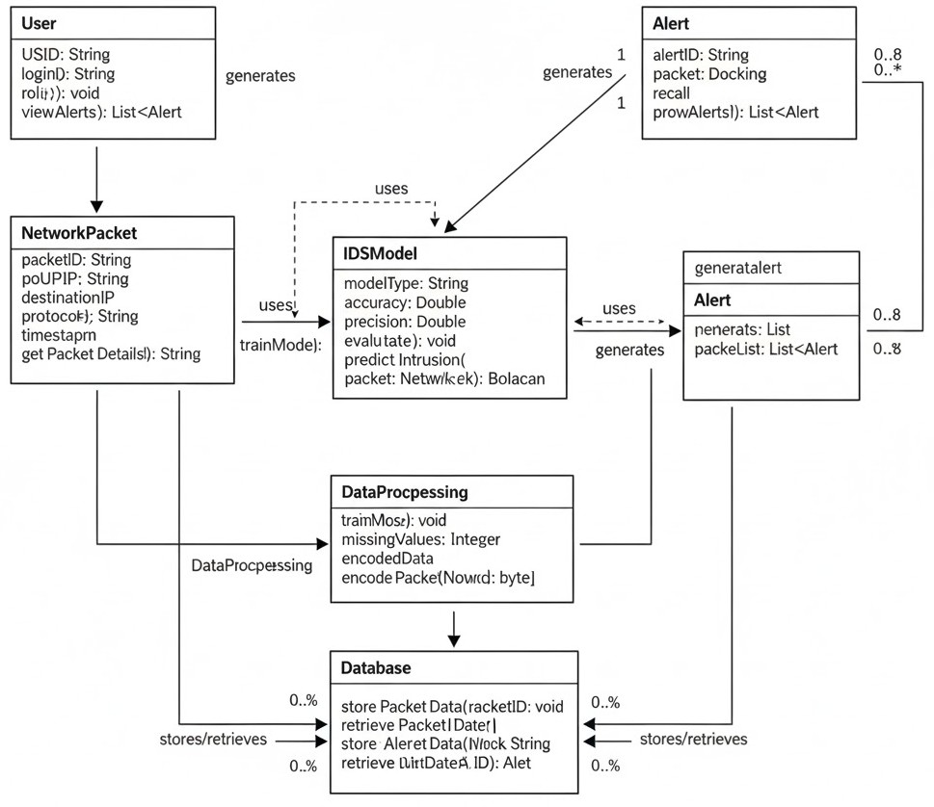
Fig 3: Class diagram of intrusion detection system

    - Sequence Diagrams
The Sequence Diagram for the intrusion detection system Figure[4] illustrates the flow of interactions between the system’s components during the intrusion detection process. First, a User (such as a network administrator) submits network traffic data through the monitoring interface. The system then triggers the Data Preprocessing component, which handles tasks like parsing packet fields, encoding protocol information, and scaling numerical features. Once the data is preprocessed, it is passed to the Intrusion Detection Model, which makes a prediction to determine whether the network activity is normal or represents a potential intrusion.

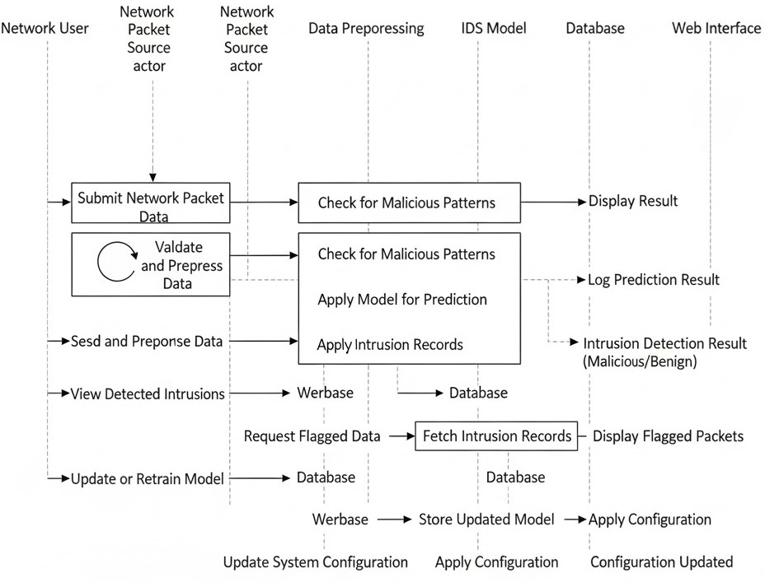

Fig 4: Sequence of intrusion detection system

    - Activity Diagrams
The Activity Diagram for the intrusion detection system visually represents the flow of activities involved in analyzing incoming network traffic. The Figure[5] begins with the network administrator or monitoring tool submitting raw packet or log data into the system. Once the data is received, it moves into the preprocessing stage, where tasks such as packet parsing, feature extraction, protocol encoding, and normalization are performed. After preprocessing is complete, the system forwards the processed network features to the intrusion detection model, which analyzes the data and generates a prediction indicating whether the activity is normal or potentially malicious.

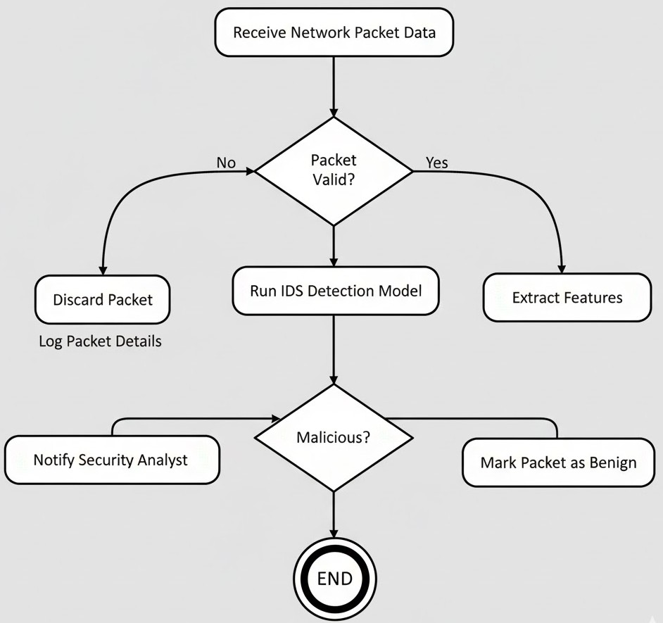

Fig 5: Activity diagram of intrusion detection system

Database Design
    - ER Diagrams
The Entity-Relationship (ER) Diagram for the intrusion detection system models the relationships between key entities involved in network monitoring and intrusion analysis. The primary entities include NetworkPacket, User, Model, and Alert. The NetworkPacket entity contains attributes such as PacketID, SourceIP, DestinationIP, Protocol, Timestamp, and PayloadSize to capture the details of each incoming packet or log entry. The User entity, representing system users such as security analysts or administrators, includes attributes like UserID, Name, and Role. The Alert entity stores information about detected intrusions, with attributes such as AlertID, PacketID, ThreatType, Severity, and Timestamp. The Model entity represents the machine learning model used for detection and includes attributes like ModelID, ModelType, Accuracy, and Version.

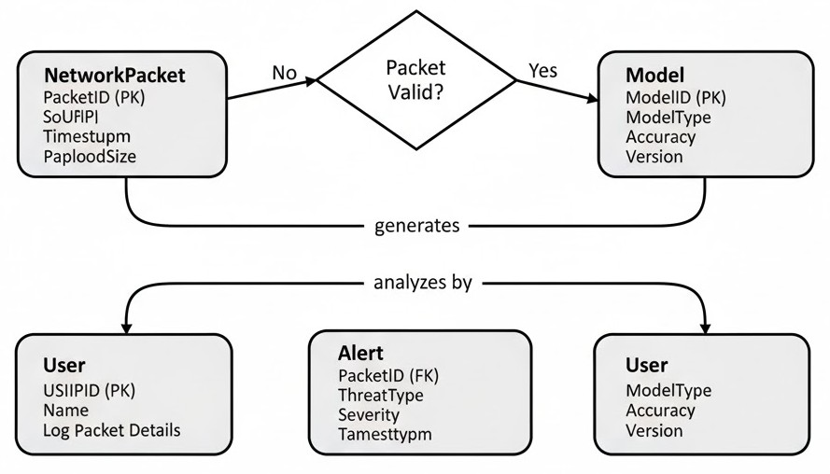

Fig 6: ER diagram of intrusion detection system

    - Data Dictionary
In an intrusion detection system using machine learning, the data dictionary provides a structured overview of the dataset’s features used for network analysis and intrusion prediction. Common attributes include Duration, representing the length of the network connection; ProtocolType, indicating the communication protocol used; Service, specifying the network service accessed; SourceBytes and DestinationBytes, capturing the volume of data sent and received; and Flag, variable, typically Label (Normal/Attack), indicates whether a network activity is legitimate or malicious. This dictionary ensures clarity in feature definitions, enabling effective preprocessing, model training, and accurate interpretation of intrusion detection results.

Database name: my sql
Table 1:User
Sno | Attribute Name | Data Type | Description
1 | User _id | INT (Primary Key) | Unique identifier  for each user.
2 | User_ name | VARCHAR(100) | Name of the user.
3 | Email | VARCHAR(100) | Email address of  the user
4 | password | VARCHAR(25) | Encrypted password for user  authentication
5 | Registration_ data | DATETIME | Date and time of  user registration
6 | Role | ENUM(‘SuperAdmin’,  'Admin',  'User') | Role of the user in  the system (Admin or Regular User)

Table 2:detection
Sno | Attribute Name | Data Type | Description
1 | Id | INT (Primary Key) | Unique identifier  for each detection.
2 | User_id | INT | Unique identifier  for each user.
3 | Prediction | VARCHAR(20) | Network activity (Normal/Attack)
4 | Confidence | FLOAT | Confidence percentage of model
5 | Timestamp | DATETIME | Date and time of  user detection
6 | Ip_address | VARCHAR(45) | Ip address of user
7 | Protocol | VARCHAR(10) | protocal type of detection
8 | Src_bytes | INT | capturing the volume of data sent
9 | Dst_bytes | INT | capturing the volume of data recieved

Implementation

Algorithms

- Load Dataset
  - Import your dataset, which includes network activity information such as Duration, Protocol Type, Service, Source Bytes, Destination Bytes, and Label (Normal/Attack)

- Data Collection
  - Data source: You collect network traffic data that includes information about each connection or packet, such as:
    - Duration: The length of the network connection.
    - Protocol Type: The protocol used (e.g., TCP, UDP, ICMP).
    - Service: The network service accessed during the connection.
    - Source Bytes: Amount of data sent from source to destination.
    - Destination Bytes: Amount of data sent from destination to source.
    - Flag: Status of the connection (e.g., SF, REJ).

- Data Preprocessing
The data needs to be cleaned and transformed before training the model. The following steps are common:
  - a. Handle Missing Values:
  - Detect missing values: Identify missing or null values in the dataset.
  - Fill or drop missing data:
    - For numerical features, fill missing values with the mean or median of the feature.
    - For categorical features, either fill with the mode or drop rows/columns if
there’s too much missing data.
  - b. Encode Categorical Variables:
Many machine learning models (including Random Forest) require numerical inputs. Categorical features such as ProtocolType or Service need to be converted to numeric values.

  - Label Encoding: For ordinal data (categories with an inherent order like connection flags), use label encoding (assigning integer values).
  - One-Hot Encoding: For nominal data (no inherent order), such as ProtocolType, use one-hot encoding to create binary columns for each category.
  - c. Convert Date Information:
  - The Timestamp feature can be transformed into a numeric format, such as a Unix timestamp (seconds since the epoch).
  - Alternatively, you can extract features such as:
    - Day of the week, hour of the day, month, etc., if the timing of network activity affects intrusion likelihood.

- Data Splitting
Once the data is cleaned and transformed, you need to split the dataset into:
  - a. Training Set (80%):
  - The training set is used to teach the model patterns in the data. It includes both features (X) and the target label (y, attack or normal).
  - b. Test Set (20%):
  - The test set is used to evaluate how well the model generalizes to unseen data. This set helps determine the model’s ability to predict future intrusion events.

- Model Training with Random Forest
The Random Forest Classifier is an ensemble machine learning algorithm that uses multiple decision trees to make predictions. The steps involved in training the Random Forest model are:
  - a. Initialize Random Forest Model:
  - Specify the number of trees (n_estimators), the maximum depth of each tree (max_depth), and other hyperparameters.
  - Random Forest combines predictions from multiple decision trees, improving accuracy and reducing overfitting.
  - b. Train the Model:
  - Train the Random Forest model using the training data (X_train and y_train).

Pseudo code

Step 1: Import necessary libraries
Import pandas as pd
Import numpy as np
Import RandomForestClassifier from sklearn.ensemble
Import train_test_split from sklearn.model_selection
Import accuracy_score, confusion_matrix, classification_report from sklearn.metrics

Step 2: Load the dataset
data = pd.read_csv('network_traffic_data.csv')

Step 3: Preprocess the data
- Handle missing values (impute or drop)
- Convert categorical variables into numerical format (e.g., using OneHotEncoder)
- Normalize or scale numerical features (e.g., StandardScaler or MinMaxScaler)
- Split the data into features (X) and labels (y)
X = data.drop('label', axis=1)
y = data['label']

Step 4: Split the dataset into training and testing sets
X_train, X_test, y_train, y_test = train_test_split(X, y, test_size=0.3, random_state=42)

Step 5: Initialize the Random Forest model
rf_model = RandomForestClassifier(n_estimators=100, max_depth=10, random_state=42)

Step 6: Train the model on the training data
rf_model.fit(X_train, y_train)

Step 7: Predict the outcomes on the test set
y_pred = rf_model.predict(X_test)

Step 8: Evaluate the model
accuracy = accuracy_score(y_test, y_pred)
conf_matrix = confusion_matrix(y_test, y_pred)
class_report = classification_report(y_test, y_pred)
Step 9: Output the evaluation results
Print("Accuracy:", accuracy)
Print("Confusion Matrix:", conf_matrix)
Print("Classification Report:", class_report)

Step 10: Feature importance (optional)
feature_importances = rf_model.feature_importances_
Print("Feature Importance:", feature_importances)

Step 11: Save the trained model (optional)

Source code

from flask import Flask, request, render_template, redirect, url_for, session, flash

import pickle

import numpy as np

import pandas as pd

from sklearn.preprocessing import LabelEncoder

import bcrypt

# Load the trained intrusion detection model

# The model was previously trained using Random Forest and saved as a .pkl file

with open('model/intrusion_detection_model.pkl', 'rb') as f:

model = pickle.load(f)

# Initialize the Flask web application

app = Flask(__name__)

app.secret_key = 'your_secret_key' # Secret key used for user session handling

# Mock database to temporarily store user registration details

users = {}

# LabelEncoder to convert categorical protocol types into numerical values

# Must match the encoder used during model training

label_encoder = LabelEncoder()

# Home page route

@app.route('/')

def index():

if 'username' not in session:

return redirect(url_for('login'))

return render_template('index.html')

# Login page route

@app.route('/login', methods=['GET', 'POST'])

def login():

if request.method == 'POST':

username = request.form['username']

password = request.form['password']

# Validate username and password

if username in users and users[username]['password'] == password:

session['username'] = username

return redirect(url_for('index'))

else:

flash('Invalid username or password. Please try again.')

return render_template('login.html')

# Registration page route

@app.route('/register', methods=['GET', 'POST'])

def register():

if request.method == 'POST':

username = request.form['username']

email = request.form['email']

password = request.form['password']

# Check if user already exists

if username in users:

flash('Username already exists. Please choose a different one.')

else:

users[username] = {'email': email, 'password': password}

flash('Registration successful. Please log in.')

return redirect(url_for('login'))

return render_template('register.html')

# Prediction route

@app.route('/predict', methods=['POST'])

def predict():

if request.method == 'POST':

# Extract inputs from form

duration = float(request.form['Duration'])

protocol = request.form['ProtocolType']

src_bytes = float(request.form['SourceBytes'])

dst_bytes = float(request.form['DestinationBytes'])

# Encode the protocol type

protocol_encoded = label_encoder.fit_transform([protocol])[0]

# Prepare input for model

input_data = np.array([[duration, protocol_encoded, src_bytes, dst_bytes]])

# Predict using the model

prediction = model.predict(input_data)

# Convert prediction to readable result

if prediction[0] == 0:

result = 'Normal Activity'

else:

result = 'Intrusion Detected'

return render_template('index.html', prediction=result)

# Run the Flask application

if __name__ == "__main__":

app.run(debug=True)

Database Queries
import mysql.connector
# Function to connect to the MySQL database
def database_db():
try:
# Establish the database connection
connection = mysql.connector.connect(
host="localhost", # Host where the MySQL server is running
user="root", # Default MySQL username
password="", # Default password (change if needed)
database="database_db" # Your database name
)
if connection.is_connected():
print("Database connection successful!")
return connection
except mysql.connector.Error as err:

print(f"Error: {err}")
return None
# Test the database connection
if __name__ == "__main__":
db = database_db()
if db:
print("Closing the database connection.")
db.close()

Testing

Test Plan

- Objective
To verify that the intrusion detection system accurately classifies network activities as normal or malicious.
- Test Scope
  - Data Integrity: Ensure that the network dataset is complete and correctly preprocessed.
  - Model Accuracy: Test the model's ability to correctly classify activities (normal vs. attack).
  - Performance: Assess the model’s processing time, especially for large network traffic volumes.
  - Edge Cases: Handle rare or unusual traffic patterns, such as extremely high bandwidth usage or uncommon protocols.
  - Deployment: Verify that the model works correctly when integrated into the live monitoring system.
- Test Types
    - Unit Tests:
  - Test individual preprocessing steps (e.g., missing value handling, feature encoding, scaling).
  - Validate the functionality of each component in the IDS model pipeline.
- Integration Tests:
  - Ensure that the intrusion detection model integrates correctly with the data pipeline and external systems (e.g., logs, packet capture tools, databases).
- System Tests:
  - Test the end-to-end process from traffic input to prediction output (normal or malicious).
  - Check if the system is able to handle different formats and types of network data.

- Regression Tests:
- Test the model's behavior with updated datasets to ensure that improvements or changes do not negatively affect detection performance.
- Performance Tests:
- Measure response time for real-time intrusion detection.
- Test scalability for large-scale deployment (e.g., handling millions of packets).
- Security Tests:
- Verify that the system does not expose sensitive data or network logs.
- Test for vulnerabilities such as adversarial attacks that attempt to evade detection.
- Test Data
  - Training Data: Use historical network activity data containing known attack and normal patterns.
  - Testing Data: A separate dataset for evaluating the model’s performance.
  - Edge Case Data: Traffic with extreme values or rare attack behaviors.
  - Simulated Data: Create synthetic traffic data to simulate attack patterns not present in the training set.

Test Cases

    - Unit Testing

Data Preprocessing Functions:
- Test data imputation methods (e.g., filling missing values) to ensure they handle missing network data correctly.
- Test encoding functions (e.g., OneHotEncoding) to verify categorical features such as protocol types or services are transformed into the correct format.
Model Training and Prediction:
- Test individual model methods like training (fit()) and prediction (predict()) to ensure the model is learning and making intrusion predictions accurately.
Evaluation Metrics Calculation:
- Test functions that compute accuracy, precision, recall, F1-score, and AUC to ensure correct implementation.

Table 3: Unit testing
Test  ID | Component | Test Description | Expected Outcome
UT01 | Data Preprocessing | Test missing value imputation method | Missing values  should be handled appropriately
UT02 | Model Training &  Prediction | Test the fit() method of  Random Forest | Model should train  without errors
UT03 | Model Training & Prediction | Test the predict() method for predictions on test data | Predictions should be correctly  classified
UT04 | Evaluation Metrics | Test accuracy, precision,  recall, F1-score calculation | Metrics should be  computed correctly

    - Integration Testing

Data Pipeline Integration
      - Ensure that the data preprocessing steps integrate smoothly with the model training and prediction pipeline (e.g., checking that processed network features are correctly passed into the model).
Model Integration
      - Ensure the model’s predictions (normal or malicious activity) are correctly stored or transmitted to the appropriate external systems (e.g., an intrusion monitoring dashboard or an alert notification system).

Table 4: Integration Testing

Test ID | Component | Test Description | Expected Outcome
IT01 | Data Pipeline | Test integration of preprocessing | Processed data should pass  correctly to the model
IT02 | Model Integration | Test model integration with external systems (e.g., APIs) | Predictions should be returned to external system without  errors

IT03 | Error Handling | Test model integration with external  systems (e.g., APIs) | System should log errors and  handle gracefully
IT04 | Database  Integration | Verify saving of intrusion prediction results to the database | Predictions should be saved  correctly in the database

    - System Testing

End-to-End Workflow
      - The full process—from data input (network traffic data) to model prediction (normal or malicious)—should work as expected. The model should correctly classify activities based on the input data.
      - Edge cases (e.g., extremely large packet sizes, uncommon protocols or services) should be handled correctly.
Functionality
      - The system should classify malicious network activity accurately. The prediction results should match known attack labels in test datasets, with acceptable performance metrics (e.g., accuracy > 90%, precision and recall balanced).
Performance and Scalability
      - The system should process network activity within the required time frame (e.g., in real-time or near-real-time).
      - The system should handle high volumes of network traffic data without significant delays or crashes.

Table 5: System testing

Test  ID | Test Type | Test Description | Expected Outcome
ST01 | End-to-End Workflow | Test entire system from data input to intrusion prediction output | System should process data correctly and output predictions
ST02 | Functionality | Test intrusion detection with typical and edge-case network activities | System should classify network activities correctly based on test data
ST03 | Performance  & Scalability | Test system’s response time  under heavy load | System should process  Transactions in real-time without delays
ST04 | Security | Test system's handling of  sensitive data | Data should be encrypted  and securely handled

Test Results
Unit Tests should confirm that individual components (data preprocessing, model training, evaluation metrics) function correctly.
Integration Tests should verify that the intrusion detection system components interact smoothly and handle network data appropriately.
System Tests should confirm that the complete intrusion detection system is functional, performs under load, is secure, and recovers gracefully from errors.

Table 6: Test Results

Test ID | Test Type | Result | Comments
TC01 | Unit Testing | Passed | Missing values handled correctly.
TC02 | Unit Testing | Passed | Categorical variables encoded  properly.
TC03 | Unit Testing | Unit Testing | Unit Testing
TC04 | Integration Testing | Passed | Data pipeline integration worked seamlessly.
TC05 | Integration Testing | Passed | Predictions are returned and stored in the database correctly.

Implementation Results

Screenshots
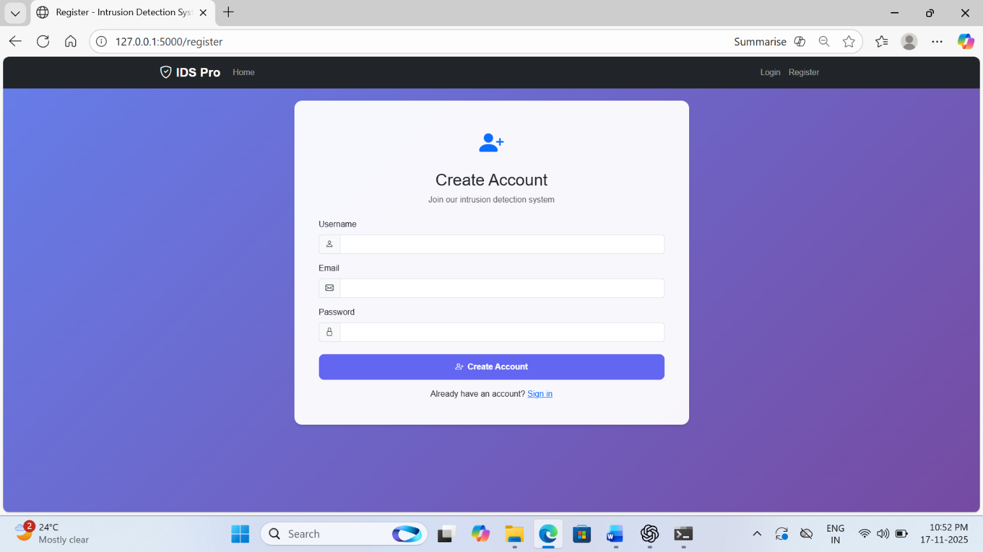
Register page: a register is a small, fast storage location within a CPU used to hold temporary data and instructions during processing.
Fig 7: Register page of intrusion detection system

Login page: A login is the process of gaining authorized access to a system or application by providing credentials, typically a username and password.
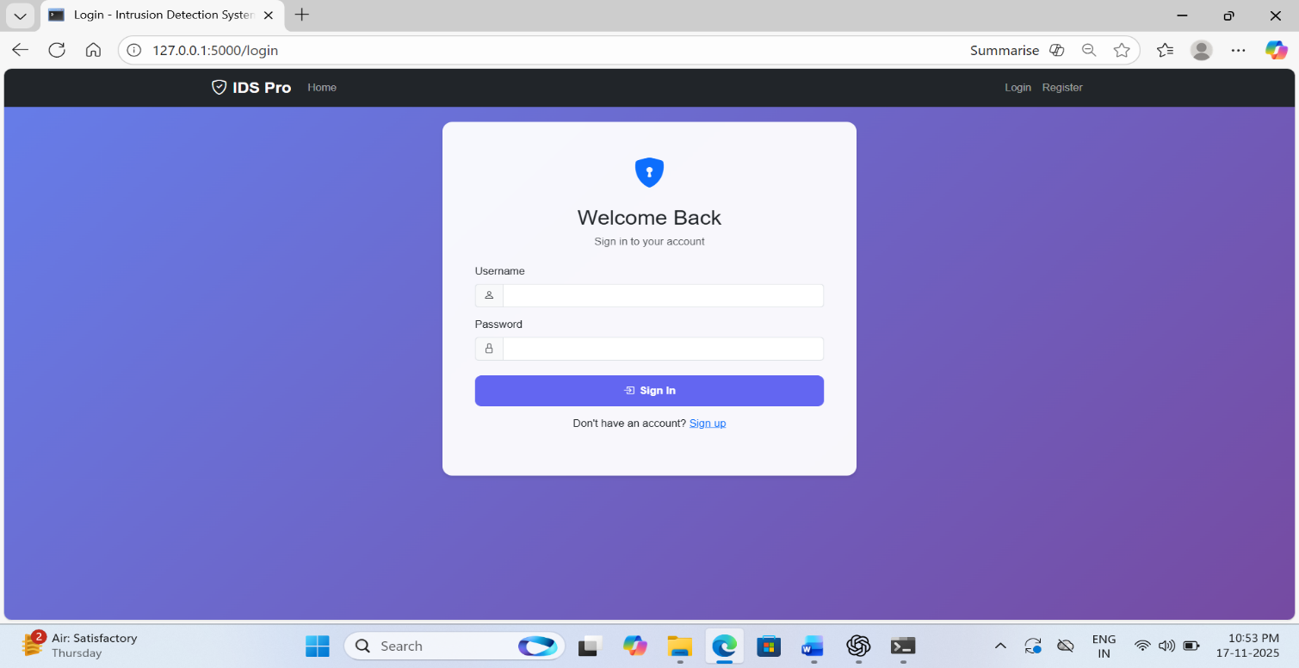

Fig 8: Login page of intrusion detection system
  - Output Screens

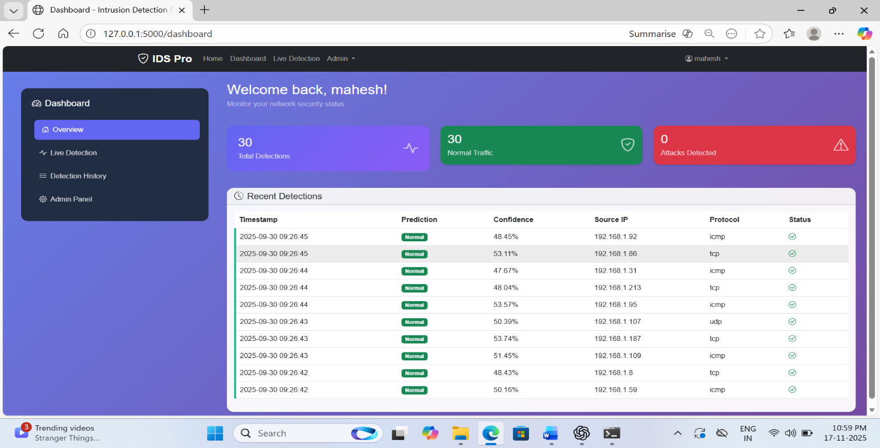
Dashboard Menu: It allows users to move between overview, live detection, detection history, and admin options without refreshing the page.
Fig 9: Dashboard menu of intrusion detection system
Live Detection: The Live Detection module shows real-time analysis of incoming network packets.
As data flows through the system, each request is immediately classified as normal or suspicious
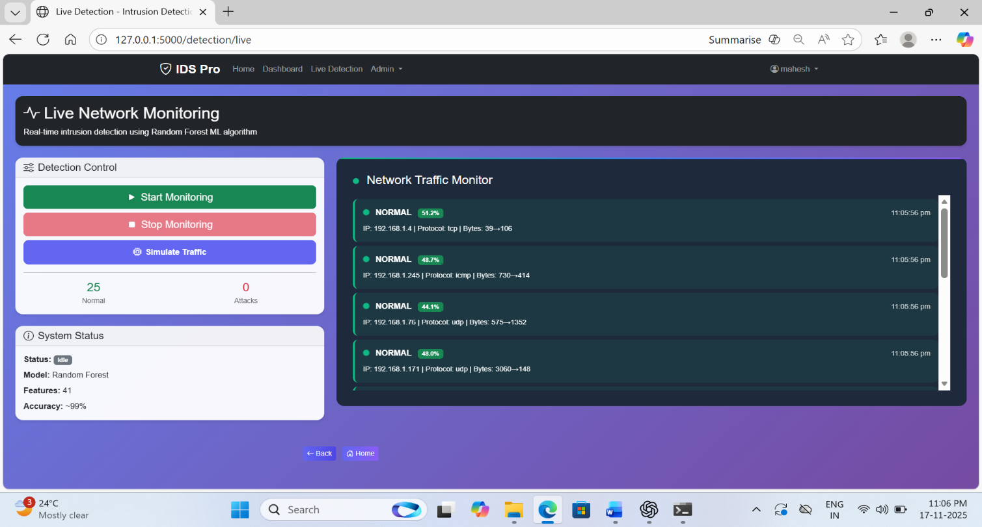
Fig 10: Live detection of intrusion detection system

Detection History: The Detection History page stores all past detection records, including timestamps, predictions, confidence scores, source IP addresses, and protocols.

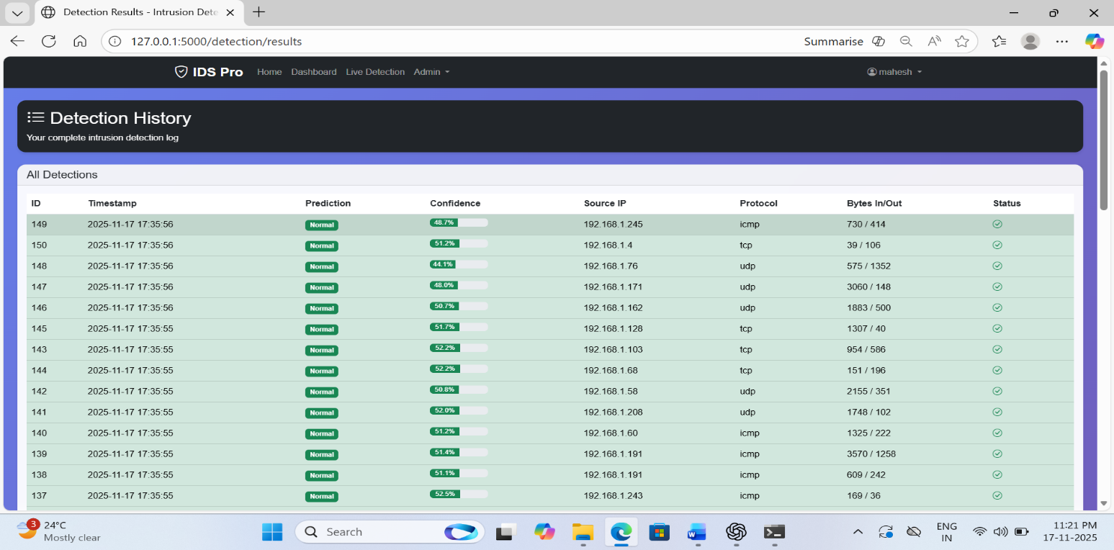

Fig 11: Detection history of intrusion detection system
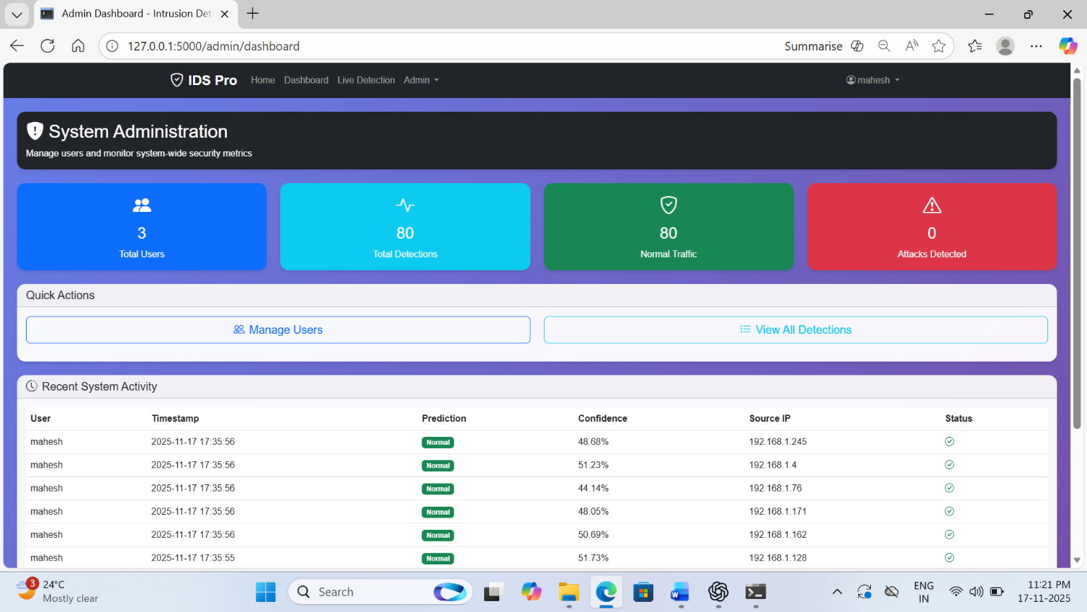
Admin Panel: The Admin Panel offers administrative controls such as user management, configuration settings, model updates, and system logs. Only authorized users can access this panel, ensuring the system's security and integrity
Fig 12: Admin panel of intrusion detection system
User Management: This section allows administrators to create, edit, and manage system users, including assigning roles such as SuperAdmin, Admin, or User. It also displays user details like email, status, creation date, and provides options to update or delete accounts
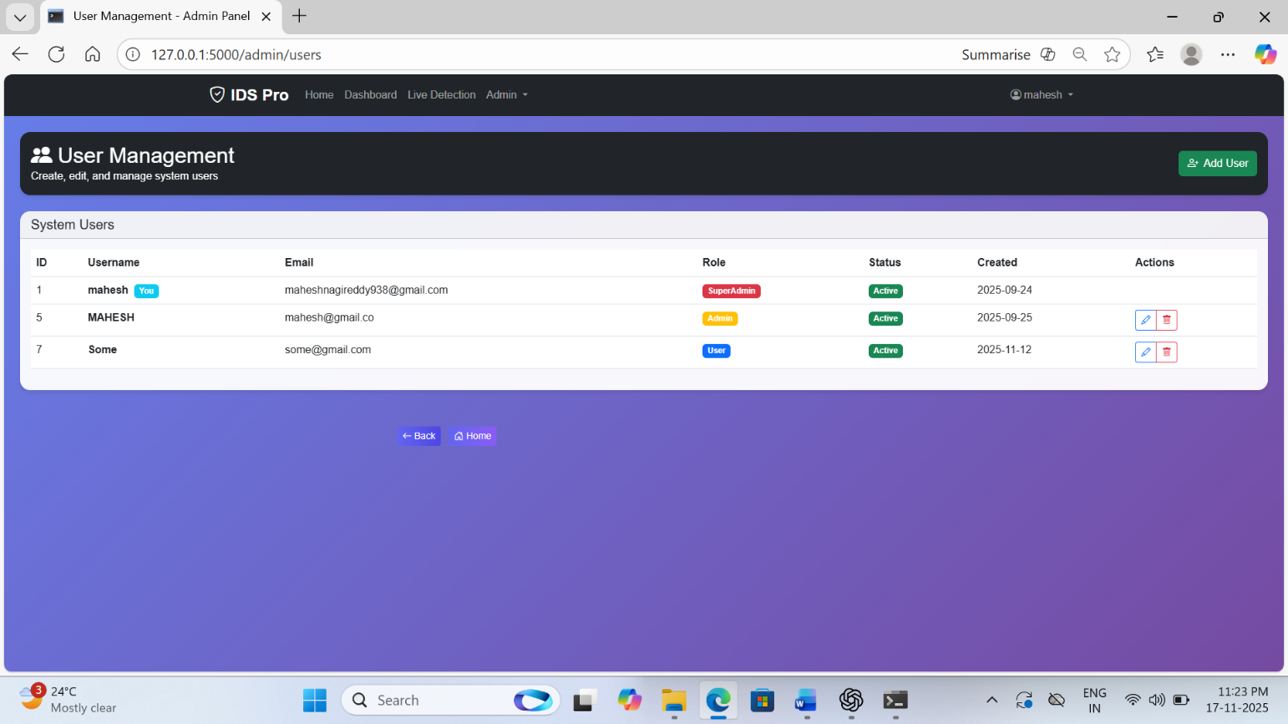
Fig 13: User management of intrusion detection system

Landing Page: The landing page provides an overview of the AI-powered Intrusion Detection System, showcasing its key features and offering quick access to the Dashboard and Live Detection module

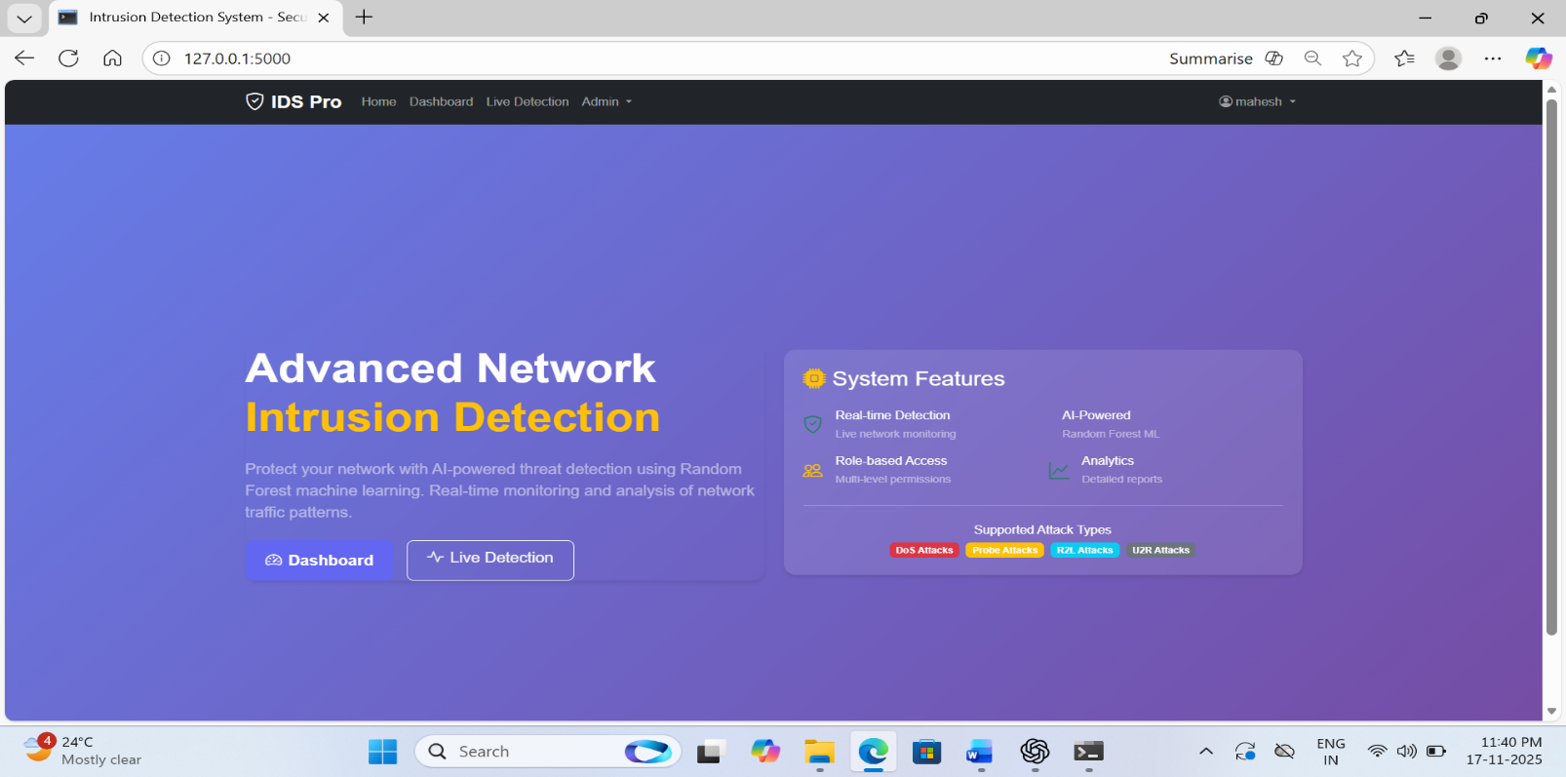 Fig 14: Landing page of intrusion detection system

Conclusions and Future Scope

Conclusion
Intrusion detection is a critical application of machine learning, aimed at safeguarding network systems and preventing unauthorized access or malicious activities. The effectiveness of such systems depends on their ability to accurately differentiate between normal and abnormal network traffic. By leveraging advanced models, features like traffic patterns, protocol types, source and destination IPs, and packet characteristics can be analyzed to detect anomalies indicative of potential attacks.
The system’s performance is often evaluated using metrics such as accuracy, precision, recall, and F1-score, which collectively provide insights into its reliability and efficiency. However, achieving high performance in intrusion detection is challenging due to the highly imbalanced nature of network datasets, as actual attacks are rare compared to normal traffic. A well-designed intrusion detection system must not only identify attacks with high precision but also maintain a low false-alarm rate to avoid interrupting legitimate network operations. Speed is equally important, as real-time detection is essential for mitigating threats before they cause significant damage.

The successful implementation of an intrusion detection system requires a combination of effective data preprocessing, feature engineering, and model training. When combined with deployment frameworks like Flask, such systems can be seamlessly integrated into organizational networks. While machine learning greatly enhances detection capabilities, it is essential to continually update the models with new data to adapt to emerging cyber-attack techniques, ensuring long-term effectiveness and resilience.

Limitations
Intrusion detection systems face several limitations that affect their overall performance. A major challenge is the high class imbalance in network datasets, where malicious traffic is rare compared to normal activity, often causing models to favor benign predictions and potentially miss attacks. The dynamic and evolving nature of cyber threats also reduces the effectiveness of static models, requiring frequent updates and retraining, which can be resource-intensive.
False positives remain a concern, as incorrectly flagged normal traffic can disrupt operations and reduce system trust. Additionally, real-time intrusion detection demands significant computational efficiency to analyze large volumes of network traffic without delays. Ensuring data privacy and secure handling of sensitive network logs further adds complexity. These limitations emphasize the need for continuous model refinement, adaptive learning approaches, and strong infrastructure to maintain effective intrusion detection.

Future Enhancements
Future improvements in intrusion detection can focus on adopting advanced machine learning techniques, including deep learning models such as LSTMs and Transformers, to better capture complex network behaviors. Real-time threat detection can be enhanced using streaming frameworks like Apache Kafka or Spark Streaming for faster response. Incorporating Explainable AI (XAI) will help security teams understand why certain traffic is flagged as malicious, improving trust and transparency. Behavioral analytics, such as user activity patterns and device usage trends, can further strengthen detection accuracy. Integrating blockchain for secure logging and immutable event records can reduce tampering risks. Additional progress can be made through improved feature engineering, dynamic model updates that adapt to evolving attack patterns, and multi-layered security approaches that combine intrusion detection with authentication measures. Finally, collaborative threat databases shared across organizations can significantly enhance global cyber-attack awareness and strengthen system resilience.

Reference

[1] M. Tavallaee, E. Bagheri, W. Lu and A. A. Ghorbani, “A Detailed Analysis of the KDD CUP 99 Data Set,” 2009 IEEE Symposium on Computational Intelligence for Security and Defence Applications, 2009. DOI: 10.1109/CISDA.2009.5356528.
[2] N. Moustafa and J. Slay, “UNSW-NB15: A Comprehensive Data Set for Network Intrusion Detection Systems,” 2015 Military Communications and Information Systems Conference (MilCIS), 2015. DOI: 10.1109/MilCIS.2015.7348942.
[3] W. Wang, X. Zhang, S. Gombault and S. Jukic, “Deep Learning-Based Intrusion Detection System: A Review,” IEEE Access, vol. 8, pp. 219650–219670, 2020. DOI: 10.1109/ACCESS.2020.3042593.
[4] H. Hindy et al., “A Taxonomy and Survey of Intrusion Detection System Design Techniques, Network Threats and Datasets,” IEEE Communications Surveys & Tutorials, vol. 23, no. 3, pp. 1383–1422, 2021. DOI: 10.1109/COMST.2021.3059299.
[5] S. Shone and T. N. Ngoc, “A Deep Learning Approach to Network Intrusion Detection,” IEEE Transactions on Emerging Topics in Computational Intelligence, vol. 2, no. 1, pp. 41–50, 2018. DOI: 10.1109/TETCI.2017.2772792.
[6] S. Shah, A. Issac and K. Sudeep, “Ensemble-Based Machine Learning Models for Efficient Intrusion Detection,” 2020 IEEE International Conference on Advanced Networks and Telecommunications Systems (ANTS), 2020. DOI: 10.1109/ANTS50601.2020.9342819.
[7] A. Javaid, Q. Niyaz, W. Sun and M. Alam, “A Deep Learning Approach for Network Intrusion Detection System,” 2016 IEEE Big Data Security on Cloud, 2016. DOI: 10.1109/BigDataSecurity-HPSC-IDS.2016.17.
[8] F. Iglesias and T. Zseby, “Analysis of Network Traffic Features for Anomaly Detection,” Machine Learning, vol. 101, no. 1–3, pp. 59–84, 2015. DOI: 10.1007/s10994-014-5473-9.
[9] S. Garg, S. K. Peddoju and R. K. Goyal, “Behavior-Based Intrusion Detection in IoT Networks Using Machine Learning Techniques,” 2020 IEEE International Conference on Communications Workshops (ICC Workshops), 2020. DOI: 10.1109/ICCWorkshops49005.2020.9145093.

Appendices
- Appendix A: Dataset Description

- Features:
  - Source IP: IP address of the device sending the network packet.
  - Destination IP: IP address receiving the packet.
  - Protocol: Type of protocol used (TCP, UDP, ICMP, etc.).
  - Packet Size: Size of the network packet in bytes.
  - Timestamp: Date and time when the network activity occurred.
  - Flags / Ports: Connection flags or port numbers used during communication.
- Label:
  - 1 (Malicious), 0 (Benign).

- Appendix B: Performance Metrics

- Accuracy: Percentage of correctly classified network activities.
- Precision: Fraction of predicted malicious activities that are actually malicious.
- Recall (Sensitivity): Fraction of actual attacks detected by the system.
- F1-Score: Harmonic mean of precision and recall.

- Appendix C: Algorithms Used

- Supervised Learning: Logistic Regression, Random Forest, XG Boost.
- Unsupervised Learning: Isolation Forest, k-Means Clustering.
- Hybrid Models: Combination of anomaly detection and classification techniques.
- Appendix D: Tools and Libraries
- Programming Languages: Python.
- Libraries:
  - scikit-learn: Model training and evaluation.
  - pandas, numpy: Data preprocessing.
  - Flask: Deployment of real-time intrusion detection system.

- Appendix E: Real-Time Setup

- Data Ingestion: Tools like Kafka or RabbitMQ for streaming network packets.
- Deployment Frameworks: TensorFlow Serving, Flask, or FastAPI.
- Appendix F: Ethical Considerations
- Privacy: Ensure compliance with GDPR or other data protection regulations when handling network logs.
- Bias Mitigation: Detect and reduce biases in traffic data to avoid incorrect
or unfair classifications
These appendices provide additional context and clarity to the methodology and implementation of an Intrusion Detection System (IDS).

