Experiment 1
Aim:
To demonstrate basic JavaScript operations including console logging, alert boxes, and array manipulations.
Description:
Part a:
Console logging "Hello, World!" and Calculating sum of two numbers and displaying in an alert box
Part b:
Creating an array of 5 cities, Displaying the total number of cities, Adding a new city at the end, Removing the first city, Finding and logging the index of a specific city.
Code:
index.html:
<!DOCTYPE html>
<html lang="en">
<head>
<meta charset="UTF-8">
<meta name="viewport" content="width=device-width, initial-scale=1.0">
<title>mahesh-24A21F0066</title>
<link href="https://cdn.jsdelivr.net/npm/bootstrap@5.3.2/dist/css/bootstrap.min.css" rel="stylesheet">
</head>
<body class="p-4">
<div class="container">
<h1 class="mb-4" style="text-align: center;">Experiment 1 : JavaScript Basics</h1>
<h2>Part A: Hello World and Sum Calculation</h2>
<button id="sumBtn" class="btn btn-primary mb-4">Calculate Sum</button>
<h2>Part B: Array Operations</h2>
<div id="arrayOutput" class="border p-3 rounded bg-light"></div>
</div>
<script src="https://cdn.jsdelivr.net/npm/bootstrap@5.3.2/dist/js/bootstrap.bundle.min.js"></script>
<script src="script.js"></script>
</body>
</html>

script.js:
// Part A: Hello World and Sum Calculation
console.log("Hello, World!");
document.getElementById('sumBtn').addEventListener('click', function() {
const num1 = Number(prompt("Enter first value:"));
const num2 = Number(prompt("Enter second value:"));
const sum = num1 + num2;
alert(`The sum of ${num1} and ${num2} is ${sum}`);
});

// Part B: Array Operations
const cities = ["Lakkavaram", "Malikipuram", "Razole", "Narsapur", "Seetharampuram"];

// Function to display array operations
function displayArrayOperations() {
let output = document.getElementById('arrayOutput');

// Log total number of cities
output.innerHTML += `<p>Total number of cities: ${cities.length}</p>`;

// Add a new city at the end
cities.push("Battelanka");
output.innerHTML += `<p>After adding Battelanka: ${cities.join(", ")}</p>`;

// Remove the first city
const removedCity = cities.shift();
output.innerHTML += `<p>Removed city: ${removedCity}</p>`;
output.innerHTML += `<p>Cities after removal: ${cities.join(", ")}</p>`;

// Find and log the index of a specific city
const cityToFind = "Razole";
const cityIndex = cities.indexOf(cityToFind);
output.innerHTML += `<p>Index of ${cityToFind}: ${cityIndex}</p>`;
}

// Call the function when the page loads
window.onload = displayArrayOperations;

Outputs:

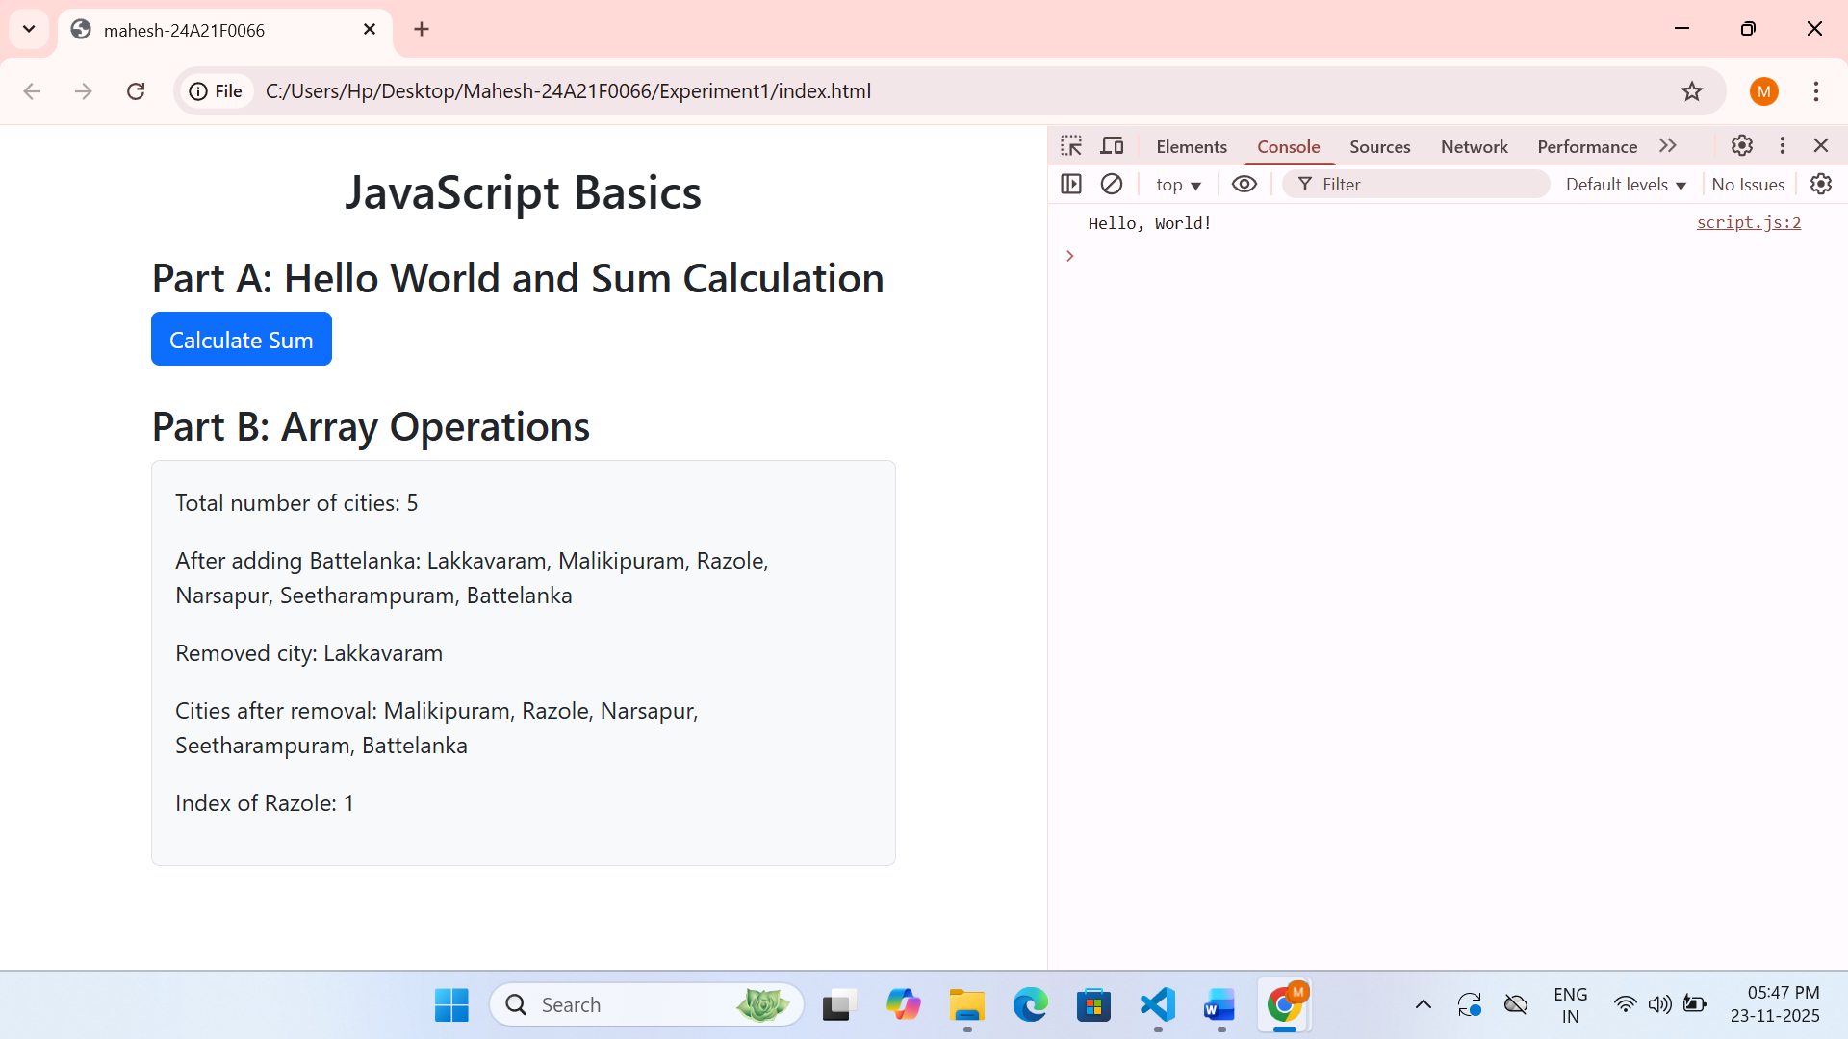

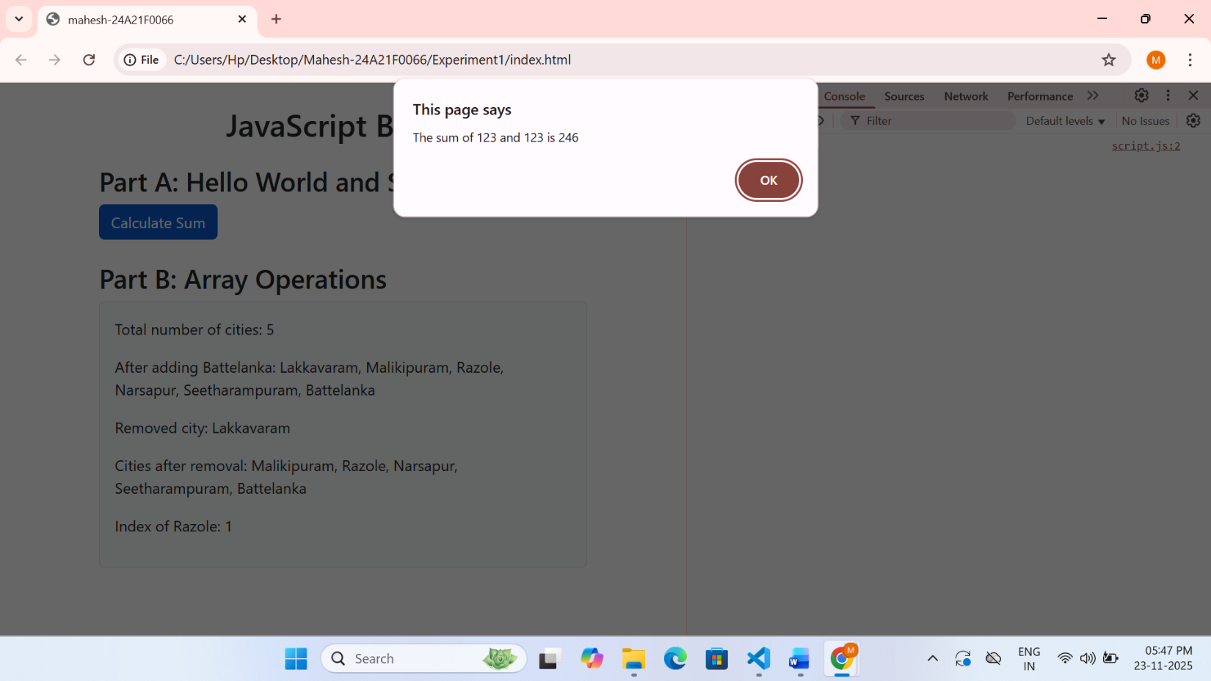
Experiment 2

Aim :
To demonstrate string manipulation operations in JavaScript.
Description :
String length calculation, Substring extraction using substring() method, Word replacement using replace() method, Palindrome check function that ignores spaces and special characters
Code:
Html file:
<!DOCTYPE html>
<html lang="en">
<head>
<meta charset="UTF-8">
<meta name="viewport" content="width=device-width, initial-scale=1.0">
<title>mahesh-24A21F0066</title>
<link href="https://cdn.jsdelivr.net/npm/bootstrap@5.3.2/dist/css/bootstrap.min.css" rel="stylesheet">
</head>
<body class="p-4">
<div class="container">
<h1 class="mb-3">String Manipulation</h1>
<div class="mb-3">
<input type="text" id="inputString" class="form-control" placeholder="Enter a string">
</div>
<div class="d-flex flex-wrap gap-2 mb-3">
<button id="checkLength" class="btn btn-primary">Length</button>
<button id="extractJS" class="btn btn-secondary">Extract JS</button>
<button id="replaceWord" class="btn btn-warning">Replace</button>
<button id="checkPalindrome" class="btn btn-success">Palindrome</button>
</div>
<div id="results" class="p-3 border rounded bg-light">Results will appear here...</div>
</div>
<script src="https://cdn.jsdelivr.net/npm/bootstrap@5.3.2/dist/js/bootstrap.bundle.min.js"></script>
<script src="script.js"></script>
</body>
</html>
script.js:
// Function to display results
function showResult(message) {
document.getElementById('results').innerHTML += `<p>${message}</p>`;
}
// Check string length
document.getElementById('checkLength').addEventListener('click', function() {
const inputString = document.getElementById('inputString').value;
showResult(`The length of the string is: ${inputString.length}`);
});
// Extract "JavaScript"
document.getElementById('extractJS').addEventListener('click', function() {
const inputString = document.getElementById('inputString').value;
if (inputString.includes('JavaScript')) {
const extracted = inputString.substring(inputString.indexOf('JavaScript'), inputString.indexOf('JavaScript') + 10);
showResult(`Extracted: "${extracted}"`);
} else {
showResult('The string does not contain "JavaScript"');
}
});
// Replace word
document.getElementById('replaceWord').addEventListener('click', function() {
const inputString = document.getElementById('inputString').value;
const replaced = inputString.replace('old', 'new');
showResult(`Original: "${inputString}"<br>Replaced: "${replaced}"`);
});
// Check if string is palindrome
document.getElementById('checkPalindrome').addEventListener('click', function() {
const inputString = document.getElementById('inputString').value;
const result = isPalindrome(inputString);
showResult(`"${inputString}" is ${result ? 'a palindrome' : 'not a palindrome'}`);
});

// Function to check if a string is a palindrome
function isPalindrome(str) {
// Remove non-alphanumeric characters and convert to lowercase
const cleanStr = str.replace(/[^a-zA-Z0-9]/g, '').toLowerCase();
// Compare with reversed string
const reversedStr = cleanStr.split('').reverse().join('');
return cleanStr === reversedStr;
}

Output:

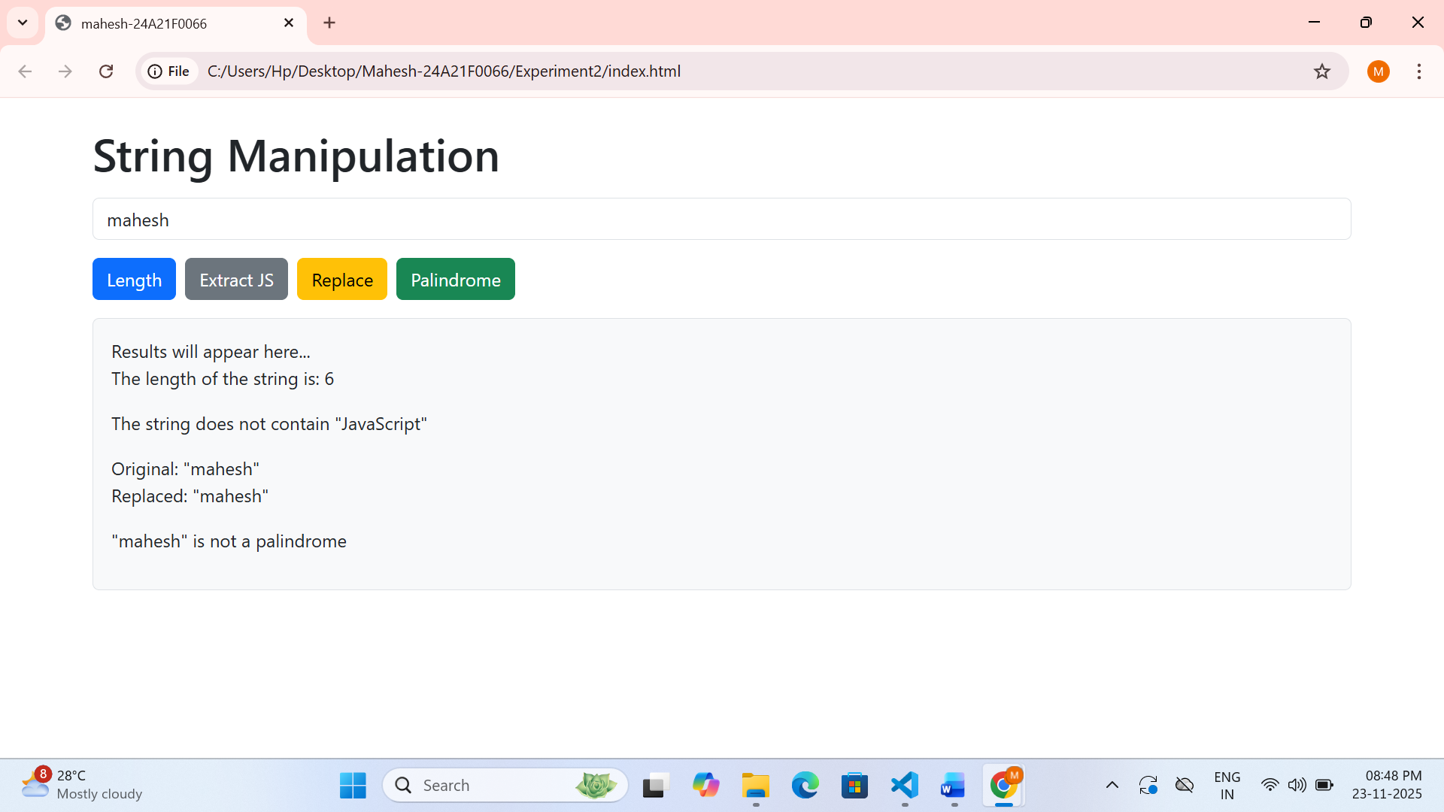
Experiment 3
Aim:
To demonstrate working with JavaScript objects, properties, and methods.
Description:
Creating an object with properties and methods, Dynamically adding properties to an object, Looping through object keys and values
Code:
Html file:
<!DOCTYPE html>
<html lang="en">
<head>
<meta charset="UTF-8">
<meta name="viewport" content="width=device-width, initial-scale=1.0">
<title>mahesh-24A21F0066</title>
<link href="https://cdn.jsdelivr.net/npm/bootstrap@5.3.2/dist/css/bootstrap.min.css" rel="stylesheet">
</head>
<body class="p-4">
<div class="container">
<h1 class="mb-4 text-center">JavaScript Objects</h1>
<div class="d-flex flex-wrap gap-2 mb-3">
<button id="displayInfo" class="btn btn-primary">Display Student Info</button>
<button id="addProperty" class="btn btn-success">Add Passed Property</button>
<button id="displayKeys" class="btn btn-warning">Display Keys & Values</button>
</div>
<div id="output" class="border rounded p-3 bg-light">
<p>Results will appear here...</p>
</div>
</div>
<script src="https://cdn.jsdelivr.net/npm/bootstrap@5.3.2/dist/js/bootstrap.bundle.min.js"></script>
<script src="script.js"></script>
</body>
</html>

script.js:
// Create student object
const student = {
name: "mahesh",
grade: 85,
subjects: ["c", "java", "python", "fullstack"],
displayInfo: function() {
return `Name: ${this.name}, Grade: ${this.grade}, Subjects: ${this.subjects.join(", ")}`;
}
};
function showOutput(message) {
document.getElementById('output').innerHTML = message;
}
document.getElementById('displayInfo').addEventListener('click', function() {
showOutput(`<h3>Student Information:</h3><p>${student.displayInfo()}</p>`);
});
document.getElementById('addProperty').addEventListener('click', function() {
student.passed = student.grade >= 60;
let message = `<h3>Added 'passed' property:</h3>`;
message += `<p>${student.name} has ${student.passed ? 'passed' : 'failed'} with a grade of ${student.grade}.</p>`;
showOutput(message);
});
document.getElementById('displayKeys').addEventListener('click', function() {
let message = `<h3>All Keys and Values:</h3><ul>`;
for (let key in student) {
// Check if the property is not a function
if (typeof student[key] !== 'function') {
message += `<li><strong>${key}:</strong> ${Array.isArray(student[key]) ? student[key].join(", ") : student[key]}</li>`;
} else {
message += `<li><strong>${key}:</strong> [Function]</li>`;
}
}
message += `</ul>`;
showOutput(message);
});

Output:

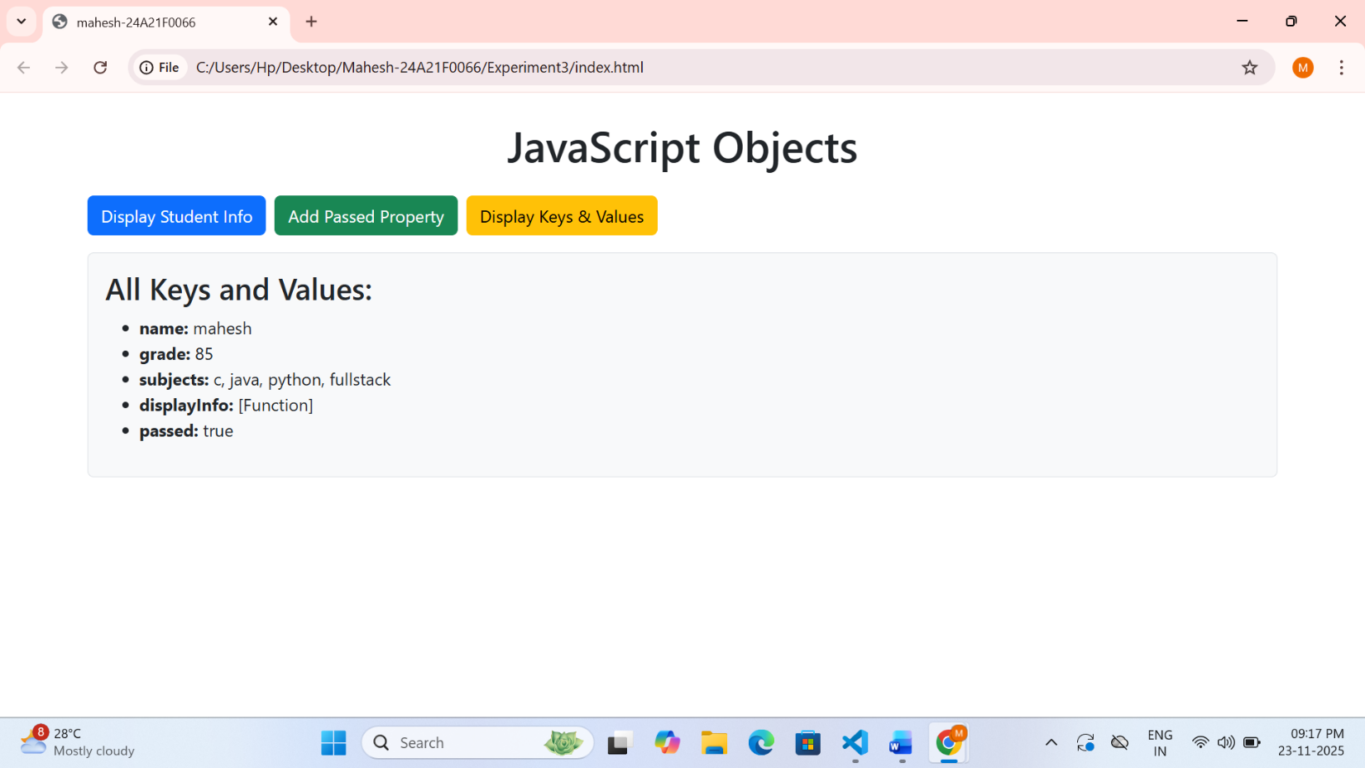

Experiment 4

Aim:
To demonstrate DOM manipulation and event handling in JavaScript
Description:
Click event listener on a button, Mouseover event listener to change image border color, Document-level key press event listener.
Code:
Html file:
<!DOCTYPE html>
<html lang="en">
<head>
<meta charset="UTF-8">
<meta name="viewport" content="width=device-width, initial-scale=1.0">
<title>mahesh-24A21F0066</title>
<link href="https://cdn.jsdelivr.net/npm/bootstrap@5.3.2/dist/css/bootstrap.min.css" rel="stylesheet">
<style>
img {
width: 250px;
border: 3px solid black;
}
#keyPressed {
font-weight: bold;
color: blue;
}
</style>
</head>
<body class="p-4">
<div class="container">
<h1 class="text-center mb-4">DOM Manipulation and Event Listeners</h1>
<div class="row text-center" style="border: 2px solid ;">
<div class="col-md-4 mb-4">
<h3>Click Event</h3>
<button id="clickMe" class="btn btn-primary">Click Me</button>
</div>
<div class="col-md-4 mb-4">
<h3>Mouse Over Event</h3>
<img id="imageElement" src="swrnlogo.png" class="img-fluid rounded" alt="Image">
</div>
<div class="col-md-4 mb-4">
<h3>Key Press Event</h3>
<p>Press any key</p>
<p>Key pressed: <span id="keyPressed">None yet</span></p>
</div>
</div>
<div id="output" class="border rounded p-3 bg-light">
</div>
</div>
<script src="https://cdn.jsdelivr.net/npm/bootstrap@5.3.2/dist/js/bootstrap.bundle.min.js"></script>
<script src="script.js"></script>
</body>
</html>
script.js:
function logEvent(message) {
const output = document.getElementById('output');
const time = new Date().toLocaleTimeString();
const entry = `
<div class="alert alert-info py-1 my-1">
<small>[${time}] ${message}</small>
</div>
`;
output.innerHTML = entry + output.innerHTML;
}
function logEvent(message) {
const output = document.getElementById('output');
const time = new Date().toLocaleTimeString();
const log = `
<div class="alert alert-info py-1 my-1">
<small>[${time}] ${message}</small>
</div>
`;
output.innerHTML = log + output.innerHTML;
}

document.getElementById('clickMe').addEventListener('click', function() {
logEvent('Button clicked!');
});
document.getElementById('imageElement').addEventListener('mouseover', function() {
this.style.borderColor = 'red';
logEvent('Mouse over image - border turned red');
});
document.getElementById('imageElement').addEventListener('mouseout', function() {
this.style.borderColor = 'black';
logEvent('Mouse out image - border reset to black');
});
document.addEventListener('keydown', function(event) {
document.getElementById('keyPressed').textContent = event.key;
logEvent(`Key pressed: ${event.key}`);
});

swarnlogo.png:



Output:

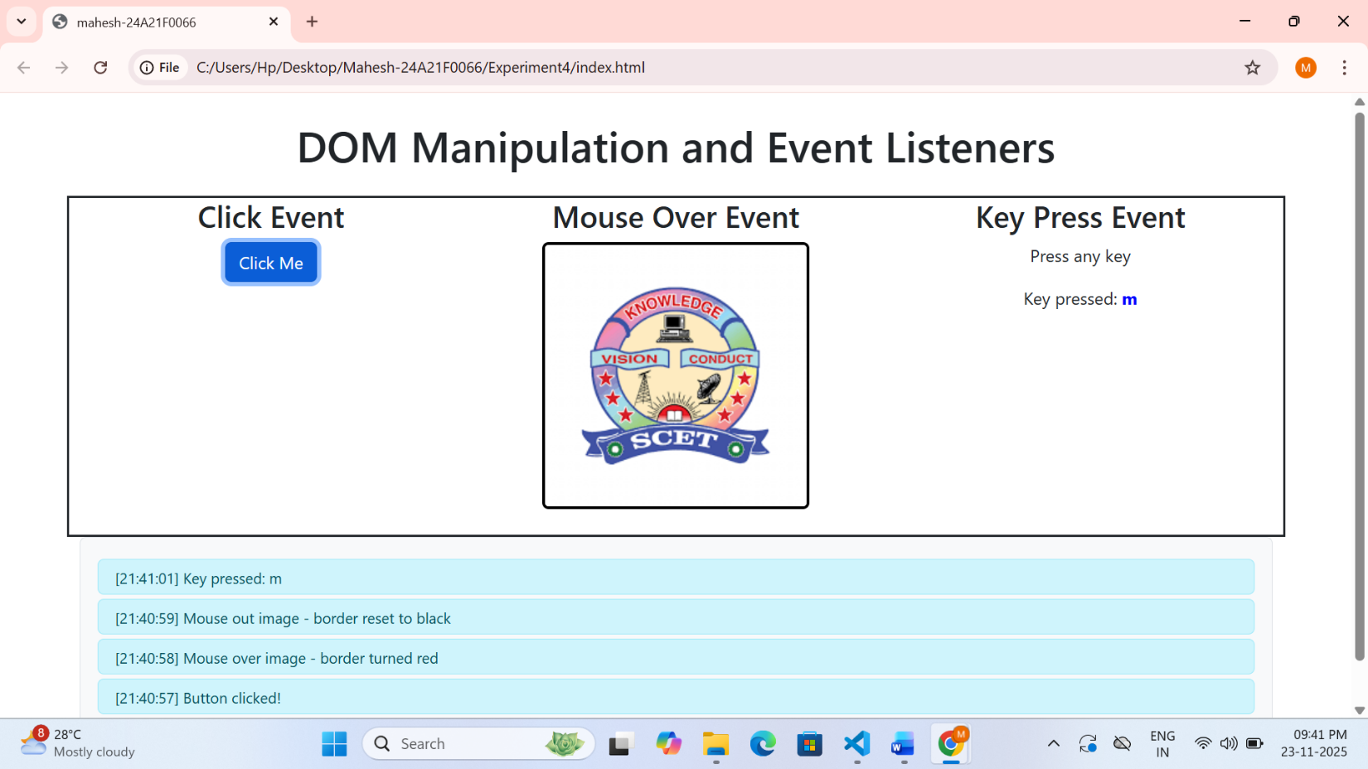

Experiment 5
Aim:
To demonstrate a simple React application for tracking issues.
Description:
Functional React components, Static data for issues, Conditional styling based on issue status, Component composition
Code:
Html file:
<!DOCTYPE html>
<html>
<head>
<meta charset="UTF-8" />
<meta name="viewport" content="width=device-width, initial-scale=1.0" />
<title>mahesh-24A21F0066</title>
<link href="https://cdn.jsdelivr.net/npm/bootstrap@5.3.2/dist/css/bootstrap.min.css" rel="stylesheet">
<script src="https://unpkg.com/react@17/umd/react.development.js"></script>
<script src="https://unpkg.com/react-dom@17/umd/react-dom.development.js"></script>
<script src="https://unpkg.com/@babel/standalone/babel.min.js"></script>
<style>
body{background:#f2f4f8}
.box{
border:2px solid #dee2e6;
border-left:8px solid;
background:#fff;
padding:15px;
border-radius:8px;
margin-bottom:15px;
transition:.2s
}
.box:hover{
background:#f8f9fa;
transform:scale(1.01)
}
</style>
</head>

<body class="p-4">
<div class="container">
<h2 class="text-center mb-4 fw-bold">Issue Tracker</h2>
<div id="root"></div>
</div>

<script type="text/babel">

const Issue = ({i}) => (
<div className="box" style={{borderLeftColor:i.status==="Open"?"#28a745":"#dc3545"}}>
<h5>{i.title}</h5>
<p>{i.description}</p>
<span className={`badge ${i.status==="Open"?"bg-success":"bg-danger"}`}>{i.status}</span>
</div>
);

const App = () => {
const issues = [
{title:"API rate limit exceeded",description:"Dashboard fails due to API throttling",status:"Open"},
{title:"Dark mode color mismatch",description:"Text unreadable in dark theme",status:"Open"},
{title:"Notification sound not playing",description:"Audio alert fails in browser",status:"Closed"},
{title:"Search filter not updating",description:"Filters do not refresh results",status:"Open"}
];

return (
<div>
<p class="fw-bold mb-3">Total Issues:
<span class="badge bg-primary">{issues.length}</span>
</p>

{issues.map((i,k)=><Issue key={k} i={i}/>)}
</div>
);
};

ReactDOM.render(<App/>, document.getElementById("root"));
</script>
</body>
</html>

Output:

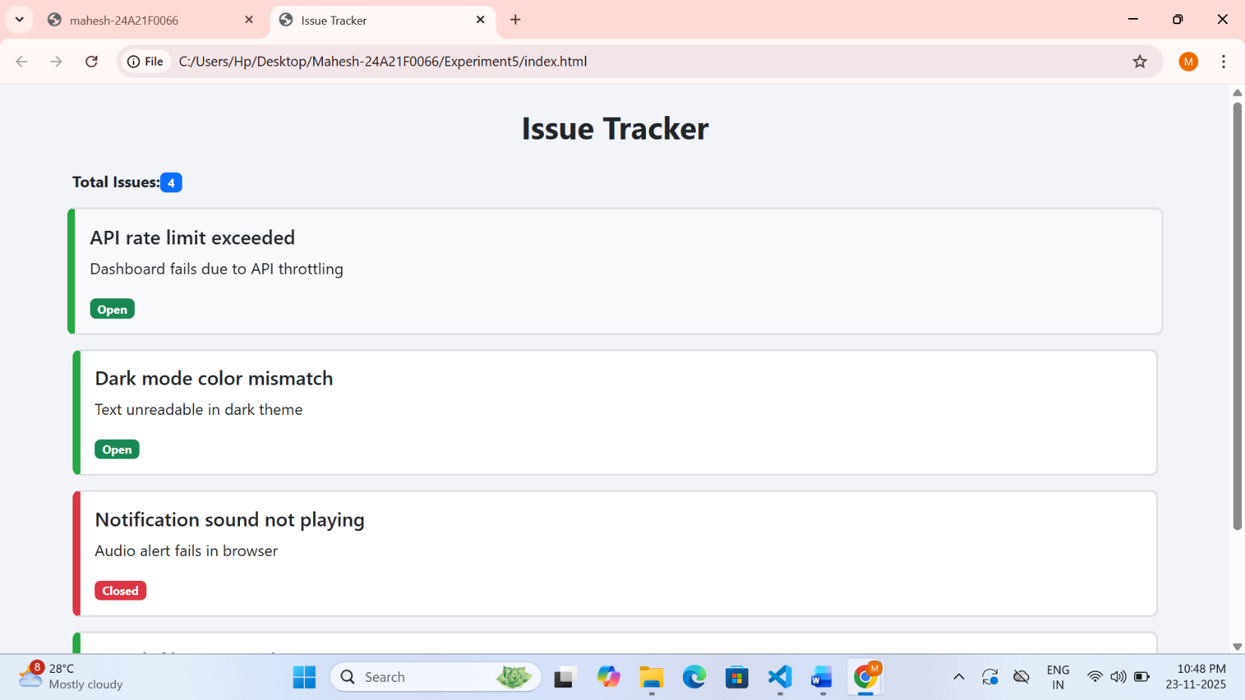

Experiment 6
Aim:
To demonstrate a React counter component using hooks for state management and side effects.
Description:
React functional component with useState hook, useEffect hook for simulating data fetching, Multiple state update functions, Conditional rendering based on loading state
Code:
Html file:
<!DOCTYPE html>
<html lang="en">
<head>
<meta charset="UTF-8" />
<meta name="viewport" content="width=device-width, initial-scale=1.0" />
<title>mahesh-24A21F0066</title>
<link href="https://cdn.jsdelivr.net/npm/bootstrap@5.3.0/dist/css/bootstrap.min.css" rel="stylesheet" />
<script src="https://unpkg.com/react@17/umd/react.development.js"></script>
<script src="https://unpkg.com/react-dom@17/umd/react-dom.development.js"></script>
<script src="https://unpkg.com/@babel/standalone/babel.min.js"></script>
</head>
<body class="bg-light">
<div id="root" class="container mt-5"></div>
<script type="text/babel">
const Counter = () => {
const [count, setCount] = React.useState(0);
const [loading, setLoading] = React.useState(true);
React.useEffect(() => {
setTimeout(() => setLoading(false), 1500);
}, []);

return (
<div className="card p-4 text-center shadow-sm">
<h1>React Counter</h1>
{loading ? (
<p className="text-muted">Loading...</p>
) : (
<>
<div className="display-3 fw-bold mb-4">{count}</div>
<div className="d-flex justify-content-center gap-2 flex-wrap">
<button className="btn btn-warning" onClick={() => setCount(c => c - 1)}>Decrement</button>
<button className="btn btn-success" onClick={() => setCount(c => c + 1)}>Increment</button>
<button className="btn btn-primary" onClick={() => setCount(c => c * 2)}>Double</button>
<button className="btn btn-danger" onClick={() => setCount(0)}>Reset</button>
</div>
</>
)}
</div>
);
};
ReactDOM.render(<Counter />, document.getElementById("root"));
</script>
<script src="https://cdn.jsdelivr.net/npm/bootstrap@5.3.0/dist/js/bootstrap.bundle.min.js"></script>
</body>
</html>

Output:
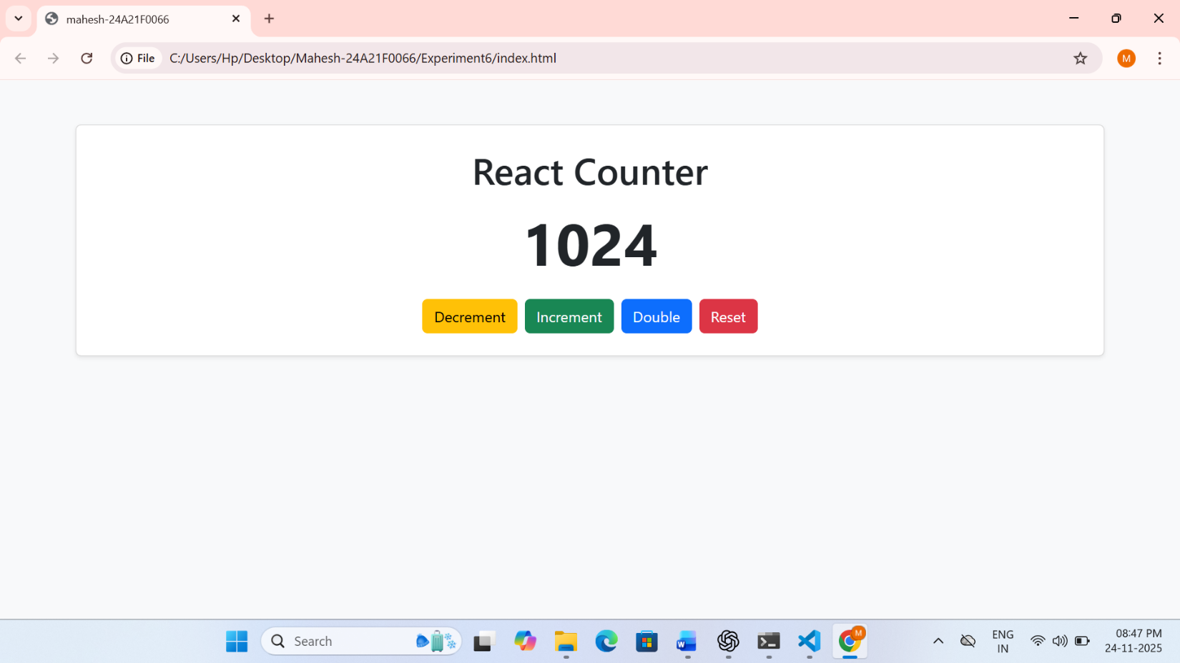

Experiment 7
Aim:
To demonstrate creating a REST API using Express.js.
Description:
Express.js server setup, REST API implementation, Request logging middleware, JSON payload parsing, CRUD operations for products
GET /: Returns "Hello, Express!"
GET /products: Returns a list of all products
GET /products/:id: Returns details of a specific product
POST /products: Adds a new product
PUT /products/:id: Updates an existing product
DELETE /products/:id: Deletes a product
Code:
server.js:
const express = require('express');
const app = express();
const PORT = 3000;
// Middleware to log requests
app.use((req, res, next) => {
console.log(`${new Date().toISOString()} - ${req.method} ${req.url}`);
next();
});
// Parse JSON payloads
app.use(express.json());
// Sample product data
let products = [
{ id: 1, name: 'Laptop', price: 999.99, category: 'Electronics' },
{ id: 2, name: 'Smartphone', price: 699.99, category: 'Electronics' },
{ id: 3, name: 'Headphones', price: 149.99, category: 'Accessories' }
];
// Root endpoint
app.get('/', (req, res) => {
res.send('Hello, Express!');
});
// GET all products
app.get('/products', (req, res) => {
res.json(products);
});
// GET product by ID
app.get('/products/:id', (req, res) => {
const id = parseInt(req.params.id);
const product = products.find(p => p.id === id);
if (!product) {
return res.status(404).json({ message: 'Product not found' });
}
res.json(product);
});
// POST new product
app.post('/products', (req, res) => {
const { name, price, category } = req.body;
if (!name || !price) {
return res.status(400).json({ message: 'Name and price are required' });
}
const newId = products.length > 0 ? Math.max(...products.map(p => p.id)) + 1 : 1;
const newProduct = {
id: newId,
name,
price,
category: category || 'Uncategorized'
};
products.push(newProduct);
res.status(201).json(newProduct);
});
// PUT update product
app.put('/products/:id', (req, res) => {
const id = parseInt(req.params.id);
const index = products.findIndex(p => p.id === id);
if (index === -1) {
return res.status(404).json({ message: 'Product not found' });
}
const { name, price, category } = req.body;
products[index] = {
id,
name: name || products[index].name,
price: price || products[index].price,
category: category || products[index].category

};
res.json(products[index]);
});
// DELETE product
app.delete('/products/:id', (req, res) => {
const id = parseInt(req.params.id);
const index = products.findIndex(p => p.id === id);
if (index === -1) {
return res.status(404).json({ message: 'Product not found' });
}
const deletedProduct = products[index];
products = products.filter(p => p.id !== id);

res.json({ message: 'Product deleted', product: deletedProduct });
});
// Start server
app.listen(PORT, () => {
console.log(`Server running on http://localhost:${PORT}`);
});

package.json:
{
"name": "express-rest-api",
"version": "1.0.0",
"description": "Express.js REST API for Products",
"main": "server.js",
"scripts": {
"start": "node server.js"
},
"dependencies": {
"express": "^4.17.1"
}
}

Outputs:
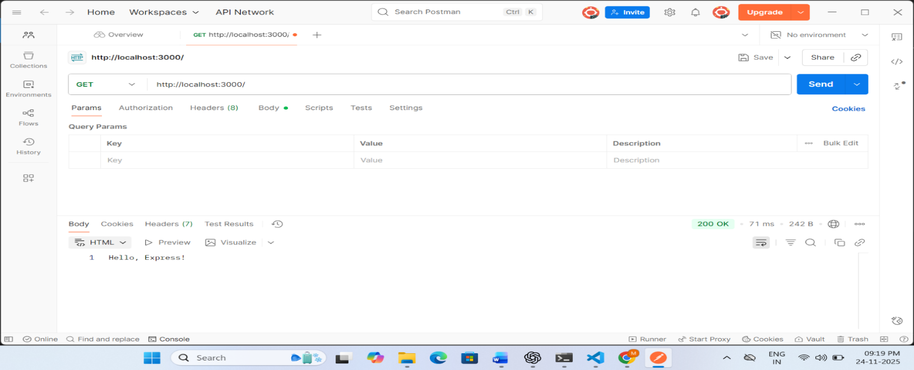
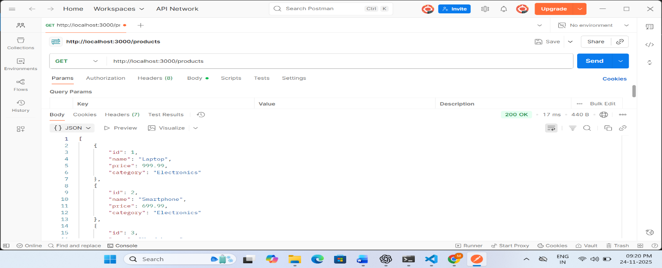
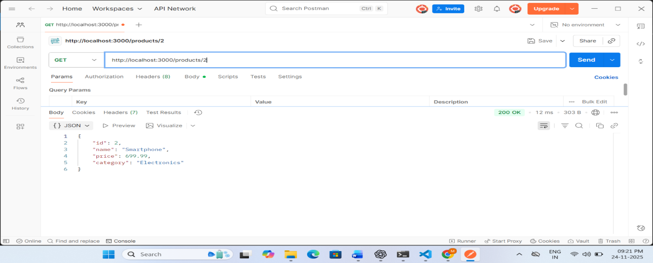
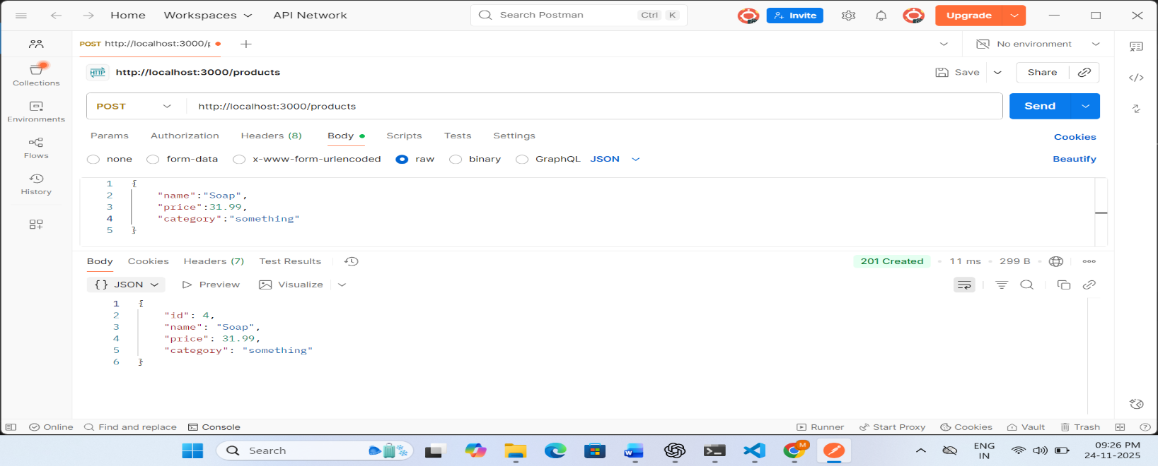
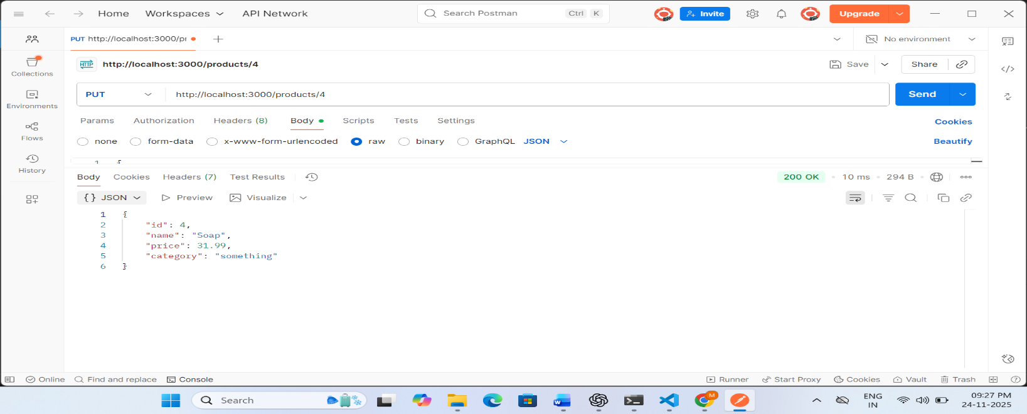
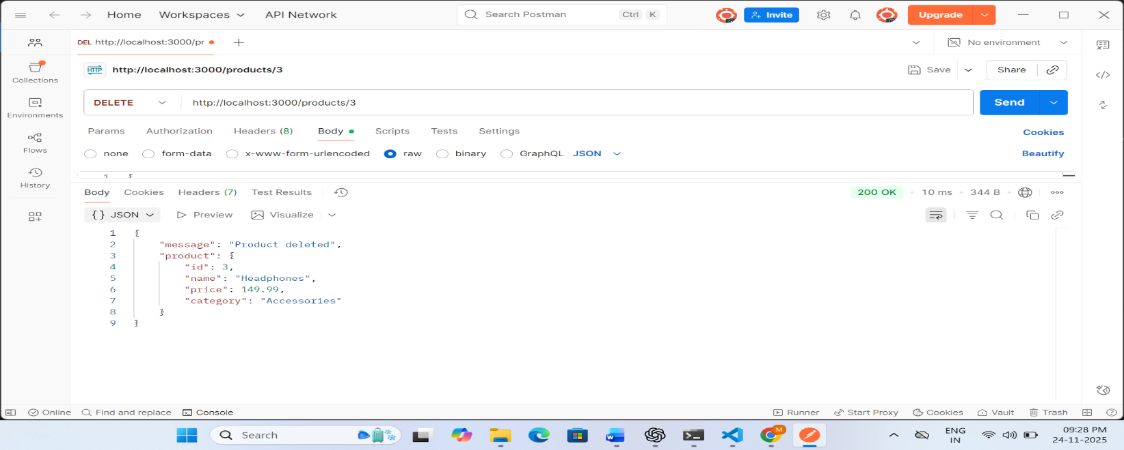

Experiment 8

Aim:

This experiment demonstrates how to create a full-stack application by integrating MongoDB with Express.js backend and React frontend. It implements a product management system with CRUD operations.

Description:

MongoDB Integration**: Uses Mongoose to define schemas and models
Express.js REST API: Implements CRUD operations for products
React Frontend: Interactive UI for managing products
Form Validation: Basic validation for required fields
Mock Data: Simulates API interactions for demonstration purposes

Implementation:

Backend: Express.js server with MongoDB connection
Data Model: Product schema with name, price, description, and category
Frontend: React components for product listing and form submission
State Management: React hooks (useState, useEffect) for managing application state

Code:

--> Client(html file):

<!DOCTYPE html>
<html lang="en">
<head>
<meta charset="UTF-8">
<meta name="viewport" content="width=device-width, initial-scale=1.0">
<title>Experiment 8 - MongoDB with Express and React</title>
<script src="https://unpkg.com/react@17/umd/react.development.js"></script>
<script src="https://unpkg.com/react-dom@17/umd/react-dom.development.js"></script>
<script src="https://unpkg.com/@babel/standalone/babel.min.js"></script>
<style>
body {
font-family: Arial, sans-serif;
max-width: 800px;
margin: 0 auto;
padding: 20px;
}
.product-form {
border: 1px solid #ddd;
padding: 20px;
margin-bottom: 20px;
border-radius: 5px;
}
.form-group {
margin-bottom: 15px;
}
.form-group label {
display: block;
margin-bottom: 5px;
}
.form-group input {
width: 100%;
padding: 8px;
box-sizing: border-box;
}
button {
padding: 10px 15px;
background-color: #4CAF50;
color: white;
border: none;
cursor: pointer;
border-radius: 4px;
}
button:hover {
background-color: #45a049;
}
.product-list {
margin-top: 20px;
}
.product-item {
border: 1px solid #ddd;
padding: 10px;
margin-bottom: 10px;
border-radius: 5px;
}
.error {
color: red;
margin: 10px 0;
}
</style>
</head>
<body>
<div id="root"></div>

<script type="text/babel">
// Main App Component
const App = () => {
const [products, setProducts] = React.useState([]);
const [loading, setLoading] = React.useState(true);
const [error, setError] = React.useState(null);
const [formData, setFormData] = React.useState({
name: '',
price: '',
description: '',
category: ''
});

// Fetch products on component mount
React.useEffect(() => {
fetchProducts();
}, []);

// Function to fetch products from API
const fetchProducts = async () => {
try {
setLoading(true);
// In a real app, this would be a fetch to your actual API
// For demonstration, we'll use a mock response

// Simulating API call delay
await new Promise(resolve => setTimeout(resolve, 1000));

// Mock data (in a real app, this would come from the API)
const mockProducts = [
{ _id: '1', name: 'Laptop', price: 999.99, description: 'High-performance laptop', category: 'Electronics' },
{ _id: '2', name: 'Smartphone', price: 699.99, description: 'Latest model', category: 'Electronics' },
{ _id: '3', name: 'Headphones', price: 149.99, description: 'Noise cancelling', category: 'Accessories' }
];

setProducts(mockProducts);
setLoading(false);

// In a real app with an actual backend:
// const response = await fetch('http://localhost:5000/api/products');
// if (!response.ok) throw new Error('Failed to fetch products');
// const data = await response.json();
// setProducts(data);
} catch (err) {
setError(err.message);
setLoading(false);
}
};

// Handle form input changes
const handleChange = (e) => {
const { name, value } = e.target;
setFormData({
...formData,
[name]: value
});
};

// Handle form submission
const handleSubmit = async (e) => {
e.preventDefault();

try {
// Validate form
if (!formData.name || !formData.price) {
setError('Name and price are required');
return;
}

// In a real app, this would be a POST to your API
// For demonstration, we'll just add to the local state

// Create new product with mock ID
const newProduct = {
_id: Date.now().toString(),
name: formData.name,
price: parseFloat(formData.price),
description: formData.description,
category: formData.category
};

// Add to products array
setProducts([...products, newProduct]);

// Reset form
setFormData({
name: '',
price: '',
description: '',
category: ''
});

setError(null);

// In a real app with an actual backend:
// const response = await fetch('http://localhost:5000/api/products', {
// method: 'POST',
// headers: { 'Content-Type': 'application/json' },
// body: JSON.stringify(formData)
// });
// if (!response.ok) throw new Error('Failed to add product');
// const newProduct = await response.json();
// setProducts([...products, newProduct]);
} catch (err) {
setError(err.message);
}
};

return (
<div>
<h1>Product Management System</h1>
<p>MongoDB + Express + React Integration</p>

<div className="product-form">
<h2>Add New Product</h2>
{error && <div className="error">{error}</div>}
<form onSubmit={handleSubmit}>
<div className="form-group">
<label htmlFor="name">Product Name:</label>
<input
type="text"
id="name"
name="name"
value={formData.name}
onChange={handleChange}
/>
</div>
<div className="form-group">
<label htmlFor="price">Price:</label>
<input
type="number"
id="price"
name="price"
step="0.01"
value={formData.price}
onChange={handleChange}
/>
</div>
<div className="form-group">
<label htmlFor="description">Description:</label>
<input
type="text"
id="description"
name="description"
value={formData.description}
onChange={handleChange}
/>
</div>
<div className="form-group">
<label htmlFor="category">Category:</label>
<input
type="text"
id="category"
name="category"
value={formData.category}
onChange={handleChange}
/>
</div>
<button type="submit">Add Product</button>
</form>
</div>

<div className="product-list">
<h2>Products</h2>
{loading ? (
<p>Loading products...</p>
) : products.length === 0 ? (
<p>No products found</p>
) : (
products.map(product => (
<div key={product._id} className="product-item">
<h3>{product.name}</h3>
<p><strong>Price:</strong> ${product.price.toFixed(2)}</p>
{product.description && <p><strong>Description:</strong> {product.description}</p>}
{product.category && <p><strong>Category:</strong> {product.category}</p>}
</div>
))
)}
</div>
</div>
);
};

// Render the app
ReactDOM.render(<App />, document.getElementById('root'));
</script>
</body>
</html>

--> models(product.js):

const mongoose = require('mongoose');

const productSchema = new mongoose.Schema({
name: { type: String, required: true },
price: { type: Number, required: true },
description: String,
category: String,
createdAt: { type: Date, default: Date.now }
});

module.exports = mongoose.model('Product', productSchema);

Server.js:

const express = require('express');
const mongoose = require('mongoose');
const cors = require('cors');
const app = express();
const PORT = 5000;

// Middleware
app.use(cors());
app.use(express.json());

// MongoDB Connection (replace with your actual connection string when using)
// For demonstration purposes, we'll use a placeholder connection string
const MONGO_URI = 'mongodb://localhost:27017/shop';

mongoose.connect(MONGO_URI, {
useNewUrlParser: true,
useUnifiedTopology: true
})
.then(() => console.log('MongoDB connected'))
.catch(err => console.error('MongoDB connection error:', err));

// Import Product Model
const Product = require('./models/Product');

// Routes
app.get('/', (req, res) => {
res.send('MongoDB Express API is running');
});

// Get all products
app.get('/api/products', async (req, res) => {
try {
const products = await Product.find();
res.json(products);
} catch (err) {
res.status(500).json({ message: err.message });
}
});

// Get a single product
app.get('/api/products/:id', async (req, res) => {
try {
const product = await Product.findById(req.params.id);
if (!product) {
return res.status(404).json({ message: 'Product not found' });
}
res.json(product);
} catch (err) {
res.status(500).json({ message: err.message });
}
});

// Create a product
app.post('/api/products', async (req, res) => {
const product = new Product({
name: req.body.name,
price: req.body.price,
description: req.body.description,
category: req.body.category
});

try {
const newProduct = await product.save();
res.status(201).json(newProduct);
} catch (err) {
res.status(400).json({ message: err.message });
}
});

// Update a product
app.put('/api/products/:id', async (req, res) => {
try {
const product = await Product.findById(req.params.id);
if (!product) {
return res.status(404).json({ message: 'Product not found' });
}

if (req.body.name) product.name = req.body.name;
if (req.body.price) product.price = req.body.price;
if (req.body.description) product.description = req.body.description;
if (req.body.category) product.category = req.body.category;

const updatedProduct = await product.save();
res.json(updatedProduct);
} catch (err) {
res.status(400).json({ message: err.message });
}
});

// Delete a product
app.delete('/api/products/:id', async (req, res) => {
try {
const product = await Product.findById(req.params.id);
if (!product) {
return res.status(404).json({ message: 'Product not found' });
}

await product.remove();
res.json({ message: 'Product deleted' });
} catch (err) {
res.status(500).json({ message: err.message });
}
});

// Start server
app.listen(PORT, () => {
console.log(`Server running on http://localhost:${PORT}`);
});

Package.json:

{
"name": "mongodb-express-react",
"version": "1.0.0",
"description": "MongoDB Integration with Express and React",
"main": "server.js",
"scripts": {
"start": "node server.js",
"client": "cd client && npm start",
"dev": "concurrently \"npm run start\" \"npm run client\""
},
"dependencies": {
"express": "^4.17.1",
"mongoose": "^6.0.12",
"cors": "^2.8.5"
},
"devDependencies": {
"concurrently": "^6.3.0"
}
}

