SclinNexus - Requirements
A Comprehensive Clinical Trail Management System

Version 1.0

[Company]
[Comments]

This document is the property of and proprietary to [Company]. Contents of this document should not be disclosed to any unauthorized person. This document may not, in whole or in part, be reduced, reproduced, stored in a retrieval system, translated, or transmitted in any form or by any means, electronic or mechanical outside the [Company].

Document Management Information
Document Information
Document Title | SclinNexus - Clinical Trial Web Application Specification
Document Number | [Company]-SOC2-SCM-SOP-001
Document Classification | Internal Use Only
Document Status | Approved

Document Release Details
Version | Date | Additions/ Modifications | Prepared/ Revised by | Approved By
1.0 | 19-Mar-2026 | SclinNexus – A Comprehensive Clinical Trail Management system specification including Website, CRO Workspace, and Sponsor Workspace

Contents
1. SclinNexus Website 5
1.1 User Website Home Page 5
2. CRO Workspace Requirements 6
2.1 CRO Registration - Backend (Platform Administration) 6
2.2 Sign In 8
2.3 CRO Menu 9
2.4 Masters 10
2.4.1 Email Templates 10
2.4.2 Study Phases 14
2.4.3 Country 16
2.4.4 Locations 20
2.4.5 Regions 24
2.5 Clinical Programs 27
2.5.1 Sponsors 27
2.5.2 Studies 30
2.5.2.1 Step 1: Basic Study Information 30
2.5.2.2 Step 2: Timeline and Coverage 31
2.5.2.3 Step 3: Study Configuration 32
2.5.2.4 Step 4: Study Design 33
2.5.2.5 Step 5: Study Team Assignment 35
2.5.2.6 Step 6: Publish Study 36
2.6 CRO Team Administration 38
2.6.1 Team Members 38
2.6.2 Roles & Permissions 40
2.7 Activity Log 42
2.8 Choose Sponsor Workspace 46
2.9 Profile Settings 48
2.9.1 My Profile 48
2.9.2 Change Password 51
2.10 Dashboard 52
3. CRO Module: Pre-defined Email Notifications 54
3.1 Team Member Management Email Templates 54
3.1.1 CRO Team Member Welcome Email 54
3.1.2 Team Member Role Assignment 55
3.1.3 Team Member Study Assignment 56
3.1.4 CRO Team Member Account Activation (Post-Verification) 57
3.2 Study Management Email Templates 58
3.3 Study Status Email Templates 58
3.3.1 Study Close Out 58
3.3.2 Study Lock 60
3.3.3 Study Unlock 61
3.3.4 Study Published to UAT 62
3.3.5 Study Published to LIVE 63
3.3.6 Study Status Change Notification 65
3.4 Sponsor Management Email Templates 66
3.4.1 Sponsor Invitation Email 66
3.4.2 Study Assignment Notification 67
3.5 Password & Security Email Templates 68
3.5.1 Password Reset Request 68
3.5.2 Password Changed Confirmation 69
3.5.3 New Login Detection 70
3.5.4 Account Locked Notification 71
4. Functional Considerations for Lock and Unlock of S Dashboard 73

SclinNexus Website

User Website Home Page
Feature Name | Public Website Home Page
Requirement | The public-facing website www.sclinnexus.com shall be accessible. It must display a Home Page and provide links to the Privacy Policy, Terms of Use, and Cookie Policy.
Explanation | This serves as the public entry point for clinical trial sponsors, CROs, and site staff, providing essential legal and informational content to all visitors before login.
Mandatory fields | N/A
Interface Messages | N/A
Business Rules | - Configurable Branding: The primary Logo and Product Name ("SclinNexus") shall be configurable in a centralized location (e.g., admin panel). Any changes made to these assets must reflect instantly across the entire public website and subsequent authenticated areas of the application.  - Home Page Content Sections: The following sections must be present on the home page:  - Main Banner/Gateway Image  - Integrated Clinical Platform Section (highlighting unified data and workflows)  - Designed for Modern Clinical Research (highlighting adaptability and compliance)  - Why Choose SclinNexus (differentiators)  - Ready to Accelerate Your Clinical Trials? (Call-to-action)  - Schedule a Demo (form or link)  - Contact Us (methods/form)  - Footer Links: Links to the Privacy Policy, Terms of Use, and Cookie Policy must be present in the footer of all public-facing pages (Home, About, Contact, etc.).  - Public Access: No login, registration, or authentication shall be required to access these pages.  - Compliance & Standards: The website must be compliant with data protection regulations applicable to clinical research (e.g., GDPR, HIPAA, FDA 21 CRF where applicable for marketing sites) and follow W3C web standards for accessibility.  - Multi-lingual Support: The webpage must support multi-lingual content, allowing users to switch languages (e.g., English, Spanish) to facilitate global clinical trial accessibility.
Important points: | - Do not specify any customer logos or information.  - Use generic stock imagery or abstract graphics where images are required.
PostgreSQL Script | N/A - This is a frontend/UI requirement.

CRO Workspace Requirements

CRO Registration - Backend (Platform Administration)
Feature Name | CRO Administration Registration (Sign Up)
User Story | As a new CRO user, I want to register using my Full Name and Email Address so that I can create an account. Upon submission, I expect to receive a verification email with an activation link to verify my identity before setting my password.
Explanation | This feature allows CRO team members to create an account. Email verification ensures the user's identity. The password is set after verification, enhancing security by ensuring the email is valid before credentials are fully established. This supports compliance with FDA 21 CFR Part 11 regarding system access controls.
Mandatory fields | Full Name, Email Address
Interface Messages | - Success: "Registration successful! Please check your email to activate your account and set your password."  - Error (Duplicate): "The email address is already registered. Please use a different email or sign in."  - Error (Invalid Email): "Please enter a valid email address."  - Error (Expired Token): "The activation link has expired. Please request a new registration."
Business Rules | - Email Validation: System must validate the email format using standard regex patterns before processing.  - Duplicate Check: System must check for duplicate email addresses in the users table. If found, registration is rejected with the appropriate error message.  - Token Generation: Upon successful validation, a unique, cryptographically secure activation token must be generated and stored in the user record with an expiration timestamp (e.g., 24-48 hours).  - Email Template: The verification email content shall be pulled from a pre-defined template stored in the Email Templates Section of the admin panel. The template must include placeholders for the activation link.  - Verification Email: An email containing the activation link (www.sclinnexus.com/activate?token=[unique-token]) shall be sent to the provided address using the predefined template.  - Account State: The user account shall remain in an 'Inactive' or 'Pending' state in the database until the link is clicked.  - Post-Verification Password Setup: Upon clicking the activation link:  - The system shall verify the token is valid and not expired.  - The user shall be redirected to a Set Password page.  - The user must enter and confirm a password meeting complexity requirements.  - Upon successful password setup, the account status shall be updated to 'Active'.  - Password Complexity: Password must meet defined complexity rules (minimum 8 characters, at least one uppercase letter, one number, and one special character).  - Audit Trail (21 CFR Part 11): The system shall log the registration attempt, token generation, email delivery, token verification, and password setup events with timestamps for audit purposes.
Important points: | - Ensure email delivery system is reliable and does not mark verification emails as spam.  - Activation links should expire after a defined period for security.
PostgreSQL Script | Platform Administration:  Table 1: pa_cro_users - CRO User Accounts  CREATE TABLE cro_users (  id BIGSERIAL PRIMARY KEY,  -- User Information  full_name VARCHAR(255) NOT NULL,  email_address VARCHAR(255) NOT NULL UNIQUE,  contact_number VARCHAR(50),  job_title VARCHAR(255),  -- Organization Information  organization_code VARCHAR(50) UNIQUE,  organization_name VARCHAR(255) NOT NULL,  -- Authentication  password_hash VARCHAR(255),  activation_token VARCHAR(255) UNIQUE,  token_expiry TIMESTAMP,  refresh_token VARCHAR(255),  -- Account Status  account_status VARCHAR(20) DEFAULT 'pending'  CHECK (account_status IN ('pending', 'active', 'suspended', 'locked', 'inactive')),  failed_login_attempts INT DEFAULT 0,  account_locked_until TIMESTAMP,  last_login_at TIMESTAMP,  last_login_ip INET,  -- Verification Timestamps  email_verified_at TIMESTAMP,  password_set_at TIMESTAMP,  password_updated_at TIMESTAMP,  terms_accepted_at TIMESTAMP,  -- Foreign Keys  role_id BIGINT,  -- Audit Fields  created_by BIGINT,  created_at TIMESTAMP DEFAULT NOW(),  updated_by BIGINT,  updated_at TIMESTAMP DEFAULT NOW(),  deleted_at TIMESTAMP  );  -- Indexes  CREATE INDEX idx_pa_cro_users_email ON pa_cro_users(email) WHERE deleted_at IS NULL;  CREATE INDEX idx_pa_cro_users_activation_token ON pa_cro_users(activation_token);  CREATE INDEX idx_pa_cro_users_organization_code ON pa_cro_users(organization_code);  CREATE INDEX idx_pa_cro_users_status ON pa_cro_users(account_status);

Sign In
Feature Name | CRO User Authentication (Sign In)
Requirement | Registered users shall be able to log in using either: (1) Email Address and Password, or (2) Email Address and a One-Time Password (OTP).
Explanation | Provides flexible and secure access. Password-based login is for standard access, while OTP offers a password less option or an additional factor for multi-factor authentication (MFA), enhancing security. (FDA 21 CFR 11.30 - Security of the system)
Mandatory fields | Email Address, and either Password or OTP.
Interface Messages | Success: Redirect to CRO Dashboard.  Error (Invalid Credentials): "Invalid email address or password."  Error (Inactive Account): "Your account is not yet activated. Please check your email for the activation link."  Error (Invalid OTP): "The OTP entered is invalid or has expired."  Info (OTP Sent): "An OTP has been sent to your registered email address."
Business Rules | - For password login, the system must validate the email and password hash combination.  - For OTP login, the system must:  - Verify the email exists.  - Generate a time-based OTP and send it to the user's email.  - The OTP must be valid for a short duration (e.g., 5-10 minutes).  - Invalidate the OTP after successful use or expiry.  - After 5 failed login attempts, the account may be temporarily locked for a predefined period.  - All login attempts (success/fail) must be logged in the activity_log table. (FDA 21 CFR 11.10(e) - Audit trail)
PostgreSQL Script | -- Add login tracking columns to users table  ALTER TABLE cro_users  ADD COLUMN last_login_at TIMESTAMP;  ALTER TABLE cro_users  ADD COLUMN failed_login_attempts INTEGER DEFAULT 0;  ALTER TABLE cro_users  ADD COLUMN account_locked_until TIMESTAMP;  -- OTP Table for MFA authentication  CREATE TABLE cro_user_otp (  otp_id SERIAL PRIMARY KEY,  user_id INTEGER REFERENCES cro_users(user_id),  otp_code VARCHAR(6) NOT NULL,  expiry_time TIMESTAMP NOT NULL,  is_used BOOLEAN DEFAULT FALSE,  created_at TIMESTAMP DEFAULT CURRENT_TIMESTAMP  );

CRO Menu
Feature Name | CRO Workspace Navigation Menu
Requirement | Upon successful login, the user is redirected to the CRO Dashboard. The left navigation menu shall provide access to all CRO workspace features.
Explanation | This defines the primary navigation structure for the CRO workspace, ensuring users can access all modules based on their permissions.
Mandatory fields | N/A
Interface Messages | N/A
Business Rules | - Menu items displayed must be dynamically controlled by the user's assigned role and permissions.  - The menu structure is as follows:  - Dashboard  - Clinical Programs  - Sponsors  - Studies  - CRO Team Administration  - Team Members  - Roles & Permissions  - Masters  - Email Templates  - Study Phases  - Country  - Locations  - Regions  - Activity Log  - Profile Settings  - My Profile  - Change Password  - Logout  - The header shall contain icons/functions for: Maximize/Minimize Left Nav, Choose Sponsor Workspace dropdown, and a Global Search bar.
PostgreSQL Script | -- Permissions are handled via the Roles & Permissions feature.  -- Example: A table to store menu items and their hierarchy.  CREATE TABLE cro_menu_items (  menu_id SERIAL PRIMARY KEY,  menu_name VARCHAR(100) NOT NULL,  parent_menu_id INTEGER REFERENCES menu_items(menu_id),  menu_url VARCHAR(500),  display_order INTEGER,  is_active BOOLEAN DEFAULT TRUE  );  -- A permissions table linking roles to menu items.  CREATE TABLE cro_role_menu_permissions (  role_id INTEGER NOT NULL,  menu_id INTEGER NOT NULL,  PRIMARY KEY (role_id, menu_id)  );

Masters

Email Templates
Parent Menu Name | Masters
Feature Name | Email Templates
Requirement | The system shall allow authorized users to create and manage email templates for automated communications, including Template Name, Template Code, Email Category, Description, Status, and comprehensive email content configuration with dynamic placeholders.
Acceptance Criteria | 1. Access & Initiation:  • Accessible only to users with appropriate permissions within "Masters > Email Templates".  • Main view displays a list of all existing email templates with columns: Template Name, Template Code, Category, Status, Last Updated, Actions (Edit/Delete/Preview).  • Clicking "Add Template" button opens a new creation screen/modal.  2. Create Email Template - Core Fields (Your Request):  • Template Name: Text field (Mandatory) - Display name for the template  • Template Code: Text field (Mandatory, Unique) - System identifier/code (e.g., WELCOME_EMAIL, STUDY_INVITATION)  • Email Category: Dropdown selection (Optional) - Categorizes templates by purpose  • Description: Textarea (Optional) - Detailed description of template purpose and usage  • Status: Dropdown (Active/Inactive) - Default: Active  3. Suggested Additional Fields (For Complete Functionality):  • Subject Line: Text field (Mandatory) - Email subject with placeholder support  • Email Body: Rich Text Editor / HTML Editor (Mandatory) - WYSIWYG editor for designing email content  • From Name: Text field (Optional) - Custom sender name (defaults to system name if blank)  • From Email: Email field (Optional) - Custom reply-to email (defaults to system email if blank)  • Placeholders/Variables: Display panel showing available dynamic variables (e.g., {FullName}, {StudyName}, {Link})  • Attachments: File upload (Optional) - Ability to attach default files to emails  • CC/BCC: Email fields (Optional) - Default CC and BCC recipients  • Template Type: Dropdown (Transactional, Promotional, Notification) - For internal routing/processing  4. Placeholder/Variable Support:  • System shall support dynamic placeholders in both Subject and Body.  • Placeholders are enclosed in curly braces: {PlaceholderName}  • Available placeholders are context-aware based on the trigger event.  • Preview mode should show sample data replacing placeholders.  5. Rich Text/HTML Editor Features:  • Text formatting (Bold, Italic, Underline)  • Font size and color selection  • Bullet points and numbering  • Hyperlink insertion  • Image embedding  • HTML source code view/edit option  • Table creation  6. Preview Functionality:  • "Preview" button opens a modal showing rendered email with sample placeholder data.  • Users can test how the email will appear to recipients.  7. Duplicate/Copy Template:  • "Copy" or "Duplicate" action creates a new template based on an existing one.  • System auto-modifies Template Code to ensure uniqueness (e.g., WELCOME_EMAIL_COPY).  8. Status Control:  • Only "Active" templates are available for selection in trigger configurations.  • "Inactive" templates are hidden from selection but retained in the system.  9. Version History (Optional but Recommended):  • Track changes to email templates over time.  • View who changed what and when.  • Option to revert to previous versions.
Default Value | • Status: Defaults to "Active"  • Category: No default selection  • All other fields are empty until populated
Messages | • Success (Create): "Email template '[Template Name]' created successfully."  • Success (Update): "Email template '[Template Name]' updated successfully."  • Success (Delete): "Email template '[Template Name]' deleted successfully."  • Error (Create): "Failed to create email template. Please try again."  • Error (Update): "Failed to update email template. Please try again."  • Error (Delete): "Cannot delete template. It is in use by active triggers/processes."  • Validation (Template Name): "Template Name is required."  • Validation (Template Code): "Template Code is required."  • Validation (Unique Code): "Template Code already exists. Please use a unique code."  • Validation (Subject): "Subject Line is required."  • Validation (Body): "Email Body is required."  • Warning (In Use): "This template is currently referenced by active studies/triggers. Deactivation recommended instead of deletion."
Database Tables | Table 1: master_email_templates  • template_id: INT (Primary Key, Auto-Increment)  • template_name: VARCHAR(255) (NOT NULL)  • template_code: VARCHAR(100) (NOT NULL, UNIQUE)  • category: VARCHAR(100) (NULLABLE) - e.g., 'Welcome', 'Invitation', 'Notification'  • description: TEXT (NULLABLE)  • subject_line: VARCHAR(500) (NOT NULL)  • email_body: TEXT (NOT NULL) - HTML content  • from_name: VARCHAR(255) (NULLABLE)  • from_email: VARCHAR(255) (NULLABLE)  • cc_emails: TEXT (NULLABLE) - JSON array or comma-separated  • bcc_emails: TEXT (NULLABLE) - JSON array or comma-separated  • template_type: VARCHAR(50) (NULLABLE) - 'Transactional', 'Promotional', 'Notification'  • status: ENUM('Active', 'Inactive') (DEFAULT 'Active')  • created_by: INT (Foreign Key to user)  • created_at: TIMESTAMP  • updated_by: INT (Foreign Key to user)  • updated_at: TIMESTAMP  • is_system_template: BOOLEAN (DEFAULT FALSE) - Indicates if template is system-critical and should not be deleted  Table 2: master_email_template_attachments  • attachment_id: INT (Primary Key, Auto-Increment)  • template_id: INT (Foreign Key to master_email_templates.template_id, ON DELETE CASCADE)  • file_name: VARCHAR(255)  • file_path: VARCHAR(500)  • file_size: INT - Size in KB  • uploaded_at: TIMESTAMP
Mock-up | 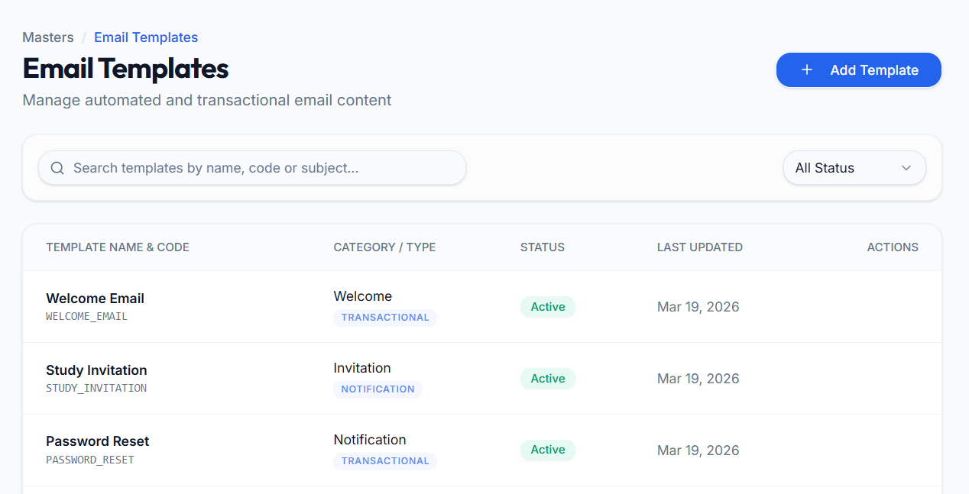  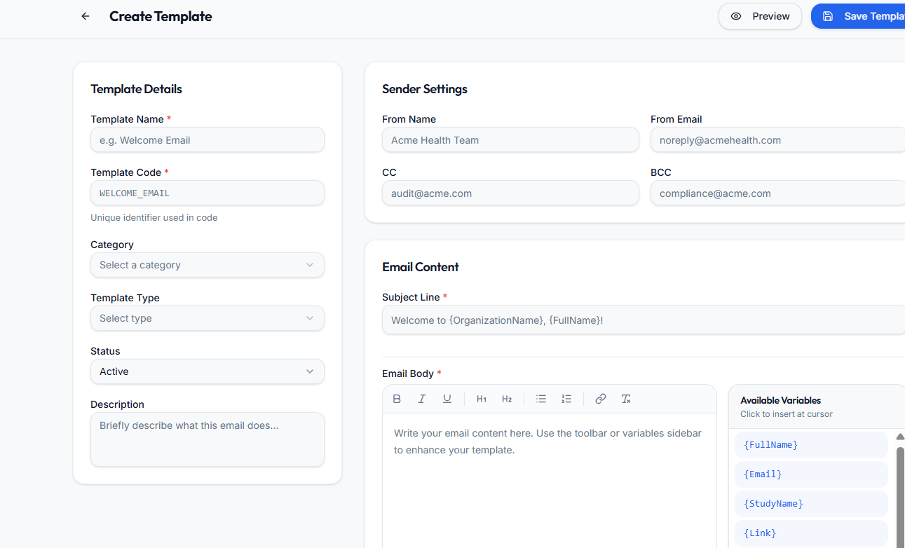  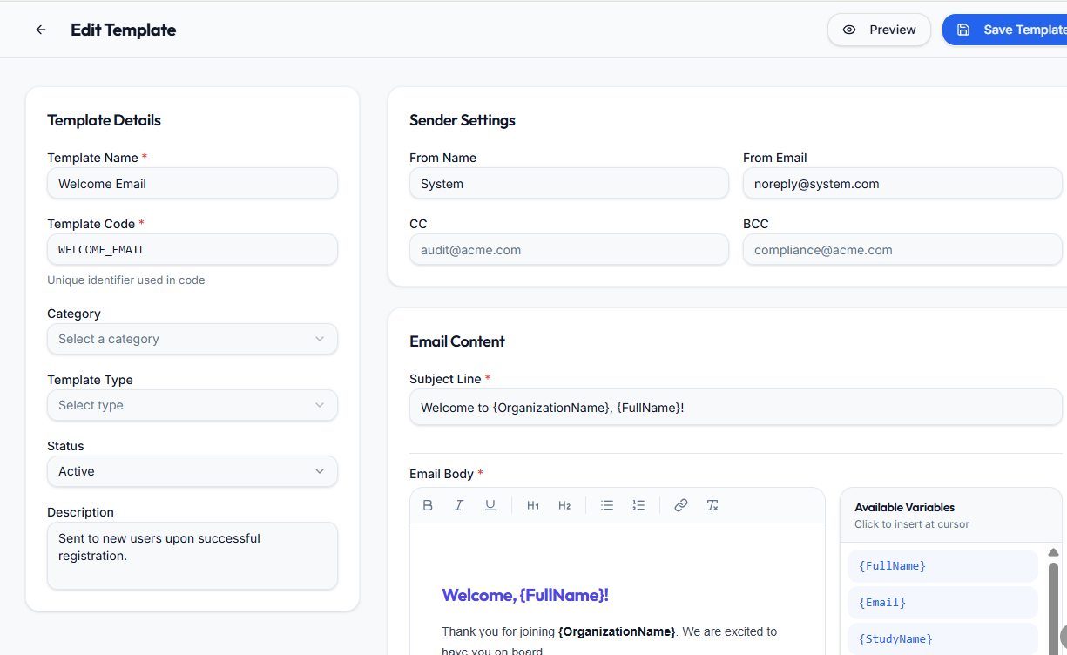

Study Phases
Parent Menu Name | Masters
Feature Name | Study Phases
Requirement | The system shall allow authorized users to create and manage Study Phases, which are used to categorize clinical studies by their development stage (e.g., Phase I, Phase II, Phase III, Phase IV).
Acceptance Criteria | 1. Access & Initiation:  • Accessible only to users with appropriate permissions within "Masters > Study Phases".  • Main view displays a list of all existing study phases with columns: Phase Name, Status, Created Date, Last Updated, Actions (Edit/Delete).  • Clicking "Add Phase" button opens a new creation screen/modal.  2. Create Study Phase - Core Fields (Your Request):  • Phase Name*: Text field (Mandatory, Unique) - Name of the study phase (e.g., "Phase I", "Phase II", "Phase III", "Phase IV", "Pilot Study", "Feasibility")  • Status: Dropdown selection (Active/Inactive) - Default: Active  4. View Functionality:  • Main list view displays:  ◦ Phase Name  ◦ Status with visual indicator (Active/Inactive badge)  ◦ Created By / Created At  ◦ Actions: Edit, Delete  5. Edit Functionality:  • Clicking Edit icon opens the phase details in edit mode.  • All fields (except possibly system-protected phases) are editable.  • Changes are saved and reflected immediately.  6. Delete Functionality - Dependency Check:  • Each phase record has a "Delete" icon in the Actions column.  • Clicking Delete triggers a dependency check:  ◦ System checks if the phase is associated with any existing Studies (in cro_studies table).  • If dependencies exist:  ◦ Delete action is prevented.  ◦ Error message is displayed: "Cannot delete Study Phase. This phase is associated with existing studies."  ◦ Recommendation: Deactivate the phase instead of deleting.  • If no dependencies exist:  ◦ Confirmation modal appears: "Are you sure you want to delete this Study Phase?"  ◦ Upon confirmation, the phase is permanently deleted from the system.  7. Status Control:  • Only "Active" phases are available for selection in Study Creation (Step 1 dropdown).  • "Inactive" phases are hidden from selection but retained in the system for historical data integrity.  • Changing a phase to "Inactive" does not affect existing studies using that phase.  8. Default Seeding (Initial Data):  • System shall be seeded with standard clinical trial phases upon installation/migration:  ◦ Phase I  ◦ Phase II  ◦ Phase III  ◦ Phase IV  ◦ Phase I/II  ◦ Phase II/III  ◦ Pilot Study  ◦ Feasibility Study  ◦ Observational Study  ◦ Expanded Access
Default Value | • Status: Defaults to "Active" for new phases
Messages | • Success (Create): "Study Phase '[Phase Name]' created successfully."  • Success (Update): "Study Phase '[Phase Name]' updated successfully."  • Success (Delete): "Study Phase '[Phase Name]' deleted successfully."  • Error (Create): "Failed to create Study Phase. Please try again."  • Error (Update): "Failed to update Study Phase. Please try again."  • Error (Delete - Dependencies): "Cannot delete Study Phase. This phase is associated with existing studies."  • Error (Delete - General): "Failed to delete Study Phase. Please try again."  • Validation (Phase Name): "Phase Name is required."  • Validation (Unique Name): "Phase Name already exists. Please use a unique name."  • Confirmation (Delete): "Are you sure you want to delete this Study Phase?"
Table 1 | Table Name: master_study_phases  • phase_id: INT (Primary Key, Auto-Increment)  • phase_name: VARCHAR(255) (NOT NULL, UNIQUE)  • description: TEXT (NULLABLE) - Optional detailed description  • status: ENUM('Active', 'Inactive') (DEFAULT 'Active')  • created_by: INT (Foreign Key to user)  • created_at: TIMESTAMP  • updated_by: INT (Foreign Key to user)  • updated_at: TIMESTAMP
Mock-up | 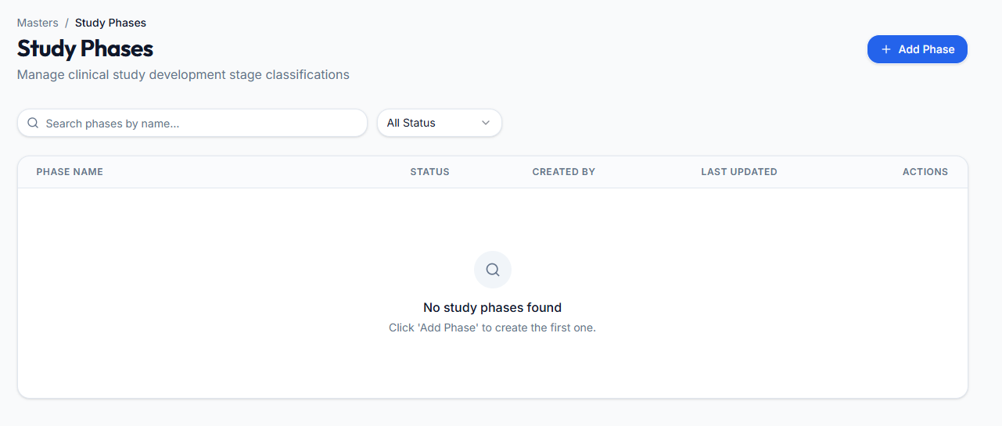  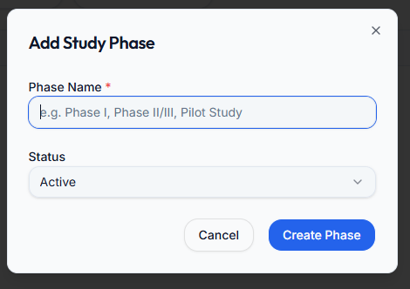

Country
Parent Menu Name | Masters
Feature Name | Country
Requirement | The system shall allow authorized users to create and manage Country records, which are used throughout the system for address fields, region coverage in studies, and geographical data population.
Acceptance Criteria | 1. Access & Initiation:  • Accessible only to users with appropriate permissions within "Masters > Country".  • Main view displays a list of all existing countries with columns: Country Name, Status, Actions (Edit/Delete).  • Clicking "Add Country" button opens a new creation screen/modal.  2. Create Country - Core Fields:  • Country Name*: Text field (Mandatory, Unique) - Full name of the country (e.g., "United States", "India", "United Kingdom")  • Status: Dropdown selection (Active/Inactive) - Default: Active  3. View Functionality:  • Main list view displays:  ◦ Country Name  ◦ Description  ◦ Status with visual indicator (Active/Inactive badge)  ◦ Actions: Edit, Delete  4. Edit Functionality:  • Clicking Edit icon opens the country details in edit mode.  • All fields are editable.  • Changes are saved and reflected immediately.  5. Delete Functionality - Dependency Check:  • Each country record has a "Delete" icon in the Actions column.  • Clicking Delete triggers a dependency check:  ◦ System checks if the country is associated with any:  • Sponsors (address fields)  • Studies (Region Covered)  • Locations (Site locations)  • Study Region Data (populated postal codes/cities/districts)  • If dependencies exist:  ◦ Delete action is prevented.  ◦ Error message is displayed: "Cannot delete Country. This country is associated with existing records (Sponsors, Studies, Locations)."  ◦ Recommendation: Deactivate the country instead of deleting.  • If no dependencies exist:  ◦ Confirmation modal appears: "Are you sure you want to delete this Country?"  ◦ Upon confirmation, the country is permanently deleted from the system.  6. Status Control:  • Only "Active" countries are available for selection in:  ◦ Sponsor address fields  ◦ Study Region Covered dropdown  ◦ Location address fields  ◦ Any other country selection fields  • "Inactive" countries are hidden from selection but retained in the system for historical data integrity.  • Changing a country to "Inactive" does not affect existing records that reference that country.  7. Default Seeding (Initial Data):  • System shall be seeded with all UN member states and commonly used territories upon installation/migration.  • Minimum seed data should include:  ◦ United States  ◦ India  ◦ United Kingdom  ◦ Canada  ◦ Australia  ◦ Germany  ◦ France  ◦ Japan  ◦ China  ◦ Brazil  ◦ And all other countries as per international standard  8. Import/Export Functionality:  • Export: Ability to export country list to Excel/CSV  • Import: Ability to bulk import countries via Excel/CSV for easy setup  9. Search and Filter:  • Search by Country Name  • Filter by Status (Active/Inactive/All)
Default Value | • Status: Defaults to "Active" for new countries  • All other fields are empty until populated
Messages | • Success (Create): "Country '[Country Name]' created successfully."  • Success (Update): "Country '[Country Name]' updated successfully."  • Success (Delete): "Country '[Country Name]' deleted successfully."  • Success (Import): "[X] countries imported successfully. [Y] records skipped due to errors."  • Success (Export): "Export completed successfully."  • Error (Create): "Failed to create Country. Please try again."  • Error (Update): "Failed to update Country. Please try again."  • Error (Delete - Dependencies): "Cannot delete Country. This country is associated with existing records (Sponsors, Studies, Locations)."  • Error (Delete - General): "Failed to delete Country. Please try again."  • Error (Import): "Failed to import countries. Please check file format and try again."  • Error (Export): "Failed to export data. Please try again."  • Validation (Country Name): "Country Name is required."  • Validation (Unique Name): "Country Name already exists. Please use a unique name."  • Confirmation (Delete): "Are you sure you want to delete this Country?"  • Warning (In Use): "This country is currently used by [X] records. Deactivation recommended instead of deletion."
Database Table | Table Name: master_countries  • country_id: INT (Primary Key, Auto-Increment)  • country_name: VARCHAR(255) (NOT NULL, UNIQUE)  • status: ENUM('Active', 'Inactive') (DEFAULT 'Active')  • is_system_country: BOOLEAN (DEFAULT FALSE) - Protect standard countries from deletion  • created_by: INT (Foreign Key to user)  • created_at: TIMESTAMP  • updated_by: INT (Foreign Key to user)  • updated_at: TIMESTAMP
Mock-up | 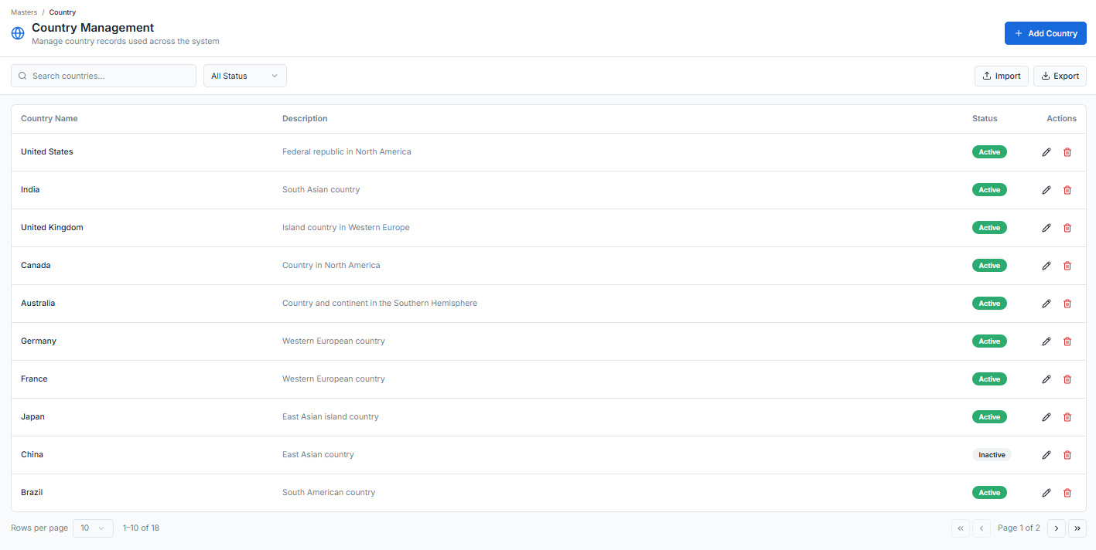  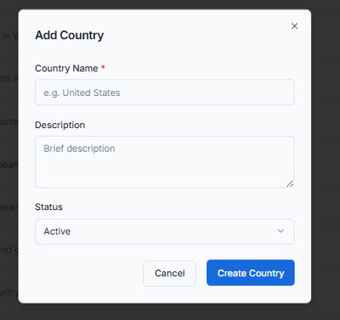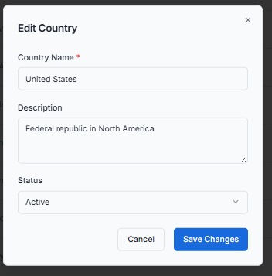  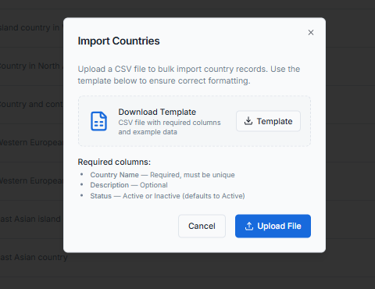

Locations
Parent Menu Name | Masters
Feature Name | Locations
Requirement | The system shall allow authorized users to create and manage Location records, which define geographical hierarchies (Country, State, District, City, Postal Code) for use throughout the system in address fields, site management, and study region data population.
Acceptance Criteria | 1. Access & Initiation:  • Accessible only to users with appropriate permissions within "Masters > Locations".  • Main view displays a list of all existing locations with columns: Country, State, District, City, Postal Code, Status, Actions (Edit/Delete).  • Clicking "Add Location" button opens a new creation screen/modal.  2. Create Location - Core Fields:  • Country: Dropdown selection from master_countries (Mandatory) - Select the country  • City: Text field (Mandatory) - Name of the city  • District: Text field (Optional) - District or county name  • State: Text field (Mandatory) - State, province, or region name  • Postal Code: Text field (Mandatory) - ZIP or postal code  • Status: Dropdown selection (Active/Inactive) - Default: Active  3. Field Dependencies and Behavior:  • Country dropdown populates from master_countries table (Active countries only).  • State, District, City, Postal Code are text fields that users can populate.  • The combination of Country + State + District + City + Postal Code should be unique to prevent duplicate location entries.  4. View Functionality:  • Main list view displays:  ◦ Country  ◦ State  ◦ District  ◦ City  ◦ Postal Code  ◦ Status with visual indicator (Active/Inactive badge)  ◦ Actions: Edit, Delete  5. Edit Functionality:  • Clicking Edit icon opens the location details in edit mode.  • All fields are editable.  • Changes are saved and reflected immediately.  • Uniqueness validation (Country+State+District+City+Postal Code) is enforced during edit.  6. Delete Functionality - Dependency Check:  • Each location record has a "Delete" icon in the Actions column.  • Clicking Delete triggers a dependency check:  ◦ System checks if the location is associated with any:  • Sites (if Sites module exists)  • Sponsor Addresses  • Study Locations  • Team Member Addresses  • If dependencies exist:  ◦ Delete action is prevented.  ◦ Error message is displayed: "Cannot delete Location. This location is associated with existing records."  ◦ Recommendation: Deactivate the location instead of deleting.  • If no dependencies exist:  ◦ Confirmation modal appears: "Are you sure you want to delete this Location?"  ◦ Upon confirmation, the location is permanently deleted from the system.  7. Status Control:  • Only "Active" locations are available for selection in:  ◦ Site address fields  ◦ Sponsor address fields  ◦ Any other location selection fields  • "Inactive" locations are hidden from selection but retained in the system for historical data integrity.  • Changing a location to "Inactive" does not affect existing records that reference that location.  8. Import/Export Functionality:  • Export: Ability to export locations list to Excel/CSV with all fields  • Import: Ability to bulk import locations via Excel/CSV for easy setup  ◦ Import template should include columns: Country, State, District, City, Postal Code, Status  ◦ Validation during import:  • Country must exist in master_countries  • Mandatory fields must not be empty  • Duplicate combinations are flagged and skipped  9. Search and Filter:  • Search by: Country, State, District, City, Postal Code  • Filter by: Status (Active/Inactive/All)  • Filter by: Country (dropdown)  10. Integration with Study Region Data:  • Locations from this master should be usable in the Study Step 2 "Region Covered" data population.  • When a country is selected in Study Step 2, all associated locations (State, District, City, Postal Code) should be available for study forms and data collection.
Default Value | • Status: Defaults to "Active" for new locations  • All other fields are empty until populated
Messages | • Success (Create): "Location [City, State, Country] created successfully."  • Success (Update): "Location updated successfully."  • Success (Delete): "Location deleted successfully."  • Success (Import): "[X] locations imported successfully. [Y] records skipped due to errors."  • Success (Export): "Export completed successfully."  • Error (Create): "Failed to create location. Please try again."  • Error (Update): "Failed to update location. Please try again."  • Error (Delete - Dependencies): "Cannot delete Location. This location is associated with existing records."  • Error (Delete - General): "Failed to delete location. Please try again."  • Error (Import): "Failed to import locations. Please check file format and try again."  • Error (Export): "Failed to export data. Please try again."  • Validation (Country): "Country is required."  • Validation (City): "City is required."  • Validation (State): "State is required."  • Validation (Postal Code): "Postal Code is required."  • Validation (Unique Combination): "Location with this Country, State, District, City, and Postal Code already exists."  • Validation (Country Exists): "Selected country does not exist in Country master."  • Confirmation (Delete): "Are you sure you want to delete this location?"  • Warning (In Use): "This location is currently used by [X] records. Deactivation recommended instead of deletion."
Table 1 | master_locations
Fields (with datatype & key) | • location_id: INT (Primary Key, Auto-Increment)  • country_id: INT (Foreign Key to master_countries.country_id, NOT NULL)  • state: VARCHAR(255) (NOT NULL)  • district: VARCHAR(255) (NULLABLE)  • city: VARCHAR(255) (NOT NULL)  • postal_code: VARCHAR(50) (NOT NULL)  • status: ENUM('Active', 'Inactive') (DEFAULT 'Active')  • is_system_location: BOOLEAN (DEFAULT FALSE) - Protect critical locations from deletion  • created_by: INT (Foreign Key to user)  • created_at: TIMESTAMP  • updated_by: INT (Foreign Key to user)  • updated_at: TIMESTAMP  • UNIQUE KEY unique_location (country_id, state, district, city, postal_code)
Mock-up | 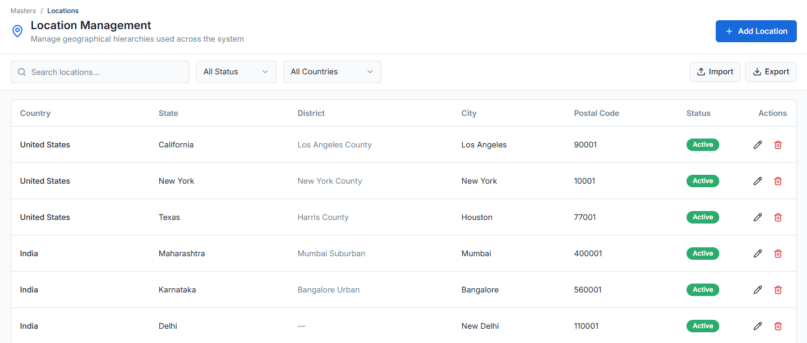  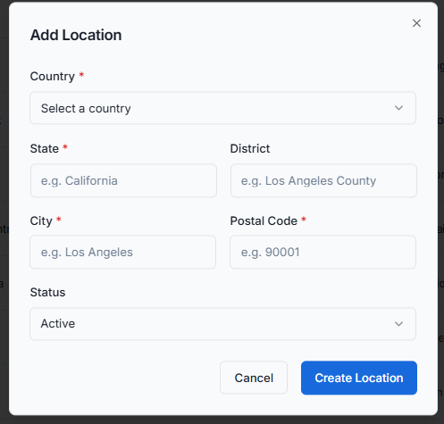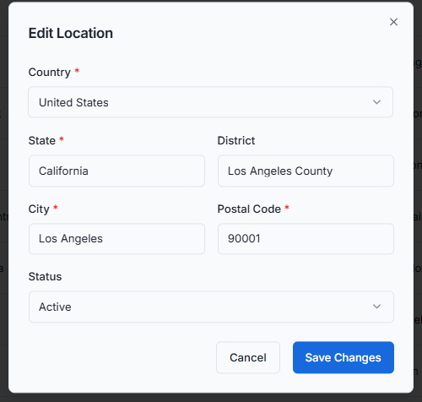  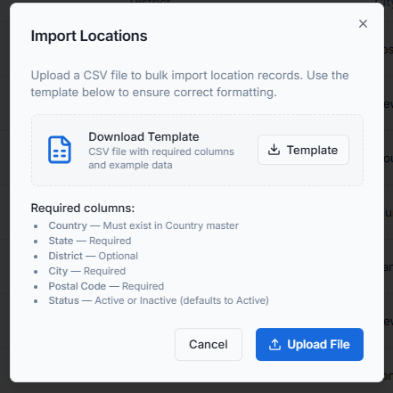

Regions
Parent Menu Name | Masters
Feature Name | Region
Requirement | The system shall allow authorized users to create and manage Region records, which define geographical groupings (e.g., "North America", "Europe", "Asia-Pacific") for use in study coverage, reporting, and organizational structuring.
Acceptance Criteria | 1. Access & Initiation:  • Accessible only to users with appropriate permissions within "Masters > Region".  • Main view displays a list of all existing regions with columns: Region Name, Description, Status, Actions (Edit/Delete).  • Clicking "Add Region" button opens a new creation screen/modal.  2. Create Region - Core Fields:  • Region Name*: Text field (Mandatory, Unique) - Name of the geographical region (e.g., "North America", "Europe", "Asia-Pacific", "Latin America", "Middle East & Africa")  • Description: Textarea (Optional) - Detailed description of the region, including countries covered or purpose  • Status: Dropdown selection (Active/Inactive) - Default: Active  3. View Functionality:  • Main list view displays:  ◦ Region Name  ◦ Description (truncated if long)  ◦ Status with visual indicator (Active/Inactive badge)  ◦ Created Date  ◦ Actions: Edit, Delete  4. Edit Functionality:  • Clicking Edit icon opens the region details in edit mode.  • All fields are editable.  • Changes are saved and reflected immediately.  • Region Name uniqueness is enforced during edit.  5. Delete Functionality - Dependency Check:  • Each region record has a "Delete" icon in the Actions column.  • Clicking Delete triggers a dependency check:  ◦ System checks if the region is associated with any:  • Studies (Region Covered field)  • Countries (if Country master includes Region field)  • Sites (if Sites module includes Region)  • Sponsors (if Sponsor master includes Region)  • If dependencies exist:  ◦ Delete action is prevented.  ◦ Error message is displayed: "Cannot delete Region. This region is associated with existing records (Studies, Countries, etc.)."  ◦ Recommendation: Deactivate the region instead of deleting.  • If no dependencies exist:  ◦ Confirmation modal appears: "Are you sure you want to delete this Region?"  ◦ Upon confirmation, the region is permanently deleted from the system.  6. Status Control:  • Only "Active" regions are available for selection in:  ◦ Study Region Covered dropdown  ◦ Country master Region field  ◦ Any other region selection fields  • "Inactive" regions are hidden from selection but retained in the system for historical data integrity.  • Changing a region to "Inactive" does not affect existing records that reference that region.  7. Default Seeding (Initial Data):  • System shall be seeded with standard geographical regions upon installation/migration:  ◦ North America - United States, Canada, Mexico  ◦ Latin America - Central and South American countries  ◦ Europe - European Union and European countries  ◦ Asia-Pacific - East Asia, Southeast Asia, Australia, New Zealand  ◦ Middle East & Africa - Middle Eastern and African countries  ◦ South Asia - India, Pakistan, Bangladesh, Sri Lanka, etc.  ◦ Global - Worldwide coverage  8. Search and Filter:  • Search by: Region Name, Description  • Filter by: Status (Active/Inactive/All)
Default Value | • Status: Defaults to "Active" for new regions  • Description: Empty by default
Messages | • Success (Create): "Region '[Region Name]' created successfully."  • Success (Update): "Region '[Region Name]' updated successfully."  • Success (Delete): "Region '[Region Name]' deleted successfully."  • Success (Import): "[X] regions imported successfully. [Y] records skipped due to errors."  • Success (Export): "Export completed successfully."  • Error (Create): "Failed to create region. Please try again."  • Error (Update): "Failed to update region. Please try again."  • Error (Delete - Dependencies): "Cannot delete Region. This region is associated with existing records (Studies, Countries, etc.)."  • Error (Delete - General): "Failed to delete region. Please try again."  • Validation (Region Name): "Region Name is required."  • Validation (Unique Name): "Region Name already exists. Please use a unique name."  • Confirmation (Delete): "Are you sure you want to delete this region?"  • Warning (In Use): "This region is currently used by [X] records. Deactivation recommended instead of deletion."
Table Name | Table Name: master_regions  • region_id: INT (Primary Key, Auto-Increment)  • region_name: VARCHAR(255) (NOT NULL, UNIQUE)  • description: TEXT (NULLABLE)  • status: ENUM('Active', 'Inactive') (DEFAULT 'Active')  • is_system_region: BOOLEAN (DEFAULT FALSE) - Protect standard regions from deletion  • display_order: INT (NULLABLE) - For custom sorting in dropdowns  • created_by: INT (Foreign Key to user)  • created_at: TIMESTAMP  • updated_by: INT (Foreign Key to user)  • updated_at: TIMESTAMP
Mock up | 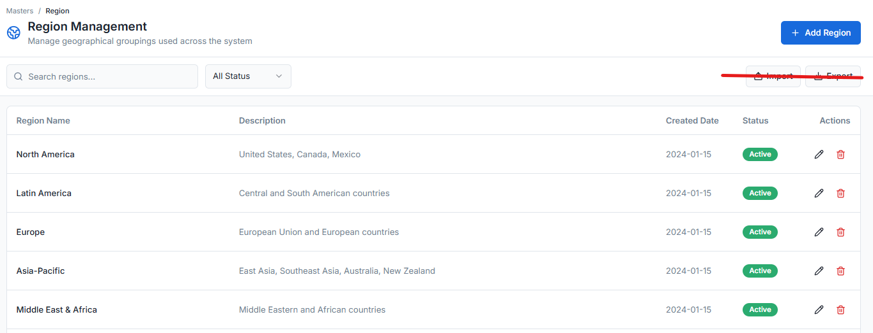  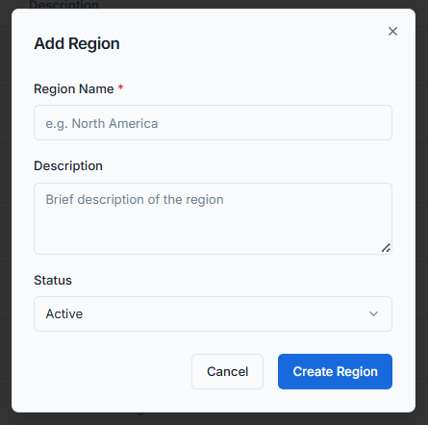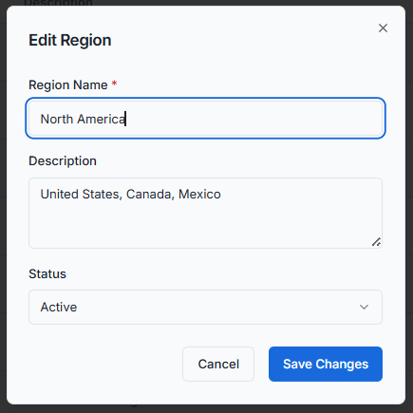

Clinical Programs

Sponsors
Parent Menu Name | Clinical Programs
Feature Name | Sponsors
Requirement | The system shall allow authorized users to manage Sponsors, including the ability to create new sponsors with comprehensive details, view the sponsor list with key information, edit sponsor details (with email address restrictions), delete sponsors (subject to dependency checks), export sponsor data to Excel, and trigger invitation emails upon sponsor creation. All actions shall be logged in the Activity Log.
Acceptance Criteria | - Access & Initiation:  - Accessible only to users with appropriate permissions within the "Clinical Programs > Sponsors" sub-module.  - The main view displays a list of all existing sponsors with columns: Sponsor Name, Email Address, Contact Number, Organization Name, Status, Actions (Edit/Delete).  - Clicking "Add Sponsor" button opens a new creation screen/modal.  - Create Sponsor - Complete Field Set:  - Sponsor Photograph: Image upload field  - Accepted formats: JPEG, PNG  - Max file size: 2MB  - Full Name: Text field (Mandatory)  - Contact Number: Text field with phone number format validation (Mandatory)  - Email Address: Email format field (Mandatory, must be unique in the system)  - Organization Name: Text field (Mandatory)  - Website: URL format field (Optional)  - Registration Number: Text field (Mandatory, unique identifier for the sponsor)  - Address Line 1: Text field (Optional)  - Address Line 2: Text field (Optional)  - City: Text field (Mandatory)  - District*: Text field (Mandatory)  - State: Text field (Optional)  - Zipcode: Text field (Optional)  - Country: Dropdown selection from Country master (Optional)  - Status: Dropdown selection (Active/Inactive) - Default: Active  - View Functionality:  - Main list view displays the following columns:  - Sponsor Name (Full Name from creation)  - Email Address  - Contact Number  - Organization Name  - Status (Active/Inactive with visual indicator, e.g., badge/green dot)  - Actions: Edit icon, Delete icon  - Clicking on a sponsor row opens a detailed view showing all fields including photograph and complete address.  - Edit Functionality - Email Restriction:  - Clicking Edit icon opens the sponsor details in edit mode.  - Email Address field shall be disabled/non-editable in edit mode.  - All other fields (except email) are editable.  - Changes can be saved, cancelled, or reverted.  - Upon successful edit, changes are reflected in the main view.  - Delete Functionality - Dependency Check:  - Each sponsor record has a "Delete" icon in the Actions column.  - Clicking Delete triggers a dependency check:  - System checks if the sponsor is associated with any Studies, Contracts, or other dependent records.  - If dependencies exist:  - Delete action is prevented.  - Error message is displayed: "Cannot delete sponsor. This sponsor is associated with existing studies/contracts."  - If no dependencies exist:  - Confirmation modal appears: "Are you sure you want to delete this sponsor?"  - Upon confirmation, the sponsor is permanently deleted from the system.  - Export Functionality:  - An "Export" button is available on the main list view.  - Clicking Export generates an Excel file (.xlsx format).  - File Naming Convention: Sponsor_Details_DD_MMM_YYYY HHmm.xlsx  - Example: Sponsor_Details_09_Feb_2026 1300.xlsx  - Export includes all sponsor fields:  - Full Name, Email Address, Contact Number, Organization Name, Website, Registration Number, Address Line 1, Address Line 2, City, District, State, Zipcode, Country, Status, Created Date  - Email Generation (Invitation):  - Upon successful creation of a sponsor, an automated invitation email is triggered.  - Email is sent to the provided Email Address.  - Email contains:  - Welcome message and introduction to the CRO Workspace  - Login credentials or portal access instructions  - Contact information for support  - Email template shall be configurable via Masters > Email Templates.  - Activity Log Integration:  - All actions performed on sponsors shall be recorded in the Activity Log, which includes email generation also.
Default Value | - Status: Defaults to "Active"  - All other mandatory fields are empty until populated by the user.  - Optional fields are empty by default.
Messages | - Success (Create): "Sponsor '[Full Name]' created successfully. An invitation email has been sent to [Email Address]."  - Success (Edit): "Sponsor '[Full Name]' updated successfully."  - Success (Delete): "Sponsor '[Full Name]' deleted successfully."  - Success (Export): "Export completed successfully. File: [FileName]"  - Error (Create): "Failed to create sponsor. Please try again."  - Error (Edit): "Failed to update sponsor. Please try again."  - Error (Delete - Dependencies): "Cannot delete sponsor. This sponsor is associated with existing studies/contracts."  - Error (Delete - General): "Failed to delete sponsor. Please try again."  - Error (Export): "Failed to export data. Please try again."  - Validation (Full Name): "Full Name is required."  - Validation (Contact Number): "Contact Number is required."  - Validation (Email Address): "Email Address is required."  - Validation (Email Format): "Please enter a valid email address."  - Validation (Duplicate Email): "Email Address already exists in the system."  - Validation (Organization Name): "Organization Name is required."  - Validation (Registration Number): "Registration Number is required."  - Validation (Duplicate Registration Number): "Registration Number already exists."  - Validation (City): "City is required."  - Validation (District): "District is required."  Validation (Photograph Format): "Invalid file format. Please upload JPEG or PNG."  - Validation (Photograph Size): "File size exceeds 2MB limit."  - Confirmation (Delete): "Are you sure you want to delete this sponsor?"
Database Tables | - Table 1: cro_sponsors  sponsor_id: INT (Primary Key, Auto-Increment)  photograph_path: VARCHAR(500) (NULLABLE) -- Stores file path or URL  full_name: VARCHAR(255) (NOT NULL)  contact_number: VARCHAR(50) (NOT NULL)  email_address: VARCHAR(255) (NOT NULL, UNIQUE)  organization_name: VARCHAR(255) (NOT NULL)  website: VARCHAR(255) (NULLABLE)  registration_number: VARCHAR(100) (NOT NULL, UNIQUE)  address_line1: VARCHAR(255) (NULLABLE)  address_line2: VARCHAR(255) (NULLABLE)  location_id -- Could be foreign key to location master.location_id  status: ENUM('Active', 'Inactive') (DEFAULT 'Active')  created_by: INT (Foreign Key to users cro_team_members.team_member_id)  created_at: TIMESTAMP  updated_at: TIMESTAMP  is_deleted: BOOLEAN (DEFAULT FALSE) -- For soft delete if implemented

Studies

Step 1: Basic Study Information
Parent Menu Name | Clinical Programs
Feature Name | Studies - Step 1: Basic Study Information
Requirement | The system shall guide users through a 6-step wizard to create a new study, beginning with the collection of basic study information.
Acceptance Criteria | - Access & Initiation:  - Accessible only to users with appropriate permissions within "Clinical Programs > Studies".  - Clicking "Add Study" button launches a 6-step wizard interface.  - Step 1 of 6 is displayed: "Basic Study Information".  - Form Fields - Step 1:  - Study ID / Protocol Number: Text field (Mandatory, must be unique)  - Study Title: Text field (Mandatory)  - Study Phase: Dropdown selection from Study Phases master (Mandatory)  - Scope of the Study: Multi-select checkbox or dropdown (Mandatory)  - Options: EDC, Survey, ePRO  - At least one scope must be selected  - Therapeutic Area: Text field or dropdown from master (Optional)  - Study Description: Text area/Multiline field (Optional)  - Sponsor Name*: Auto-complete dropdown (Mandatory)  - As user types, system suggests matching sponsor names from cro_sponsors (Organization code, and name also shown in the dropdown)  - Navigation:  - "Next" button proceeds to Step 2: Timeline and Coverage  - "Cancel" button exits the wizard without saving  - System validates all mandatory fields before allowing navigation to Step 2
Default Value | • All fields empty by default  • No scope options pre-selected
Messages | - Validation (Study ID): "Study ID / Protocol Number is required."  - Validation (Unique Study ID): "Study ID already exists. Please use a unique identifier."  - Validation (Study Title): "Study Title is required."  - Validation (Study Phase): "Please select a Study Phase."  - Validation (Scope): "Please select at least one Scope of Study."  - Validation (Sponsor): "Please select a Sponsor."  - Navigation: "Please complete all mandatory fields before proceeding."
Table 1
Database Table | Table 1: cro_studies  • study_id: INT (Primary Key, Auto-Increment)  • protocol_number: VARCHAR(100) (NOT NULL, UNIQUE)  • study_title: VARCHAR(500) (NOT NULL)  • study_phase_id: INT (Foreign Key to master_study_phases.phase_id, NOT NULL)  • scope_edc: BOOLEAN (DEFAULT FALSE)  • scope_survey: BOOLEAN (DEFAULT FALSE)  • scope_epro: BOOLEAN (DEFAULT FALSE)  • therapeutic_area: VARCHAR(255) (NULLABLE)  • study_description: TEXT (NULLABLE)  • sponsor_id: INT (Foreign Key to cro_sponsors.sponsor_id, NOT NULL)  • created_by: INT (Foreign Key to user)  • created_at: TIMESTAMP  • updated_at: TIMESTAMP

Step 2: Timeline and Coverage
Parent Menu Name | Clinical Programs
Feature Name | Studies - Step 2: Timeline and Coverage
Requirement | The system shall display dynamic fields in Step 2 based on the Scope of Study selected in Step 1, and shall populate postal codes, cities, and districts based on the selected Region Covered.
Acceptance Criteria | - Dynamic Field Display:  - Fields shown in Step 2 depend on Scope selected in Step 1.  - If Scope includes EDC:  - Start Date: Date picker (Mandatory)  - Expected End Date: Date picker (Mandatory, must be after Start Date)  - Max. Number of Sites: Numeric field (Mandatory, positive integer)  - Max. Number of Enrollments: Numeric field (Mandatory, positive integer)  - Region Covered*: Dropdown/Dynamic Dropdown (Mandatory) - Region selection  - Randomization Method: Dropdown (Optional) - e.g., Centaralized, Simple, Block, Stratified  - If Scope includes Survey or ePRO:  - Start Date*: Date picker (Mandatory)  - Expected End Date: Date picker (Mandatory, must be after Start Date)  - Max. Number of Enrollments: Numeric field (Mandatory, positive integer)  - Region Covered*: Dropdown/Dynamic Dropdown (Mandatory) - Country selection  - Randomization Approach: Dropdown (Optional) - Centralized Randomization (Default), Site-Based Randomization (Decentralized)  - Navigation:  - "Previous" button returns to Step 1  - "Next" button proceeds to Step 3: Study Configuration  - "Save as Draft" option available to save progress
Default Value | - All date fields empty  - All numeric fields empty  - No region pre-selected  - Randomization Method: Empty/Not selected
Messages | - Validation (Start Date): "Start Date is required."  - Validation (End Date): "Expected End Date is required."  - Validation (Date Logic): "Expected End Date must be after Start Date."  - Validation (Max Sites - EDC only): "Maximum Number of Sites is required."  - Validation (Max Enrollments): "Maximum Number of Enrollments is required."  - Validation (Region): "Please select Region Covered."  - Validation (Numeric): "Please enter a valid positive number."
Database Tables | Table 1: cro_studies (Update)  - start_date: DATE (NULLABLE until step completion)  - expected_end_date: DATE (NULLABLE)  - max_sites: INT (NULLABLE) - For EDC only  - max_enrollments: INT (NULLABLE)  - region_covered: VARCHAR(100) (NULLABLE) - Country code/ID  - randomization_method: VARCHAR(100) (NULLABLE)

Step 3: Study Configuration
Parent Menu Name | Clinical Programs
Feature Name | Studies - Step 3: Study Configuration
Requirement | The system shall allow configuration of study features and modules based on the Scope of Study selected in Step 1.
Acceptance Criteria | - Dynamic Configuration Options:  - Configuration toggles shown depend on Scope selected in Step 1.  - If Scope includes EDC:  - Enable Consent Manager: Checkbox/Toggle (ON/OFF)  - Enable Query Manager: Checkbox/Toggle (ON/OFF)  - Enable Data Manager: Checkbox/Toggle (ON/OFF)  - Enable Navigation Bar: Checkbox/Toggle (ON/OFF)  - If Scope includes Survey or ePRO:  - Enable Consent Manager: Checkbox/Toggle (ON/OFF)  - Enable Query Manager: Checkbox/Toggle (ON/OFF)  - Enable Navigation Bar: Checkbox/Toggle (ON/OFF)  - (Data Manager option is NOT shown for Survey/ePRO)  - Configuration Behavior:  - Each toggle enables/disables the corresponding module/feature in the final study.  - Tooltips or help text explain the purpose of each manager/feature.  - Navigation:  - "Previous" button returns to Step 2  - "Next" button proceeds to Step 4: Study Design  - • All selections are saved when navigating
Default Value | • All configuration options default to OFF / Unchecked
Messages | - Info (Consent Manager): "Enables electronic consent management for participants."  - Info (Query Manager): "Enables query raising and resolution workflows."  - Info (Data Manager): "Enables data validation and cleaning tools."  - Info (Navigation Bar): "Displays study navigation menu for users."
DatabaseTable | Table: cro_study_configuration  - config_id: INT (Primary Key, Auto-Increment)  - study_id: INT (Foreign Key to cro_studies.study_id, UNIQUE)  - enable_consent_manager: BOOLEAN (DEFAULT FALSE)  - enable_query_manager: BOOLEAN (DEFAULT FALSE)  - enable_data_manager: BOOLEAN (DEFAULT FALSE)  - enable_navigation_bar: BOOLEAN (DEFAULT FALSE)  - configured_by: INT (Foreign Key to user)  - configured_at: TIMESTAMP

Step 4: Study Design
Parent Menu Name | Clinical Programs
Feature Name | Studies - Step 4: Study Design (Form Builder)
Requirement | The system shall provide a comprehensive Form Builder with Block and Page features, enabling field configuration, validation rules, conditional logic, collaboration tools, and trigger-based notifications.
Acceptance Criteria | - Form Builder Structure:  - Blocks: Container for related pages/sections  - Pages: Container for fields/questions within a block  - Drag-and-drop interface for organizing blocks, pages, and fields  - Field Configuration:  - Ability to add various field types: Text, Number, Date, Dropdown, Radio, Checkbox, File Upload, Signature, etc.  - Field properties: Label, Help Text, Placeholder, Mandatory/Optional, Default Value  - Validation Rules:  - Built-in validations: Required, Min/Max Length, Range, Email, Phone, etc.  - Regex Pattern Examples:  - Email: ^[a-zA-Z0-9._%+-]+@[a-zA-Z0-9.-]+\.[a-zA-Z]{2,}$  - Phone: ^\d{10}$ or ^\d{3}-\d{3}-\d{4}$  - Alphanumeric: ^[a-zA-Z0-9]+$  - Custom regex patterns can be defined  - Conditional Logic:  - Conditional Visibility supported:  - Direction: Forward direction only (conditions can affect later elements only)  - Scope: Applicable between Blocks, Pages, Questions, and within Options  - Example: Show Page 2 only if Question 1 = "Yes"  - Example: Show Block B only if Page 1 is completed  - Example: Enable Option C only if previous option selected  - Collaboration & Audit Tools:  - Comments/Annotations: Users can add comments to fields/pages  - Change History: Track who changed what and when  - Reviewer Assignment: Assign specific users to review sections  - Approval Workflow: Mark sections as "Ready for Review", "Approved", "Changes Requested"  - Configure Submission Controls:  - Save Progress: Allow partial saves  - Submit Once: Prevent multiple submissions  - Submit Window: Date/time restrictions for submissions  - Confirmation Page: Custom message after submission  - Redirect URL: After submission, redirect to external URL  - Triggers Feature:  - Upon condition (e.g., specific answer, form completion, data threshold):  - Email Trigger: Send email to specified recipients (CRO team, Sponsor, Site)  - Notification Trigger: Generate in-app notification  - Trigger conditions can be complex (AND/OR combinations)  - Email templates configurable via Masters  - Navigation:  - "Previous" button returns to Step 3  - "Next" button proceeds to Step 5: Study Team Assignment (when design is complete)  - "Save Design" button saves current form builder progress
Default Value | - Empty form builder canvas  - No blocks, pages, or fields by default
Messages | - Success: "Study design saved successfully."  - Validation (Conditional Logic): "Forward direction only - conditions cannot reference future elements."  - Validation (Circular Reference): "Circular condition detected. Please review logic."  - Trigger Created: "Trigger configured successfully."
Database Tables | Table 1: cro_study_forms  - form_id: INT (Primary Key, Auto-Increment)  - study_id: INT (Foreign Key to cro_studies.study_id  - form_structure: JSON (Complete form definition)  - version: INT  - created_by: INT  - created_at: TIMESTAMP  - updated_at: TIMESTAMP  Table 2: cro_study_triggers  - trigger_id: INT (Primary Key, Auto-Increment)  - study_id: INT  - trigger_condition: JSON (Condition definition)  - trigger_action: ENUM('Email', 'Notification', 'Both')  - trigger_recipients: JSON (Email addresses/roles)  - email_template_id: INT (Foreign Key to email templates)  - is_active: BOOLEAN (DEFAULT TRUE)

Step 5: Study Team Assignment
Parent Menu Name | Clinical Programs
Feature Name | Studies - Step 5: Study Team Assignment
Requirement | The system shall allow assignment of CRO team members to the study with specific roles such as Data Manager, Project Manager, and Site Manager.
Acceptance Criteria | - Team Assignment Interface:  - Display list of currently assigned team members (if any)  - "Add Team Member" button to open selection modal  - Add Team Member Feature:  - Modal shows list of available CRO team members from cro_team_members  - Search/filter options: By Name, By Role, By Email  - For each selected team member, assign a Study Role:  - Dropdown options: Data Manager, Project Manager, Site Manager, Monitor, CRA, etc.  - Multiple team members can be added in one session  - Assigned Team Members View:  - Table displays:  - Team Member Name  - CRO Role (from their profile)  - Assigned Study Role (specific to this study)  - Assigned Date  - Actions: Remove from Study, Change Role  - Validation:  - Same team member cannot be assigned twice to same study  - At least one team member must be assigned before proceeding (optional requirement - confirm if mandatory)  - Navigation:  - "Previous" button returns to Step 4  - "Next" button proceeds to Step 6: Publish Study  - Assignments are saved when navigating
Default Value | - No team members assigned by default
Messages | - Success (Add): "Team member [Name] assigned as [Study Role]."  - Success (Remove): "Team member removed from study."  - Validation (Duplicate): "This team member is already assigned to the study."  - Validation (Minimum): "Please assign at least one team member to the study." (If mandatory)
Database Tables | Table: cro_study_team_assignments  - assignment_id: INT (Primary Key, Auto-Increment)  - study_id: INT (Foreign Key to cro_studies.study_id, ON DELETE CASCADE)  - team_member_id: INT (Foreign Key to cro_team_members.team_member_id)  - assigned_by: INT (Foreign Key to user)  - assigned_at: TIMESTAMP  - is_active: BOOLEAN (DEFAULT TRUE)  - UNIQUE KEY unique_study_member (study_id, team_member_id)

Step 6: Publish Study
Parent Menu Name | Clinical Programs
Feature Name | Studies - Step 6: Publish Study
Requirement | The system shall allow publishing of studies to UAT or LIVE environments with versioning, database creation, tenant isolation, and invitation link generation.
Acceptance Criteria | - Environment Selection:  - Target Environment: Radio buttons or dropdown  - Options: UAT, LIVE  - Selection determines subsequent behavior and database creation  - Status Selection:  - Status: Dropdown  - Options: Published, Active, Inactive, Locked  - Description: Text field (Optional) - Notes about this publication  - Database Creation - UAT Environment:  - Upon publishing to UAT, system automatically creates a dedicated database for the sponsor/study.  - Database Naming Convention: UAT_[StudyID]  - Example: UAT_STUDY_123  - Table Naming Convention: All tables within this database start with prefix usp_ (UAT Sponsor Prefix)  - Example: usp_participants, usp_responses, usp_audit  - Database contains all necessary tables for study data collection based on form design.  - Database Creation - LIVE Environment:  - Upon publishing to LIVE, system automatically creates a dedicated database for the sponsor/study.  - Database Naming Convention: [StudyID] (without prefix)  - Example: STUDY_123  - Table Naming Convention: All tables within this database start with prefix sp_(Sponsor Prefix)  - Example: sp_participants, sp_responses, sp_audit  - Database contains all necessary tables for live data collection.  - Versioning:  - Every published study creates a versioned study release.  - Releases are shown in a table format with columns:  - Version (e.g., v1.0, v1.1, v2.0)  - Environment (UAT/LIVE)  - Status (Published/Active/Inactive/Locked)  - Description  - Published Date  - Published By  - Actions: View, Rollback (if applicable)  - UAT and LIVE Access Links:  - For UAT environment: UAT Link is generated and displayed  - For LIVE environment: LIVE Link is generated and displayed  - Links are shown in the study view and version history table  - Example: https://[workspace-domain]/study/[study-id]/uat or /live  - Invitation Links and Email Generation:  - Invitation links are enabled for UAT or LIVE/Production environments.  - "Send Invitations" button available for each environment.  - Upon clicking, system generates unique invitation links for each participant/sponsor contact.  - Email Trigger: Invitation emails are sent automatically with:  - Study name and environment  - Unique access link  - Login credentials (if applicable)  - Instructions  - Final Step Validation:  - All previous steps must be completed before publishing  - Confirmation modal: "Are you sure you want to publish this study to [UAT/LIVE]?"  - Version number auto-increments based on previous releases
Default Value | - Environment: No default  - Status: "Published" as default  - Description: Empty
Messages | - Success (Publish - UAT): "Study published to UAT successfully. Database 'UAT_[StudyID]' created. Version [Version] released."  - Success (Publish - LIVE): "Study published to LIVE successfully. Database '[StudyID]' created. Version [Version] released."  - Success (Invitations): "Invitation emails sent successfully."  - Error (Database Creation): "Failed to create study database. Please contact system administrator."  - Validation (Incomplete): "Please complete all previous steps before publishing."  - Confirmation: "Are you sure you want to publish this study to [Environment]? This action will create a new version."
Table 1 | Table: cro_study_versions  - version_id: INT (Primary Key, Auto-Increment)  - study_id: INT (Foreign Key to cro_studies.study_id)  - version_number: VARCHAR(20) (e.g., '1.0', '1.1', '2.0')  - environment: ENUM('UAT', 'LIVE')  - status: ENUM('Published', 'Active', 'Inactive', 'Locked')  - description: TEXT (NULLABLE)  - database_name: VARCHAR(255) (Name of created database)  - uat_link: VARCHAR(500) (NULLABLE)  - live_link: VARCHAR(500) (NULLABLE)  - published_by: INT (Foreign Key to user)  - published_at: TIMESTAMP  - is_current: BOOLEAN (DEFAULT FALSE) - Indicates if this is the active version  Table: cro_study_invitations  - invitation_id: INT (Primary Key, Auto-Increment)  - study_id: INT  - version_id: INT  - environment: ENUM('UAT', 'LIVE')  - recipient_email: VARCHAR(255)  - recipient_type: ENUM('Sponsor', 'Site', 'Participant', 'CRO')  - invitation_link: VARCHAR(500) (Unique token/link)  - sent_at: TIMESTAMP  - sent_by: INT  - status: ENUM('Sent', 'Opened', 'Expired')

CRO Team Administration

Team Members
Parent Menu Name | CRO Team Administration
Feature Name | Team Members
Requirement | The system shall allow authorized users to manage CRO Team Members, including the ability to create new users with role assignments, study assignments, and photograph uploads, along with comprehensive view, delete, and export capabilities.
Acceptance Criteria | - Access & Initiation:  - Accessible only to users with admin privileges within the "CRO Team Administration > Team Members" sub-module.  - The main view displays a list of all existing team members with columns: Full Name, Email Address, Assigned Role, Assigned Studies.  - Clicking "Add Team Member" button opens a new creation screen/modal.  - Create Team Member - Mandatory Fields:  - Full Name: Text field (Mandatory)  - Email Address: Email format field (Mandatory, must be unique in the system)  - Assign Role: Dropdown selection from available roles in cro_roles (Mandatory)  - Photograph: Image upload field (Mandatory)  - Accepted formats: JPEG, PNG  - Max file size: 3MB  - Recommended dimensions: 300x300 pixels  - Create Team Member - Optional Fields:  - Contact Number: Text field with phone number format validation  - Study Assignment Section:  - A dedicated "Study Assignment" section is available in the creation screen.  - UI displays a list or multi-select dropdown of available Studies (from Clinical Programs > Studies).  - Admin can select one or more studies to assign to the team member.  - Selected studies are saved and will appear in the "Assigned Studies" column in the main view.  - Email Generation:  - Upon successful creation of a team member, an automated email is triggered.  - Email is sent to the provided Email Address.  - Email contains:  - Welcome message  - Login credentials or setup instructions  - Assigned role information  - Assigned studies list (if any)  - View Functionality:  - Main list view displays the following columns:  - Full Name  - Email Address  - Assigned Role  - Assigned Studies (Dropdown multi-selection) “Study Assignment" link)  - Clicking on a team member row opens a detailed view or edit screen showing all fields including photograph and contact number.  - Delete Functionality:  - Each team member record has a "Delete" option/icon.  - Clicking Delete triggers a confirmation modal: "Are you sure you want to delete this team member?"  - Upon confirmation, the team member is permanently removed from the system.  - Associated user account should be deactivated or removed.  - Export Functionality:  - An "Export" button is available on the main list view.  - Clicking Export generates a file (CSV or Excel format) containing all team member records.  - Export includes columns: Full Name, Email Address, Assigned Role, Assigned Studies, Contact Number.  - Email Template:  - An email notification will be sent to the team member upon successful role or study assignment.  - Reference Email Templates feature for customizable welcome email content.  - Audit Logging:  - All create, update, delete, study assignment actions on team members should be logged in Activity Log.
Default Value | If there not records, then shown as “No data available yet. Add team members and assign studies to get started.”  Mandatory fields must be completed before proceeding.
Messages | - Success (Create): "Team Member '[Full Name]' created successfully. An email has been sent to [Email Address]."  - Success (Delete): "Team Member '[Full Name]' deleted successfully."  - Error (Create): "Failed to create team member. Please try again."  - Error (Delete): "Failed to delete team member. Please try again."  - Validation (Full Name): "Full Name is required."  - Validation (Email Address): "Email Address is required."  - Validation (Email Format): "Please enter a valid email address."  - Validation (Duplicate Email): "Email Address already exists in the system."  - Validation (Role): "Please assign a role."  Validation (Photograph): "Photograph is required."  - Validation (Photograph Format): "Invalid file format. Please upload JPEG or PNG."  - Validation (Photograph Size): "File size exceeds 3MB limit."  - Validation (Contact Number): "Please enter a valid contact number."  - Confirmation (Delete): "Are you sure you want to delete this team member?"  - Export Success: "Export completed successfully."  - Export Error: "Failed to export data. Please try again."
Database Tables | - Table 1: cro_team_members  - team_member_id: INT (Primary Key, Auto-Increment)  - full_name: VARCHAR(255) (NOT NULL)  - email_address: VARCHAR(255) (NOT NULL, UNIQUE)  - password_hash: VARCHAR(255) (NOT NULL)  - role_id: INT (Foreign Key to cro_roles.role_id, NOT NULL)  - photograph_path: VARCHAR(500) (NOT NULL) -- Stores file path or URL  - contact_number: VARCHAR(50) (NULLABLE)  - created_by: INT (Foreign Key to users.id or cro_team_members.team_member_id)  - created_at: TIMESTAMP  - updated_at: TIMESTAMP  - is_active: BOOLEAN (DEFAULT TRUE)  - Table 2: cro_team_member_studies  - assignment_id: INT (Primary Key, Auto-Increment)  - team_member_id: INT (Foreign Key to cro_team_members.team_member_id, ON DELETE CASCADE)  - study_id: INT (Foreign Key to sp_studies.study_id) -- Assuming studies table exists  - assigned_at: TIMESTAMP  - assigned_by: INT (Foreign Key to user who assigned)

Roles & Permissions
Parent Menu Name | CRO Team Administration
Feature Name | Roles & Permissions
Requirement | The system shall allow authorized users to create a new Role by defining basic details and assigning granular access permissions to all left navigation features.
Acceptance Criteria | - Access & Initiation:  - Accessible only to users with admin privileges within the "Roles & Permissions" sub-module.  - Clicking "Add Role" opens a new creation screen/modal.  - Role Details:  - "Role Name" field (Mandatory)  - "Description" field (Mandatory)  - System prevents submission if mandatory fields are empty.  - Access Control Configuration:  - UI displays a vertical list of all left navigation features (as defined below in Feature Breakdown).  Category Name KPI Name / Feature Description Permission  Dashboard - Study Portfolio Total Studies Total studies across system View, Export  Dashboard - Study Portfolio Active Studies Currently active studies View, Export  Dashboard - Study Portfolio Studies in UAT Studies in testing phase View, Export  Dashboard - Study Portfolio Studies in Production / Live Studies in production phase View, Export  Dashboard - Study Portfolio Locked Studies Studies locked for changes View, Export  Dashboard - Study Portfolio Completed Studies Closed studies View, Export  Dashboard - Study Portfolio Study Trend Study growth over time View, Export  Dashboard - CRO Team Total CRO Users Total users in CRO workspace View, Export  Dashboard - CRO Team Active Users Active users in last X days View, Export  Dashboard - CRO Team Role Distribution Users by role (CRA, PM, DM) View, Export  Dashboard - CRO Team Team Utilization % Resource utilization View, Export  Dashboard - CRO Team New Users Added User onboarding trend View, Export  Dashboard - CRO Team CRA Workload Work assigned per CRA View, Export  Dashboard - CRO Team Studies per Project Manager Studies handled per PM View, Export  Dashboard - CRO Team Sites per CRA Sites assigned per CRA View, Export  Clinical Programs Sponsors Manage sponsor organizations View, Create, Edit, Delete, Export  Clinical Programs Studies Manage study lifecycle and configuration View, Create, Edit, Delete, Duplicate, Lock, Import, Export, Configure, Publish  CRO Team Administration Team Members Manage CRO users View, Create, Edit, Delete, Export  CRO Team Administration Roles & Permissions Manage access control and roles View, Create, Edit, Delete  Masters Email Templates Manage system email templates View, Create, Edit, Delete  Masters Study Phases Define study lifecycle phases View, Create, Edit, Delete  Masters Country Manage country master data View, Create, Edit, Delete, Export  Masters Locations Manage location master data View, Create, Edit, Delete, Export  Activity Log Activity Log Track system activities and audit trail View, Delete, Export  - For each feature, the UI provides checkboxes/toggles for the specific permissions listed above.  - "Select All" and "Unselect All" options are required at the feature/module level.  - Audit Logging:  - All create, update, delete actions on team members should be logged in Activity Log.
Default Value | - Default System Role:  - A default role named "CRO Administrator" is created automatically by the system.  - This role has all permissions enabled (checked) for all features and widgets.  - The CRO Administrator role cannot be deleted or edited.  - New Custom Roles  - For all newly created custom roles, every permission for every feature default to OFF / Unchecked.  - Toggle/checkbox UI element shall be used for permission selection.
Messages | - Success: "Role '[Role Name]' created successfully."  - Error: "Failed to create role. Please try again."  - Duplicate: "Role name '[Role Name]' already exists. Please use a different name."  - Validation (Role Name): "Role Name is required."  - Validation (Description): "Description is required."  - Validation (Permissions): "At least one permission must be selected to create the role."  - Delete Confirmation: "Are you sure you want to delete the role '[Role Name]'? This action cannot be undone."  - Delete Success: "Role '[Role Name]' deleted successfully."  - Delete Error: "Cannot delete role '[Role Name]' as it is assigned to active users."
Database Tables | - Table 1: cro_roles  - role_id: INT (Primary Key, Auto-Increment)  - role_name: VARCHAR(255) (NOT NULL, UNIQUE)  - description: TEXT (NOT NULL)  - is_system_role: BOOLEAN (DEFAULT FALSE) — [ADDED to identify CRO Administrator]  - created_by: INT (Foreign Key to users.id)  - created_at: TIMESTAMP  - updated_at: TIMESTAMP  - Table 2: cro_role_permissions  - permission_id: INT (Primary Key, Auto-Increment)  - role_id: INT (Foreign Key to cro_roles.role_id, ON DELETE CASCADE)  - feature_name: VARCHAR(255) (NOT NULL)  - can_view: BOOLEAN (DEFAULT FALSE)  - can_create: BOOLEAN (DEFAULT FALSE)  - can_delete: BOOLEAN (DEFAULT FALSE)  - can_edit: BOOLEAN (DEFAULT FALSE)  - can_export: BOOLEAN (DEFAULT FALSE)  - can_duplicate: BOOLEAN (DEFAULT FALSE) — [ADDED for Studies]  - can_lock: BOOLEAN (DEFAULT FALSE) — [ADDED for Studies]  - can_import: BOOLEAN (DEFAULT FALSE) — [ADDED for Studies]  - can_configure: BOOLEAN (DEFAULT FALSE) — [ADDED for Studies]  - can_publish: BOOLEAN (DEFAULT FALSE) — [ADDED for Studies]

Activity Log
Parent Menu Name | CRO Workspace
Feature Name | Activity Log
Requirement | The system shall provide a comprehensive Activity Log that records all significant user actions, system events, and data changes across the CRO Workspace for audit, compliance, and troubleshooting purposes.
Acceptance Criteria | 1. Access & Initiation:  • Accessible to users with appropriate permissions (e.g., Administrators, Auditors) within "CRO Team Administration > Activity Log" or as a standalone menu item.  • Clicking "Activity Log" opens the main log view screen.  2. Logged Events (What to Track):  The system shall record the following types of events:  User Management Events:  • User login success/failure  • User logout  • User profile updates (name, contact number, photograph)  • Password changes  • Password reset requests  • User account lockout/unlock  Role & Permissions Events:  • Role created, updated, deleted  • Permission changes to roles  • User role assignments/changes  Team Member Events:  • Team member created, updated, deleted  • Team member study assignments  Sponsor Events:  • Sponsor created, updated, deleted  • Sponsor invitation emails sent  • Sponsor data exports  Study Events:  • Study created (all steps)  • Study updated (any step)  • Study deleted  • Study published (UAT/LIVE)  • Study version created  • Study configuration changes  • Study design/form builder changes  • Study team assignments  • Study invitations sent  • Study status changes (Active/Inactive/Locked)  Master Data Events:  • Email Templates: Create, Update, Delete  • Study Phases: Create, Update, Delete  • Country: Create, Update, Delete  • Locations: Create, Update, Delete  • Region: Create, Update, Delete  Data Export Events:  • Any data export action (Sponsors, Studies, Team Members, etc.)  Delete Events:  • Any record deletion with dependency checks  3. Activity Log Display Fields:  The main log view shall display the following columns:  • Timestamp: Date and time of the event  • User: Full name/email of the user who performed the action  • Action: Brief description of the action (e.g., "Created", "Updated", "Deleted", "Exported")  • Module: The module where the action occurred (e.g., "Sponsors", "Studies", "Team Members")  • Entity: The specific record/entity affected (e.g., "Sponsor: Pfizer", "Study: COVID-19 Trial")  • Details: Additional information or changes made (e.g., "Changed Study Phase from Phase I to Phase II")  • IP Address: Source IP address of the request  • Status: Success/Failure of the action  4. Detailed View:  • Clicking on any log entry opens a detailed view showing:  ◦ All above information in expanded format  ◦ Before/after values for updates (if applicable)  ◦ User agent/browser information  ◦ Session ID (optional)  5. Search and Filter Capabilities:  • Date Range Filter: Select from/to dates to narrow log entries  • User Filter: Filter by specific user(s)  • Module Filter: Filter by module (Sponsors, Studies, Team Members, etc.)  • Action Type Filter: Filter by action (Create, Update, Delete, Export, Login, etc.)  • Entity Filter: Filter by specific entity ID or name  • Status Filter: Filter by Success/Failure  • Free Text Search: Search across all fields for keywords  6. Export Functionality:  • Export button to download Activity Log data  • Export formats: Excel (XLSX), CSV, PDF  • Export includes all currently filtered/search results or selected entries  • File naming convention: Activity_Log_YYYYMMDD_HHmmss.xlsx  7. Data Retention and Archival:  • Define data retention period (e.g., 1 year, 3 years, 5 years) based on compliance requirements.  • Older logs should be automatically archived or purged based on policy.  • Archived logs should be retrievable if needed.  8. Real-time Monitoring (Optional):  • Option to view live activity stream.  • Auto-refresh capability for monitoring.  9. Permissions:  • View Access: Only users with "View" permission for Activity Log can access the log.  • Export Access: Only users with "Export" permission can export log data.  • Delete Access: Activity Log entries should NOT be deletable by regular users (system retention only).
Default Value | • Default view shows last 7 days of activity.  • Sorted by Timestamp (descending) - newest first.  • Default page size: 50 records per page.
Messages | • Success (Export): "Activity Log exported successfully."  • Error (Export): "Failed to export Activity Log. Please try again."  • Info (No Data): "No activity logs found for the selected criteria."  • Info (Loading): "Loading activity logs..."
Database Table | [Create the following table based on review]  Table name: cro_activity_log  • log_id: BIGINT (Primary Key, Auto-Increment)  • timestamp: TIMESTAMP (NOT NULL, DEFAULT CURRENT_TIMESTAMP)  • user_id: INT (Foreign Key to users or cro_team_members.team_member_id, NULLABLE for system events)  • user_name: VARCHAR(255) (NULLABLE) - Denormalized for performance  • action_type: VARCHAR(50) (NOT NULL) - e.g., 'CREATE', 'UPDATE', 'DELETE', 'EXPORT', 'LOGIN', 'LOGOUT', 'PUBLISH', 'SEND'  • module: VARCHAR(100) (NOT NULL) - e.g., 'Sponsors', 'Studies', 'Team Members', 'Roles', 'Email Templates', 'Country', 'Locations', 'Region', 'Auth'  • entity_type: VARCHAR(100) (NULLABLE) - e.g., 'Sponsor', 'Study', 'TeamMember', 'Role'  • entity_id: INT (NULLABLE) - ID of the affected record  • entity_name: VARCHAR(500) (NULLABLE) - Name/title of the affected record (denormalized)  • action_description: TEXT (NULLABLE) - Human-readable description  • before_value: JSON (NULLABLE) - Snapshot of data before change (for updates)  • after_value: JSON (NULLABLE) - Snapshot of data after change (for updates)  • ip_address: VARCHAR(50) (NULLABLE)  • user_agent: TEXT (NULLABLE)  • session_id: VARCHAR(100) (NULLABLE)  • status: ENUM('SUCCESS', 'FAILURE', 'WARNING') (DEFAULT 'SUCCESS')  • failure_reason: TEXT (NULLABLE) - If status = FAILURE  • INDEX idx_timestamp (timestamp DESC)  • INDEX idx_user_id (user_id)  • INDEX idx_module (module)  • INDEX idx_action_type (action_type)  • INDEX idx_entity (entity_type, entity_id)
Fields (with datatype & key)

Choose Sponsor Workspace
Parent Menu Name | CRO Workspace
Feature Name | Workspace Selection / Choose Workspace
Requirement | The system shall provide a dedicated workspace selection interface that allows users to choose between returning to the Main Dashboard or selecting a Sponsor-specific workspace. The interface shall support searching and scrolling through available sponsor workspaces.
Acceptance Criteria | 1. Access & Initiation:  • Accessible via a "Workspace" or "Choose Workspace" menu/item in the main navigation.  • May also be accessible via a workspace switcher icon in the header/navigation bar.  • Clicking "Choose Workspace" opens the workspace selection screen/modal.  2. Workspace Selection Interface Layout:  • The interface shall be organized into two main sections:  1. Return to Main Dashboard (Primary navigation option)  2. Sponsor Workspaces (List of all accessible sponsor workspaces)  3. Return to Main Dashboard Option:  • Prominently displayed at the top of the workspace selection interface.  • Visual treatment: Larger card, distinctive color, or separate section with "Main Dashboard" or "CRO Workspace Home" label.  • Icon: House/home icon.  • Clicking this option navigates the user to the main CRO Workspace Dashboard.  4. Sponsor Workspaces Section:  • Section header: "Sponsor Workspaces" or "Select a Sponsor Workspace".  • Displays all sponsors for which the user has access/permissions.  • Each sponsor workspace is represented as a selectable card/tile or list item.  5. Sponsor Workspace Card/Item Display:  Each sponsor entry shall display:  • Sponsor Logo/Photograph (if available) or default placeholder icon  • Sponsor Name (e.g., "Pfizer", "Merck", "Johnson & Johnson")  • Organization Name (if different from Sponsor Name)  • Active Studies Count (optional but recommended) - e.g., "12 active studies"  • Status Indicator (optional) - e.g., Green dot for active sponsor  6. Search Functionality:  • A search bar shall be provided at the top of the Sponsor Workspaces section.  • Placeholder text: "Search sponsors..." or "Type to filter sponsors".  • As user types, the list of sponsor workspaces dynamically filters to show only matches.  • Search shall match against:  ◦ Sponsor Name  ◦ Organization Name  ◦ Any other relevant identifier  • Real-time filtering (no submit button required).  7. Scrolling Functionality:  • If the number of sponsor workspaces exceeds the visible area, a scrollbar shall appear.  • Infinite scroll or pagination options:  ◦ Option A: Vertical scroll with fixed height container  ◦ Option B: Paginated view with "Load More" button  ◦ Option C: Infinite scroll as user reaches bottom  • Recommendation: Fixed height container with vertical scrollbar for simplicity.  8. Empty State:  • If user has no accessible sponsor workspaces:  ◦ Display message: "No sponsor workspaces available."  ◦ "Return to Main Dashboard" option remains available.  9. Selection Action:  • Clicking on a sponsor workspace card navigates the user to that sponsor's dedicated workspace/dashboard.  • The sponsor workspace should show studies, metrics, and data specific to that sponsor.  • The workspace switcher should indicate the currently selected sponsor (if any).  10. Recent/Quick Access (Optional Enhancement):  • Consider adding a "Recent Workspaces" section showing last 3-5 accessed sponsors.  11. Favorites/Pinned (Optional Enhancement):  • Allow users to pin/favorite frequently accessed sponsor workspaces.  12. Responsive Design:  • Interface shall be usable on desktop, tablet, and mobile devices.  • On mobile, sponsor cards may stack vertically with appropriate sizing.
Default Value | • No default selection - user must explicitly choose a workspace.  • Search bar empty by default showing all accessible sponsors.
Messages | • Section Header: "Return to Main Dashboard"  • Section Header: "Sponsor Workspaces"  • Search Placeholder: "Search sponsors..."  • Empty State: "No sponsor workspaces available."  • Loading: "Loading your workspaces..."  • Error: "Failed to load workspaces. Please try again."  • Count (Optional): "Showing X of Y sponsors"
Table 1 | cro_sponsors
Fields (with datatype & key) | • sponsor_id: INT (Primary Key, Auto-Increment)  • full_name: VARCHAR(255) (NOT NULL) - Sponsor name  • organization_name: VARCHAR(255) (NOT NULL)  • photograph_path: VARCHAR(500) (NULLABLE) - Sponsor logo  • email_address: VARCHAR(255) (NOT NULL)  • status: ENUM('Active', 'Inactive') (DEFAULT 'Active')  • (Other sponsor fields as defined previously)
Mock up | 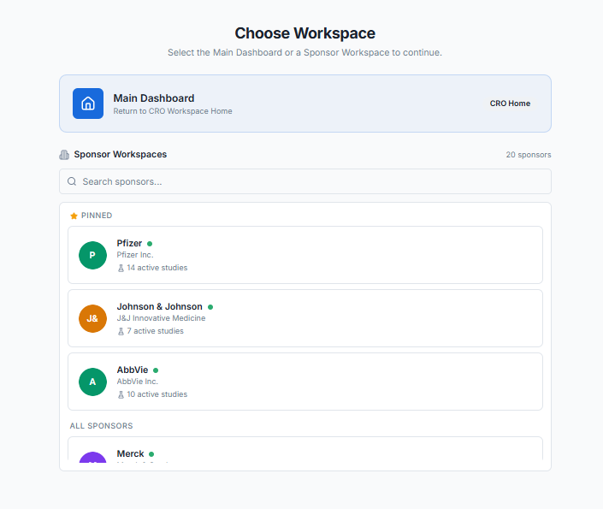

Profile Settings

My Profile
Parent Menu Name | Profile Settings
Feature Name | My Profile
Requirement | The system shall allow authenticated users to view and update their personal profile information, including Full Name, Email Address (read-only), Role, Photograph, and Contact Number.
Acceptance Criteria | 1. Access & Initiation:  • Accessible to all authenticated users via a profile icon or "My Profile" link in the top navigation bar or user menu.  • No special permissions required - users can only access their own profile.  • Clicking "My Profile" opens the profile view screen.  2. Profile View Mode:  • Upon accessing My Profile, the system displays the user's current profile information in view mode:  ◦ Full Name (displayed as text)  ◦ Email Address (displayed as text)  ◦ Role (displayed as text - shows assigned role(s))  ◦ Photograph (displayed as image thumbnail)  ◦ Contact Number (displayed as text)  • An "Edit Profile" button is available to switch to edit mode.  3. Profile Edit Mode:  • Clicking "Edit Profile" switches to edit mode with the following fields:  a) Full Name*: Text field (Mandatory, Editable)  ◦ Pre-populated with current Full Name  ◦ User can modify their full name  ◦ Validation: Required field  b) Email Address: Text field (Read-only, Non-editable)  ◦ Displayed as plain text or disabled input field  ◦ User cannot change their email address (must contact administrator for email changes)  ◦ Visual indicator (gray background, lock icon) shows it's read-only  c) Role: Display only (Non-editable)  ◦ Shows user's assigned role(s) from cro_team_members.role_id  ◦ Cannot be changed by user (must be changed by administrator)  ◦ If user has multiple roles, display all roles (comma-separated or bullet list)  d) Photograph: Image upload field (Editable)  ◦ Displays current photograph (if exists) or placeholder image  ◦ "Upload New Photo" button to select image file  ◦ "Remove Photo" option to delete current photograph  ◦ Accepted formats: JPEG, PNG, GIF  ◦ Max file size: 2MB  ◦ Recommended dimensions: 300x300 pixels (square)  ◦ Image preview after selection before saving  e) Contact Number: Text field (Editable)  ◦ Pre-populated with current Contact Number  ◦ User can modify their contact number  ◦ Optional field (not mandatory)  ◦ Validation: Phone number format validation (optional but recommended)  4. Save and Cancel Actions:  • Save: Updates profile with changed information  • Cancel: Discards changes and returns to view mode  • Confirmation prompt if user attempts to leave edit mode with unsaved changes  5. Success and Error Handling:  • Upon successful save, system displays success message and returns to view mode with updated information.  • If validation fails, error messages are displayed and user remains in edit mode.  6. Photograph Management:  • Uploaded photographs should be stored securely with appropriate naming convention.  • System should maintain only one photograph per user (new upload replaces old one).  • Photograph should be resized/optimized for web display if necessary.  7. Audit Trail:  • Changes to profile information should be logged in Activity Log:  ◦ "User [Name] updated their profile information."  ◦ "User [Name] updated their photograph."  • No logging for view-only access.
Default Value | • Profile displays current values from user/team member record.  • If no photograph exists, display default avatar/placeholder image.  • If no contact number exists, field displays as empty or "Not provided".
Messages | • Success (Update): "Your profile has been updated successfully."  • Success (Photo Upload): "Profile photograph updated successfully."  • Success (Photo Remove): "Profile photograph removed successfully."  • Error (Update): "Failed to update profile. Please try again."  • Error (Photo Upload): "Failed to upload photograph. Please try again."  • Validation (Full Name): "Full Name is required."  • Validation (Photo Format): "Invalid file format. Please upload JPEG, PNG, or GIF."  • Validation (Photo Size): "File size exceeds 2MB limit. Please upload a smaller image."  • Validation (Contact Number): "Please enter a valid contact number."  • Confirmation (Unsaved Changes): "You have unsaved changes. Are you sure you want to leave?"
Database Tables

Change Password
Parent Menu Name | Profile Settings
Feature Name | Change Password
Requirement | The system shall allow authenticated users to change their account password securely by verifying their current password and enforcing password strength policies.
Acceptance Criteria | 1. Access & Initiation:  • Accessible to all authenticated users via Profile Settings menu or a dedicated "Change Password" option.  • Clicking "Change Password" opens the change password screen/modal.  2. Change Password Form Fields:  • Current Password: Password field (Mandatory) - User must enter their existing password for verification  • New Password: Password field (Mandatory) - User enters their desired new password  • Confirm New Password*: Password field (Mandatory) - User re-enters new password to confirm  3. Password Strength Requirements:  • Minimum length: 8 characters  • Maximum length: 64 characters  • Must contain at least one uppercase letter (A-Z)  • Must contain at least one lowercase letter (a-z)  • Must contain at least one number (0-9)  • Must contain at least one special character (!@#$%^&*()_+-=[]{};:,.<>?)  4. Password Strength Indicator:  • As user types new password, a visual strength meter displays:  ◦ Weak: Meets only 1-2 criteria  ◦ Medium: Meets 3-4 criteria  ◦ Strong: Meets all 5+ criteria  • Helper text shows password requirements.  5. Validation Rules:  • Current Password must match the user's existing password.  • New Password must meet all password strength requirements.  • New Password and Confirm New Password must match exactly.  • New Password must not be the same as Current Password.  6. Form Actions:  • Change Password: Validates and processes password change  • Cancel: Discards changes and returns to previous screen  7. Success and Error Handling:  • Success: "Your password has been changed successfully."  • Error (Current Password): "Current password is incorrect."  • Error (New Password Match): "New password and confirmation do not match."  • Error (Same Password): "New password must be different from your current password."  • Error (Password Requirements): "Password must be at least 8 characters and include uppercase, lowercase, number, and special character."  • Validation (Required): "All fields are required."  8. Security Measures:  • All password fields must be masked in the UI.  • Passwords must be hashed before storing.  • Implement rate limiting to prevent brute force attempts.
Default Value | • All password fields are empty by default.
Messages | • Success: "Your password has been changed successfully."  • Error (Current Password): "Current password is incorrect."  • Error (New Password Match): "New password and confirmation do not match."  • Error (Same Password): "New password must be different from your current password."  • Error (Password Requirements): "Password must be at least 8 characters and include uppercase, lowercase, number, and special character."  • Validation (Required): "All fields are required."
Database Tables

CRO Dashboard
Parent Menu Name | Dashboard
Feature Name | Dashboard
Requirement
Acceptance Criteria | - Accessible under Sponsor Workspace → Dashboard.  - Available only to users with “View Dashboard” permission.  - Displays widgets dynamically based on enabled sub-modules as defined in role management  - Supports filters: Site, Country, Date Range.  - Supports drill-down (Study → Site → Subject → Record level).  - Supports export (PDF, Excel, CSV).  - Supports configurable widgets (enable/disable/reorder).  - Data refreshes in near real-time.  - Default Value  - Default view: Study-level summary  - Widgets enabled: Core KPIs only  - Date filter: Last 30 days  Widgets are:  - Study Portfolio Overview  Category Name KPI Name Description Chart Type AI Capability Formula / Required Data Elements Priority  Study Portfolio Total Studies Total studies across system KPI Card Trend detection COUNT(StudyID) High  Study Portfolio Active Studies Currently active studies KPI Card Predict study load COUNT(Status = Active) High  Study Portfolio Studies in UAT Studies in testing phase KPI Card Environment usage prediction COUNT (Environment = UAT) Medium  Study Portfolio Studies in Production/ Live Studies in Production phase KPI Card Environment usage prediction COUNT (Environment = Production) Medium  Study Portfolio Locked Studies Studies locked for changes KPI Card Risk flagging (stalled studies) COUNT(Status = Locked) Medium  Study Portfolio Completed Studies Closed studies KPI Card Completion trend prediction COUNT(Status = Completed) High  Study Portfolio Study Trend Study growth over time Line Chart Forecast study pipeline COUNT(StudyID) by Month Medium  - CRO Team Management  Category Name KPI Name Description Chart Type AI Capability Formula / Data Elements Priority  CRO Team Total CRO Users Total users in CRO workspace KPI Card Workforce trend prediction COUNT(UserID) High  CRO Team Active Users Active users in last X days KPI Card Engagement detection COUNT(Login Activity) High  CRO Team Role Distribution Users by role (CRA, PM, DM) Pie Chart Workforce planning COUNT(Role) High  CRO Team Team Utilization % Resource utilization Gauge Over/under utilization detection (Assigned Work / Capacity) × 100 Critical  CRO Team New Users Added User onboarding trend Line Chart Hiring prediction COUNT(New Users by Date) Medium
Default Value
Messages
Mock-up

CRO Module: Pre-defined Email Notifications
- The following emails are editable but cannot be deleted by any personnel, including the administration team.
- Parameters are maintained group-wise.
- Templates should allow configuration of roles in the To, Cc, and Bcc fields.
- Every email template should have Header, Content, and Footer section.
- Header section should allow to configure the Sponsor’s Organization Logo.
- If any modifications done on the email templates activity trail logs are recorded.

Team Member Management Email Templates

CRO Team Member Welcome Email
Attribute | Value
Template Code | CRO_TEAM_MEMBER_WELCOME
Trigger Event | When a new team member is added by administrator
Subject Line | Welcome to SclinNexus CRO Workspace - {OrganizationName}
Parameters:
Parameter | Description | Source
{FullName} | Team member's full name | User table
{EmailAddress} | Team member's email address | User table
{AssignedRole} | Role assigned (Data Manager, Project Manager, etc.) | Role table
{AssignedStudies} | List of assigned studies | Study assignment table
{LoginLink} | Workspace login link | System URL
{SetupInstructions} | Account setup instructions | System config
{SupportEmail} | Support contact email | System config
{CurrentYear} | Current year | System date
Sample Template Text:
Dear {FullName},

Welcome to the team!. You have been added as a team member to the SclinNexus Workspace.

Account Details:
- Organization: {OrganizationName}
- Email Address: {EmailAddress}
- Assigned Role: {AssignedRole}
- Assigned Studies: {AssignedStudies}

Please set up your account using the link below: {LoginLink}

If you have any questions, please contact your administrator or reach out to {SupportEmail}.

SclinNexus Administrator

Team Member Role Assignment
Attribute | Value
Template Code | TEAM_MEMBER_ROLE_ASSIGNMENT
Trigger Event | When a team member is assigned a new role
Subject Line | Role Assignment Update - {NewRole}
Parameters:
Parameter | Description | Source
{FullName} | Team member's full name | User table
{OldRole} | Previous role (if applicable) | Role table
{NewRole} | Newly assigned role | Role table
{AssignedBy} | Administrator who assigned the role | User table
{AssignedAt} | Date and time of assignment | System timestamp
{PermissionSummary} | Summary of permissions for new role | Role permission table
{SupportEmail} | Support contact email | System config
{CurrentDate} | Current date | System date
Sample Template Text:
Dear {FullName},

Your role in the SclinNexus CRO Workspace has been updated.

Role Update Details:
- Previous Role: {OldRole}
- New Role: {NewRole}
- Assigned By: {AssignedBy}
- Assigned On: {AssignedAt}

Permission Summary for {NewRole}:
{PermissionSummary}

Please log out and log back in for the new permissions to take effect.

If you believe this change was made in error, please contact {SupportEmail}.

Thank you,
SclinNexus Administrator

Team Member Study Assignment
Attribute | Value
Template Code | CRO_TEAM_MEMBER_STUDY_ASSIGNMENT
Trigger Event | When a team member is assigned to a study
Subject Line | Study Assignment - {StudyName} ({ProtocolNumber})
Parameters:
Parameter | Description | Source
{FullName} | Team member's full name | User table
{StudyName} | Name of the study | Study table
{ProtocolNumber} | Protocol number/Study ID | Study table
{AssignedRole} | Role within the study | Study assignment table
{SponsorName} | Sponsor organization name | Sponsor table
{StudyLink} | Link to study workspace | System URL
{SupportEmail} | Support contact email | System config
{CurrentDate} | Current date | System date
Sample Template Text:
Dear {FullName},

You have been assigned to the following study:

Study Details:
- Study Name: {StudyName}
- Protocol Number: {ProtocolNumber}
- Sponsor: {SponsorName}
- Your Role: {AssignedRole}

Access the study workspace here: {StudyLink}

Please familiarize yourself with the study protocol and requirements.

For questions, contact {SupportEmail}

Thank you,
SclinNexus Team

CRO Team Member Account Activation (Post-Verification)
Attribute | Value
Template Code | TEAM_MEMBER_ACCOUNT_ACTIVATION
Trigger Event | When user clicks verification link and needs to set password
Subject Line | Set Your Password - Complete Your SclinNexus Registration
Parameters:
Parameter | Description | Source
{FullName} | User's full name | User table
{EmailAddress} | User's email address | User table
{SetPasswordLink} | Link to set password page | System generated
{PasswordRequirements} | Password complexity requirements | System config
{SupportEmail} | Support contact email | System config
{CurrentYear} | Current year | System date
Sample Template Text:
Dear {FullName},

Your email address has been successfully verified!

Please click the link below to set your password and complete your registration:
{SetPasswordLink}

Password Requirements:
{PasswordRequirements}

- Minimum 8 characters
- At least one uppercase letter (A-Z)
- At least one lowercase letter (a-z)
- At least one number (0-9)
- At least one special character (!@#$%^&*)

Email Address: {EmailAddress}

For security reasons, this link will expire in 24 hours.

If you have any questions, please contact us at {SupportEmail}.

Thank you,
SclinNexus Team

Study Management Email Templates

Study Status Email Templates

Study Close Out
Attribute | Value
Template Code | SPONSOR_STUDY_CLOSE_OUT
Trigger Event | When study is closed out
Subject Line | Study Close Out Notice - {StudyName}
Parameters:
Parameter | Description | Source
{PersonName} | Recipient's full name | User table
{StudyName} | Name of the study | Study table
{StudyID} | Protocol number/Study ID | Study table
{CloseOutDate} | Study close-out date | Study table
{FinalDataLockDate} | Date when data will be locked | Study config
{ArchiveAccessDetails} | Archive access instructions | System config
{SupportEmail} | Support contact email | System config
{CurrentDate} | Current date | System date
Sample Template Text:
Dear {PersonName},

The following study has been officially closed out:

Study Details:
- Study Name: {StudyName}
- Protocol Number: {StudyID}
- Close Out Date: {CloseOutDate}

Important Information:
- Final data lock will occur on: {FinalDataLockDate}
- After data lock, no further data entry or modifications will be permitted
- Study data will be archived and available for read-only access

Archive Access: {ArchiveAccessDetails}

Please ensure all pending queries are resolved and all required data entries are completed before the data lock date.

For questions regarding study close out, please contact {SupportEmail}.

Thank you for your contributions to this study.

Study Administration Team

Study Lock
Attribute | Value
Template Code | SPONSOR_STUDY_LOCK
Trigger Event | When study is locked (no further data entry)
Subject Line | Study Locked - {StudyName} - No Further Data Entry Permitted
Parameters:
Parameter | Description | Source
{PersonName} | Recipient's full name | User table
{StudyName} | Name of the study | Study table
{StudyID} | Protocol number/Study ID | Study table
{LockOutDate} | Study lock-out date | Study table
{SupportEmail} | Support contact email | System config
{CurrentDate} | Current date | System date
Sample Template Text:
Dear {PersonName},

The following study has been locked:

Study Details:
- Study Name: {StudyName}
- Protocol Number: {StudyID}
- Lock Date: {LockOutDate}

The study is now in READ-ONLY mode. The following actions are no longer permitted:
- New data entry
- Modifying existing data
- Raising new queries
- Subject enrollment
- Consent submissions

If you believe this action was taken in error or need to request an exception, please contact {SupportEmail}.

Thank you,
Study Administration Team

Study Unlock
Attribute | Value
Template Code | SPONSOR_STUDY_UnlOCK
Trigger Event | When a locked study is unlocked (data entry permitted again)
Subject Line | Study Unlocked - {StudyName} - Data Entry Resumed
Parameters:
Parameter | Description | Source
{PersonName} | Recipient's full name | User table
{StudyName} | Name of the study | Study table
{StudyID} | Protocol number / Study ID | Study table
{UnlockDate} | Study unlock date | Study table / Audit log
{UnlockedBy} | User who performed unlock | User table / Audit log
{SupportEmail} | Support contact email | System config
{CurrentDate} | Current date | System date
Parameter | Description | Source
{PersonName} | Recipient's full name | User table
{StudyName} | Name of the study | Study table
{StudyID} | Protocol number/Study ID | Study table
{LockOutDate} | Study lock-out date | Study table
{SupportEmail} | Support contact email | System config
{CurrentDate} | Current date | System date
Sample Template Text:
Dear {PersonName},
The following study has been unlocked:
Study Details:
- Study Name: {StudyName}
- Protocol Number: {StudyID}
- Unlock Date: {UnlockDate}
- Unlocked By: {UnlockedBy}
The study is now active and editable. The following actions are now permitted:
- New data entry
- Modification of existing data
- Raising and responding to queries
- Subject enrollment
- Consent submissions
Please ensure that all updates comply with applicable study protocols, audit requirements, and data integrity guidelines.
If you believe this action was taken in error or require further clarification, please contact {SupportEmail}.
Thank you,
Study Administration Team

Study Published to UAT
Attribute | Value
Template Code | STUDY_PUBLISHED_UAT
Trigger Event | When a study is published to UAT environment
Subject Line | Study Published to UAT - {StudyName} ({ProtocolNumber}) - Version {VersionNumber}
Parameters:
Parameter | Description | Source
{PersonName} | Recipient's full name | User table
{StudyName} | Name of the study | Study table
{ProtocolNumber} | Protocol number/Study ID | Study table
{VersionNumber} | Version number of the study release | Study version table
{UATLink} | UAT environment access link | System URL
{PublishedBy} | User who published the study | User table
{PublishedAt} | Date and time of publication | System timestamp
{NextSteps} | Instructions for UAT testing | System config
{SupportEmail} | Support contact email | System config
{CurrentDate} | Current date | System date
Sample Template Text:
Dear {PersonName},

The following study has been successfully published to the UAT environment:

Study Details:
- Study Name: {StudyName}
- Protocol Number: {ProtocolNumber}
- Version: {VersionNumber}
- Published By: {PublishedBy}
- Published On: {PublishedAt}

UAT Access Link: {UATLink}

Please perform UAT testing before proceeding to LIVE publication.

For technical assistance, contact {SupportEmail}

Thank you,
SclinNexus Team

Study Published to LIVE
Attribute | Value
Template Code | CRO_STUDY_PUBLISHED_LIVE
Trigger Event | When a study is published to LIVE/Production environment
Subject Line | Study Published to LIVE - {StudyName} ({ProtocolNumber}) - Version {VersionNumber}
Parameters:
Parameter | Description | Source
{PersonName} | Recipient's full name | User table
{StudyName} | Name of the study | Study table
{ProtocolNumber} | Protocol number/Study ID | Study table
{VersionNumber} | Version number of the study release | Study version table
{LIVELink} | LIVE environment access link | System URL
{PublishedBy} | User who published the study | User table
{PublishedAt} | Date and time of publication | System timestamp
{AnnouncementDetails} | Additional announcement information | System config
{SupportEmail} | Support contact email | System config
{CurrentDate} | Current date | System date
Sample Template Text:
Dear {PersonName},

The following study has been successfully published to the LIVE environment:

Study Details:
• Study Name: {StudyName}
• Protocol Number: {ProtocolNumber}
• Version: {VersionNumber}
• Published By: {PublishedBy}
• Published On: {PublishedAt}

LIVE Access Link:
{LIVELink}

{AnnouncementDetails}

The study is now available for sponsor access and site enrollment.

For questions, contact {SupportEmail}

Thank you,
SclinNexus Team

Study Status Change Notification
Attribute | Value
Template Code | CRO_STUDY_STATUS_CHANGE
Trigger Event | When study status changes (Active/Inactive/Locked/Completed)
Subject Line | Study Status Updated - {StudyName} ({ProtocolNumber}) - {NewStatus}
Parameters:
Parameter | Description | Source
{PersonName} | Recipient's full name | User table
{StudyName} | Name of the study | Study table
{ProtocolNumber} | Protocol number/Study ID | Study table
{OldStatus} | Previous status | Study table
{NewStatus} | New status | Study table
{ReasonForChange} | Reason for status change (if provided) | User input
{ChangedBy} | User who changed the status | User table
{ChangedAt} | Date and time of change | System timestamp
{ImpactDescription} | Description of impact of status change | System config
{StudyLink} | Link to study details | System URL
{SupportEmail} | Support contact email | System config
{CurrentDate} | Current date | System date
Sample Template Text:
Dear {PersonName},

The status of the following study has been updated:

Study Details:
- Study Name: {StudyName}
- Protocol Number: {ProtocolNumber}
- Previous Status: {OldStatus}
- New Status: {NewStatus}
- Changed By: {ChangedBy}
- Changed On: {ChangedAt}

Reason for Change: {ReasonForChange}

Impact: {ImpactDescription}

Click below to view study details: {StudyLink}

For questions, contact {SupportEmail}

Thank you,
SclinNexus Team

Sponsor Management Email Templates

Sponsor Invitation Email
Attribute | Value
Template Code | CRO_SPONSOR_INVITATION
Trigger Event | When a new sponsor is created in the system
Subject Line | Invitation to SclinNexus Sponsor Workspace
Parameters:
Parameter | Description | Source
{SponsorName} | Sponsor's full name | Sponsor table
{OrganizationName} | Sponsor's organization name | Sponsor table
{EmailAddress} | Sponsor's email address | Sponsor table
{InvitationLink} | Unique invitation link | System generated
{SupportEmail} | Support contact email | System config
{CurrentYear} | Current year | System date
Sample Template Text:
Dear {SponsorName},

You have been invited to access the SclinNexus Workspace on behalf of {OrganizationName}.

Please click the link below to access your study workspace: {InvitationLink}

This invitation link will expire in 7 days for security purposes.

During registration, you will be able to:
- Set up your login credentials
- Access your sponsor dashboard
- View study progress and metrics
- Manage site activities

If you have any questions or did not expect this invitation, please contact {SupportEmail}.

Thank you,
SclinNexus CRO Team

Study Assignment Notification
Attribute | Value
Template Code | STUDY_ASSIGNMENT
Trigger Event | When a sponsor and users are assigned to a new study
Subject Line | New Study Assignment - {StudyName} ({ProtocolNumber})
Parameters:
Parameter | Description | Source
{SponsorName} | Sponsor's full name | Sponsor table
{OrganizationName} | Sponsor's organization name | Sponsor table
{StudyName} | Name of the study | Study table
{ProtocolNumber} | Protocol number/Study ID | Study table
{StudyPhase} | Study phase | Study phase master
{Environment} | UAT or LIVE environment | Study version table
{AccessLink} | Study access link | System URL
{SupportEmail} | Support contact email | System config
{CurrentDate} | Current date | System date
Sample Template Text:
Dear {SponsorName},

You have been assigned to a new study on the SclinNexus platform.

Study Details:
- Study Name: {StudyName}
- Protocol Number: {ProtocolNumber}
- Study Phase: {StudyPhase}
- Environment: {Environment}

Access your study workspace here:
{AccessLink}

Please review the study details and ensure all information is accurate.

For questions, contact {SupportEmail}

Thank you,
SclinNexus CRO Team

Password & Security Email Templates

Password Reset Request
Attribute | Value
Template Code | CRO_PASSWORD_RESET_REQUEST
Trigger Event | When user requests password reset
Subject Line | Password Reset Request - SclinNexus CRO Workspace
Parameters:
Parameter | Description | Source
{FullName} | User's full name | User table
{EmailAddress} | User's email address | User table
{ResetLink} | Password reset link | System generated
{TokenExpiryHours} | Token expiry duration | System config
{IPAddress} | Request IP address | Request header
{UserAgent} | Browser/device information | Request header
{SupportEmail} | Support contact email | System config
{CurrentDateTime} | Current date and time | System datetime
Sample Template Text:
Dear {FullName},

A password reset request was received for your SclinNexus Workspace account.

Request Details:
- Date and Time: {CurrentDateTime}
- IP Address: {IPAddress}
- Device/Browser: {UserAgent}

To reset your password, click the link below: {ResetLink}

This link will expire in {TokenExpiryHours} hours.

Email Address: {EmailAddress}

If you did not request this password reset, please ignore this email. Your password will remain unchanged.

For security concerns, contact {SupportEmail}

Thank you,
SclinNexus Security Team

Password Changed Confirmation
Attribute | Value
Template Code | USER_PASSWORD_CHANGED_CONFIRMATION
Trigger Event | When user successfully changes password
Subject Line | Password Changed Successfully - SclinNexus CRO Workspace
Parameters:
Parameter | Description | Source
{FullName} | User's full name | User table
{EmailAddress} | User's email address | User table
{ChangeDateTime} | Date and time of change | System datetime
{IPAddress} | Request IP address | Request header
{UserAgent} | Browser/device information | Request header
{SupportEmail} | Support contact email | System config
{CurrentDate} | Current date | System date
Sample Template Text:
Dear {FullName},

Your SclinNexus Workspace password was successfully changed.

Change Details:
- Date and Time: {ChangeDateTime}
- IP Address: {IPAddress}
- Device/Browser: {UserAgent}
- Email Address: {EmailAddress}

If you made this change, no further action is required.

If you did NOT make this change, please contact support immediately: {SupportEmail}

Thank you,
SclinNexus Security Team

New Login Detection
Attribute | Value
Template Code | NEW_LOGIN_DETECTION
Trigger Event | When successful login from new device/location
Subject Line | New Login Detected - SclinNexus CRO Workspace
Parameters:
Parameter | Description | Source
{FullName} | User's full name | User table
{EmailAddress} | User's email address | User table
{LoginDateTime} | Login date and time | System datetime
{IPAddress} | IP address of login | Request header
{Location} | Approximate location | GeoIP lookup
{Browser} | Browser information | User agent
{OS} | Operating system | User agent
{DeviceType} | Device type (Desktop/Mobile/Tablet) | User agent
{SupportEmail} | Support contact email | System config
{CurrentDate} | Current date | System date
Sample Template Text:
Dear {FullName},

A new login was detected on your SclinNexus Workspace account.

Login Details:
- Date and Time: {LoginDateTime}
- IP Address: {IPAddress}
- Location: {Location}
- Device: {DeviceType}
- Browser: {Browser}
- Operating System: {OS}
- Email Address: {EmailAddress}

If this was you, no further action is required.

If this was NOT you, please contact support immediately: {SupportEmail}

Thank you,
SclinNexus Security Team

Account Locked Notification
Attribute | Value
Template Code | USER_ACCOUNT_LOCKED
Trigger Event | When account is locked due to multiple failed login attempts
Subject Line | Account Temporarily Locked - SclinNexus Workspace
Parameters:
Parameter | Description | Source
{FullName} | User's full name | User table
{EmailAddress} | User's email address | User table
{FailedAttempts} | Number of failed login attempts | User table
{LockDurationMinutes} | Duration of lock in minutes | System config
{LockExpiryTime} | Time when lock will expire | System timestamp
{IPAddress} | IP address of attempts | Request header
{SupportEmail} | Support contact email | System config
{ResetLink} | Password reset link | System URL
{CurrentDate} | Current date | System date
Sample Template Text:
Dear {FullName},

Your SclinNexus Workspace account has been temporarily locked due to multiple failed login attempts.

Account Details:
- Email Address: {EmailAddress}
- Failed Attempts: {FailedAttempts}
- Source IP Address: {IPAddress}

Lock Details:
- Lock Duration: {LockDurationMinutes} minutes
- Lock Expires On: {LockExpiryTime}

To regain access:
1. Wait for the lock to expire, OR
2. Reset your password using the link below: {ResetLink}

If you continue to experience issues, please contact {SupportEmail}.

Thank you,
SclinNexus Security Team

Functional Considerations for Lock and Unlock a Study
Category | Lock / Unlock | Action | Description
Study | Lock | Lock entire study | Entire study is locked and becomes read-only; no further data entry or updates allowed
Study | Lock | Attempt data entry | System blocks any new data entry or modification after study is locked
Study | Lock | Raise new query | Users cannot create new queries once study is locked
Study | Lock | Manage open queries | Existing queries can only be viewed (or optionally responded based on configuration)
Study | Lock | Subject enrollment | New subject enrollment is not allowed after study lock
Study | Unlock | Unlock entire study | Study becomes active and editable again
Study | Unlock | Resume data entry | Users can enter and modify data after study is unlocked
Study | Unlock | Query management | Users can raise, respond, and close queries
Study | Unlock | Unauthorized unlock attempt | System blocks unlock if user does not have permission
Study | Unlock | Unlock with missing reason | System blocks unlock if mandatory reason is not provided

Category | Lock / Unlock | Action | Description
Cross-Level | Lock | Study lock impact | Locking study automatically locks all sites and subjects
Cross-Level | Lock | Site lock impact | Locking site automatically locks all subjects within the site
Cross-Level | Unlock | Study unlock cascade | Unlocking study may unlock all sites and subjects (based on configuration)
Cross-Level | Unlock | Partial unlock restriction | Lower-level entities cannot be unlocked if higher level is still locked
Cross-Level | Lock/Unlock | Audit trail capture | All lock/unlock actions are recorded with user, date, and reason
Cross-Level | Unlock | Data change tracking | Any data updated after unlock is fully tracked in audit logs
Cross-Level | Lock/Unlock | System notification | System sends notifications to relevant users on lock/unlock actions

