Table of Contents

1) References 1

2) scalar/Vector/Matrix/Tensor 1

2) Importance of Linear Algebra: 2

3) Matrices: nXm 2

4)Operations on Matrices 5

5) Properties of Transpose of Matrices : 7

6) Hermitian Matrices and Skew Hermitian Matrices 8

7) Determinants: 12

8) Minors and Cofactors of elements in a determinant: 14

9)Properties of Determinants: 16

10) Determinants Explained again: 18

11) Minors and Cofactors of elements in a Determinant 19

12) Properties of Determinants 21

# 1) References

<https://www.udemy.com/course/math-for-data-sciencedata-analysis-and-python-programming/learn/lecture/29005774?start=180#overview>

# 2) scalar/Vector/Matrix/Tensor

1

-> Scalar is a single number

1

2

--> Vector is an array of numbers written either in row form or column form

1 2

3 4

---> Matrix is a 2d array in which rows and columns are there

1 2 1 5

3 4 7 9

1 3 2 4

9 4 7 1

--> Tensor is n dimensional array with n more than 2

# 2) Importance of Linear Algebra:

-> Linear Algebra has a faster computation speed in dealing with any type of problem

-> It helps to understand the insights and background behind various types of algorithms used in latest technologies.

-> It helps us in decison making

# 3) Matrices: nXm

a) Square Matrix:

-> No of rows and columns are equal

-> left to right diagonal elements are called Principal diagonal elements of matrix

b) Row and Column matrix:

-> Matrix that has only one row is called row matrix

-> Matrix that has only one column is called column matrix

c) Singleton matrix:

-> Matrix that has one element in it is called singleton matrix

d) Zero/Null Matrix:

-> If all entries in matrix are zero, it is called zero or null matrix

e) Diagonal Matrix:

-> Matrix that has non zero entries only in diagonal elements is called Diagonal matrix .

-> All non diagonal elements will be zero

Diagonal matrix is a square matrix

f) Scalar matrix:

-> Scalar matrix is a diagonal matrix in which diagonal elements are same.

g) Unit Matrix or Identity matrix:

-> Identity matrix is a diagonal matrix in which diagonal elements have value equal to 1.

h) Triangular Matrix:

-> Trianglular matrix shoule be a square matrix

-> Matrix in which elements above(Lower triangular matrix) or below(Upper Triangular matrix) the principal diagonal is zero

eg:

1 0 0 1 -1 5

2 1 0 0 9 8

2 2 3 0 0 7

i) Equivalence Matrices :

-> Two matrices are equivalent if their order is same

j) Equal Matrices:

-> Two matrices are equal if their corresponding entries are same.

-> Equal matrices should be an equivalence matrices.

k) Transpose of a matrix:

-> If we convert a matrix : row into columns or column into rows - then the matrix we obtain is called transpose of a matrix

l) Symmetric and Skew Symmetric matrices

[Aij] = [Aji]

-> This means that if i transpose a matrix and if both the matrices are same matrices it is called Symmetric matrix

[Aij]=-[Aji]

-> If i transpose a matrix and if the resulting matrix is negative of original matrix then it is called skew symmetric matrix

# 4)Operations on Matrices

a) Operation of matrices include Addition, Subtraction and multiplication of Matrices

b) Addition of Matrices

-> Two matrices can be added only if they are of the same order[rows=columns]

b.1) Properties of matrix Addition:

1) Commutative law: A+B = B+A

2) Associative law: A+(B+C)= (A+B)+C

3) A + 0 = 0 + A = A ( Additive Identity existence ) where 0 is null matrix

4) A+ (-A) = 0 (Existence of Additive inverse)

5) If A+B = B+C -> then A= C

c) Matrix multiplication and its properties

c.1) Scalar multiplication

If A -> 1 2

3 4

Then 2A -> 2 4

6 8

c.2) In multiplication of two matrices, no of colums in matrix 1 should always be equal to no of rows in matrix 2

If A has order :3x2 and B has order: 2x3, then the product will be of order: 3x3

c.3) Sclar multiplication:

K(A+B) =K(A+B)

k,l (K+L)=KA+LA

C.4) Multiplication of matrices :

AB != BA

A(BC) = (AB)C -> Associative law

A(B+C) = AB+AC -> Distributive law applicable

Here -> indicates order

A -> mxn

B -> nxp

C -> nxp , then distributive law is appliable

c.5) Unit matrix

I2 -> 1 0

0 1

I3 -> 1 0 0

0 1 0

0 0 1

# 5) Properties of Transpose of Matrices :

´ Indicates Transpose of a matrix

-> Transpose of a matrix means : convert rows into columns and columns into rows.

-> If A and B are two matrices ,

Then :

a) ( A ± B)´ = A´ ± B´

b) (A´)´ = A

c) (AB)´ = B´A´

# 6) Hermitian Matrices and Skew Hermitian Matrices

a) Hermitian Matrix:

-> The hermitian matrix has complex numbers as its elements, and it is equal to its conjugate transpose matrix.

-> Hermitian matrix is a square matrix, which is equal to its conjugate transpose matrix.

-> Non diagonal elements of hermitian matrix are complex numbers

a.1) Hermitian Matrix of Order 2 x 2:

-> Here the non-diagonal elements are complex numbers.

-> Only the first element of the first row and the second element of the second row are real numbers.

-> Also, the complex number of the first-row second element is a conjugate complex number of the second-row first element.

eg:

3 3-2i

3-2i 2

a.2) Hermitian Matrix of Order 3 x 3

-> Here also the non-diagonal elements are all complex numbers.

-> The elements connecting the diagonal from the first row first element to the third-row third element are all real numbers.

-> Also, notice that an element in the position (i, j) is the complex conjugate of the element in the position (j, i).

-> For example, in the matrix below, 2 + i is present in the first row and the second column, whereas it's conjugate 2 - i is present in the second row and first column.

-> The same is the case with other complex numbers as well.

1 2+i 5-4i

2-i 4 6i

5+4i -6i 2

a.3) Hermitian Matrix Formula

-> From the above two matrices, it is clear that the diagonal elements of a Hermitian matrix are always real.

-> Also, the element in the position (i, j) is the complex conjugate of the element in the position (j, i).

_

A= (A´)

b) Skew Hermitian Matrix:

-> A matrix will be known as the skew-Hermitian matrix if there is a square matrix in which the negation of the matrix and its conjugate transpose matrix are similar to each other,

i.e., A^H = -A

or

___

[Aij]= -[Aji]

-> Here AH is used to indicate the conjugate transpose of matrix A. It can also be indicated by the symbol A*

-> Thus by definition: A square matrix A=[Aij] is called skew Hermitian matrix, if for all i and j,

[Aij]= -[Aji]

b.1) 2x2:

xi y+zi

-y+zi wi

-> Here x,y,z are used to indicate real numbers

b.2) 3x3

ai b+ci c+di

-b+ci ei g+hi

-c+di -g+hi ki

b.3) Properties of skew hermitian matrix:

-> The diagonal entries are either purely imaginary or zero.

-> Elements other than diagonal elements may have real as well as imaginary parts.

-> The imaginary part of the ith row and jth column, other than diagonal elements, is the same.

-> The real part of the ith row and jth column, other than diagonal elements, is the same but have opposite signs.

b.4)

--> Aij

i 2+3i 2+i

-(2-3i) 0 5i

-(2-i) 5i 2i

-> Aji

i -(2-3i) -(2-i)

2+3i 0 5i

2+i 5i 2i

-> Aij

-i -(2+3i) -(2+i)

-2-3i 0 -5i

-2-i -5i -2i

_____

-> -[Aji]

i 2+3i 2+i

-(2-3i) 0 5i

-(2-i) 5i 2i

-> Hence it is an example of skew hermitian matrix

# 7) Determinants:

-> A square matrix will have its own determinant

-> While matrix is an arrangement. Determinant will have its own value

a) Determinant for matrix A is written as:

det A or |A|

b) For Matrix A of order 2x2

1 2

3 4

det A = 1x4-2x3

= 4-6

= -2

c) for matrix A of order 3x3

2 3 0

-1 0 5

1 2 -3

2 -> 0 5 -3 -> -1 5 +0-> -1 0

2 -3 1 -3 1 2

-> =2[0-10]-3[3-5]+0[-2-0]

= -20+6+0

= -14

d) Now in above example we took determinant using value of rows, similarly we can get determinant using value of columns

2 3 0

-1 0 5

1 2 -3

d.1)

2 -> 0 5 -(-1)-> 3 0 +1->3 0

2 -3 2 -3 0 5

= 2[0-10]+1[-9-0]+1[15-0]

= -20-9+15

= -14

e) Thus we can take row or column and we will get same value as determinant

# 8) Minors and Cofactors of elements in a determinant:

a) Consider a determinant for 2x2 matrix

a.1) Minor for 2x2 matrix

1 2

3 4

-> The minor for the element 1 : M11 is , Leaving colum which has 1 and row which has element 1 , we will get Minor M11 as: 4

-> The minor for the element 2 : M12 is, 3

-> The minor for the element 3 : M21 is, 2

-> The minor for the element 4 : M22 is, 1

a.2) To these minors we obtain the cofactors by assigning the signs

-> for a 2x2 matrix we give sign as:

+ -

- +

a.3) So the cofactors will be:

M11=4 C11= 4

M12=3 C12= -3

M21=2 C21= -2

M22=1 C22= 1

b) For a 3x3 matrix:

1 2 -1

0 1 5

1 2 -1

Scheme for cofactor in 3x3 matrix:

+ - +

- + -

+ - +

M11 -> 1 5 -> Whose determinant is = -1-10 = -11 , C11= -11

2 -1

M12 -> 0 5 -> Whose determinant is = 0-5=-5, C12= 5

1 -1

M13 -> 0 1 -> Whose determinant is 0-1= -1, C13= -1

1 2

-> Like this we can find all the minors and cofactors of 3x3 matrix

# 9)Properties of Determinants:

a) If we interchange rows and columns of a determinant, then its value remains unchanged.

-> True for 2x2 as well as 3x3 matrix / determinant

b) If we change 2 rows or 2 columns of a determinant, value of the determinant remains same but its sign is changed.

-> True for 2x2 as well as 3x3 matrix/ determinant

c) If any 2 rows or 2 columns of a determinant are same, then the value of that determinant will be zero

eg:

1 1

5 5

1 5 2

2 -1 0

2 -1 0

d) If we multiply all elements,of any row or any column by k, where k is real number, Then the value of the determinant becomes k times the original value

-> Suppose a 2x2 matrx :

1 5

2 -1

d.1) Its determinat is -1=10 = -11

d.2) Suppose if i multiply first column by 2,

2 5

4 -1

Then its determinant is: -2-20= -22

-> Thus the determinant is k times the original value

e) If we have determinant of form :

a1+ λ1 a2+λ2 a3+λ3 = a1 a2 λ3 + λ1 λ2 λ3

b1 b2 b3 b1 b2 b3 b1 b2 b3

c1 c2 c3 c1 c2 c3 c1 c2 c3

->

# 10) Determinants Explained again:

a) Determinant for a 2x2 matrix

* We can find value of determinant only if it is a square matrix

1. Determinant for a 3x3 matrix

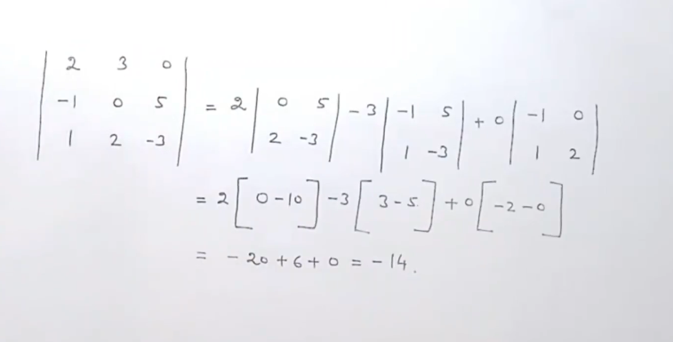

1. Earlier we have taken determinant by expanding first row, similarly we can take determinant by expanding first column also.
2. OR we can find determinant by taking any row or any column
3. Expanding first column to find value of determinant

# 11) Minors and Cofactors of elements in a Determinant

1. Consider that we have a determinant of order 2x2

1. Here Minor of element 1 is written as M11 = 4

* Similarly for other elements :

1. When we give signs to these minors, we obtain cofactors

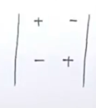

* Hence the cofactor will be like below:

* Thus we found the minor and cofactor of 2x2 determinant above.

1. Consider a 3x3 determinant

Minors and cofactors of elements of first row:

# 12) Properties of Determinants

a) If we interchange rows and elements of a determinant, the value of the determinant remains unchanged.

Similarly for a 3x3 matrix:

b) If two rows(or columns) of a determinant are interchanged, then the value of the determinant remains same, but its sign is changed.

Similarly for a 3x3 matrix



c) If two rows or columns of a determinant are same, i.e all its elements are identical – then the value of the determinant is zero.

1. If any row or column is multiplied by a number K, then the value of the determinant becomes k times the original

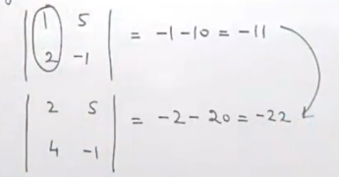

Similarly for 3x3 determinant

1. If we have determinant of the form as shown below, then :

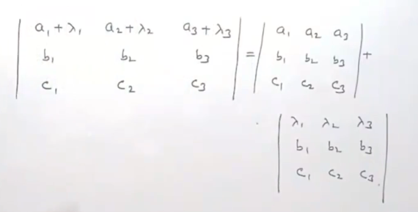

1. If in any determinant – In any row or column we add or subtract the elements of another row or column, then the value of the determinant is unchanged

For a 2x2 determinant:

* According to this property, even if we multiply second column by 2 times and then add, then also the value of the determinant is unchanged.

**Use of properties of determinants:**

* Sometimes expanding a determinant is a laborious task, using these properties we can find the value of determinant easily

# 13) Differentiation of a Determinant

1. Suppose we have a determinant of order 2x2

Here f’(x), g’(x) are differentiation of f(x),g(x) respectively

* Here we do differentiation row wise, first part we will have differentiation of elements of first row and second part we will have differentiation of elements of second row

* Now doing differentiation column wise . Here we do differentiation column wise, first part we will have differentiation of elements of first column and second part we will have differentiation of elements of second column
* Similarly for 3x3 matrix

1. Illustration

# 13) Rank of a matrix

a) A positive integer r is said to be the rank of a non-zero matrix A if:

i) There exists atleast one minor in A of order which is not zero

ii) Every minor in A of order greater than r is zero

it is written as ρ(A) = r

Here ρ is pronounced as row.