1. <https://confluence.dbvis.com/display/UG100/Viewing+Table+Relationships>
2. To see how a table is related to other tables through Foreign Keys:

* Locate the table in the **Databases** tab tree,
* Double-click the node to open its **Object View** tab,
* Select the **References** sub tab,
* Select **Imported Keys** from the drop-down list in the toolbar to see tables referenced by foreign keys in this table,
* Select **Exported Keys** from the drop-down list to see tables referencing this table by foreign keys.

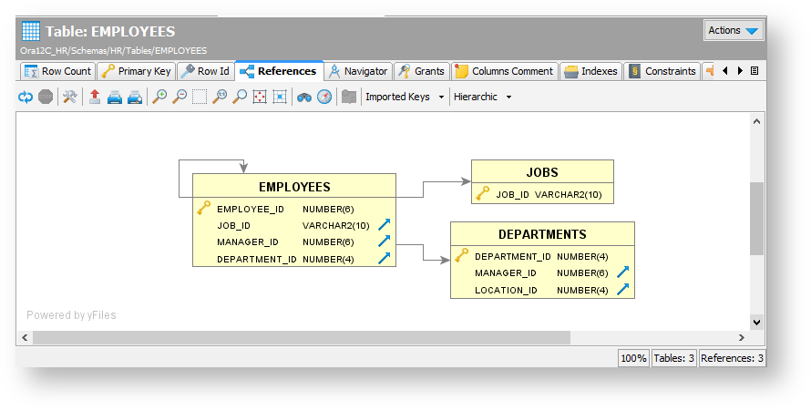

You can select among different graph layouts in the layout drop-down list in the toolbar: **Hierarchic**, **Organic**, **Orthogonal**, or **Circular**.

Other layout settings can be changed in the **Graph Control** area, which is shown or hidden with the settings toggle button in the toolbar. For instance, you can select how much information to include for each table in the graph: just the **Table Name**, the **Primary Key** column(s) or all **Columns**.

The graph can be **Exported** to a file in **JPG**, **GIF**, **PNG**, **SVG** or **PDF** or **Saved** as a Graph Modeling Language (**GML**) file that you can then open in the [yEd](http://www.yworks.com/en/products_yed_about.html) tool from yWorks for further manipulation.

You can control whether the table names should be [qualified with the schema/catalog](https://confluence.dbvis.com/display/UG100/Delimited+Identifiers+and+Qualifiers) in the graph.