**1) To Make copy of my changes**

1. Stash the unstaged files

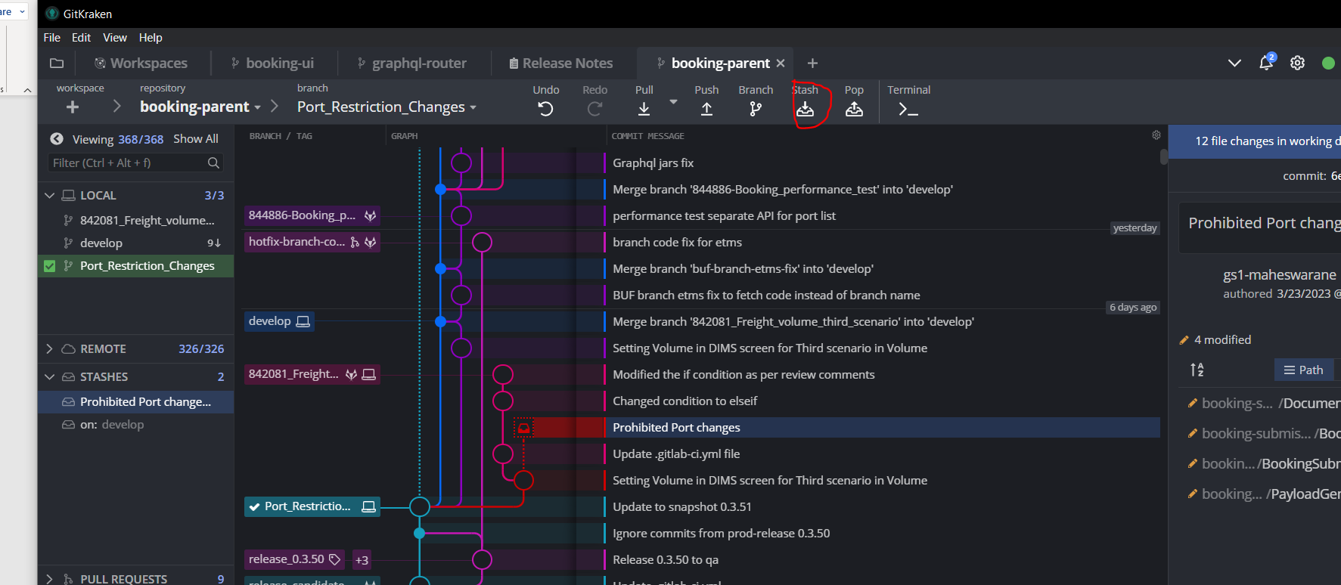

1. Select a particular branch

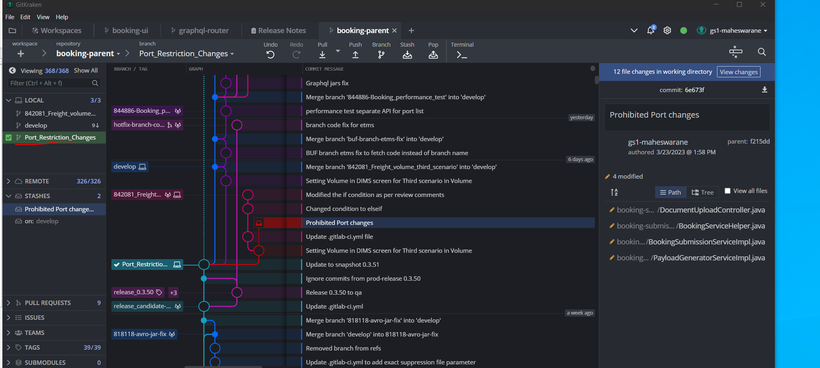

1. Pop the stash

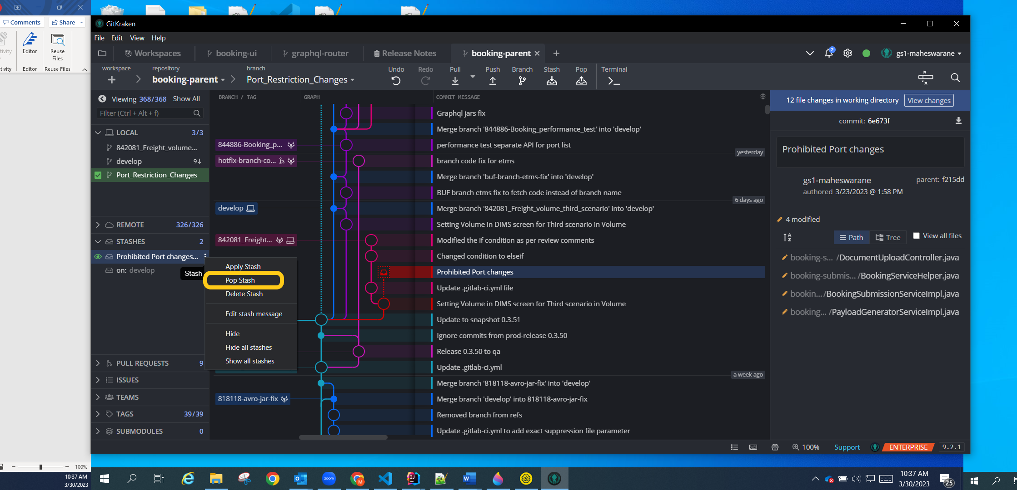

1. Now all changes will go to Port_Restriction_changes branch and it will be listed as part of unstaged files

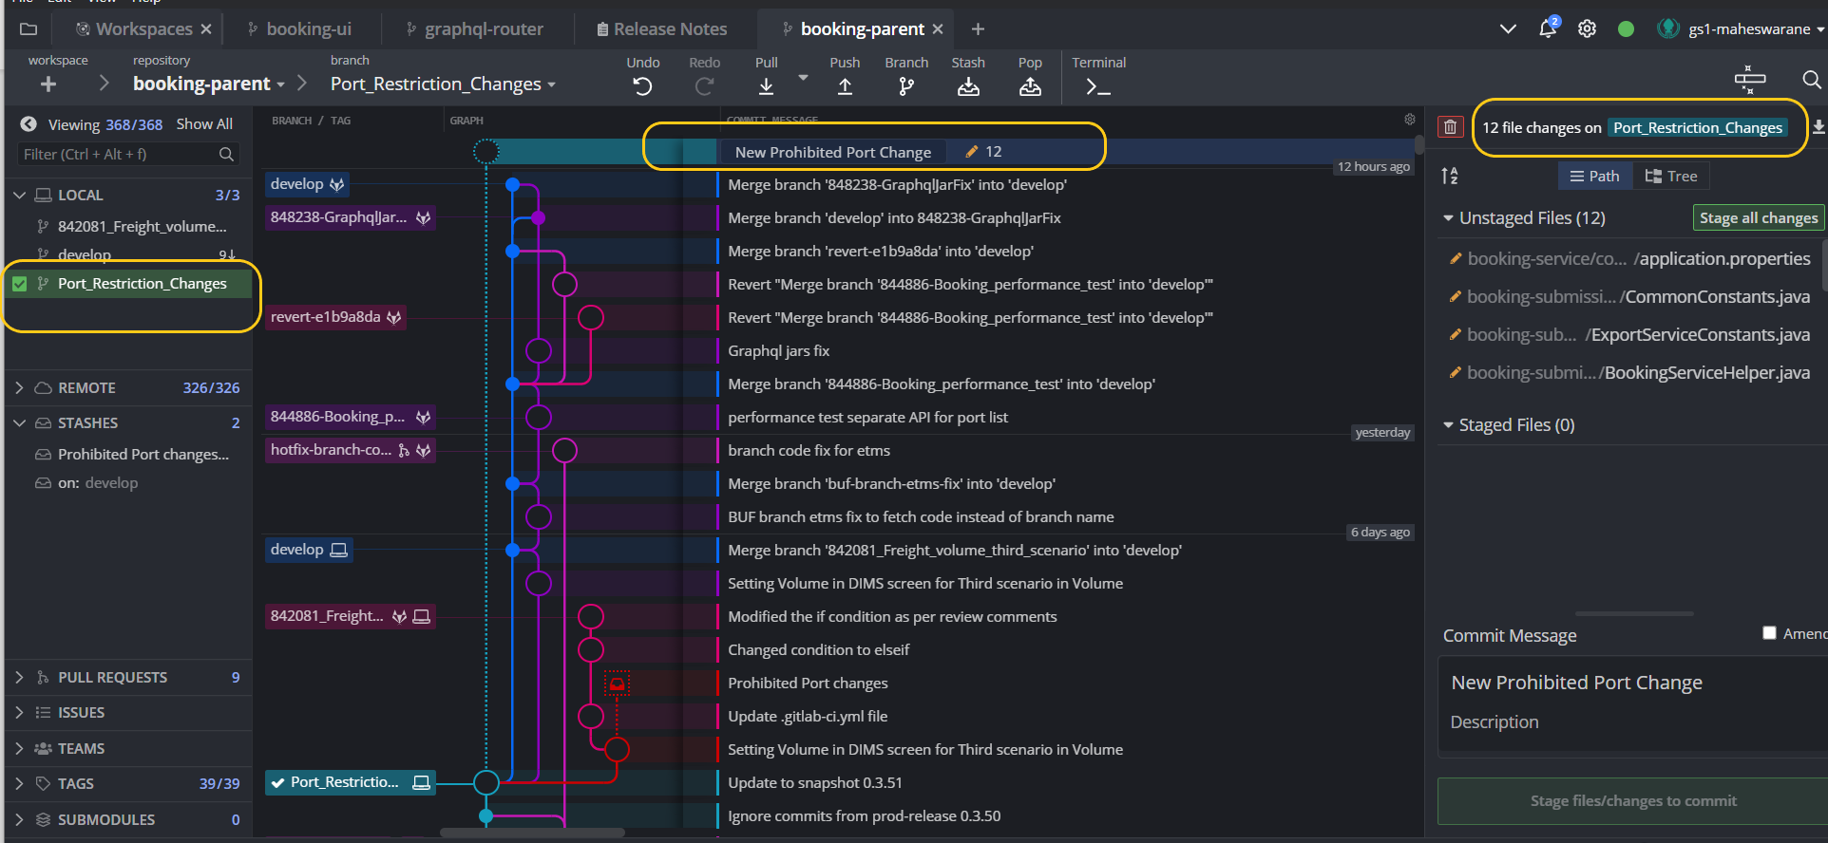

**2) For Merge conflicts**

**a)**  Ensure no changes are there in staged

b) checkout to develop.. pull latest changes

**b)**  Go to your branch.. go to three dots -> Merge branch xxxx into develop

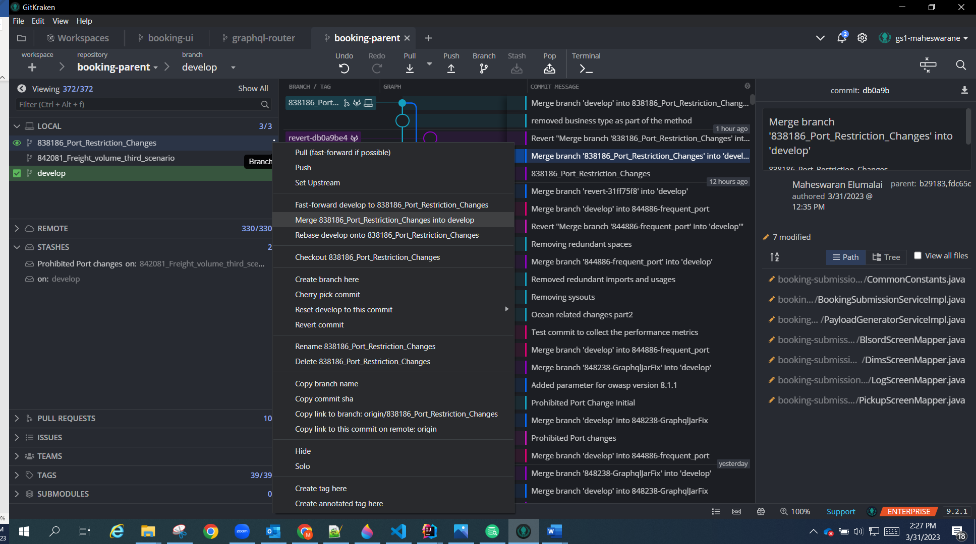c) In the resolve merge conflicts screen, select the changes you want

d) Then save