Contents

Create a project in IntelliJ 2

Clone project 3

HTTPS 3

SSH 4

Pre-requisite 4

SSH Clone 5

Create branch 7

New feature/Story 7

Fetch from existing branch 8

Commit, Pull and Push 9

Add file/files to staging. 9

Commit 9

Pull 10

Push 10

Stashing 11

# Create a project in IntelliJ

Create new project using New Project

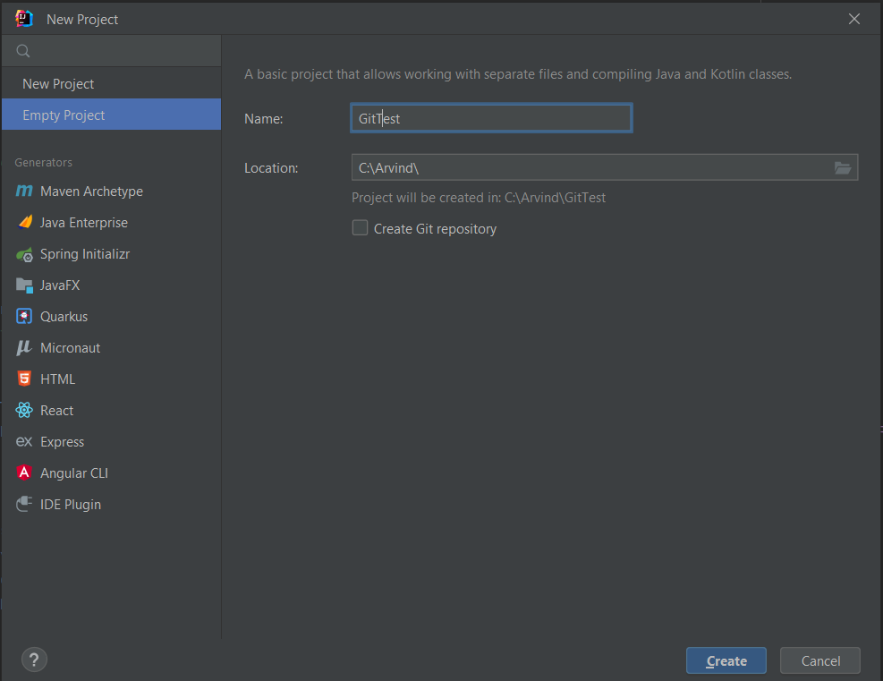

Open the terminal as below by clicking the Terminal tab; alternatively, you can use Alt + F12

# Clone project

There are two ways to clone the project, HTTPS or SSH.

## HTTPS

**$ git clone** [**https://gitlab.shared.int.tradeflow.net/tradeflow/modernized-tradeflow/modernized-tradeflow-parent.git**](https://gitlab.shared.int.tradeflow.net/tradeflow/modernized-tradeflow/modernized-tradeflow-parent.git)

Now you must enter the personal access token if you have configured 2FA in GitLab. If 2FA is not configured, you can enter gitlab username and password.

## SSH

### Pre-requisite

Log into GitLab

Goto 'Preferences' using user settings. (top right there is an icon, click and hover to Preferences)

In the left-hand side pane, Select SSH Keys. If already you have SSH keys ignore the below steps and proceed to Clone the project using SSH.

Open windows explorer; goto C:\Users\<<gs1-user>>\.ssh

If id_ed25519.pub file is not present, then follow the below steps to generate.

1. Open cmd(Command Prompt) window, type the text below by updating your e-mail address.

C:\Users\gs1-arvinde>ssh-keygen -t ed25519 -C [your_email@example.com](mailto:your_email@example.com)

1. Keep pressing enter without any values to generate the ssh files.
2. Open windows explorer; goto C:\Users\<<gs1-user>>\.ssh
3. Right click on id_ed25519.pub file; Open with notepad/edit with notepad ++.
4. Copy the contents and paste in the Key textarea. Click Add Key and you will notice the ssh key added under your SSH keys.

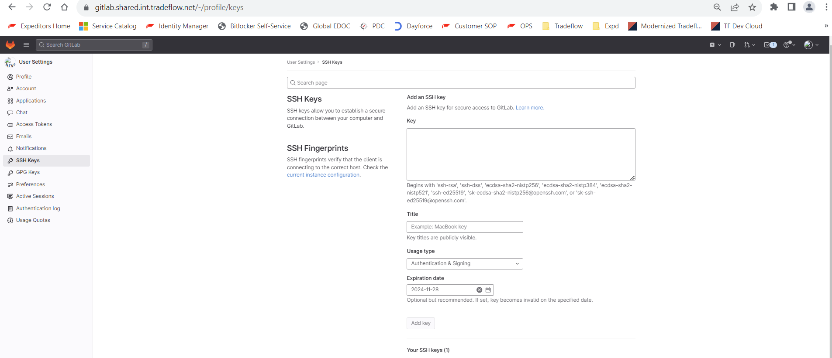

### SSH Clone

**$ git clone** [**git@gitlab.shared.int.tradeflow.net:tradeflow/modernized-tradeflow/modernized-tradeflow-parent.git**](mailto:git@gitlab.shared.int.tradeflow.net:tradeflow/modernized-tradeflow/modernized-tradeflow-parent.git)

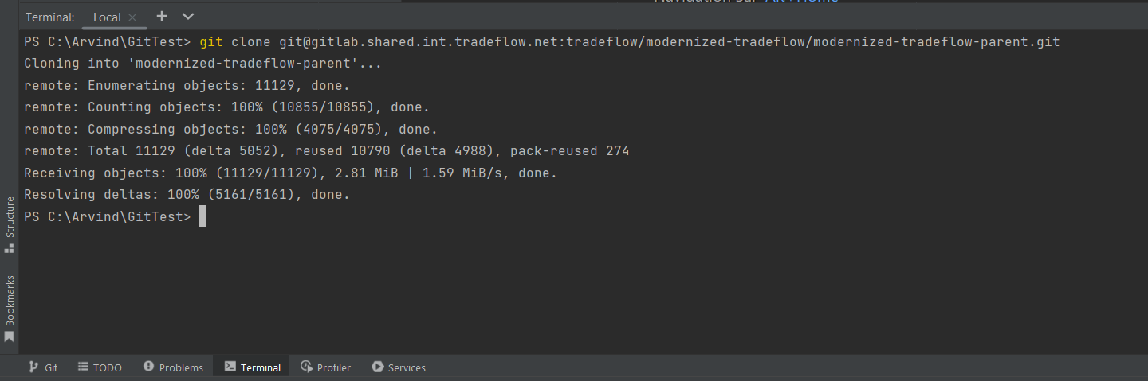

Now the project is successfully cloned, and you can view the status and what branch you are by using below commands.

$ **git status**

$ **git branch**

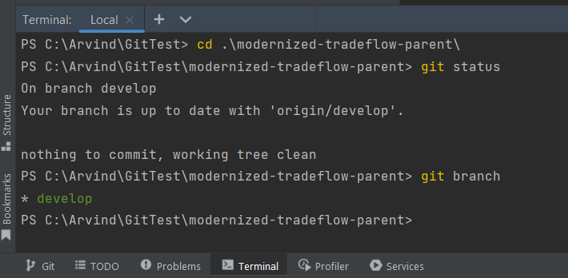

# Create branch

## New feature/Story

$ git checkout -b feature-nfr-logGraphqlRequests

You should be able to create a new branch from the main.

Added two new file and modified an existing file.

$ git status

Further if you want to compare or see the changes, Click Git tab to view as below.

## Fetch from existing branch

$ git checkout -b <<existing branch-name>

For screenshots please refer under Stashing section

# Commit, Pull and Push

## Add file/files to staging.

If you wanted to add a single or selected files, choose that path and add like below.

$ git add tradeflow-service/src/main/java/com/tradeflow/service/filters/HeadersFilter.java

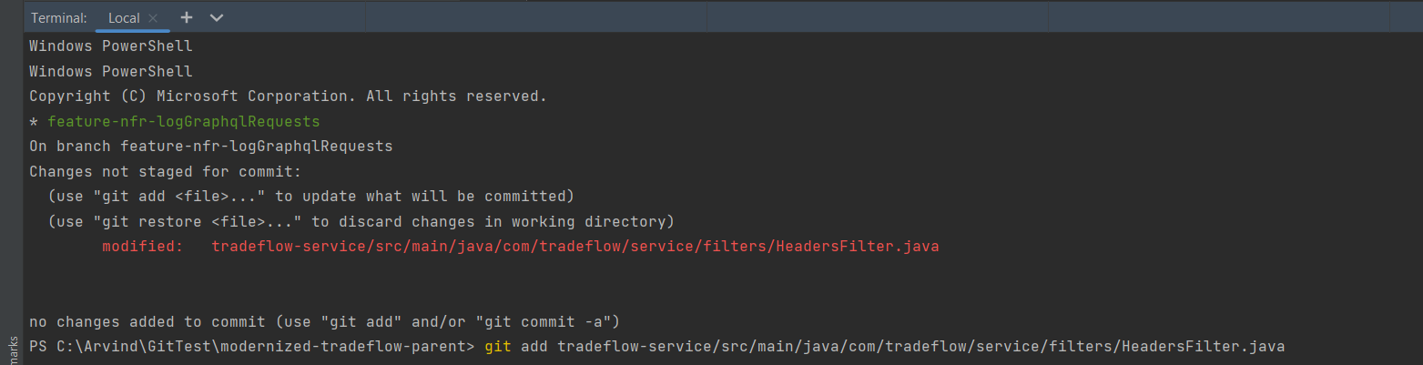

If you wanted to add all files, use the below command.

$ git add .

## Commit

$ git commit -m “<<add comments>>”

Note: GPG keys are being setup for Verifying Git. This will be taken later part of the session.

## Pull

Always ensure that you pull the latest code from develop / main branch according to your project and the push your code, if any merge issues, then you could resolve here itself and then push the latest

$ git pull origin develop

If you wanted to pull the code from any specific branch and then develop your code, then you can use the below

$ git pull origin <<branch-name>>

## Push

$ git push

Above command is used for Push; Except first time when you create a branch use the below command.

$ git push --set-upstream origin <<branch-name>>

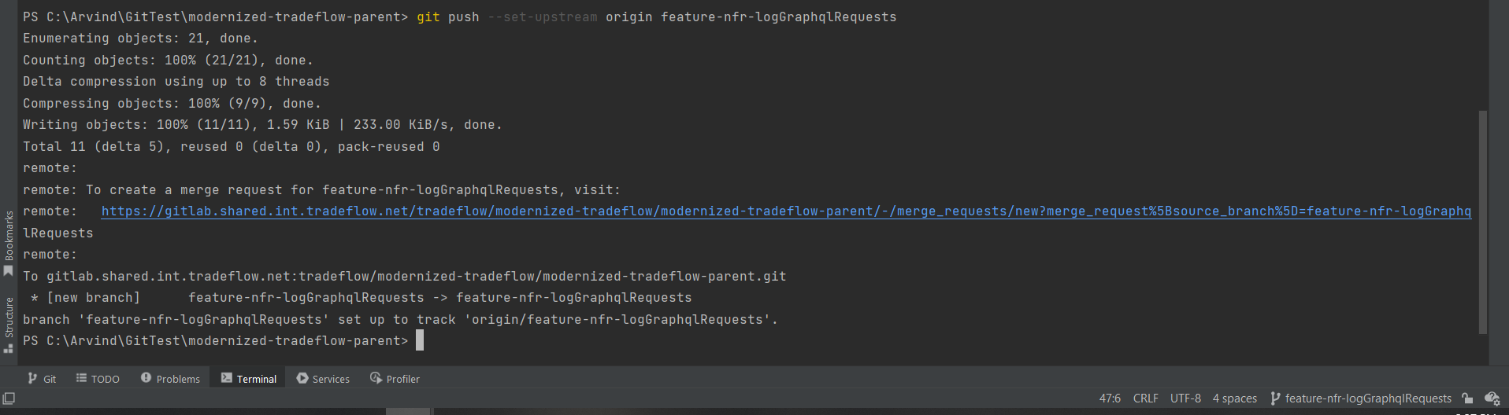

# Stashing

Suppose you are working on a feature and wanted to work on a different branch now, you can stash.

For ex: we have one tracked and 2 untracked files as below.

To stash tracked files

$ git stash

You could see the untracked files are not stashed, if you wanted to stash them as well then;

$ git stash -u

Now you wanted to checkout an existing branch and work on it, you could view all the available remote and local branches and choose from it.

To view all local branches and remote branches for switching between.

$ git branch -a

Now if you wanted to check out an existing branch then

$ git checkout -b <<existing branch-name>>

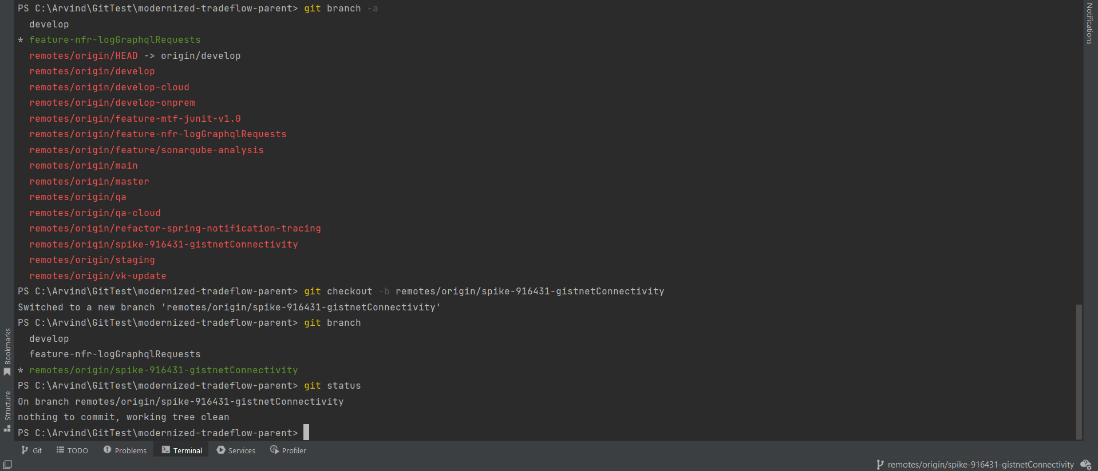

To go back to your feature where you were working, use the below commands,

$ git checkout feature-nfr-logGraphqlRequests

pop your stash files,

$ git stash pop

