Search

[Write](https://medium.com/m/signin?operation=register&redirect=https%3A%2F%2Fmedium.com%2Fnew-story&source=---two_column_layout_nav-----------------------new_post_topnav-----------)

Sign up

[Sign in](https://medium.com/m/signin?operation=login&redirect=https%3A%2F%2Fpankaj02.medium.com%2Fspring-for-graphql-schemamapping-and-querymapping-3db89bae696a&source=post_page---two_column_layout_nav-----------------------global_nav-----------)

**Spring for GraphQL: @SchemaMapping and @QueryMapping**

[[](https://pankaj02.medium.com/?source=post_page-----3db89bae696a--------------------------------)](https://pankaj02.medium.com/?source=post_page-----3db89bae696a--------------------------------)

[Pankaj Kumar](https://pankaj02.medium.com/?source=post_page-----3db89bae696a--------------------------------)

·

[Follow](https://medium.com/m/signin?actionUrl=https%3A%2F%2Fmedium.com%2F_%2Fsubscribe%2Fuser%2F241b23479801&operation=register&redirect=https%3A%2F%2Fpankaj02.medium.com%2Fspring-for-graphql-schemamapping-and-querymapping-3db89bae696a&user=Pankaj+Kumar&userId=241b23479801&source=post_page-241b23479801----3db89bae696a---------------------post_header-----------)

4 min read

·

Jul 29, 2022

32

In the last article [Getting started with Spring Boot GraphQL service](https://medium.com/@pankaj02/getting-started-with-spring-boot-graphql-service-47cdaf56ef33), we discussed features of GraphQL and its implementation in Spring for GraphQL using low-level APIs of GraphQL Java.

While low-level GraphQL Java implementation is fine for understanding the concept, you’ll mostly use higher-level abstraction provided by Spring.

In this article, we will discuss the @Controller, @QueryMapping, and @SchemaMapping of Spring for GraphQL.

Here, we’ll use the same book catalog GraphQL API, described in an earlier article (also shown below).

GraphQL query

Let’s get started!

**Controller**

Like REST API, Spring Boot offers **@Controller annotation to implement GraphQL APIs**. All you need to do is to annotate your controller class with @Controller annotation and define either @QueryMapping or @SchemaMapping annotation on the handler method.

Spring detects **@Controller beans and registers their annotated handler methods**( @QueryMapping or @SchemaMapping) as DataFetcher s (also known as a resolver).

A ***resolver/DataFetcher*** is a function that’s responsible for populating the data for a single field in your GraphQL schema.

**SchemaMapping Annotation**

The @SchemaMapping **annotation maps a handler method to a field in the GraphQL schema as**DataFetcher. All you need to do is to define the typeName and, optionally, the field with @SchemaMapping.

Additionally, if you keep the method name as same as the field name then you can omit the field from @SchemaMapping.

What happens if you don’t specify the typeName with @SchemaMapping (as shown below) ?

In this case, Spring can’t figure out which parent-type field books belong to; therefore, it'll throw BeanCreationException, at the application startup, with a helpful error message.

No parentType specified, and a source/parent method argument was also not found: BooksCatalogController#books[0 args]

Similarly, for the field bookById, you can define a data fetcher as:

Here, we have used @Argument annotation to map argument id as @Argument("id") Integer id.

Finally, you can test this by heading over to [http://localhost:8080/graphiql?path=/graphql](http://localhost:8080/graphiql?path=%2Fgraphql) in your browser.

**Data Fetcher for the child ‘Type’ field**

If you query GraphQL service with the ratings field of Book the response includes "ratings": null.

*Why?*

If you don’t specify a Data Fetcher for a field the GraphQL Java assigns a default PropertyDataFetcher. Subsequently, at the runtime this PropertyDataFetcher looks for public getRatings() field in the Book POJO (as field ratings belongs to the Book).

To solve this, you can define a Data Fetcher for ratings. As the field ratings belongs to the parent type Book, you need to pass Book in the argument.

**While GraphQL Java is executing a query, it calls the appropriate DataFetcher for each field it encounters in the query. If you don't define any DataFetcher it assigns** *PropertyDataFetcher as default.*

And, you can write without specifying the field as:

Also as:

In @SchemaMapping you can also leave out typeName and field attributes, in which case the **field name defaults to the method name**, while the type name defaults to the **simple class name of the source/parent object injected into the method**.

**QueryMapping annotation**

Instead of using @SchemaMapping, you can use @QueryMapping. Effectively,**this is a shortcut annotation to bind annotated methods for fields under the Query type**.

Moreover, you can skip the name from annotation. In this case, Spring derives the query field from the method name.

Similarly, for the Query field bookById:

You can’t use @QueryMapping for the field ratings as it doesn't belong to the type Query.

**Configuration**

By default, the Boot starter checks in src/main/resources/graphql for GraphQL schema files with extensions ".graphqls" or ".gqls ". To override this behavior, you can change the following property.

spring.graphql.schema.locations=classpath:graphql/ spring.graphql.schema.fileExtensions=.graphqls, .gqls

**Code example**

The working code example of this article is listed on [GitHub](https://github.com/techdozo/graphql-spring-annotation) . To run the example, clone the repository, and import **graphql-spring-annotation** as a project in your favorite IDE as a Gradle project.

**Summary**

Spring greatly simplifies the development of GraphQL APIs by the way of @Controller annotation. You just need to annotate your Controller classes with @Controller annotation and define either @QueryMapping or @SchemaMapping annotation on the handler method.

Spring detects @Controller beans and registers their annotated handler methods as DataFetcher s (also known as a resolver).

*Originally published at*[*https://techdozo.dev*](https://techdozo.dev/spring-for-graphql-schemamapping-and-querymapping/)*on July 29, 2022.*

[GraphQL](https://medium.com/tag/graphql?source=post_page-----3db89bae696a---------------graphql-----------------)

[Spring Boot](https://medium.com/tag/spring-boot?source=post_page-----3db89bae696a---------------spring_boot-----------------)

32

[[](https://pankaj02.medium.com/?source=post_page-----3db89bae696a--------------------------------)](https://pankaj02.medium.com/?source=post_page-----3db89bae696a--------------------------------)

[Written by Pankaj Kumar](https://pankaj02.medium.com/?source=post_page-----3db89bae696a--------------------------------)

[137 Followers](https://pankaj02.medium.com/followers?source=post_page-----3db89bae696a--------------------------------)

Software Architect @ Schlumberger ``` Cloud | Microservices | Programming | Kubernetes | Architecture | Machine Learning | Java | Python ```

Follow

More from Pankaj Kumar



[[Pankaj Kumar](https://pankaj02.medium.com/?source=author_recirc-----3db89bae696a----0---------------------ff8a1b45_e79e_4060_8442_a341da222546-------)](https://pankaj02.medium.com/?source=author_recirc-----3db89bae696a----0---------------------ff8a1b45_e79e_4060_8442_a341da222546-------)

[Pankaj Kumar](https://pankaj02.medium.com/?source=author_recirc-----3db89bae696a----0---------------------ff8a1b45_e79e_4060_8442_a341da222546-------)

**[Getting Error Handling right in gRPC](https://pankaj02.medium.com/getting-error-handling-right-in-grpc-287fc4d8cfd1?source=author_recirc-----3db89bae696a----0---------------------ff8a1b45_e79e_4060_8442_a341da222546-------)**

[Handling errors right can be tricky and it can be even trickier in gRPC. The current version of the gRPC only has limited built-in error…](https://pankaj02.medium.com/getting-error-handling-right-in-grpc-287fc4d8cfd1?source=author_recirc-----3db89bae696a----0---------------------ff8a1b45_e79e_4060_8442_a341da222546-------)

6 min read·Jul 4, 2021

36



[[Pankaj Kumar](https://pankaj02.medium.com/?source=author_recirc-----3db89bae696a----1---------------------ff8a1b45_e79e_4060_8442_a341da222546-------)](https://pankaj02.medium.com/?source=author_recirc-----3db89bae696a----1---------------------ff8a1b45_e79e_4060_8442_a341da222546-------)

[Pankaj Kumar](https://pankaj02.medium.com/?source=author_recirc-----3db89bae696a----1---------------------ff8a1b45_e79e_4060_8442_a341da222546-------)

**[gRPC: synchronous and asynchronous Server streaming RPC](https://pankaj02.medium.com/grpc-synchronous-and-asynchronous-server-streaming-rpc-3deb4a1e6cd3?source=author_recirc-----3db89bae696a----1---------------------ff8a1b45_e79e_4060_8442_a341da222546-------)**

[gRPC, one of the most popular RPC frameworks for inter-process microservices communication, supports both unary and streaming RPC. Contrary…](https://pankaj02.medium.com/grpc-synchronous-and-asynchronous-server-streaming-rpc-3deb4a1e6cd3?source=author_recirc-----3db89bae696a----1---------------------ff8a1b45_e79e_4060_8442_a341da222546-------)

7 min read·Dec 30, 2021

17

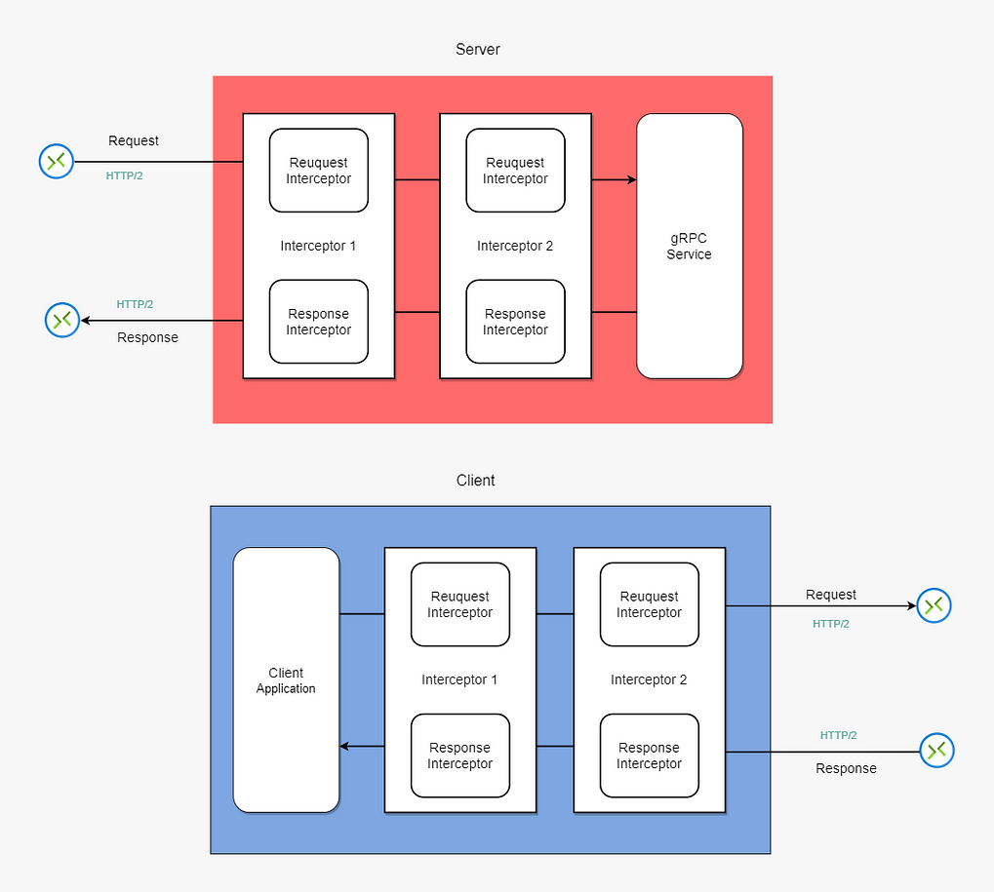

[[Pankaj Kumar](https://pankaj02.medium.com/?source=author_recirc-----3db89bae696a----2---------------------ff8a1b45_e79e_4060_8442_a341da222546-------)](https://pankaj02.medium.com/?source=author_recirc-----3db89bae696a----2---------------------ff8a1b45_e79e_4060_8442_a341da222546-------)

[Pankaj Kumar](https://pankaj02.medium.com/?source=author_recirc-----3db89bae696a----2---------------------ff8a1b45_e79e_4060_8442_a341da222546-------)

**[gRPC Interceptor: unary interceptor with code example — Techdozo](https://pankaj02.medium.com/grpc-interceptor-unary-interceptor-with-code-example-techdozo-50f27a93ec33?source=author_recirc-----3db89bae696a----2---------------------ff8a1b45_e79e_4060_8442_a341da222546-------)**

[Similar to many popular frameworks, gRPC has the concept of an interceptor. Conceptually, it’s very similar to the middleware/interceptor…](https://pankaj02.medium.com/grpc-interceptor-unary-interceptor-with-code-example-techdozo-50f27a93ec33?source=author_recirc-----3db89bae696a----2---------------------ff8a1b45_e79e_4060_8442_a341da222546-------)

6 min read·Apr 30, 2022

3

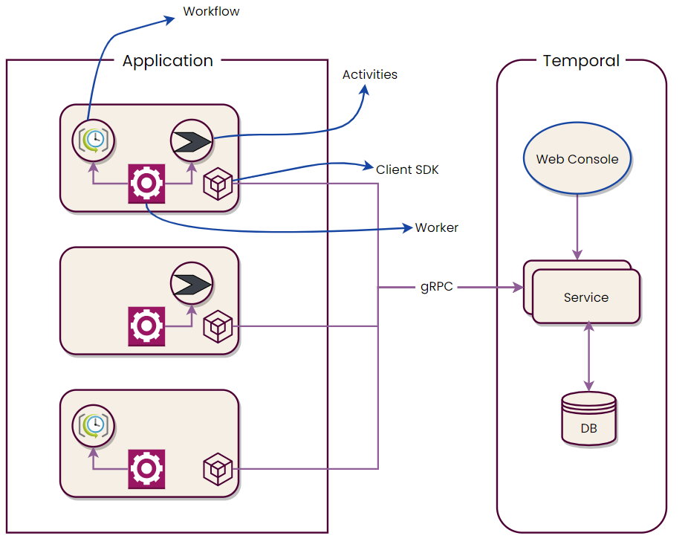

[[Pankaj Kumar](https://pankaj02.medium.com/?source=author_recirc-----3db89bae696a----3---------------------ff8a1b45_e79e_4060_8442_a341da222546-------)](https://pankaj02.medium.com/?source=author_recirc-----3db89bae696a----3---------------------ff8a1b45_e79e_4060_8442_a341da222546-------)

[Pankaj Kumar](https://pankaj02.medium.com/?source=author_recirc-----3db89bae696a----3---------------------ff8a1b45_e79e_4060_8442_a341da222546-------)

**[Workflow Orchestration with Temporal and Spring Boot](https://pankaj02.medium.com/workflow-orchestration-with-temporal-and-spring-boot-340e639b4b28?source=author_recirc-----3db89bae696a----3---------------------ff8a1b45_e79e_4060_8442_a341da222546-------)**

[In the context of any software application, a workflow (also known as a business process) is a repeatable sequence of steps to fulfil a…](https://pankaj02.medium.com/workflow-orchestration-with-temporal-and-spring-boot-340e639b4b28?source=author_recirc-----3db89bae696a----3---------------------ff8a1b45_e79e_4060_8442_a341da222546-------)

9 min read·Oct 29, 2022

4

[See all from Pankaj Kumar](https://pankaj02.medium.com/?source=post_page-----3db89bae696a--------------------------------)

Recommended from Medium

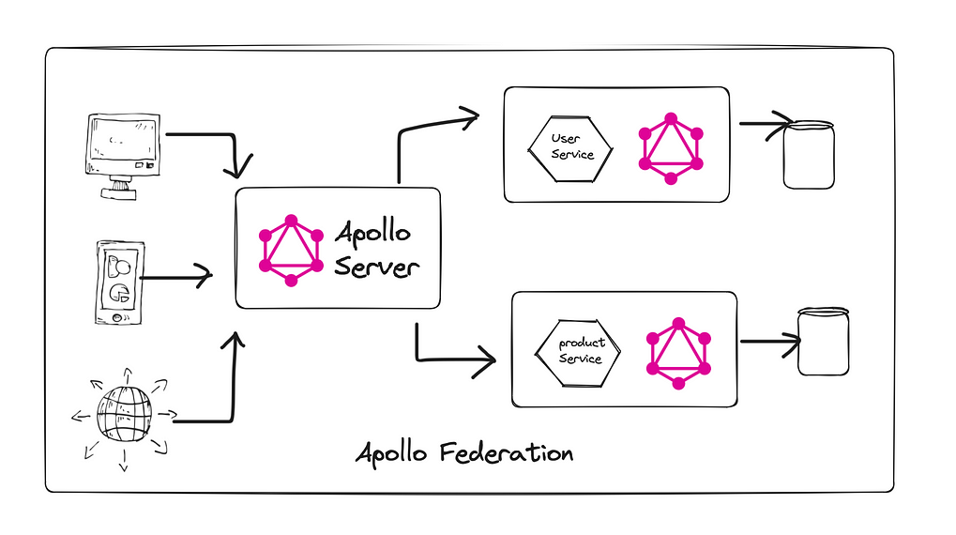

[[Vikas Taank](https://medium.com/@vikas.taank_40391?source=read_next_recirc-----3db89bae696a----0---------------------fd2caf3a_cd0e_4f17_a234_2d0d5faf7b91-------)](https://medium.com/@vikas.taank_40391?source=read_next_recirc-----3db89bae696a----0---------------------fd2caf3a_cd0e_4f17_a234_2d0d5faf7b91-------)

[Vikas Taank](https://medium.com/@vikas.taank_40391?source=read_next_recirc-----3db89bae696a----0---------------------fd2caf3a_cd0e_4f17_a234_2d0d5faf7b91-------)

in

[DevOps.dev](https://blog.devops.dev/?source=read_next_recirc-----3db89bae696a----0---------------------fd2caf3a_cd0e_4f17_a234_2d0d5faf7b91-------)

**[Getting started with GraphQL Apollo Federation](https://medium.com/@vikas.taank_40391/getting-started-with-graphql-apollo-federation-75a04eb5452e?source=read_next_recirc-----3db89bae696a----0---------------------fd2caf3a_cd0e_4f17_a234_2d0d5faf7b91-------)**

[GraphQL Federation is an architectural approach designed to build a single, cohesive GraphQL API from multiple underlying GraphQL services…](https://medium.com/@vikas.taank_40391/getting-started-with-graphql-apollo-federation-75a04eb5452e?source=read_next_recirc-----3db89bae696a----0---------------------fd2caf3a_cd0e_4f17_a234_2d0d5faf7b91-------)

·4 min read·Apr 2, 2024

23



[[Zhouirong](https://medium.com/@zhouirong0420?source=read_next_recirc-----3db89bae696a----1---------------------fd2caf3a_cd0e_4f17_a234_2d0d5faf7b91-------)](https://medium.com/@zhouirong0420?source=read_next_recirc-----3db89bae696a----1---------------------fd2caf3a_cd0e_4f17_a234_2d0d5faf7b91-------)

[Zhouirong](https://medium.com/@zhouirong0420?source=read_next_recirc-----3db89bae696a----1---------------------fd2caf3a_cd0e_4f17_a234_2d0d5faf7b91-------)

**[Apollo GraphQL Pagination](https://medium.com/@zhouirong0420/apollo-graphql-pagination-f3a0add622ae?source=read_next_recirc-----3db89bae696a----1---------------------fd2caf3a_cd0e_4f17_a234_2d0d5faf7b91-------)**

[I am recording this article as part of my learning experience.](https://medium.com/@zhouirong0420/apollo-graphql-pagination-f3a0add622ae?source=read_next_recirc-----3db89bae696a----1---------------------fd2caf3a_cd0e_4f17_a234_2d0d5faf7b91-------)

1 min read·Feb 14, 2024

Lists

](https://medium.com/@MediumStaff/list/stories-to-help-you-grow-as-a-software-developer-b1d913188c20?source=read_next_recirc-----3db89bae696a--------------------------------)](https://medium.com/@MediumStaff/list/stories-to-help-you-grow-as-a-software-developer-b1d913188c20?source=read_next_recirc-----3db89bae696a--------------------------------)

](https://medium.com/@MediumStaff/list/stories-to-help-you-grow-as-a-software-developer-b1d913188c20?source=read_next_recirc-----3db89bae696a--------------------------------)](https://medium.com/@MediumStaff/list/stories-to-help-you-grow-as-a-software-developer-b1d913188c20?source=read_next_recirc-----3db89bae696a--------------------------------)

[Stories to Help You Grow as a Software Developer](https://medium.com/@MediumStaff/list/stories-to-help-you-grow-as-a-software-developer-b1d913188c20?source=read_next_recirc-----3db89bae696a--------------------------------)

[19 stories·971 saves](https://medium.com/@MediumStaff/list/stories-to-help-you-grow-as-a-software-developer-b1d913188c20?source=read_next_recirc-----3db89bae696a--------------------------------)

](https://eddiebarth.medium.com/list/general-coding-knowledge-f2d429d4f0cd?source=read_next_recirc-----3db89bae696a--------------------------------)](https://eddiebarth.medium.com/list/general-coding-knowledge-f2d429d4f0cd?source=read_next_recirc-----3db89bae696a--------------------------------)

](https://eddiebarth.medium.com/list/general-coding-knowledge-f2d429d4f0cd?source=read_next_recirc-----3db89bae696a--------------------------------)](https://eddiebarth.medium.com/list/general-coding-knowledge-f2d429d4f0cd?source=read_next_recirc-----3db89bae696a--------------------------------)

](https://eddiebarth.medium.com/list/general-coding-knowledge-f2d429d4f0cd?source=read_next_recirc-----3db89bae696a--------------------------------)](https://eddiebarth.medium.com/list/general-coding-knowledge-f2d429d4f0cd?source=read_next_recirc-----3db89bae696a--------------------------------)

[General Coding Knowledge](https://eddiebarth.medium.com/list/general-coding-knowledge-f2d429d4f0cd?source=read_next_recirc-----3db89bae696a--------------------------------)

[20 stories·1102 saves](https://eddiebarth.medium.com/list/general-coding-knowledge-f2d429d4f0cd?source=read_next_recirc-----3db89bae696a--------------------------------)

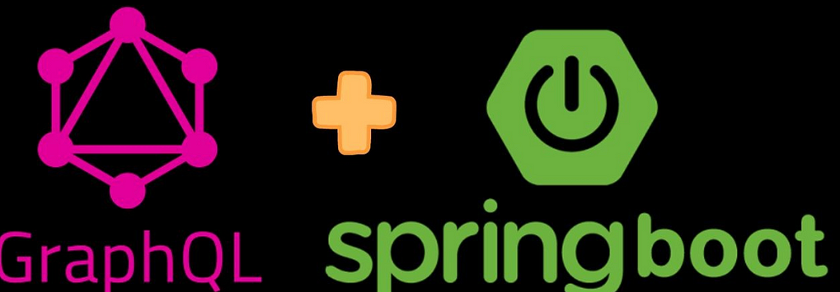

[[Maddy](https://medium.com/@maddyraj?source=read_next_recirc-----3db89bae696a----0---------------------fd2caf3a_cd0e_4f17_a234_2d0d5faf7b91-------)](https://medium.com/@maddyraj?source=read_next_recirc-----3db89bae696a----0---------------------fd2caf3a_cd0e_4f17_a234_2d0d5faf7b91-------)

[Maddy](https://medium.com/@maddyraj?source=read_next_recirc-----3db89bae696a----0---------------------fd2caf3a_cd0e_4f17_a234_2d0d5faf7b91-------)

**[Spring for GraphQL](https://medium.com/@maddyraj/spring-for-graphql-eaba978a053b?source=read_next_recirc-----3db89bae696a----0---------------------fd2caf3a_cd0e_4f17_a234_2d0d5faf7b91-------)**

[GraphQl is powerful alternative of Rest APIs. With its flexible query language and efficient data fetching capabilities, GraphQL offers…](https://medium.com/@maddyraj/spring-for-graphql-eaba978a053b?source=read_next_recirc-----3db89bae696a----0---------------------fd2caf3a_cd0e_4f17_a234_2d0d5faf7b91-------)

4 min read·Feb 9, 2024

9

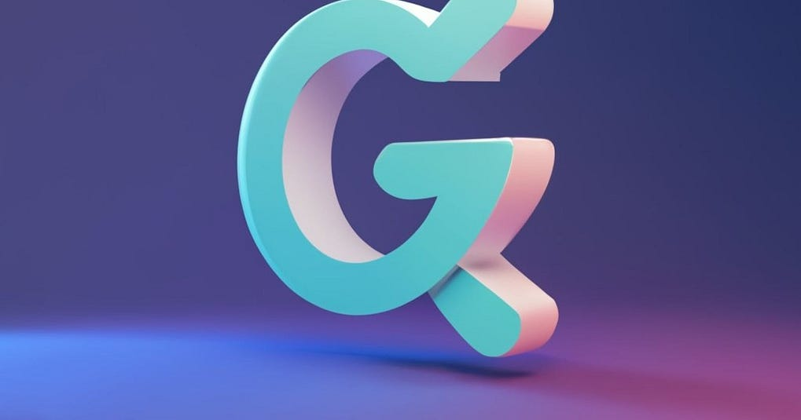

[[Jatin Sharma](https://medium.com/@jaikumarsharma94130?source=read_next_recirc-----3db89bae696a----1---------------------fd2caf3a_cd0e_4f17_a234_2d0d5faf7b91-------)](https://medium.com/@jaikumarsharma94130?source=read_next_recirc-----3db89bae696a----1---------------------fd2caf3a_cd0e_4f17_a234_2d0d5faf7b91-------)

[Jatin Sharma](https://medium.com/@jaikumarsharma94130?source=read_next_recirc-----3db89bae696a----1---------------------fd2caf3a_cd0e_4f17_a234_2d0d5faf7b91-------)

**[GraphQL](https://medium.com/@jaikumarsharma94130/graphql-f9514821fa74?source=read_next_recirc-----3db89bae696a----1---------------------fd2caf3a_cd0e_4f17_a234_2d0d5faf7b91-------)**

[Table of contents](https://medium.com/@jaikumarsharma94130/graphql-f9514821fa74?source=read_next_recirc-----3db89bae696a----1---------------------fd2caf3a_cd0e_4f17_a234_2d0d5faf7b91-------)

17 min read·Jan 1, 2024



[[Roman Dutchak](https://medium.com/@dutchakdev?source=read_next_recirc-----3db89bae696a----2---------------------fd2caf3a_cd0e_4f17_a234_2d0d5faf7b91-------)](https://medium.com/@dutchakdev?source=read_next_recirc-----3db89bae696a----2---------------------fd2caf3a_cd0e_4f17_a234_2d0d5faf7b91-------)

[Roman Dutchak](https://medium.com/@dutchakdev?source=read_next_recirc-----3db89bae696a----2---------------------fd2caf3a_cd0e_4f17_a234_2d0d5faf7b91-------)

in

[Roman Dutchak](https://medium.com/dutchak?source=read_next_recirc-----3db89bae696a----2---------------------fd2caf3a_cd0e_4f17_a234_2d0d5faf7b91-------)

**[Managing Multiple GraphQL Endpoints in a Single Application with Apollo](https://medium.com/@dutchakdev/managing-multiple-graphql-endpoints-in-a-single-application-9dbdc4a804a5?source=read_next_recirc-----3db89bae696a----2---------------------fd2caf3a_cd0e_4f17_a234_2d0d5faf7b91-------)**

[When working with multiple GraphQL endpoints in a single application, it’s important to manage the configuration and usage of these…](https://medium.com/@dutchakdev/managing-multiple-graphql-endpoints-in-a-single-application-9dbdc4a804a5?source=read_next_recirc-----3db89bae696a----2---------------------fd2caf3a_cd0e_4f17_a234_2d0d5faf7b91-------)

2 min read·Dec 13, 2023

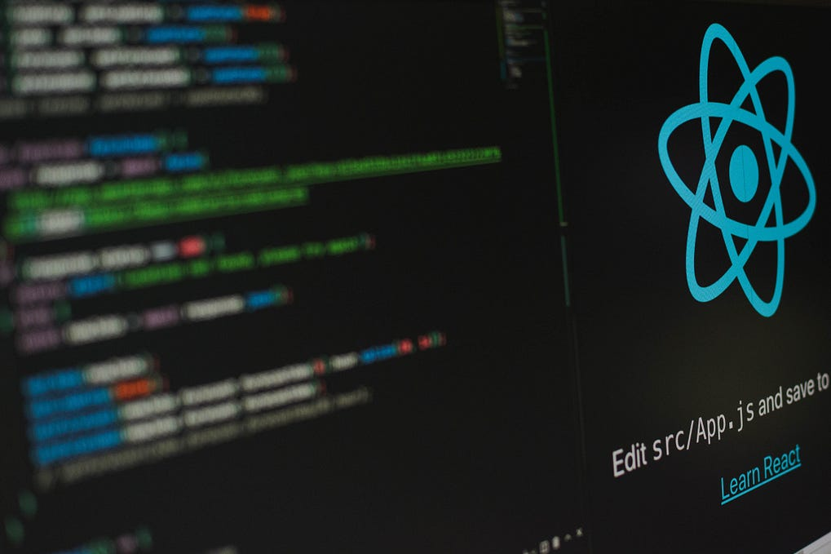

[[Lashan Faliq](https://lashanfaliq.medium.com/?source=read_next_recirc-----3db89bae696a----3---------------------fd2caf3a_cd0e_4f17_a234_2d0d5faf7b91-------)](https://lashanfaliq.medium.com/?source=read_next_recirc-----3db89bae696a----3---------------------fd2caf3a_cd0e_4f17_a234_2d0d5faf7b91-------)

[Lashan Faliq](https://lashanfaliq.medium.com/?source=read_next_recirc-----3db89bae696a----3---------------------fd2caf3a_cd0e_4f17_a234_2d0d5faf7b91-------)

**[Integrating Graphql with Redux toolkit and RTK-query](https://lashanfaliq.medium.com/integrating-graphql-with-redux-toolkit-and-rtk-query-cc8040f92bd?source=read_next_recirc-----3db89bae696a----3---------------------fd2caf3a_cd0e_4f17_a234_2d0d5faf7b91-------)**

[Redux Toolkit is the official toolset for efficient Redux development. This makes life much easier for developers by reducing boilerplate…](https://lashanfaliq.medium.com/integrating-graphql-with-redux-toolkit-and-rtk-query-cc8040f92bd?source=read_next_recirc-----3db89bae696a----3---------------------fd2caf3a_cd0e_4f17_a234_2d0d5faf7b91-------)

5 min read·Jan 11, 2024

32

[See more recommendations](https://medium.com/?source=post_page-----3db89bae696a--------------------------------)

[Help](https://help.medium.com/hc/en-us?source=post_page-----3db89bae696a--------------------------------)

[Status](https://medium.statuspage.io/?source=post_page-----3db89bae696a--------------------------------)

[About](https://medium.com/about?autoplay=1&source=post_page-----3db89bae696a--------------------------------)

[Careers](https://medium.com/jobs-at-medium/work-at-medium-959d1a85284e?source=post_page-----3db89bae696a--------------------------------)

[Blog](https://blog.medium.com/?source=post_page-----3db89bae696a--------------------------------)

[Privacy](https://policy.medium.com/medium-privacy-policy-f03bf92035c9?source=post_page-----3db89bae696a--------------------------------)

[Terms](https://policy.medium.com/medium-terms-of-service-9db0094a1e0f?source=post_page-----3db89bae696a--------------------------------)

[Text to speech](https://speechify.com/medium?source=post_page-----3db89bae696a--------------------------------)

[Teams](https://medium.com/business?source=post_page-----3db89bae696a--------------------------------)