* - [Instructor] While classes are the preferred tool for creating object templates, there is another shorter and less advanced way of doing the same thing, which relies on a basic function .

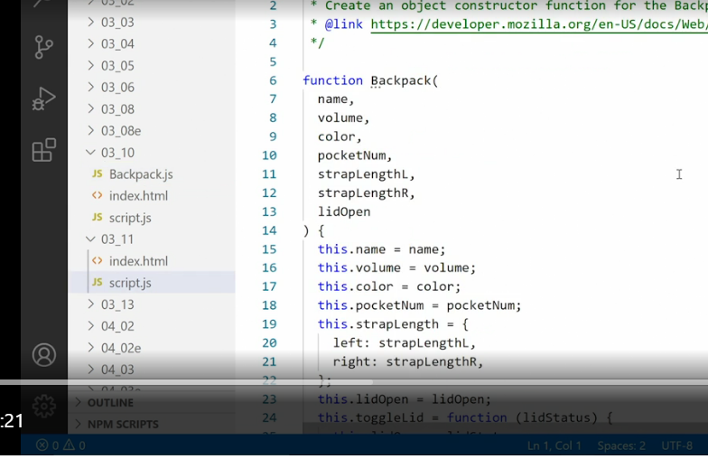

* It's called an object constructor function and you can see an example of it in the exercise files for this movie .
* Just like with the class, the object constructor uses a capitalized name to let us know this is a constructor function that produces new objects .
* The object constructor function captures the properties of the new object using its parameters and then defines and assigns values for each property and method using the this keyword and dot notation .
* So here we have this name and it's populated with the value from the name parameter that's passed to the function .
* You'll notice ***that the difference between the class and the object constructor function here is the methods live inside the main construction function, just like the properties do .***
* *So here we're assigning a new property, toggleLid and then setting up a function inside .*
* *Whereas in the class the definition of these methods happens outside the main constructor function .*
* *To create a new object from this constructor, we do the same thing we did with the class .*
* *We set up a new variable, give the variable a name, set it equal to or assign a value to it .*
* *and that new value is new Backpack .*
* So a new object based on this constructor function .

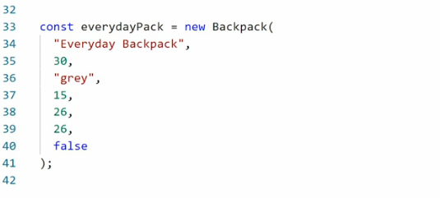

* Then we just pass in the values to match the list of properties up here and out comes a full object .
* *The end result is exactly the same as with the class but there are some significant differences* .
* A)The class allows us to do more things .
* B)We can extend classes .
* C)We can add new features to them that are not available inside an object constructor function .
* D)And the class is now the preferred tool for creating objects based on a blueprint .
* That said in old code and in a lot of tutorials **you will come across the object constructor functions** because that used to be the only way we could do this and that's why I'm covering it here .
* My rule of thumb **is use a class unless you are required to use an object constructor function** because *the classes give you more capabilities than the object constructor function* does .
* And the only reason to use the older function is if you are running it in an old code base or in old infrastructure that have yet to support classes .