* - Now that we have an overview, let's dig a little bit deeper and really understand how an object fits together .
* The object needs somewhere to live and it needs a name .
* For this, we use a container called a variable .
* And in this case, it's a constant variable .
* The const keyword says, this is a constant .

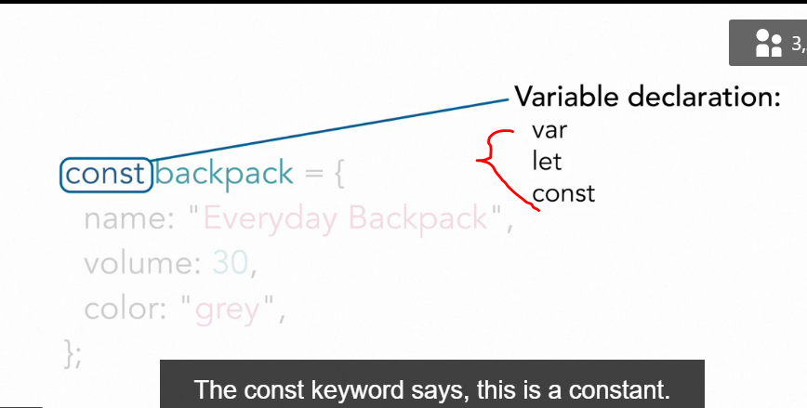

* The name is the name we use to reference this particular container .

* And whatever's on the right hand side of the equal symbol is what goes inside the container, what is assigned to that container or to that variable .
* In this case, an object .

* Now this is a constant, meaning while we can change the properties of the object inside the container, we can't remove or replace the object from the container .
* If we try to do so by calling the constant name and using the equal symbol to set the contents to something else, the browser will tell us you can't do that .
* This is a constant .
* Let me show you .
* In the exercise files for this movie 0303, we have the backpack object .
* 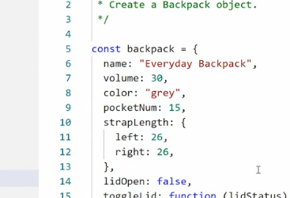
* If I go into my browser and go to the console, I can console log out the backpack by just typing out backpack .
* Here, you see the full backpack object and we have access to all this data .
* Now we can try to assign something else to the backpack constant .
* So I'll say backpack equals, whoops .
* Backpack equals five .
* Now this is a variable so technically I should now remove the object entirely and just put the number five in its place .

* But if I run this, I get an uncaught type error, assignment to constant variables, saying this is a constant .
* You can't do this .
* You can't change its contents .
* And this is the reason why we use constants for objects .
* Once we've created an object, we might want to change its properties, but we never want to change it to something entirely different .
* ***Speaking of properties, I can change its properties .***

* So for example, right now, the volume is at the 30 .
* I can then say backpack dot volume and then set it to 50 and then just call backpack again .
* And you'll see now the volume is 50 instead .
* So even though it's in the constant, the properties are not constant .
* I just can't assign something altogether different to that constant .
* That way I can't accidentally destroy my objects while working with them .