* - [Instructor] Now that we know how to declare different types of variables.
* The next question is **what can be put inside those variables**? In JavaScript, the answer is **pretty much anything.**
* JavaScript is a **weakly typed** language meaning *you don't have to declare what type of data goes into your variables you just fill the variable with whatever data you want and then JavaScript will identify or at least try to identify that data type for you.*
* In the exercise files for this movie you'll find almost all of the data types you can use in a variable.

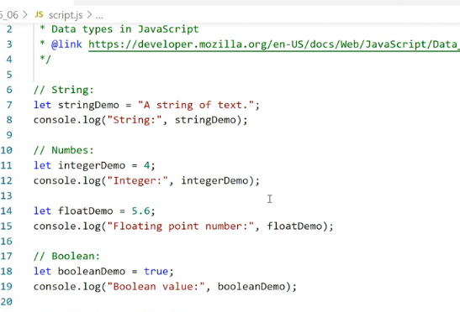

* Here we have first a **string** it's defined by using quotation marks at the beginning and end wrapping around the string.
* Then we have an **integer** this is just a number without quotation marks.
* We also have a **floating** point number so that's a number with a decimal to it.
* The reason why it's called a floating point is you can imagine a number and then you float a points in between the numbers to indicate where the decimal starts.
* That's the floating point right there we have **boolean** that's a true or false value.
* There is a **null** value so nothing saying that this value contains nothing it's just a clarity using the word null.
* We have **two types of undefined: a)** one is when you create a variable but don't assign anything to it it **automatically becomes undefined** or **if you want to you can actively assign the word undefined**
* 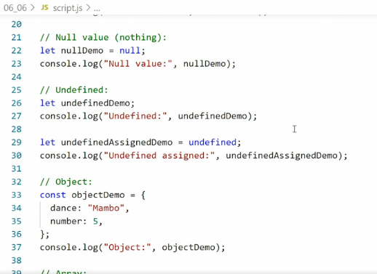 to a variable and that means the variable again is undefined.
* Then we have **objects** we've covered this extensively previously in the course you'll **remember an object is defined by putting curly brackets around some different properties and values**
* and finally, **we have an array** which we'll cover in the next chapter arrays are are likewise **defined by using a square bracket at the beginning and end and then inside the array we have a comma separated list of items and these items can then be any one of the other data types.**

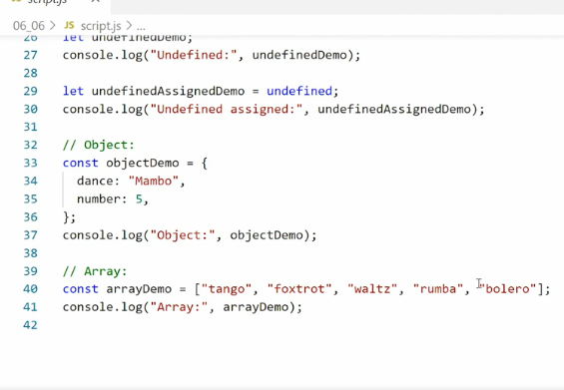

* So we can have a string and a number and an object and another array whatever you want inside each of these slots in the array.

* Jumping over to the console, we get the outputs of all these different data types, string, integer, floating point number, bullion value, no value, unidentifying two versions of that, an object and an array.
* What you should take away from this **is JavaScript does not care what type of data you put in a variable it just stores that data.**



* **Typeof:**
* If you want to find out what data type JavaScript has identified an assigned value to B, you can use a type of operator.
* So here we can say type of, so here in front of any of these values, we can say type of, save it.

* So here in front of any of these variables when we console log it out, we can just say type of and in the console it'll tell us what type of content this is.
* It'll say string in this case, because it is a string and if I go down here, let's see it'll say number because it's a number.
* So, integers and floating point numbers are both registered as numbers.