* - [Instructor] You've probably noticed in JavaScript, the equal symbol is not used the same way we use it in math.
* In JavaScript, the equal symbol means assignment.
* The value on the right side is assigned to the container on the left.
* Anytime you see a **single equal symbol, it's an assignment of a value to a variable.**
* We also use equal symbols for comparison and that's what you see down here.

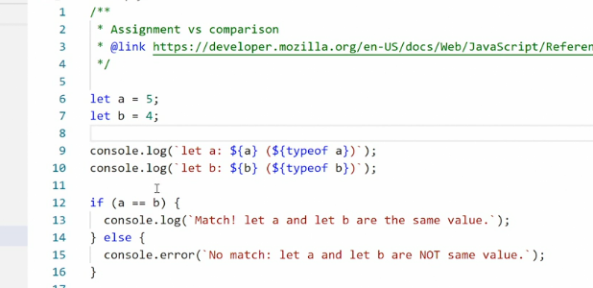

* We have **two equal symbols next to one another, And that says, we're looking to see if the value of A equals the value of B.**
* Are they the same or not? This code example in the exercise files is a really basic example to demonstrate how these different comparisons work.
* What we're doing here is just assigning a value to A and B and then we're console logging out, what the values are and also the type of data that's inside, each of these variables.
* Why we're doing that will become apparent in the second.
* Then we use a basic conditional statement.
* We'll cover conditions later on, but for now just know we're asking if this statement here is true.
* A is the same as B, then console log out, match.
* If not, then console log out no match.
* Right now, the values are five and four.
* 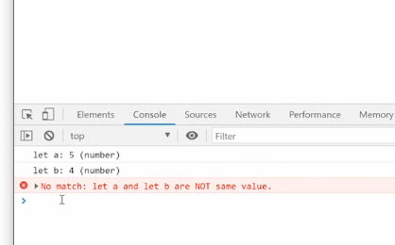
* If we save this and go to the browser, we get the output five as a number four as a number, and there is no match.
* If I go and change this to five and five, save it, go back in the browser.
* Five is a number five is a number and we have a match.
* The key to all this is this comparison.
* The two equal symbols tell us that we are doing a loose comparison.
* Meaning we're saying, are the values the same? But not absolutely the same.
* What I mean by that is I can actually change one of these values to a string.

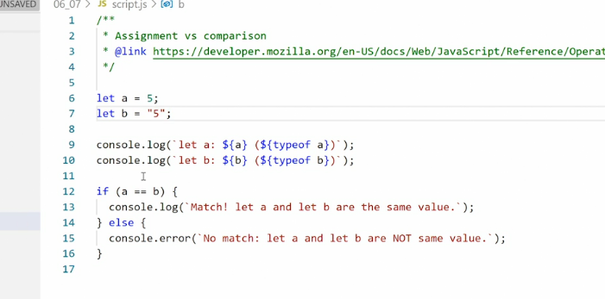

* Technically speaking, we now have a number and a string.
* But if I run this in the browser, you'll see even though five is a number and five is a string, we still have a match.

* That's because these two values look the same.
* I call this ***semiotic equivalent***, because **the two symbols look the same and carry the same meaning right now.**
* However, if I were to put in this text five and save it, we would not have a match because even though the number five and the text five, both save five, they're not the same thing.

* Graphical user interface, text, application, email

  Description automatically generated
* So JavaScript is trying to be clever here in saying that if you're just quoting a single number, you're probably trying to pass me a real number.
* So I'm going to tell you that these are the same even though they're not.
* If you want to test for that, to make sure you actually have two numbers, and not a number and a string with a number inside it, you can do an **absolute equivalence test** by adding an extra equal symbol.
* Now we have **three equal symbols.**

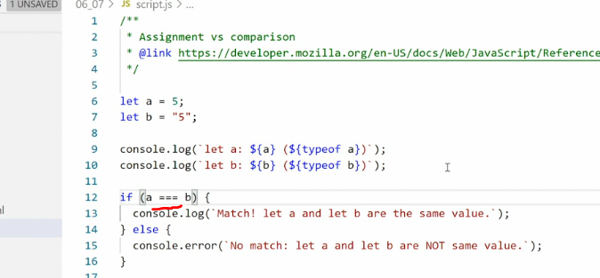

* This looks for absolute equality.

* The value on one side, and the other side has to be identical.
* Exactly the same.
* You can see it doesn't work here.
* There's no match because we have a number on a string.
* If we put in just the number, we get a match.

* Graphical user interface, text, application, email

  Description automatically generated
* But if I then do something else like I'll say five and five, there's no match, because the two values are not exactly the same.
* What you see here is any type of comparison like this, Either with two equal symbols or three equal symbols***, returns either true or false.***
* And then we can use that output in a conditional statement to say if the statement is true, then do something.
* If it's not true, then do something else.
* We also have some other comparison tools.
* We have the **larger than.**
* So if we say A is larger than B.

* If that's true, then we should get the true statement here.
* I'm going to have to actually make it true.
* So I'll say four, now A is larger than B.
* We get a true statement.
* If we turn it the other way and say A is smaller than B, then we get a false statement.
* We can also use larger than or smaller than equals two.
* Meaning if A is **either larger, than or equal to B,** then it's true.

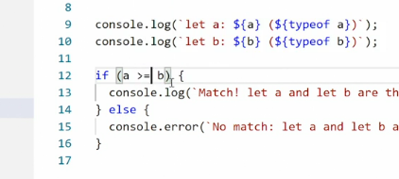

* Otherwise it's false.
* And we can do the same thing with smaller than.
* And finally, if we want to see if something is **not equal to**, we can use a bang.
* Text

  Description automatically generated
* An exclamation point and say, if A is not equal to B or if A is not absolutely equal to B, then do something.
* That's effectively just reversing the statement.
* Instead of testing whether it's true, we're testing whether it's false.