* - [Instructor] **An array is an instance of the array object and we declare a new array by creating a variable then using square brackets to wrap around a comma separated list of each of the items within that array.**
* So each of these items take up a slot in the array.

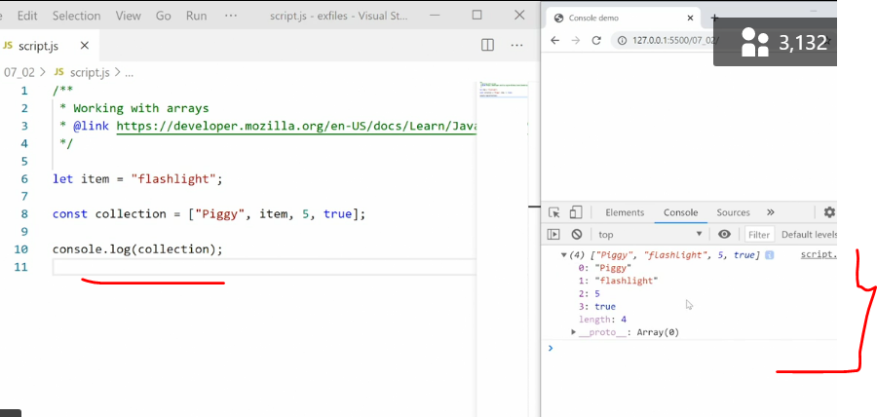

* If we console.
* log out an array in the browser, you can see here we have an array with four items and we got a list of all four of those items and you clearly see that **we can mix different data types with the same array**, so we have a string, we have a variable that pulls in the string, and we have a number and we then have a boolean value.
* Also notice at the **bottom** we have a property in the array, and it's the **length property that gives us the total length of the array.**

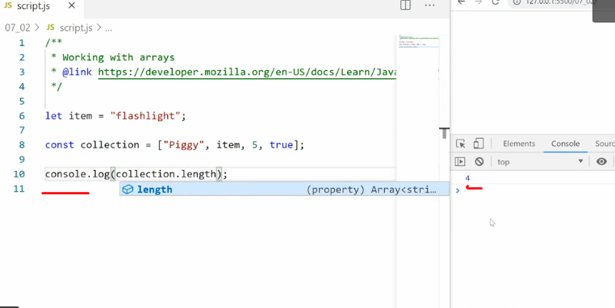

* So if I instead go here and say collection.
* length then we just get the number signifying how long that array is and how many items are in the array.
* To **access a specific item** within an array, we need to **use the index number** for the slot in the array.
* You'll notice here that the index actually starts with zero.
* So the first item at the index number is zero, the second item has the index number one, and so on.
* That means if I want to get ahold of the second item, I need to call for index number one.
* I do that using the **same square brackets**.
* So I'll say square brackets one, that is the index number.
* And when I do this I get the value of slot number two.

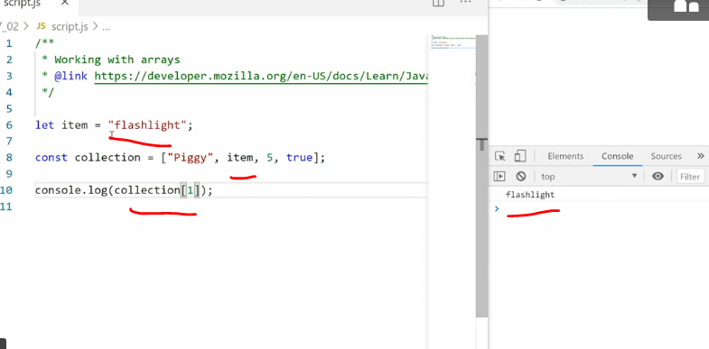

* In this case that's the variable that has the contents flashlight so that's why we're seeing flashlight in the console.
* We can assign new values to any of these slots using the same technique.
* So if I want to add a different value to the third slot, that'd be index number two, all I'd have to do is call in that slot.
* So collection square bracket two.

* That gives me the third slot, and then I'll set it equal to whatever I want to put in there instead.
* So I'll put in camera, save, and now when I expand again you'll see the third item, index number two, is set to camera instead.
* So even though the original slot was a number, I can swap it out for a string or anything else at any time because Java Script **does not care about the data type inside any of these slots**.
* *Just like you can place any data type inside a variable, you can place any data type inside any slot in an array.*
* String, a number, a boolean value, an undefined value, a null value, a true or false value, even an object or another array.
* Now let's say you want to add a new item to the end of the array.
* You can do that using this length property because the length property, you notice, has the same number as the next imagined item in this array.
* So the length is four.
* That means if I want to add a new item to the end, I can just say collection and then inside the square brackets I'll say collection again, and a length.
* This will give me the current length of the array and then I'll set that equal to new item.

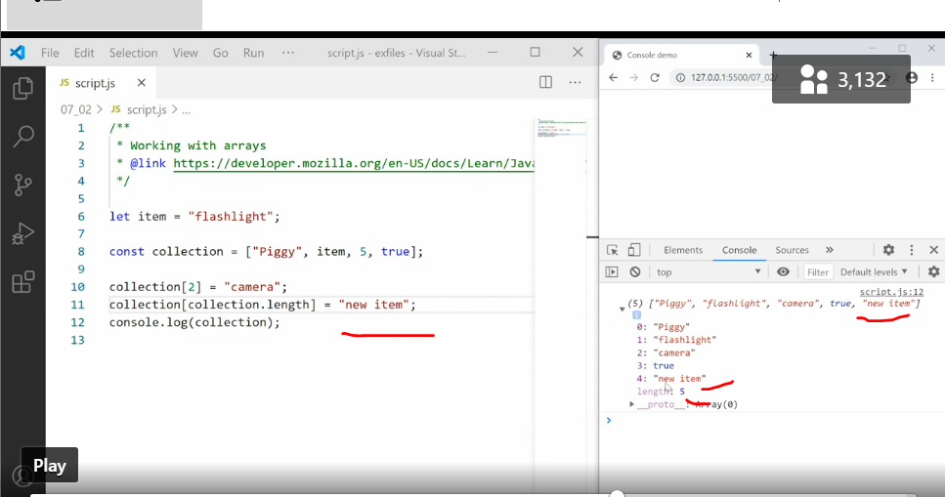

* Save that, now our array is five items long and the new item has a slot number four, which is the number we got out of collection.
* length.
* ***Interestingly you can also assign a new item to a slot that doesn't exist yet that's further down the chain.***
* So for example, we can say collection and then let's say nine.
* This is further down on the list and there aren't numbers eight, seven, six and five yet, but let's see what happens.
* So I'll say at the end and click save.

* Now our array has 10 slots, but if we look at the list we only get one, two, three, four, five, six.
* So what happened to slots five through eight? Well, we can try to output them and see what they say.
* Console.
* log collection and then say eight.
* Save that and what we get is **undefined**.

* That's what we'll get for all of those undefined slots because they are quite literally undefined.
* We never defined them so they are undefined.
* There's nothing in there and we can't pull anything out, but we can assign new values to them at any time because, like I said, Java Script doesn't care if we mix data types, so we can swap out a undefined for anything else.
* What you see here is **arrays are an extremely flexible data storage method.**
* **We can very quickly access content, we can add new content, we can replace content, and pretty much do whatever we want with it.**
* Arrays also have a long list of methods we can use to do more advanced things and we'll look at that in the next movie.