* - [Narrator] So far in the course, we've mainly looked at data and how to handle it through objects and variables and arrays.
* But the main use of JavaScript is as a scripting language, meaning we use it to write programs.
* And that's what functions are for.
* A word of note here.
* The term function is ***typically used to refer to as a function that sits on itself*** whereas a **method is a function that sits inside an object and acts on that object.**
* They're effectively the same thing, they just appear in different contexts.
* Okay, a function can be created in a couple of different ways and how we create a function has an impact on how it can be used.
* **The classic function is a function declaration** and it looks like what you see here.

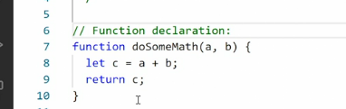

* We start with a *keyword function*, then we *give the function a**name, we pass parameters inside a parenthesis* and this can either be nothing.
* So it can be just the parenthesis or it can have parameters.
* And then we have *curly brackets wrapping* around the function body.
* Inside the function body, we perform ***actions on the data.***
* And then we can, if we want to return that data using the ***return keyword****.*
* That data gets then sent back to wherever we declared the function originally.
* Now, we don't have to do that, we can also have the function just output data directly.
* So that depends on what you want to do with the function.
* If we use a function declaration like this, ***the function is hoisted to the global scope, meaning it becomes available everywhere.***
* So even if we declare this function inside a local scope, it'll still be available everywhere else in the script.
* This function is also *really an advanced variable and it can be re-declared.*
* So just like a VAR, if you create a new function and use the same name, do some math, that new function will take precedence further down in the code.
* So you can accidentally override an existing function if you're using function declarations.
* Function declarations are easy to understand even at a glance because they quite literally say, I am a function and I have a name and these are my parameters.
* So the clarity of intent is clear any time you're using a function declaration.
* And finally*, function declarations are parsed in the order they appear in the code.*
* So if you have a function B that relies on function A, you have to make sure function A is declared before function B in the code.
* Otherwise, when you get to function B, function A is not declared yet and the script cannot run.
* So the order in which these functions are declared matters for JavaScript to work properly.
* **Another way of declaring a function is through a function expression**, and that's what you see here.
* In a function expression, *we set up a variable.*
* In this case, *a constant*, we give that constant a name and then ***we set the value of that constant equal to an anonymous function.***
* So this is a function that ***doesn't have its own name.***
* This anonymous function, again, ***has parentheses and those parentheses may contain parameters.***
* And then we have *a curly bracket wrapping around the function body.*
* So the function functions the same way as the function declaration, except it doesn't in itself have a name.
* Instead, we place it inside a variable and then we call the variable.
* This pattern of using a function expression has become the *preferred way of declaring functions* in JavaScript frameworks like react.

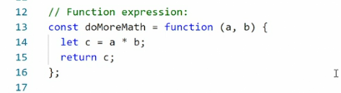

* And the current best practice is to place function expressions inside a const.
* That makes sense if you think about it because the function expression is sitting inside a variable and ***it will then have the same scope as that variable type.***
* So if we're using a const, then it is ***locally scoped or block scoped automatically.***
* So if you ***place the function in a const, it also cannot be re-declared.***
* So you're never in danger of accidentally overriding or destroying your function.
* *Finally, function expressions are not hoisted.*
* *They exist only in the scope they were created*, and this is also facilitated by the const being used.
* So in a way*, function expressions are a more advanced version of functions.*
* *To call and use either a function declaration or a function expression, we simply name it and add parentheses at the end.*
* And then if there are parameters, we pass those parameters along.
* You can see that down here.
* First I'm calling the do some math function.

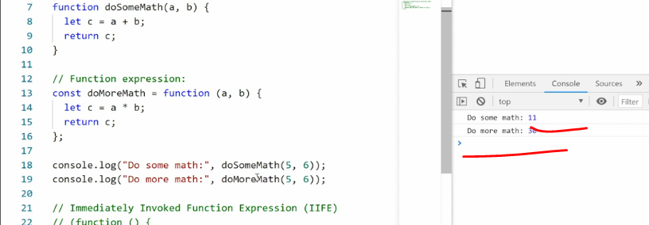

* That's the first one up here and I'm passing along my parameters, the number five and six.
* They then get populated as A and B, and A and B is used inside the function.
* Same thing below, here we call then do some math.
* You can see the calling of the function is exactly the same whether it's a function declaration or an expression.
* And again, we pass in the values.
* ***Interestingly, because we have a function expression, if we just say, do more math and save, what we get in return is the actual function instead,*** which looks weird but can be useful in some edge cases.

* So using a function expression gives you some added functionality that can be useful.
* One more thing, ***if we don't pass values to do more math***, even though it's expecting it, we'll get some weird output.

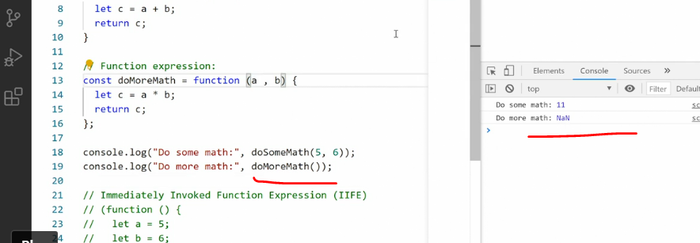

* Here we get NAN or not a number.
* ***We can solve that by setting default values for these parameters in the function expression itself.***
* So we can say A equals three and B equals two.

* So then even if we don't pass values, we get an output and it will be the default output.
* But if we pass in some values, five and six, then those values we're passing in take over and we get the correct output.

* In addition to a function declaration, a function expression and the anonymous function that sits inside here, there is one more type of function worth mentioning.
* It is the **immediately invoked function expression.**

* And you see it down here at the bottom.
* In an IIFE, ***we wrap an anonymous function or a name function inside parentheses.***
* You can see here there's a starting parentheses and an end parentheses.
* ***And then we put place another set of parentheses outside.***
* ***What happens now is this function is immediately invoked and run as soon as the browser encounters it.***
* ***So we are running this function right away without calling it.***
* *This particular pattern is a bit of an anti-pattern because you normally want to control when a function runs, but in some cases it can be handy because you want something to happen as soon as possible.*
* And you can see inside this function I'm actually using one of the other functions, do some math.

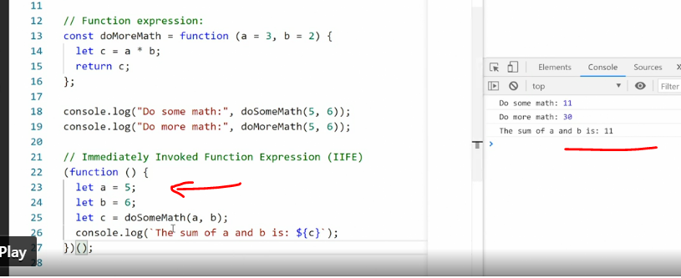

* So when I save this page now, you'll see we get an output here where we pass in values for A and B, and then we do some math and we get the output we want.
* And then we can change these values here and get a different output.