1. Before

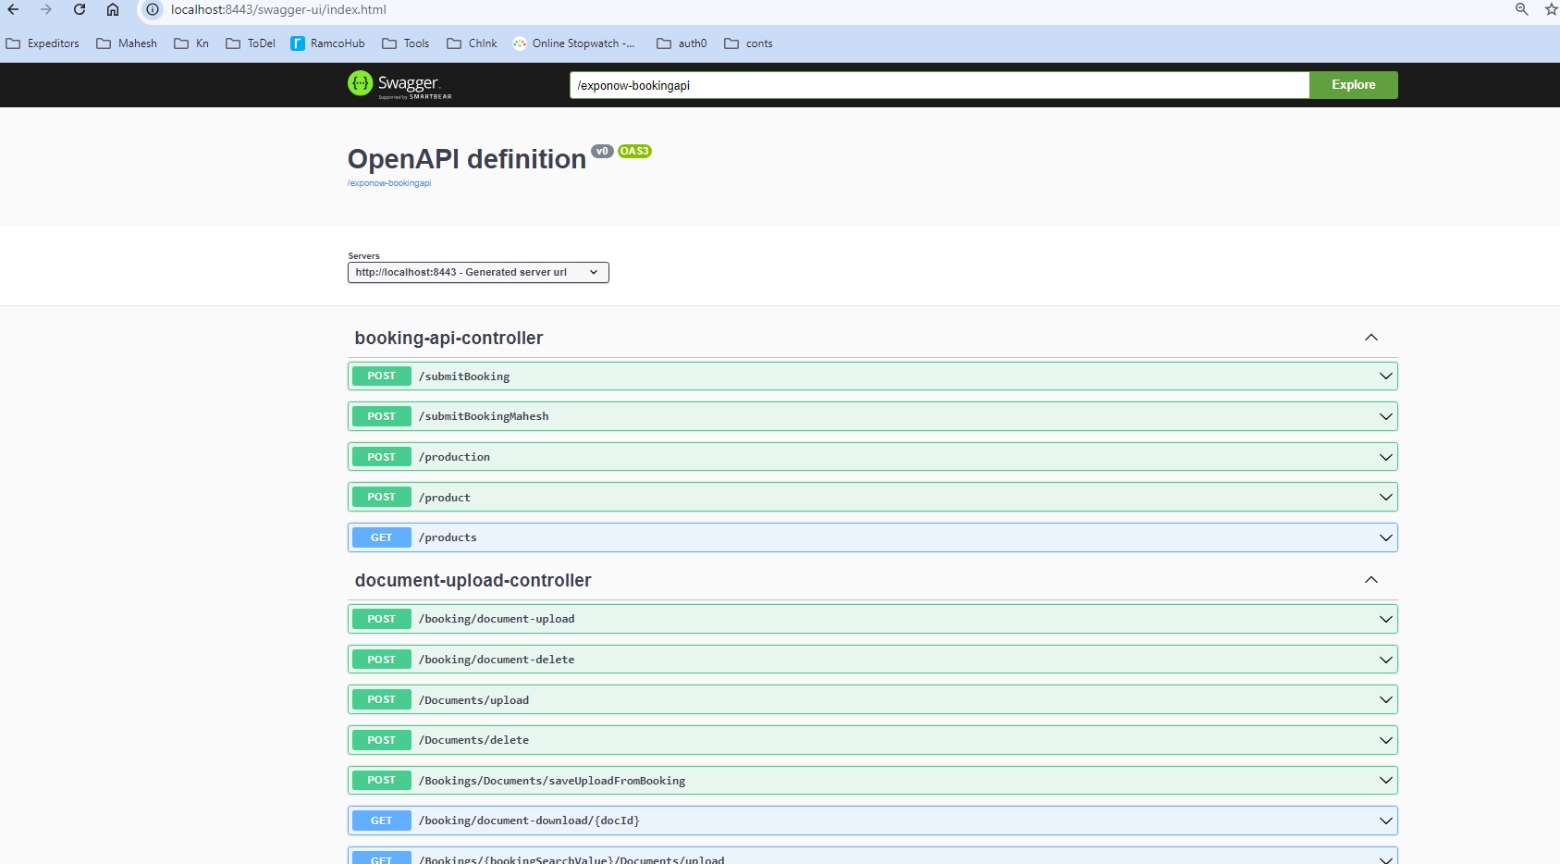

1. Create a config file and make the following changes