* - [Instructor] JavaScript is an amazing language.
* It's been around for over several decades, and it's everywhere, from your browser to the server.
* It even runs some refrigerators.
* JavaScript is also a dynamic language, which means that it is very forgiving in how it allows you to define and use variables.
* For example, you made decide to create a variable and assign it to a string value, then reassign that same variable to a complex type that you define on the spot, and then go ahead and add properties to that object.
* JavaScript allows it all.
* In fact, that's the beauty of the language, but JavaScript's dynamic and forgiving nature is both a great thing, allowing you to do virtually anything you want, and a bad thing, allowing you to make all the mistakes you want as well.
* For example, take a look at this piece of code.
* There are at least three errors in just these three lines of code.
* All of them will break my application at runtime, and only really one of them is obvious enough to find just by looking at this code.
* In other words, my app is broken, and I'm not going to find out about it until it's running.
* At this point you might be a little confused.
* Perhaps thinking that maybe the wrong course started playing.
* If this is a course about TypeScript, why am I talking about JavaScript? Well, I'm talking about JavaScript because TypeScript is designed to catch exactly these kinds of problems in your JavaScript code.
* **TypeScript adds strong static typing** on top of JavaScript, which means that **it's able to provide compile time code checking** that will not only catch many common issues before you even run your code, **but will also help you write your code by providing first-class in-line documentation** and guidance.

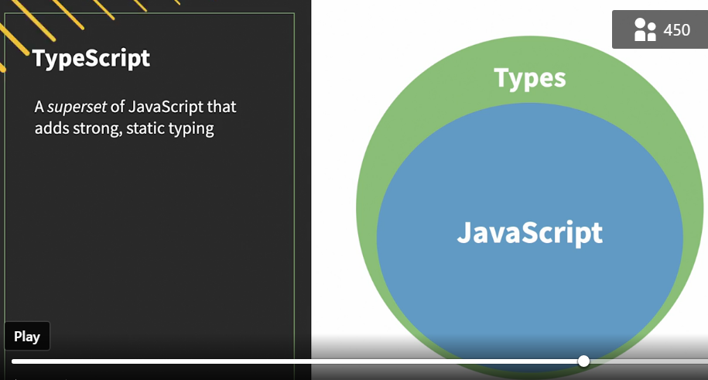

* But perhaps the most important thing is that TypeScript is a superset of JavaScript, which means that it extends the JavaScript language with all of this additional goodness, rather than creating a whole new language.

* Plus, once all is said and done, TypeScript code compiles down to JavaScript.
* So anywhere that you would use JavaScript, you can use TypeScript, after you compile it at least.

* In other words, **TypeScript is JavaScript**.
* So if you already know JavaScript, then you're already well on your way to knowing TypeScript.
* So just keep watching and I'll show you everything you need to know in order to take advantage of this powerful language.