* In this challenge, I had you ***convert an existing JavaScript application to TypeScript***, and have ***the compiled JavaScript output generated into a new folder.***
* In order to accomplish this, you had to do the following.

1. First, **install the TypeScript compiler**, if you hadn't already. Using the below command in terminal

***npm i -g typescript***

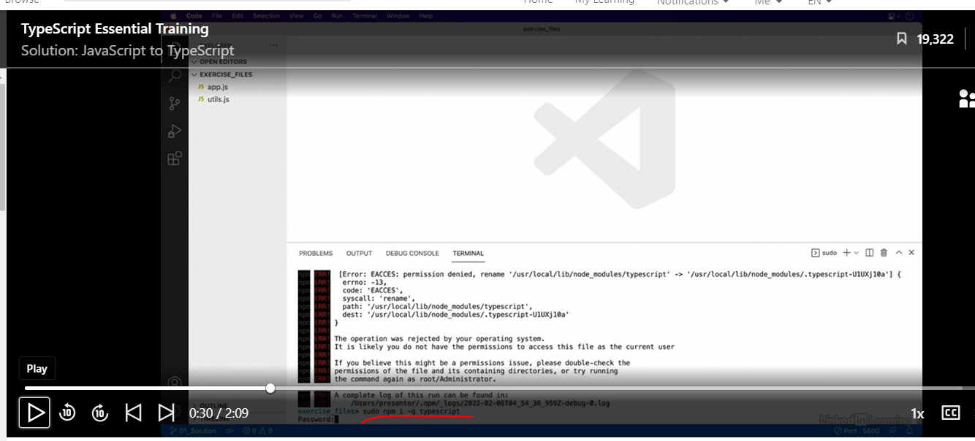

b) **Then create a new file named tsconfig.**json in the root of your project folder.

c) In this new config file, you had to define the input file paths.

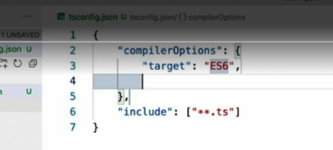

* d) Then add a new configuration section.
* e) Define the version of JavaScript that you want it to target.

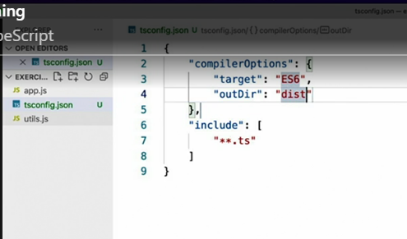

* f) Define the output folder path to the folder that you wanted to output your JavaScript files to.
* g) And finally, rename the JavaScript files to the .ts extension.

* h) With this in place, you can see if you're done by jumping out to the terminal and executing the TSC compiler command to produce the compiled JavaScript output.

1. If your output folder looks like this one, then congratulations.

* You've successfully converted the JavaScript application to TypeScript.
* If you had any problems, however, feel free to re-watch this video and the corresponding videos in this chapter to fill in any gaps.