1. Create Twillio account with phone number
2. MFA Auth0

Goto auth0 -> Security -> Multi factor authentication

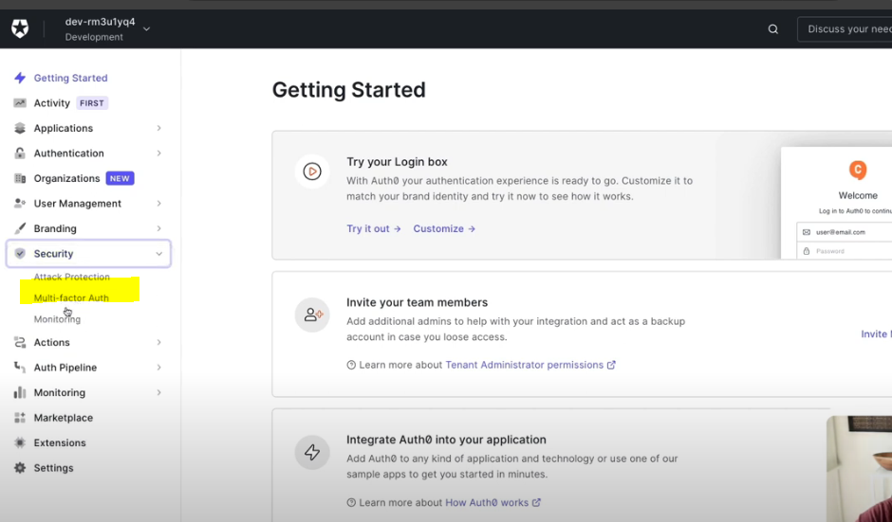

1. Factors available in Auth0

1. Enable Phone message -> delivery provider

We can use Auth0 delivery provider or twillio or custom

1. Three types of delivery method sms/sms&voice/voice and then enter twilio details

1. Enrollment /Verification template

1. Now application wont work after defining above security. We need to define how often we want our users to authenticate with multiple factors . We have two options : Adaptive MFA /Always

Adaptive MFA is Auth0 ‘s way where we test the users environment i.e use MFA only if there is a risky login scenario

Or always means always use MFA

1. Testing the application

* Go to application and login with user/pwd then screen for entering phone number

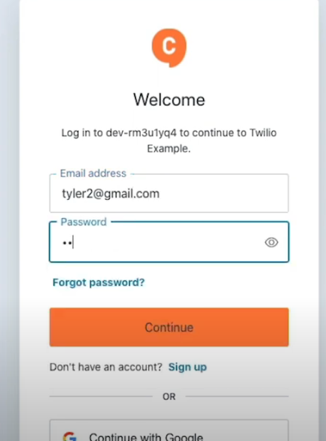

* Enter phone number

* Country code selector

* Then message comes with otp

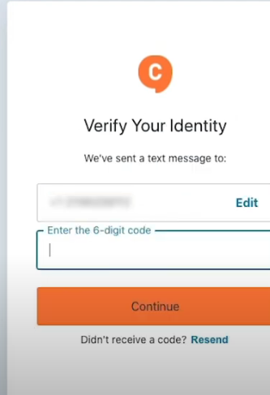

1. Now once the code is successful, we will be able to login to the application

