1. in expo-ui src\environments\environment.ts

client id , domain, scope will be specified which is used by Auth service(src\app\api\api.module.ts) for generation of tokens

*...*

*authenticationConfigMapping: [*

*{*

*host: '{{host}}',*

*config: {*

*clientID: 'TKiAoi8saKj1oCg31iyTEcbdUEhTX7d1',*

*domain: 'login.dev.test-expeditors.com', // Custom vanity login used. Original setting: 'dev-test-expeditors.auth0.com',*

*responseType: 'token id_token',*

*audience: 'https://expo-api-dev-expeditors.com',*

*redirectUri: 'https://expo-origin.dev.test-expeditors.com/session-setup',*

*logoutUri: 'https://expo-origin.dev.test-expeditors.com/logout',*

*scope: 'openid offline_access',*

*tokenNamespace: 'https://go2expo.expeditors.com',*

*},*

*....*

1. This will help generation of tokens
2. In Auth0 this application is referred as: <https://manage.auth0.com/dashboard/us/dev-test-expeditors/applications> as : go2expo-dev

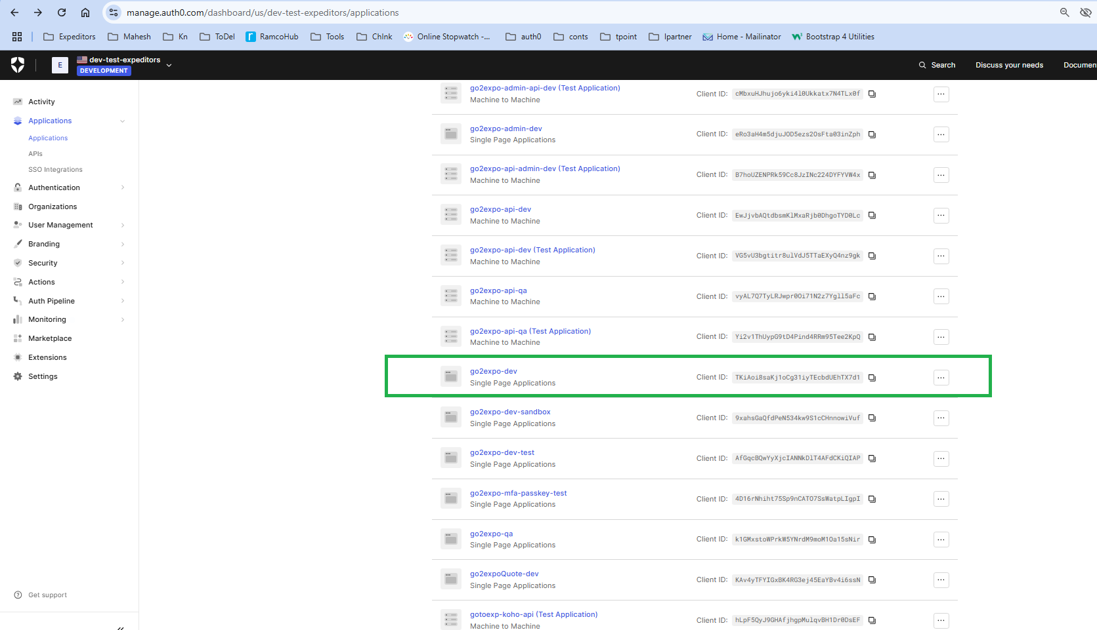

If we go in we can see: the client Id of this single page application :

<https://manage.auth0.com/dashboard/us/dev-test-expeditors/applications/TKiAoi8saKj1oCg31iyTEcbdUEhTX7d1/settings>

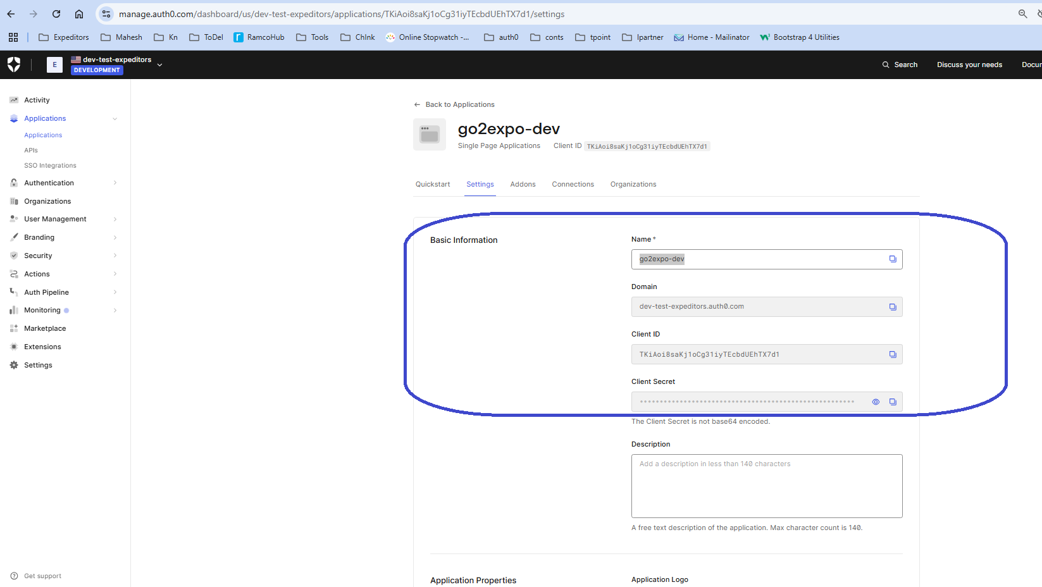

The same client id and domain will be used while generation of tokens in environment.ts discussed in point 1

1. From Client we need to connect to API: which is configured in Auth0 as:   
   go2expo-api-dev

* In apis we can see this as below:

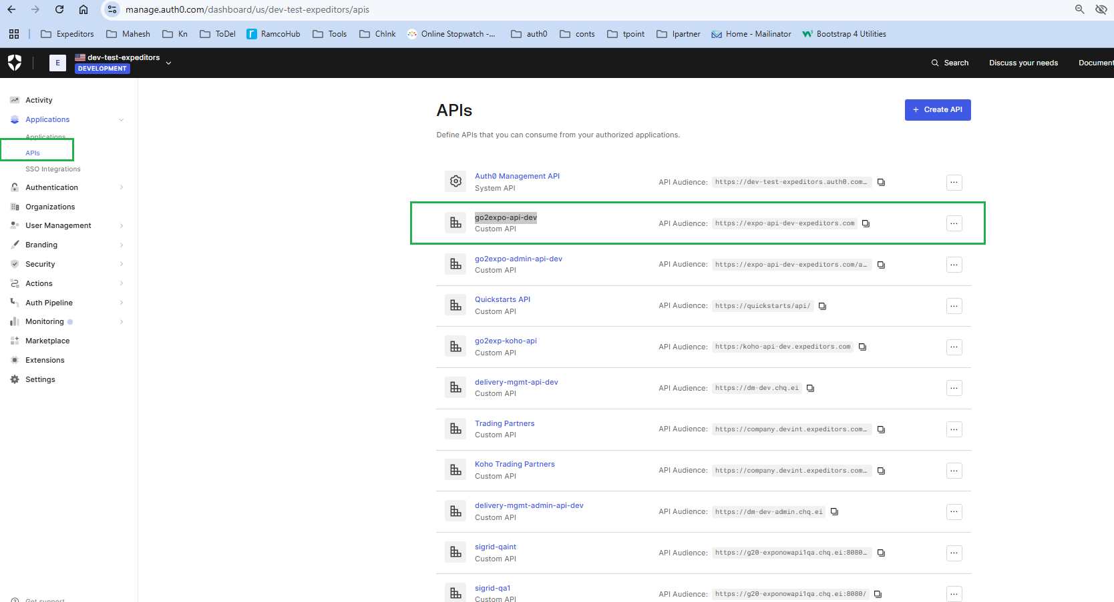

* In applications of Auth0, also we can see the same API

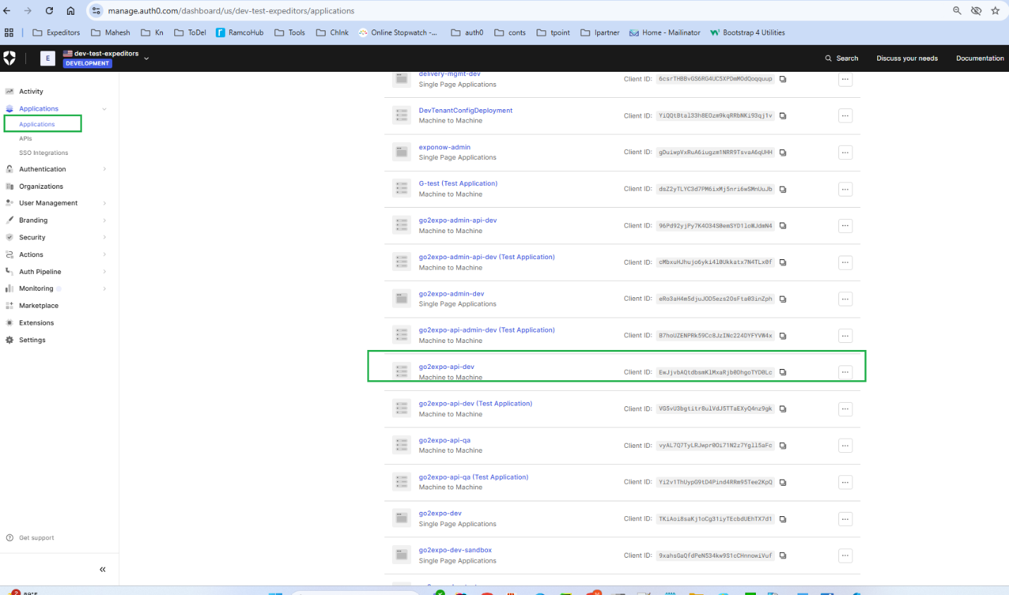

* This audience link is configured in the environment.ts of the UI applications , expo-ui for generation of token and in booking-ui for authorization

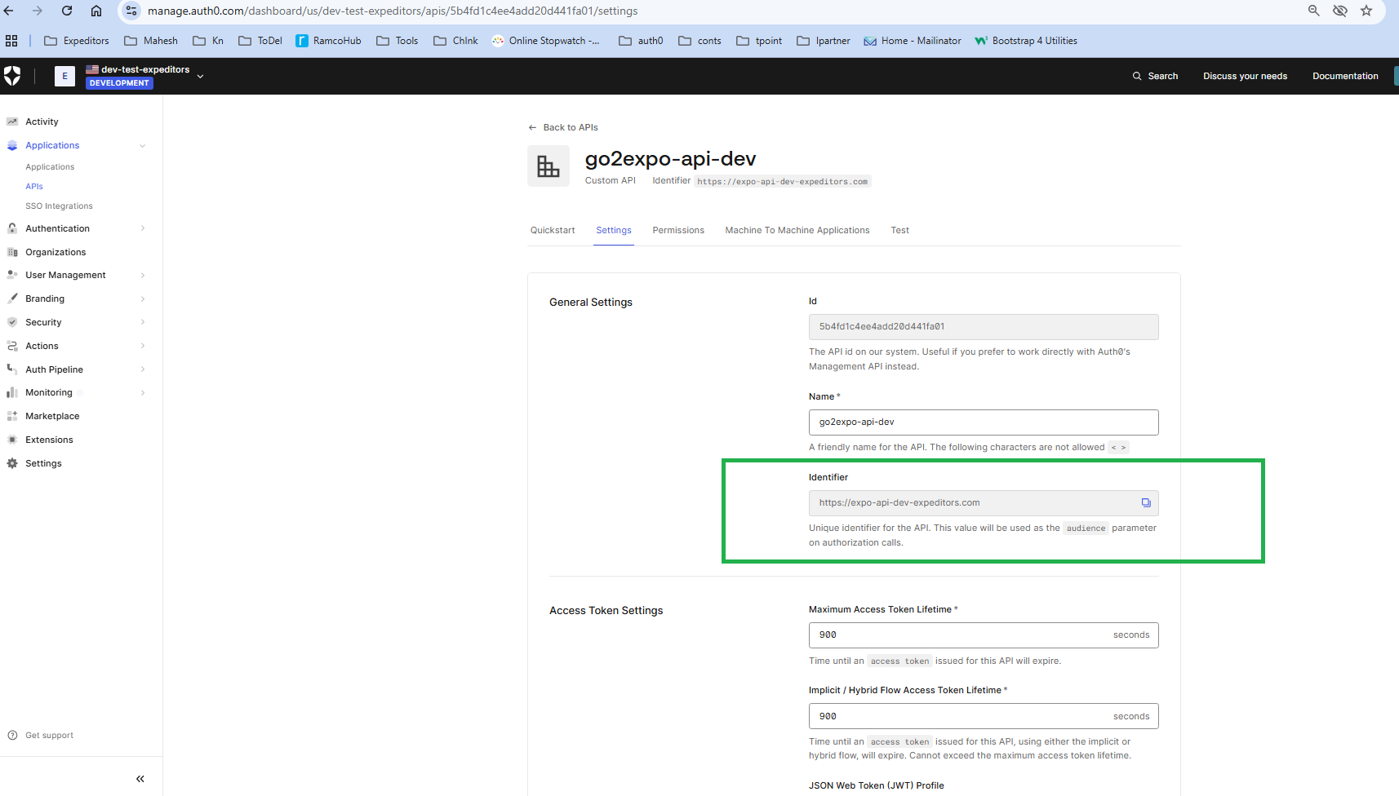

* In permissions screen, we can see the permissions assigned for this api : <https://manage.auth0.com/dashboard/us/dev-test-expeditors/apis/5b4fd1c4ee4add20d441fa01/permissions>

1. In APIS : <https://manage.auth0.com/dashboard/us/dev-test-expeditors/apis/5b4fd1c4ee4add20d441fa01/test> , test section of this API go2expo-api-dev,we can see link for generation of token

* Here we can see link for token generation: client id and client secret passed for generation of token to access this API :
* Critical data for generation of tokens include: url, client_id, client_secret, audience, grant_type
* HttpResponse<String> response = Unirest.post("https://dev-test-expeditors.auth0.com/oauth/token")
* .header("content-type", "application/json")
* .body("{\"client_id\":\"VG5vU3bgtitr8ulVdJ5TTaEXyQ4nz9gk\",\"client_secret\":\"Ep6I8cGCiBC8j-AEu8VhX6Ua5cpVuedca21at8wFN4myLm81KGl3oUN6YWNBRug5\",\"audience\":\"https://expo-api-dev-expeditors.com\",\"grant_type\":\"client_credentials\"}")
* .asString();

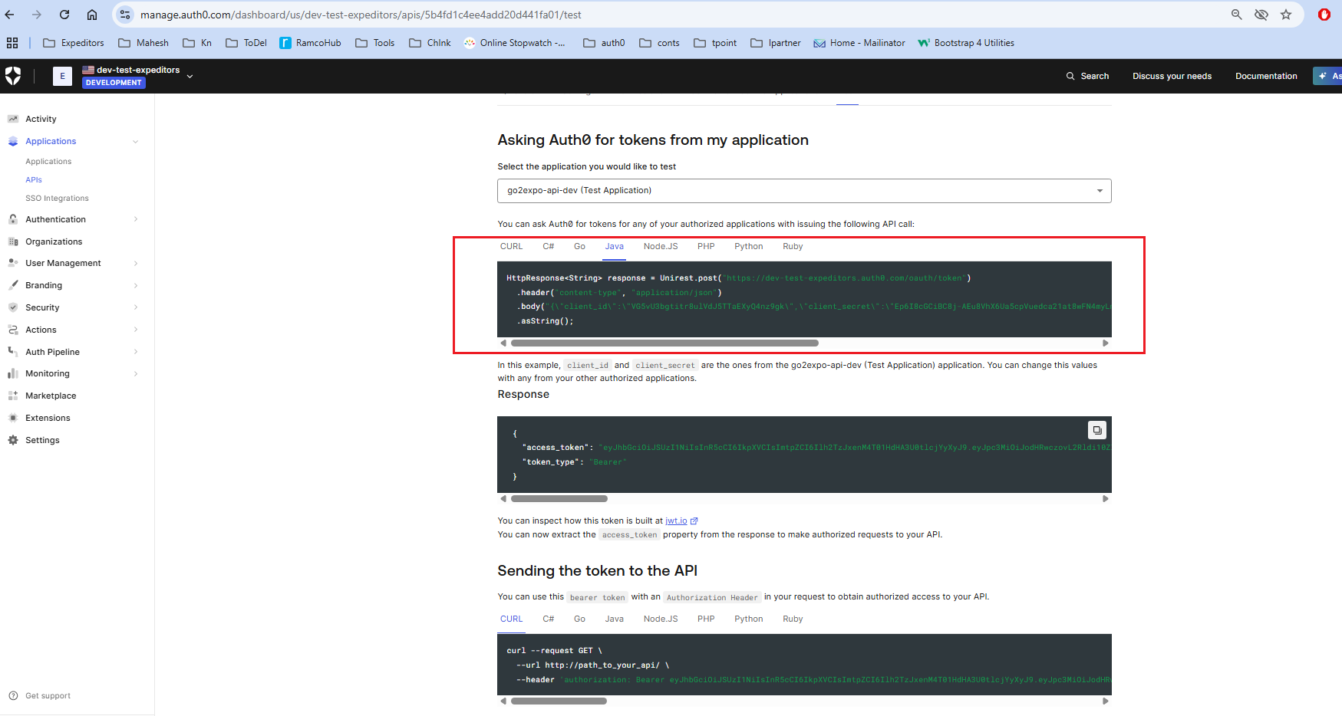

1. With this token generation is complete,
2. Now we need to make changes and configuration to access this api in backend
3. In backend it is used below in application. properties
4. **security.api-audience**=**https://expo-api-dev-expeditors.com  
   security.issuer**=**https://login.dev.test-expeditors.com/**