1. Use a JWT that came from Amazon cognito and hook that with API gateway - so that we can access protected resources in your lambda function
2. We are going to start in AWS lambda service, where we will be creating a new function.

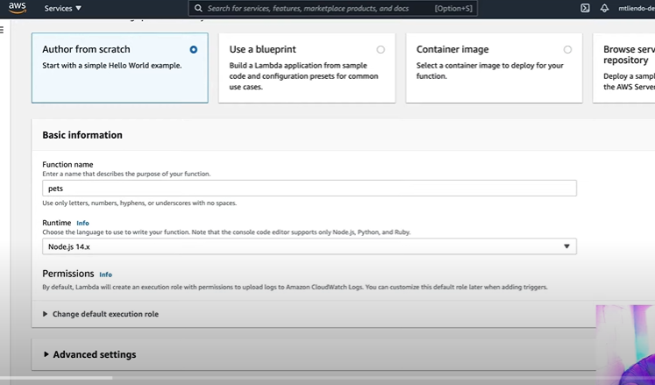

1. We are going to make: Only persons who will be able to authorized to use these resources are only authenticated users
2. Make changes in lambda code: here it is js and deploy the same.

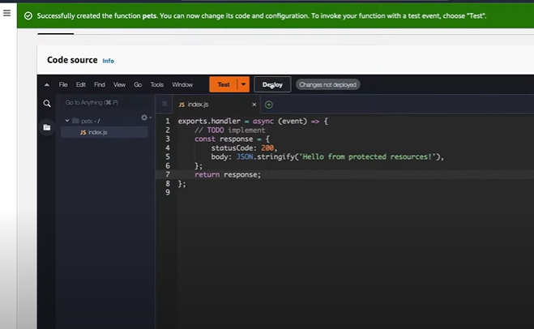

1. Now go to api gateway: In HTTP API , click build

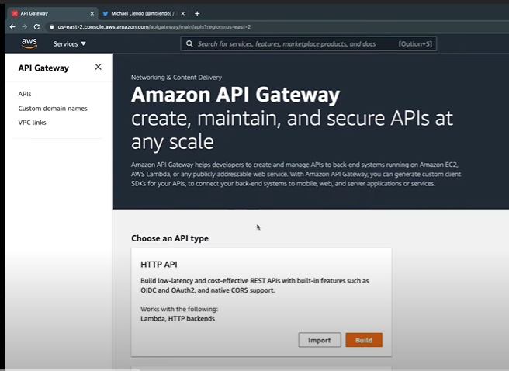

1. configure integrations in HTTP API:

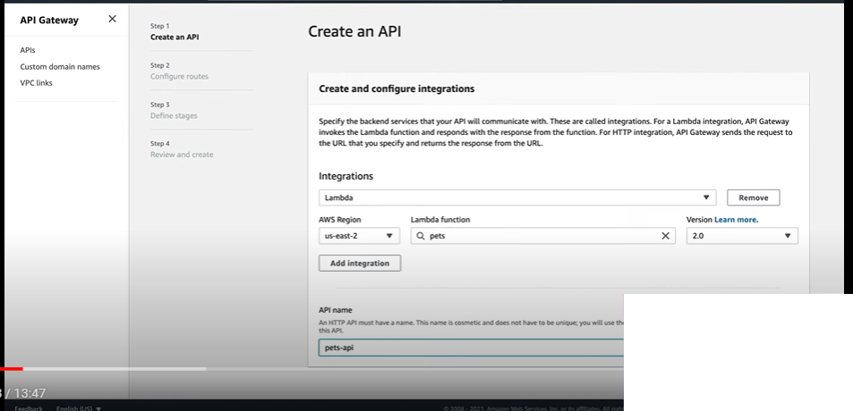

1. After step 1 which is create api which we did via integration, next step is to configure route, where we need to specify Resource path and Integration target.

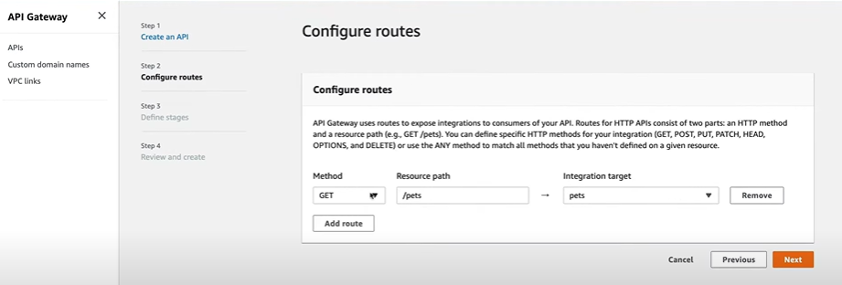

1. In configure stages, make it default

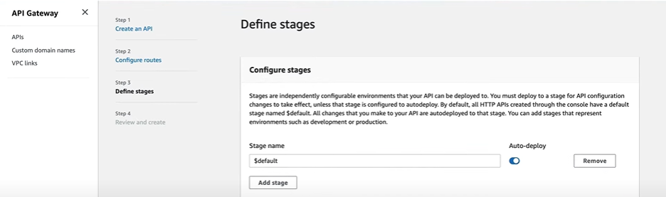

1. Now review the api for all the three stages:

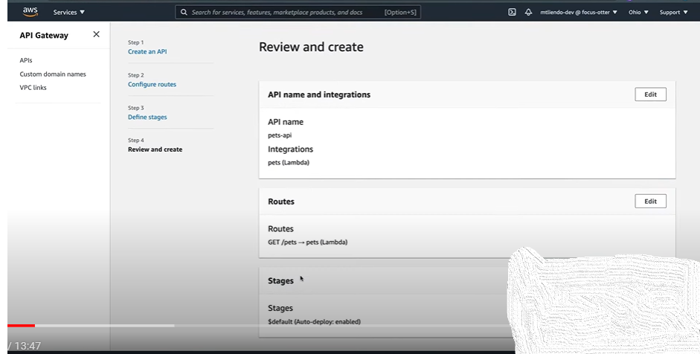

1. Now API got created successfully and copy the invoke url

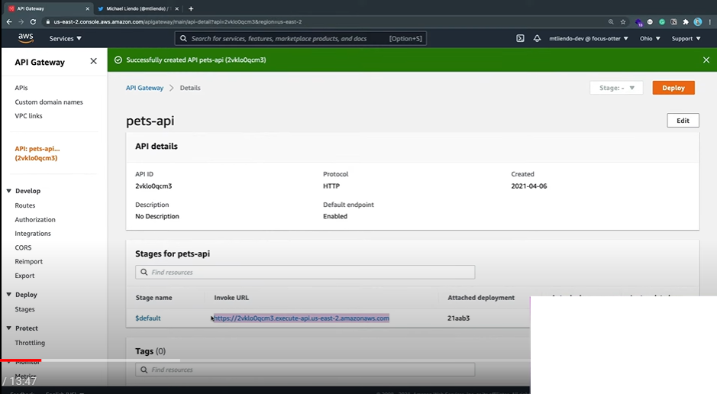

1. Try using the invoke url in postman and we can get the response

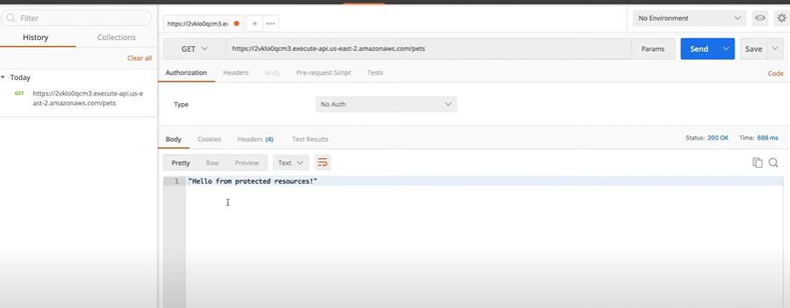

1. Now to add authorization, where only authenticated users will be able to access this service.
2. Cognito service will be used for the same. – Cognito is the service that will help authenticate our users
3. AWS cognito offers user pools and identity pools. User pools are use directories that provide sign up and sign in options for your app users.

* Identity pools provide aws credentials to grant your users access to other AWS services.

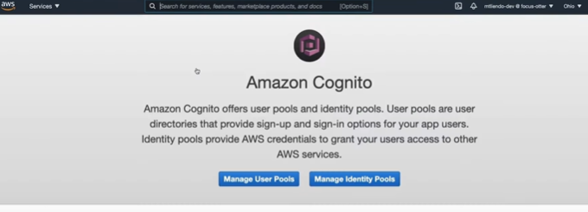

1. Creating User pool for cognito:
2. Name the pool and then click review defaults

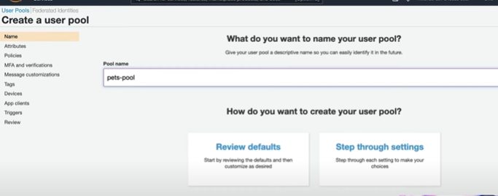

1. After verifying pool settings, click create pool so that user pools gets created

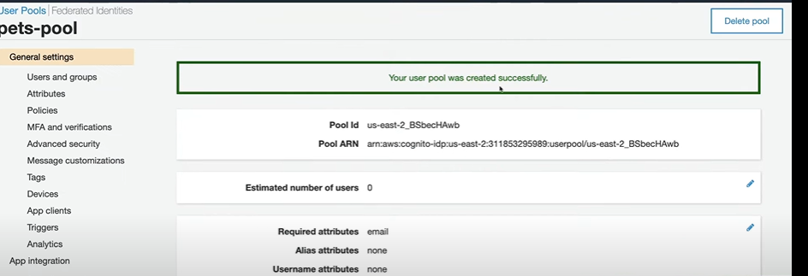

1. We will do couple of things for this pets-pool user pool we created

* In app clients , give the app client name

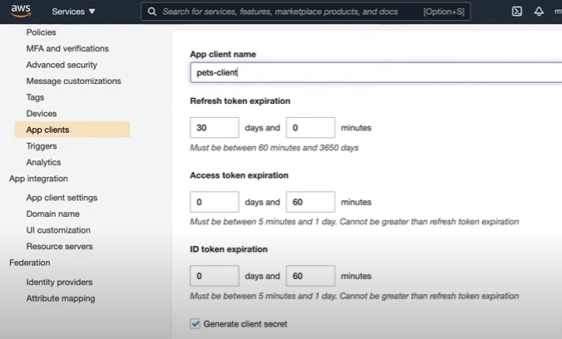

1. In App client settings. Enable Cognito User Pool

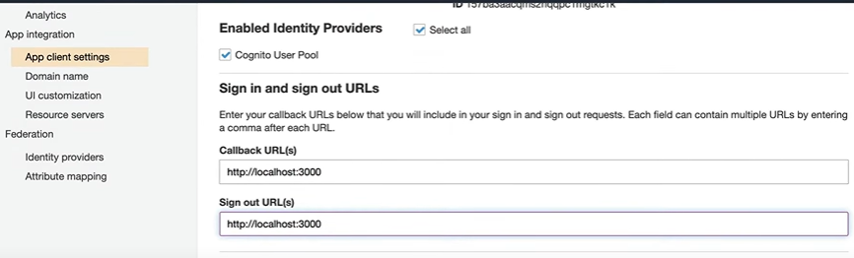

1. In OAuth give implicit grant

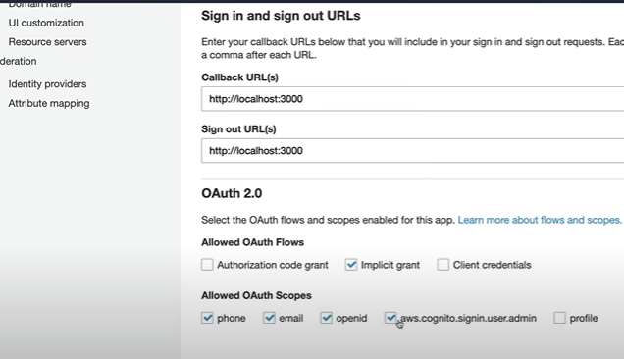

1. Next we need provide Hosted UI setting details. For that we need to setup a domain. Specify the domain name

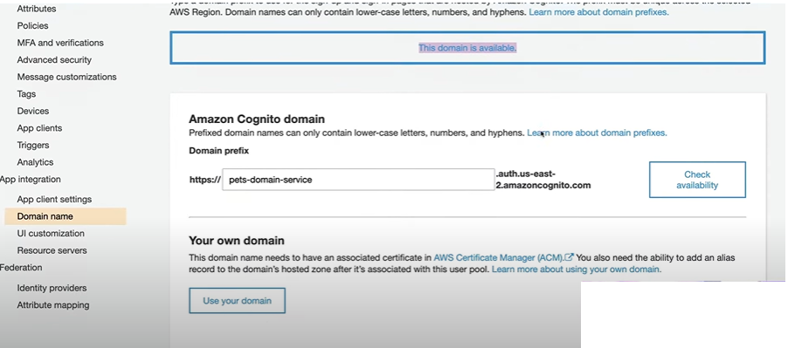

1. Now we should be able to launch the hosted UI

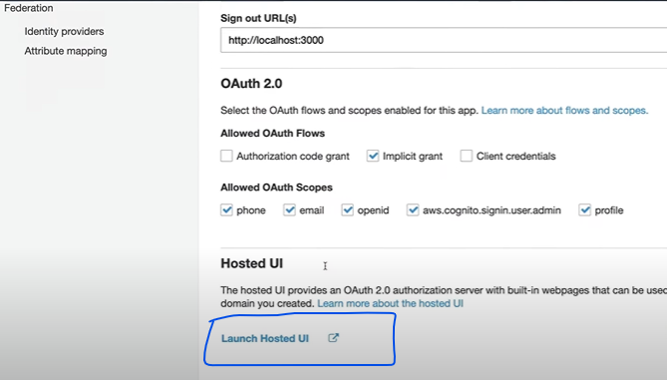

1. Now when we try to login our application the below page will be coming

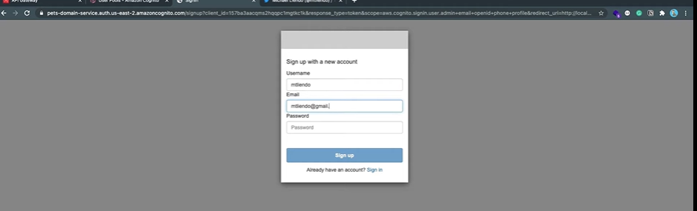

1. Now we have created user pool in cognito, but it is not tied to API gateway.
2. To do that we need to authorization tab in API gateway

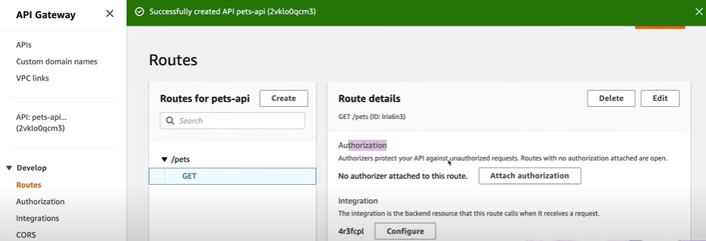

1. Attach Authorization -> Create and Attach an authorizer

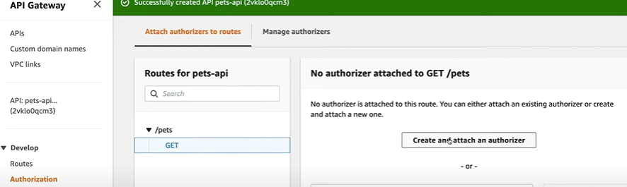

1. Use JWT as authorizer type:

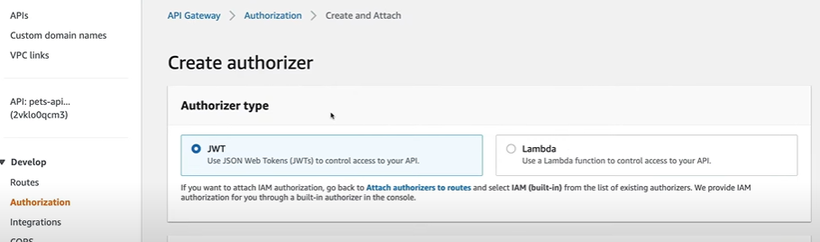

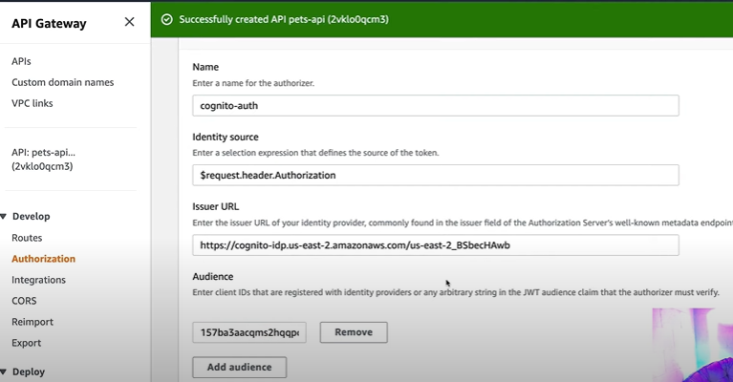

1. Now we can see below in authorization.

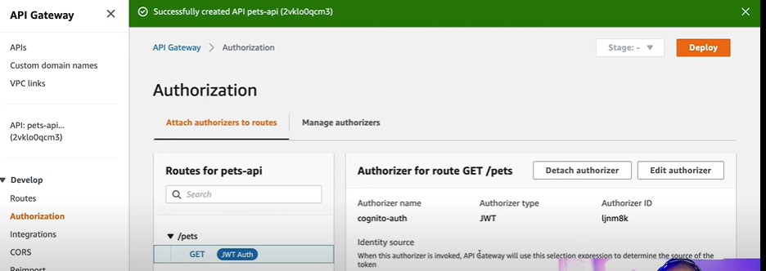

1. Now if we go to postman and hit the end point again, it will say you are not authorized

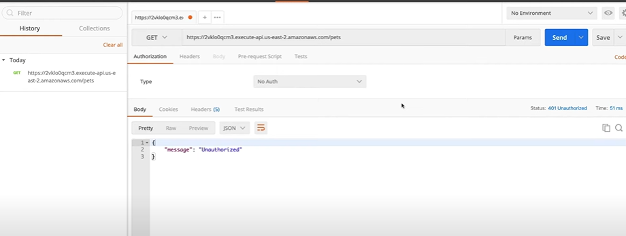

1. Now we will use the jwt token, which we had earlier and put it in header and see if we get the response

