**Getting Test Ether to Use in the Course**

Before continuing to the next lecture, we will need to obtain some test Ether!

Due to the recent [merge](https://ethereum.org/en/upgrades/merge/https:/ethereum.org/en/upgrades/merge/) the Rinkeby Network no longer exists. Instead, will want to use the Goerli network for everything in this course. This is 100% interchangeable with Rinkeby, so, there will be no actual difference.

Since we will be using the Goerli Network instead of Rinkeby, we will need to use a Goerli faucet to obtain test ether. All current faucets require some level of authentication to protect against DOS attacks and bots.

**Alchemy Goerli Faucet**

1. Visit <https://goerlifaucet.com/>
2. Register for a free Alchemy account
3. You should automatically be taken into an onboarding flow. If not you can find the Complete Onboarding button at the top right-hand of your screen:

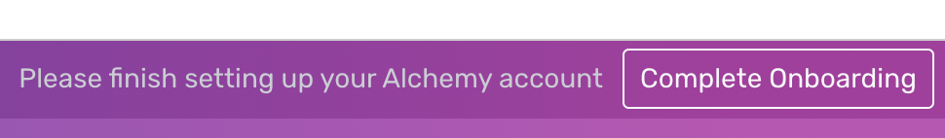

1. You will be prompted to create a team. You may enter any value you wish.
2. The next prompt will be the type of project you are building. We are just requesting ether, so, you can put anything you'd like here.
3. At the Let's choose your chain prompt, select **Ethereum** and click **Next**.
4. Select the **Free** plan
5. At the credit card payment form, click **Skip for now**.
6. Enter anything into the How did you hear about us prompt and click **Let's Build**.
7. You will be redirected back to the Goerli faucet landing page.
8. Go to the Metamask extension in your browser and make sure you are signed and the **Goerli Test Network** is selected. Then, copy the account address that is listed:

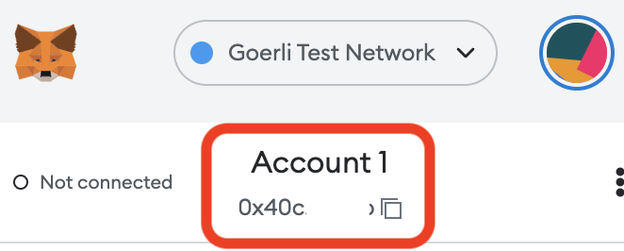

1. Paste your account address into the form on the Goerli faucet landing page and click **Send me ETH**:

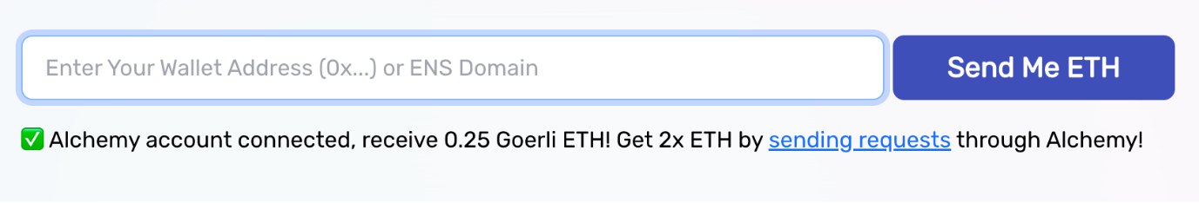

1. You will be redirected to a random screen with a link to click if you wish to view the transaction on the Georli testnet explorer:

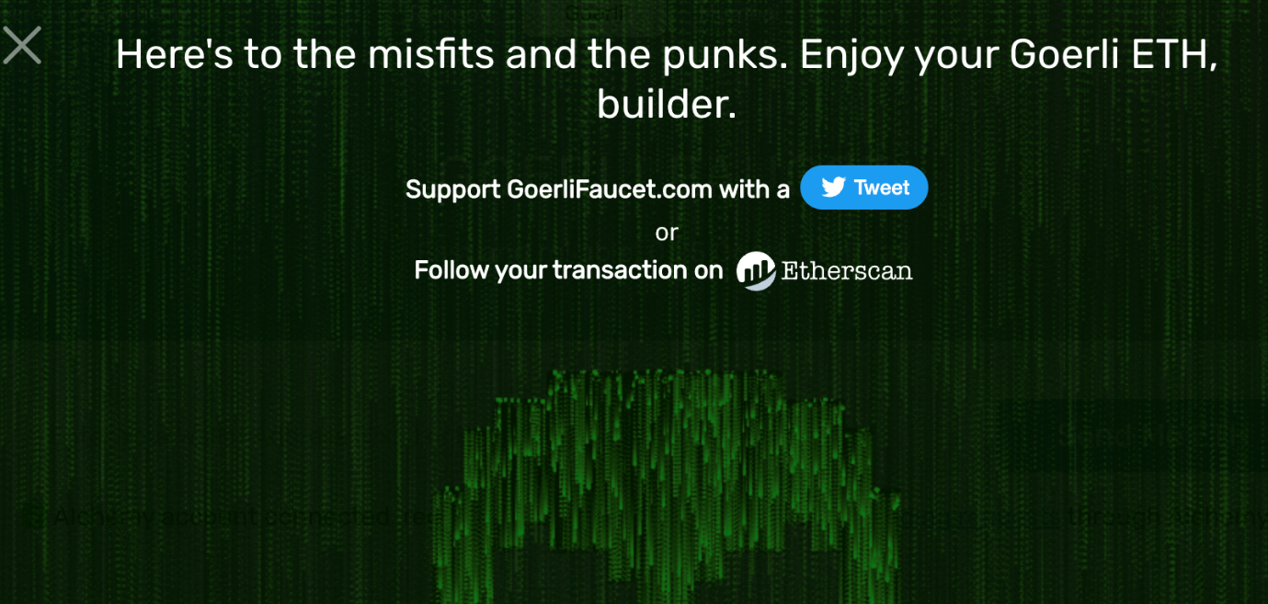

1. You may exit this now. After a few seconds or minutes, you should see your Metamask balance increase:

