**Basic Beef Commands**

1. Beef Command – Categories

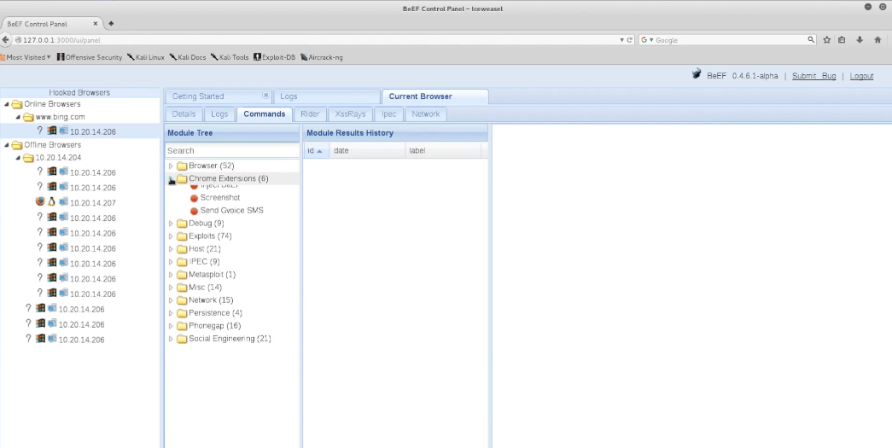

1. Browser related commands

1. Exploits

1. Social Engineering

1. Search

1. Alert sample

1. Raw javascript

1. Taking screenshot

1. Redirect plugin – helps browser to redirect to any page you want

Result of redirect

