**Mahesh Prakash Niwate** 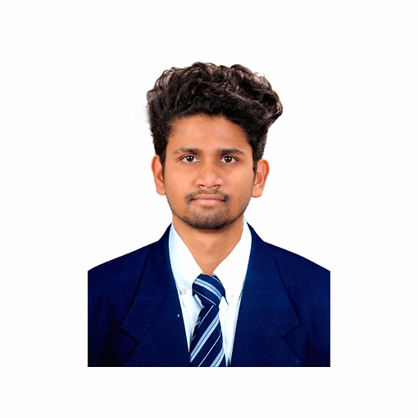

**Address:** - Kamothe, Navi Mumbai,

**Pin Code:** - 401209

**Contact No: -** (+91)7506358656

**Email-id: -** maheshniwate10@gmail.com

* **Career Objective:**

**To work with great determination and creativity in the organization, to find ideas and implement new process and handle the responsibilities to succeed in the environment of growth.**

* **Educational Qualification:**

|  |  |  |  |
| --- | --- | --- | --- |
| **Education** | **Board/**  **University** | **Institute Name** | **Year of passing** |
| **Graduation /** B.Sc.  (computer science) | Mumbai University | Pillai HOC College of Arts, Science &Commerce | 2020 |
| **12th /** HSC | State Board of Maharashtra (Pune) | Tilak Junior College of Science and Commerce | 2017 |
| **10th /** SSC | CBSE Board | MNR School of Excellence | 2015 |

* **Technical Skills:**
* Programming Language: Basics of Java, MySQL, C++, C, Python
* Web Designing: HTML 5, CSS, PHP
* Mobile Development: Android
* **Academic Project:**

1. Project Name : **Gesture Controlled Computer (Hand Gesture)**

* Technology : Python and Arduino

1. Project Name : **Smart Dustbin**

* Technology : Arduino

1. Project Name : **Security Alarm**

* Technology : Arduino
* **Extra-Curricular Activities:**
* Attended a Workshop on “Trends in Big Data and Hadoop” held by the CS Student Committee at PHCET Rasayani.
* Certification Course in “Web Development with LAMP Stack.”
* Participated in Cultural Activities held at PHCASC, Rasayani (EUFORIA).
* Complete Course of “Artificial Intelligence Certification course” by Programming Hub.
* Complete Course of “HTML Certification course” by Programming Hub.
* Complete Course of “IOT Certification course” by Programming Hub.
* Complete Course of “Machine Learning Certification course” by Programming Hub.
* Complete Course of “Python 3 Certification course” by Programming Hub.
* Complete Course of “Android Development Certification course” by Programming Hub.
* **Areas of Professional Interests:**
* Software Development
* Data Science
* Web Designing

**Mahesh Prakash Niwate**

**Applicant.**