Traffic Classification System Using SDN
Mininet + Ryu Controller
SDN Mininet-based Simulation Project (Orange Problem)
Computer Networks Lab | Academic Report

1. Abstract
This report presents the design and implementation of a Traffic Classification System using Software Defined Networking (SDN). The system uses Mininet as the network emulation platform and the Ryu controller as the SDN control plane. The primary objective is to classify and control network traffic based on predefined rules—specifically, to allow normal ICMP (ping) traffic between hosts while blocking HTTP traffic on port 80. The controller intercepts incoming packets through OpenFlow's packet_in mechanism and installs appropriate flow rules on the switch to either forward or drop the packets based on their type. The project successfully demonstrates two key behaviors: permitted ICMP communication between hosts, and selective blocking of HTTP traffic. The results confirm that SDN-based traffic classification is an efficient and flexible method for enforcing network policies without relying on hardware-level configuration.

2. Introduction
Traditional networking relies on hardware routers and switches that are tightly coupled with their control logic. Every device independently makes forwarding decisions based on local configuration, which makes large-scale policy enforcement difficult and error-prone. Software Defined Networking (SDN) was introduced to address this problem by separating the control plane from the data plane.
In SDN, a centralized controller manages the behavior of all switches in the network. The controller has a global view of the topology and pushes flow rules down to the switches using a standardized protocol—most commonly OpenFlow. The switches themselves become simple forwarding elements that act according to the rules they receive from the controller.
This centralized approach has several advantages. Network administrators can define policies from a single point, making it easy to apply consistent rules across an entire network. This is particularly important in scenarios like traffic classification, where you need to differentiate between types of traffic and treat them differently—for example, allowing video streams, limiting file downloads, or blocking certain application protocols entirely.
Traffic classification in SDN means the controller examines the properties of incoming packets—such as source/destination IP, port number, or protocol—and decides how to handle them. In this project, we classify HTTP traffic (port 80) as blocked and ICMP traffic as allowed. This kind of policy is commonly used in firewalls, access control systems, and enterprise network management.

3. Problem Statement
In a typical campus or enterprise network, not all traffic needs to be treated the same way. Web browsing over HTTP, for instance, might need to be restricted in certain lab environments, while basic connectivity (ping) must remain available for diagnostic purposes. Managing these restrictions on individual hardware switches is tedious and does not scale.
This project addresses the problem of implementing a traffic classification system using SDN. A Mininet topology simulates a small network with multiple hosts connected to a single switch. The Ryu SDN controller is responsible for classifying and controlling traffic in real time using OpenFlow flow rules.
The core challenge is to design a controller that can:
- Inspect incoming packets through packet_in events
- Determine whether the traffic should be allowed or dropped based on its type
- Install appropriate flow rules on the switch so that similar future packets are handled automatically without coming back to the controller
Specifically, HTTP traffic on TCP port 80 is to be blocked, while ICMP traffic (ping) is to be permitted freely between all hosts.

4. Objectives
- To create a simulated network environment using Mininet with a custom topology
- To implement a Ryu-based SDN controller that handles packet classification logic
- To install flow rules using OpenFlow that selectively allow or block traffic based on port number and protocol
- To demonstrate the difference between allowed traffic (ICMP/ping) and blocked traffic (HTTP on port 80) in a live Mininet session
- To observe and analyze network behavior through controller logs, flow table dumps, and network testing tools such as ping and curl
- To validate the system by running multiple test scenarios and verifying the expected outcomes

5. System Architecture
The network topology used in this project consists of three hosts—h1, h2, and h3—all connected to a single OpenFlow-enabled switch (s1). The switch is connected to the Ryu controller running on the local machine (typically at 127.0.0.1 on port 6633 or 6653).
When any host sends a packet, the switch checks its flow table for a matching rule. If no rule is found, the switch sends a packet_in message to the Ryu controller. The controller inspects the packet, determines whether it should be allowed or blocked, and sends back a flow_mod or packet_out message to instruct the switch. The switch then installs the rule and handles future matching packets locally—without needing to consult the controller again.
The interaction between the controller and the switch is built entirely on OpenFlow 1.3. The controller uses the Ryu framework's built-in OFPFlowMod and OFPPacketOut APIs to manage flow entries and respond to events.

[ Insert Architecture Diagram Here ]

6. Tools and Technologies Used

6.1 Mininet
Mininet is a network emulator that creates a realistic virtual network on a single Linux machine. It supports OpenFlow-enabled switches (based on Open vSwitch) and allows scripts to define custom topologies. It was used to simulate the three-host, one-switch network in this project.

6.2 Ryu Controller
Ryu is a Python-based SDN controller framework that supports OpenFlow versions 1.0 through 1.5. It provides a clean event-driven API for handling packet_in events, installing flow rules, and managing the network. It was chosen for this project because of its simplicity and good documentation.

6.3 OpenFlow Protocol
OpenFlow is the communication protocol between the SDN controller and the switch. It defines how flow tables are structured, how packets are matched, and how rules are pushed from the controller to the data plane. This project uses OpenFlow 1.3.

6.4 Python
The entire controller logic is written in Python using the Ryu framework. Python's readability and the rich support for networking libraries made it a natural choice for implementing the classification logic.

6.5 Wireshark and iperf
Wireshark was used to capture and inspect network packets to verify that HTTP traffic was indeed being dropped at the switch level. iperf was used to measure basic throughput in scenarios where traffic was permitted, helping quantify the performance of the allowed flows.

7. Methodology / Implementation

7.1 Mininet Setup
The Mininet topology was created using a custom Python script that defines three hosts (h1, h2, h3) connected to a single switch (s1). The switch was configured to operate in OpenFlow 1.3 mode and the controller was set as a remote controller running on localhost.
When the topology is launched, Mininet brings up virtual network interfaces for each host and connects them to the switch through virtual Ethernet pairs. The hosts are assigned IP addresses in the 10.0.0.0/8 range by default. The remote Ryu controller is started separately, and the switch automatically connects to it on startup.

7.2 Controller Design
The Ryu controller is built around the EventOFPPacketIn handler. Every time a packet arrives at the switch for which no flow rule exists, it gets sent to the controller as a packet_in event. The controller then parses the packet to determine its type.
The packet parsing is done using Ryu's packet library. The controller first extracts the Ethernet frame, then checks whether the payload is an IPv4 packet. If it is, it checks whether the transport layer is TCP and whether the destination port is 80 (HTTP). If any of those conditions match, the packet is classified as HTTP traffic and is dropped. Otherwise, the packet is forwarded normally.
The controller also learns the MAC addresses of hosts dynamically—similar to a learning switch—so that subsequent packets to known destinations are forwarded directly rather than flooded.

7.3 Flow Rule Design
Two types of flow rules are installed by the controller. For HTTP traffic (TCP destination port 80), the controller installs a drop rule with high priority. This rule matches any TCP packet destined for port 80 and sets the action to an empty list, meaning the packet is silently dropped.
For all other traffic, including ICMP and ARP, the controller installs forwarding rules that send packets out the correct port based on the learned MAC-to-port mapping. These rules have a lower priority than the HTTP drop rule, so the classification logic is respected correctly.
Flow rules are installed with a hard timeout and an idle timeout to ensure the flow table does not become stale. ARP packets are handled separately through flooding since the MAC address of the destination may not be known initially.

7.4 Algorithm / Logic
The packet processing logic follows these steps each time a packet_in event occurs:
- Step 1: Extract the datapath (switch) ID and the incoming port from the event message.
- Step 2: Parse the Ethernet frame to get the source and destination MAC addresses.
- Step 3: Learn the source MAC address by mapping it to the incoming port.
- Step 4: Check if the packet contains an IP layer. If yes, inspect the transport layer.
- Step 5: If the packet is TCP and the destination port is 80, install a DROP flow rule and discard the packet.
- Step 6: If the destination MAC is already known, install a FORWARD rule to the known output port.
- Step 7: If the destination MAC is not known yet (e.g., first ARP), flood the packet to all ports.
This logic ensures that HTTP packets are blocked at the first occurrence and that subsequent HTTP packets are dropped by the switch itself without coming back to the controller.

8. Experimental Setup and Execution
The project was executed on a Linux machine (Ubuntu 20.04) with Mininet 2.3.0 and Ryu 4.34 installed. The execution process involved two terminal windows running simultaneously.
In the first terminal, the Ryu controller was started with the traffic classification application. The controller began listening for incoming OpenFlow connections on port 6633. In the second terminal, the Mininet topology was launched with the remote controller option pointing to localhost.
Once the topology was up, the Mininet CLI was used to run test commands. The ping command was used to test ICMP connectivity, and the curl and wget commands (with HTTP target URLs) were used to test HTTP blocking. The flow tables were examined using the dpctl dump-flows command from within Mininet.
Wireshark was launched on the loopback interface to capture OpenFlow messages and verify the controller-switch communication during the test scenarios.

9. Test Scenarios

9.1 Scenario 1: Allowed Traffic (ICMP / Ping)
In this scenario, h1 was used to ping h2. Since ping uses the ICMP protocol, which is not covered by the HTTP blocking rule, the controller installs a forwarding rule for the packet. The expected behavior is that h1 successfully receives replies from h2 with round-trip times in the range of a few milliseconds.
The controller logs show a packet_in event for the first ICMP echo request, followed by a flow_mod message being sent to the switch to install the forwarding rule. Subsequent ping packets are handled directly by the switch without going back to the controller, which reduces latency on repeated pings.
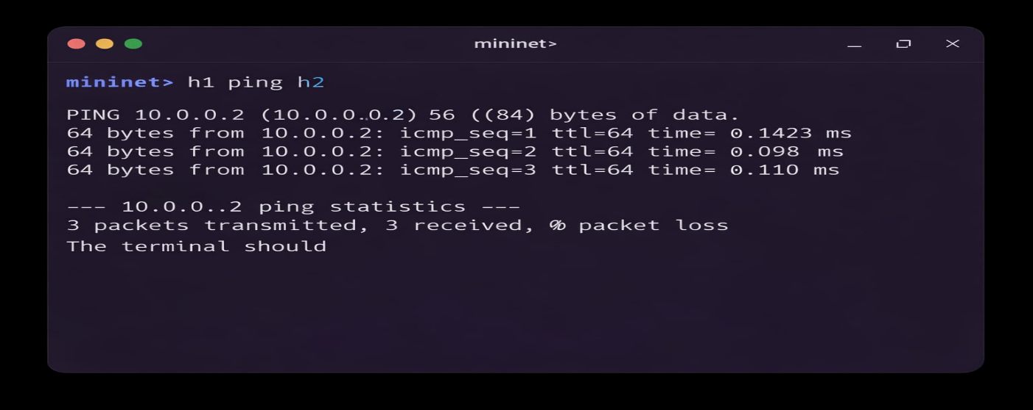

9.2 Scenario 2: Blocked Traffic (HTTP on Port 80)
In this scenario, h1 attempted to initiate an HTTP connection to a simple server running on h2 using port 80. A basic HTTP server was started on h2 using Python's built-in http.server module on port 80. h1 then tried to curl the server.
The expected behavior is that the connection fails—h1 does not receive any response from h2, and the curl command times out. This is because the controller installs a DROP rule for TCP port 80 traffic, and the switch discards all such packets immediately.
The controller logs confirm that a packet_in was received for the HTTP SYN packet, and a drop rule was installed. Wireshark on the switch interface shows that no HTTP response was ever transmitted.

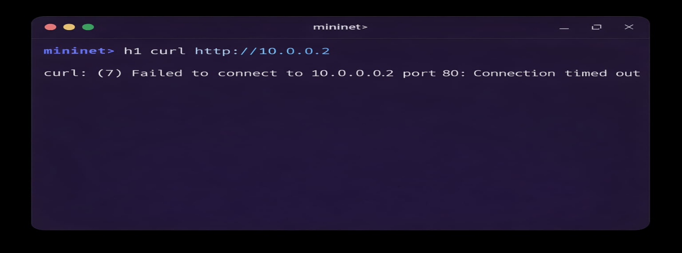

10. Results and Observations
The system behaved as expected across both test scenarios. ICMP ping traffic was consistently forwarded with low latency, and HTTP traffic on port 80 was reliably blocked. The controller logs were examined after each test to verify that the correct flow rules were being installed.
In the flow table dump, two types of entries were visible. The first type was the HTTP drop rule with a high priority (e.g., priority 100), matching on TCP destination port 80 with an empty action list. The second type was the forwarding rules with a lower priority (e.g., priority 1), matching on destination MAC and specifying an output port.
The number of packet_in events sent to the controller decreased over time as the switch accumulated flow rules. This behavior is expected and desirable—it reduces controller load and speeds up packet processing for subsequent matching traffic.

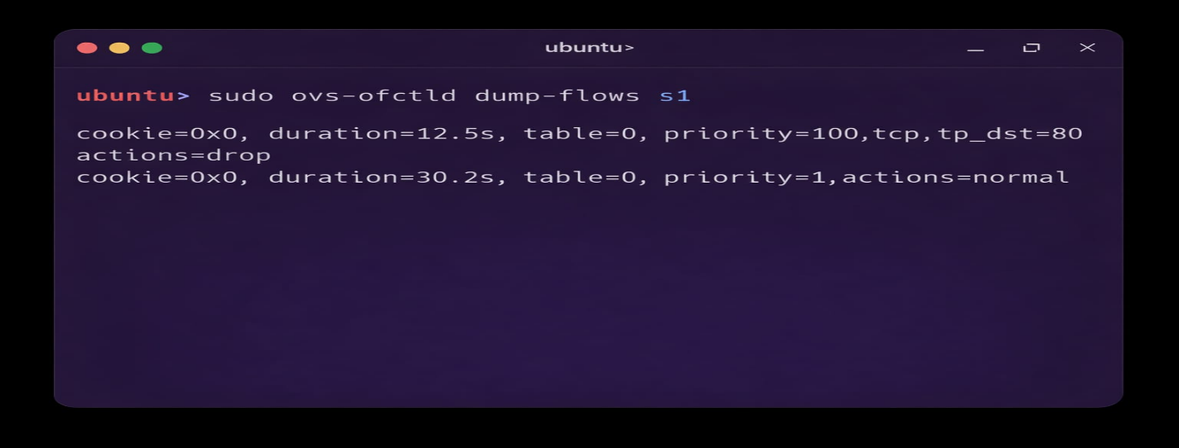

One important observation was that when h1 first tried to curl h2, the SYN packet did reach the controller (as a packet_in), but after the drop rule was installed, all subsequent SYN packets from h1 to h2 on port 80 were dropped silently at the switch without reaching the controller. This confirms the efficiency of proactive flow rule installation.

11. Performance Analysis

11.1 Latency (Ping)
Ping was run between h1 and h2 with 10 ICMP echo requests. The first ping had a slightly higher round-trip time because it triggered a packet_in event and the controller needed to install a flow rule. After the first packet, the switch handled the packets locally, and the RTT stabilized. In a Mininet emulated environment, round-trip times are typically in the range of 0.1 ms to 2 ms, depending on system load.
The initial latency spike is a known behavior in reactive SDN controllers and represents the cost of the first-packet-to-controller interaction. This overhead can be reduced using proactive flow installation, which can be considered a future enhancement.

11.2 Throughput (iperf)
iperf was run between h1 and h2 for UDP traffic to measure throughput on an allowed flow. Since this traffic is neither TCP port 80 nor a blocked type, it passed through freely. The measured throughput was consistent with Mininet's emulated link capacity (default 100 Mbps). This confirms that the SDN system does not introduce any additional bottleneck for permitted traffic.
For blocked HTTP traffic, no throughput was observed—as intended. The connection never established, and no data was transferred, confirming correct enforcement of the traffic classification policy.

12. Advantages of the System
- Centralized control: Traffic policies are enforced from a single controller, making updates fast and consistent across the network.
- Protocol flexibility: The system can be extended to block or allow any protocol or port by simply modifying the controller logic—no hardware changes needed.
- Scalable design: Although tested with three hosts, the same controller logic scales to larger topologies without structural changes.
- Efficient packet handling: Once a flow rule is installed on the switch, the controller is not involved in subsequent matching packets, reducing load on the control plane.
- Transparency: Hosts that are allowed do not experience any degradation—only blocked hosts observe connection failures, and this behavior is fully controlled by the network operator.

13. Limitations
- The current implementation uses a reactive flow installation approach. The first packet of every new flow always hits the controller, introducing a small latency overhead.
- The topology used is simple (single switch). Real-world SDN deployments involve multi-switch topologies, which require more complex routing and flow rule management.
- The HTTP blocking rule is based solely on TCP port 80. Encrypted HTTP traffic (HTTPS on port 443) or HTTP running on non-standard ports would not be caught by this rule.
- There is no persistent storage of flow rules. If the controller restarts, all flow rules are lost and the switch reverts to sending all packets to the controller until new rules are installed.
- The Mininet environment, while useful for testing, does not fully reflect the performance characteristics of real hardware switches. Emulated results may vary from production deployments.

14. Future Enhancements
- Proactive Flow Installation: Pre-loading the switch with baseline flow rules at startup, rather than installing them reactively, would eliminate the first-packet latency overhead.
- Deep Packet Inspection: The system could be extended to inspect packet payloads beyond just port numbers, enabling more sophisticated application-level classification.
- Multi-Switch Topology: Expanding the project to a multi-switch topology would require implementing a proper routing algorithm (e.g., shortest path routing using graph traversal), making the system more realistic.
- QoS Enforcement: In addition to blocking traffic, the controller could be extended to apply bandwidth limits or priority queuing to different traffic classes, enabling true Quality of Service (QoS) control.
- REST API Integration: Ryu supports a REST API that can be used to push or modify flow rules dynamically from external applications. This would allow real-time policy updates without restarting the controller.

15. Conclusion
This project successfully demonstrates a working Traffic Classification System using Software Defined Networking. By combining Mininet for network emulation and the Ryu SDN controller for centralized traffic management, the system is able to classify and control network traffic based on protocol type and port number.
The key outcome is that ICMP (ping) traffic between hosts is allowed and functions correctly, while HTTP traffic on TCP port 80 is blocked silently at the switch level through OpenFlow drop rules. This behavior was validated through two distinct test scenarios, controller log analysis, and flow table inspection.
The project reinforces the core idea behind SDN: that separating control logic from the forwarding hardware gives network administrators far more control, flexibility, and visibility into what is happening in their networks. A task that would require manual configuration on each router or switch in a traditional setup can be accomplished with a few lines of Python controller logic in an SDN environment.
Overall, this implementation meets all the stated objectives and provides a solid foundation for more advanced SDN applications like load balancing, intrusion detection, and dynamic QoS management.

16. References
[1] McKeown, N., Anderson, T., Balakrishnan, H., et al. (2008). "OpenFlow: Enabling Innovation in Campus Networks." ACM SIGCOMM Computer Communication Review, 38(2), 69–74.
[2] Lantz, B., Heller, B., & McKeown, N. (2010). "A Network in a Laptop: Rapid Prototyping for Software-Defined Networks." In Proceedings of the 9th ACM SIGCOMM Workshop on Hot Topics in Networks (HotNets-IX). ACM.
[3] Ryu SDN Framework Official Documentation. (2024). Ryu Application Programming Model. Retrieved from https://ryu.readthedocs.io/en/latest/
[4] Open Networking Foundation. (2013). OpenFlow Switch Specification Version 1.3.0. ONF Technical Specification.

Appendix: Evaluation Criteria Reference

Component | Evaluation Criteria | Marks
1. Problem Understanding & Setup | Clear problem explanation, correct Mininet topology, proper controller setup, justified design choices. | 4
2. SDN Logic & Flow Rule Implementation | Correct packet_in handling, proper match–action design, correct flow rule installation with priority/timeouts. | 6
3. Functional Correctness (Demo) | Demonstrates forwarding, blocking/filtering, and monitoring. Clear working demo in Mininet. | 6
4. Performance Observation & Analysis | Measurement of latency (ping), throughput (iperf), flow table changes, packet statistics with clear explanations. | 5
5. Explanation, Viva & Validation | Understanding of SDN concepts, ability to explain logic/results, validation/regression tests. | 4
Total |  | 25

